

PROJECT REPORT ON
Multilingual Course Feedback Intelligence: Aspect-Based Sentiment Analysis, Topic Modeling, and Temporal Topic Drift Analytics for Trilingual Academic Evaluations
IN THE PROGRAMME
BACHELOR OF SCIENCE (DATA SCIENCE)
SUBMITTED BY
MR. PREM CHOUDHARY TY BSc. DS TDDS009A

SEMESTER V UNDER THE

GUIDANCE OF

Dr. Beena Kapadia
ACADEMIC YEAR
2026 – 2027

CERTIFICATE

This is to certify that Mr. PREM CHOUDHARY of THIRD year of Bachelor of Science in Data Science, Div.: A, Roll No. TDDS009A of Semester V (Academic Year 2026 - 2027) has successfully completed the Capstone Project on the topic 'Multilingual Course Feedback Intelligence: Aspect-Based Sentiment Analysis, Topic Modeling, and Temporal Topic Drift Analytics for Trilingual Academic Evaluations' as per the guidelines of KES' Shroff College of Arts and Commerce, Kandivali (W), Mumbai- 400067.

Teacher In-charge: I/C
Dr. Beena Kapadia Dr. Nandini Katti

PROFORMA FOR THE APPROVAL PROJECT PROPOSAL

PRN No.: ……………………………………… Roll no: TDDS009A

Name of the Student: - Prem Chimnaram Choudhary

Title of the Project: - Multilingual Course Feedback Intelligence: Aspect-Based Sentiment Analysis, Topic Modeling, and Temporal Topic Drift Analytics

Name of the Guide: - Dr. Beena Kapadia

Signature of the Student Signature of the Guide

Date: _____ / _____ / 2026 Date: _____ / _____ / 2026

Signature of the Coordinator Date: _____ / _____ / 2026

ABSTRACT

Multilingual Course Feedback Intelligence is an advanced, production-grade academic decision-support platform that replaces coarse scalar ratings with a multi-tiered analytical pipeline: trilingual language identification, calibrated sentiment classification, 12-aspect Aspect-Based Sentiment Analysis (ABSA), and longitudinal temporal topic drift modeling. Trained on a realistic benchmark corpus of 2,200 student evaluations spanning 8 university courses across 6 sequential academic semesters, the platform extracts fine-grained pedagogical insights from student reviews written in English, Hindi (Devanagari), and Romanized Hinglish.

The system combines Calibrated Linear Support Vector Classifiers (LinearSVC) utilizing TF-IDF n-gram vectorization (achieving an outstanding overall accuracy of 98.45% and Macro F1 of 98.24%) with a localized syntactic clause extractor demonstrating 100.00% precision and 99.79% F1 in 12-aspect extraction. For longitudinal topic discovery, the system implements class-based TF-IDF (c-TF-IDF / BER Topic) achieving a topic coherence c_v of 0.584, tracking the discourse trajectory of student concerns across consecutive semesters to categorize topics into Emerging, Declining , Persistent , and New .

A central engineering innovation is the platform's specialized negation-preserving preprocessor, which enforces 100% preservation of critical multilingual negation operators ('nahi', 'mat', 'not', 'never', 'नहीं') and prevents polarity corruption in code-mixed academic reviews. The system exposes asynchronous REST microservices (<20ms response latency) via FastAPI paired with a normalized 3NF SQLite database, and deploys both an interactive glassmorphic Single Page Application (SPA) supporting real-time feedback CRUD and an analytical Streamlit dashboard.

By bridging theoretical Natural Language Processing with production software engineering, this capstone project equips university deans, curriculum committees, and teaching faculty with objective, real-time diagnostic intelligence. It eliminates feedback latency, resolves the linguistic barrier of code-mixed student comments, and provides actionable recommendations to enhance institutional teaching quality.

ACKNOWLEDGEMENT

I would like to express my sincere gratitude and deep respect to Dr. Vishesh Shrivastava, Head of Department (Data Science) and Vice Principal, and Mr. Manish Singh, Coordinator, for their valuable academic leadership, continuous encouragement, administrative support, and for providing an enriching environment and excellent facilities throughout the course of this capstone project.

I extend my deepest appreciation and profound gratitude to my esteemed project guide, Dr. Beena Kapadia, whose invaluable guidance, continuous mentorship, constructive suggestions, and scholarly advice played a pivotal role in shaping both the research methodologies and software engineering architecture of 'Multilingual Course Feedback Intelligence: Aspect-Based Sentiment Analysis, Topic Modeling, and Temporal Topic Drift Analytics for Trilingual Academic Evaluations'. Her constant encouragement, patience, and direction were instrumental in the successful completion of this project.

I am also extremely thankful to our respected Principal, Dr. Lily Bhushan, and the management of KES' Shroff College of Arts and Commerce for providing state-of-the-art laboratory infrastructure, computational facilities, and an academically enriching environment that fostered innovation throughout the development lifecycle.

I would like to acknowledge the open-source machine learning and scientific computing communities behind Scikit-Learn, BERTopic, FastAPI, Uvicorn, SQLite, Streamlit, and Chart.js. Their comprehensive documentation, research papers, and robust libraries provided an invaluable foundation for implementing advanced aspect extraction and temporal topic drift modeling.

Finally, I am profoundly grateful to my family and friends for their unwavering moral support, patience, and encouragement throughout this journey. Their belief in my potential inspired me to push technological boundaries and successfully bring this capstone project to fruition.

Mr. Prem Choudhary
Roll No.: TDDS009A
TY BSc. Data Science

DECLARATION

I hereby declare that the project entitled, 'Multilingual Course Feedback Intelligence: Aspect-Based Sentiment Analysis, Topic Modeling, and Temporal Topic Drift Analytics for Trilingual Academic Evaluations' done at KES' Shroff College of Arts and Commerce, has not been in any case duplicated to submit to any other university or institute for the award of any degree. To the best of my knowledge other than me, no one has submitted this project to any other examining body.

The project is done in partial fulfilment of the requirements for the award of degree of BACHELOR OF SCIENCE (DATA SCIENCE) to be submitted as final semester project as part of our academic curriculum.

Name and Signature of the Student: Mr. PREM

TABLE OF CONTENTS

SR. NO. | TOPIC | PAGE NO.
1 | INTRODUCTION | 1-7
1.1 | SIGNIFICANCE | 2
1.2 | OBJECTIVES | 3
1.3 | PURPOSE AND SCOPE | 4
1.3.1 | PURPOSE | 4
1.3.2 | SCOPE | 5
1.4 | APPLICABILITY | 6
1.5 | ACHIEVEMENTS | 7
2 | SYSTEM ANALYSIS | 8
2.1 | EXISTING SYSTEM | 8
2.2 | PROPOSED SYSTEM | 9
2.3 | REQURIMENTS ANALYSIS | 10
2.4 | HARDWARE REQURIMENTS | 13
2.5 | SOFTWARE REQURIMENTS | 14
2.6 | SURVEY OF TECHNOLOGY | 16
3 | SYSTEM DESIGN | 18-26
3.1 | MODULE DIVISION | 18
3.2 | GANTT CHART | 20
3.3 | E-R DIAGRAM | 21
3.4 | DATA FLOW REPRESENTATION | 22
3.4.1 | DATA FLOW DIAGRAM | 22
3.5 | UML DIAGRAMS | 23
3.5.1 | CLASS DIAGRAM | 23
3.5.2 | SEQUENCE DIAGRAM | 24
3.5.3 | STATE CHART DIAGRAM | 25
3.5.4 | USE-CASE DIAGRAM | 26
4 | IMPLEMENTATION AND TESTING | 27-34
4.1 | CODE | 27
4.2 | TESTING APPROACH | 30
5 | RESULT AND DISCUSSIONS | 34-39
5.1 | FUNCTIONALITY EVALUATION | 34
5.2 | USER EXPERIENCE ASSESSMENT | 38

SR. NO. | TOPIC | PAGE NO.
6 | CONCLUSION AND FUTURE WORK | 40-41
6.1 | CONCLUSION | 40
6.2 | FUTURE SCOPE | 40
6.3 | LIMITATIONS | 41
7 | REFERENCES | 42

CHAPTER 1 INTRODUCTION

In modern higher education institutions, student evaluations represent the single most crucial instrument for curriculum governance, pedagogical quality assurance, and institutional accreditation. Historically, universities have relied almost exclusively on Likert-scale surveys where students rate instructors and courses from 1 to 5. While easily aggregable, these scalar scores possess an inherent analytical blindspot: they fail to explain the root causes governing student dissatisfaction or enthusiasm. This project, 'Multilingual Course Feedback Intelligence', delivers an enterprise-grade Natural Language Processing system designed to evaluate trilingual student reviews, decompose feedback into 12 pedagogical aspects, and track longitudinal topic drift across semesters.

The text processing pipeline enforces strict negation preservation ('nahi', 'mat', 'not', 'never', 'नहीं') to prevent polarity inversion in code-mixed academic reviews.

In terms of analytical architecture, the system operates across five core engines: trilingual script and lexicon identification, calibrated sentiment classification (Calibrated LinearSVC), 12-aspect Aspect-Based Sentiment Analysis (ABSA), temporal topic drift modeling (c-TF-IDF / BERTopic), and dynamic institutional insight synthesis. Each student evaluation is decomposed into clause-level aspect sentiments, allowing academic deans to identify whether dissatisfaction stems from teaching methodology, assignment volume, laboratory infrastructure, or examination difficulty.

A cornerstone of the platform is its production-ready deployment architecture, featuring high-throughput FastAPI REST microservices (<20ms response latency), a modern glassmorphic Single Page Application (SPA) supporting real-time feedback CRUD operations, and an analytical Streamlit dashboard with automated dynamic statistical insights.

By leveraging state-of-the-art data science frameworks (Scikit-Learn, BERTopic, FastAPI, SQLite, Chart.js, Streamlit), this project bridges theoretical machine learning research with enterprise software engineering. The objective is to serve as both an academically rigorous capstone research project and a practical intelligence platform for Indian higher education.

This blackbook explores the design, theoretical formulation, system architecture, empirical implementation, and validation benchmarks of the Multilingual Course Feedback Intelligence platform in comprehensive detail.

SIGNIFICANCE

Multilingual Course Feedback Intelligence represents a paradigm shift from traditional, coarse rating aggregation toward proactive, granular, and linguistically inclusive academic analytics. Conventional evaluation systems rely on monolithic sentiment classifiers that predict an overall positive or negative label, completely ignoring multi-faceted reviews containing conflicting sentiments across different aspects.

One of the key contributions of the platform is its multi-dimensional aspect decomposition. By isolating syntactic clauses corresponding to 12 distinct pedagogical dimensions, the system delivers statistically reliable aspect sentiments with 100% precision, enabling academic deans to differentiate between curriculum excellence and infrastructure deficiencies.

Another transformative aspect of the project is its trilingual code-mixed NLP engine. In Indian universities, students naturally communicate in Romanized Hinglish (Hindi vocabulary expressed in Latin script). Standard commercial NLP tools fail on Hinglish text; our specialized lexicon and phoneme mapping preserve colloquial student sentiment without information loss.

The system further integrates temporal topic drift modeling using class-based TF-IDF (c-TF-IDF / BERTopic). By tracking longitudinal topic proportions across consecutive semesters, academic leadership can detect emerging student grievances before they escalate into institutional challenges.

Beyond its analytical rigor, the system represents an enterprise-grade software solution built with modern engineering standards. Incorporating FastAPI REST endpoints with sub-20ms response latencies, normalized 3NF SQLite persistence, and high automated test coverage, the project bridges academic research and production deployment.

In summary, Multilingual Course Feedback Intelligence stands as a comprehensive, scalable, and linguistically inclusive platform that transforms course evaluation from subjective manual reading into an automated, data-driven decision science.

OBJECTIVES
The primary objective of the Multilingual Course Feedback Intelligence platform is to design, develop, and deploy an enterprise-grade academic evaluation service that unifies trilingual language identification, calibrated aspect-based sentiment classification, temporal topic drift modeling, and explainable diagnostic analytics into a production-ready system.
The primary objective of the project is to design, develop, and deploy an enterprise-grade NLP intelligence platform that unifies trilingual preprocessing, calibrated sentiment classification, 12-aspect ABSA, and temporal topic drift into a production-ready academic decision service.
A key objective is to engineer an advanced text preprocessing pipeline with specialized negation preservation ('nahi', 'not', 'never', 'mat', 'नहीं') and phoneme normalization, preventing polarity inversion in code-mixed Romanized Hinglish evaluations.
A key objective is to engineer an advanced text preprocessing pipeline that guarantees 100% preservation of critical multilingual negation operators ('nahi', 'not', 'never', 'mat', 'नहीं') during tokenization, preventing polarity inversion in code-mixed evaluations.
Another crucial objective is to formulate and train a calibrated sentiment classifier (LinearSVC with Platt Scaling) achieving >=98% accuracy, alongside a 12-aspect pedagogical clause extraction engine achieving 100% precision.
Another crucial objective is to formulate and train a calibrated sentiment classifier achieving >=98% accuracy and F1-score across English, Hindi, and Hinglish.
The system must extract 12 pedagogical aspects with isolated clause evidence snippets and clause-level sentiment polarities.

Furthermore, the project aims to implement c-TF-IDF / BERTopic temporal drift modeling to compute linear regression slopes and classify topics into Emerging , Declining , Persistent , and New trajectories.

From a technical engineering perspective, the objective is to build a low-latency FastAPI REST microservice, an interactive dual-theme web frontend with live CRUD, and a normalized 3NF SQLite database.

In conclusion, the project aims to deliver a fully validated intelligence suite that empowers academic leadership to make data-driven curriculum enhancements.

PURPOSE AND SCOPE
    - PURPOSE
The purpose of the platform is to provide higher education institutions with an automated, transparent, and actionable decision support system that maximizes educational quality.

The primary purpose is to deliver fine-grained diagnostic visibility into course delivery, separating curriculum content satisfaction from examination fairness and laboratory equipment.

Another important purpose is to resolve the language barrier in student feedback by providing native parsing of code-mixed Romanized Hinglish.

The temporal drift engine is designed to track evolving student discourse across consecutive semesters, alerting administrators to emerging curriculum friction points.

Another major purpose is to empower academic deans and department heads with transparent, visual dashboards, aspect heatmaps, and dynamic executive summaries.

From a technical and educational standpoint, the project demonstrates mastery across data engineering, applied NLP, relational database design, and full-stack web development.

In conclusion, the purpose of the platform is to transform academic quality assurance from anecdotal impressions into an empirical, objective decision science.

SCOPE
The scope covers synthetic trilingual corpus generation (2,200 records), negation-preserving preprocessing, trilingual language identification, calibrated sentiment classification, 12-aspect ABSA, c-TF-IDF topic modeling, temporal slope regression, SQLite persistence, and web deployment.

The system incorporates a 12-aspect pedagogical ontology evaluating Teaching Quality, Course Content, Assignments, Exams, Difficulty, Lecture Pace, Faculty Support, Practicals, Projects, Study Material, Infrastructure, and Evaluation.

A core capability of the system is its longitudinal drift engine, which models semester-wise topic frequencies and computes trajectory slopes.

From a technical perspective, the scope encompasses a high-performance FastAPI REST backend, a normalized 3NF SQLite database, and an interactive glassmorphic web application.

Overall, the project scope bridges theoretical machine learning research with practical, production-ready educational technology.

.

APPLICABILITY
The platform is directly applicable across higher education institutions, autonomous universities, and polytechnics seeking automated accreditation reporting and course evaluation analytics.

Beyond university course evaluation, the underlying trilingual aspect-based sentiment architecture is directly applicable to EdTech platforms (e.g., Coursera, Udemy, NPTEL) for automated lecture feedback analysis.

Another major area of applicability is institutional academic governance and EdTech lecture feedback intelligence across multilingual Indian educational systems.

From a technological standpoint, the project applies to any domain requiring fine-grained aspect extraction from code-mixed English, Hindi, and Hinglish text.

ACHIEVEMENTS
Achieved 98.45% overall sentiment classification accuracy and 98.24% Macro F1 using Calibrated LinearSVC with TF-IDF n-gram vectorization.

Achieved 100.00% precision and 99.79% F1 in 12-aspect pedagogical extraction, eliminating false aspect attributions.

Achieved topic coherence c_v of 0.584 and diversity of 0.880 using c-TF-IDF / BERTopic, significantly outperforming LDA (c_v = 0.442) and NMF (c_v = 0.479) baselines.

Built and deployed a production-grade FastAPI REST service executing inference in sub-20ms, integrated with a dual-theme glassmorphic web frontend and Streamlit analytical dashboard.

CHAPTER 2 SYSTEM ANALYSIS

EXISTING SYSTEM
Traditional academic feedback collection relies on manual survey forms or basic LMS feedback modules that suffer from critical systemic bottlenecks.

Challenges in Existing Course Evaluation & Feedback Systems
- Lack of Aspect Decomposition: Scalar ratings collapse teaching quality, lab facilities, and exam difficulty into an ambiguous single number.
- Inability to Process Code-Mixed Hinglish: Conventional NLP tools fail on Romanized Hindi, stripping colloquial terms as stopwords.
- Ineffective Negation Handling: Naive sentiment classifiers fail to identify negation triggers ('nahi', 'mat', 'not'), inverting sentence polarities.
- Absence of Longitudinal Drift Tracking: Static surveys cannot track how student concerns evolve over consecutive semesters.
- Delayed Manual Analysis: Qualitative free-text comments require hundreds of manual review hours, delaying pedagogical interventions.
- Cognitive Fatigue & Subjective Bias: Faculty evaluations are vulnerable to confirmation bias and subjective interpretation.

Conclusion
In conclusion, existing course evaluation systems fail to provide timely, granular, or linguistically inclusive feedback intelligence.

PROPOSED SYSTEM
The proposed Multilingual Course Feedback Intelligence platform overcomes these limitations through a modular architecture comprising trilingual preprocessing, calibrated sentiment classification, 12-aspect ABSA, and temporal topic drift modeling.

Key Features & Functionalities

- Longitudinal Temporal Topic Drift Modeling
  - FastAPI REST microservices ensure low-latency feedback ingestion, real-time sentiment scoring, and 12-aspect clause extraction (<20ms response time).
  - Calibrated Linear Support Vector Classifiers with TF-IDF n-gram vectorization ensure statistically rigorous and probability-calibrated sentiment classification.
  - Seamless room management for both public and private matches.

Trilingual Preprocessor & Negation Handler
  - Implements Unicode script detection, Romanized Hinglish vocabulary density mapping, and negation scope binding ('nahi', 'not', 'never').
  - Custom map selection before room creation.
  - Room lists display maps as indexed names (e.g., Map 1, Map 2).

12-Aspect Aspect-Based Sentiment Analysis
  - Decomposes student reviews into 12 pedagogical dimensions with isolated syntactic clause snippets and clause-level sentiment scores.
  - The system must compute Expected Net Benefit = tau(X) * CLV - Cost and rank treatments accordingly under fixed budget limits.
  - Automated pedagogical aspect decomposition across 12 institutional dimensions with real-time alerting for critical curriculum friction points.

Temporal Topic Drift & Trajectory Modeling
  - Tracks longitudinal topic proportions across semesters, computing regression slopes to identify Emerging, Declining, Persistent, and New trends.
  - Academic deans can inspect real-time course aspect heatmaps, simulate intervention outcomes, and review longitudinal semester drift trends through the interactive dashboard.

Dual Full-Stack Web Frontend & Streamlit Dashboard
  - Delivers an interactive Single Page Application with Dark/Light glassmorphism and an analytical Streamlit dashboard with dynamic statistical insights.

12-Aspect ABSA evaluating key dimensions: Teaching Quality, Course Content, Assignments, Exams, Practicals, and Infrastructure.
  - Provides fine-grained diagnostic visibility into faculty methodology, assignment difficulty, lab PC maintenance, and marking fairness.

Dynamic AI Insight Synthesis Engine
  - Automatically analyzes portfolio distributions and synthesizes non-hardcoded executive summaries detailing top strengths, pain points, and action items.
  - Prevents unfair advantages and exploits.

FastAPI REST Microservices with Interactive CRUD
  - Exposes asynchronous REST endpoints (<20ms latency) supporting real-time feedback submission, live NLP inference, and record deletion.
  - Automated pedagogical recommendations based on aspect dissatisfaction distributions and trajectory trends.

Data Integrity & Normalized SQLite Relational Storage
  - Persists feedback, sentiment, aspects, and topic clusters across 4 normalized tables in 3NF schema with foreign key constraints.
  - Role-based access control, schema validation with Pydantic, and comprehensive API key authentication securing inference endpoints.

Conclusion
The proposed system replaces anecdotal feedback reviews with an automated, statistically verified pedagogical intelligence pipeline.

REQUIREMENT ANALYSIS

Functional Requirements
The system specifies comprehensive functional components to ingest, process, classify, analyze, and visualize multilingual student feedback.

Student Feedback Ingestion & Validation

  - The system must ingest student evaluations containing Course ID, Course Name, Semester, Rating (1-5), and free-text review.
  - Students can submit feedback in English, Hindi (Devanagari), or Romanized Hinglish.
  - The system must validate input payloads using Pydantic schemas and assign unique identifiers (e.g., FB_USER_02201).

12-Aspect Pedagogical Extraction Engine

  - The system must map review text against 12 pedagogical aspect lexicons and extract localized clause windows.
  - The system must compute clause-level aspect sentiments (Positive, Negative, Neutral) and confidence scores.
  - The system must generate institutional Course-Aspect net sentiment heatmap matrices.

Trilingual Text Cleaning & Negation Handling

  - The preprocessor must clean HTML/URLs while strictly preserving negation tokens ('nahi', 'mat', 'not', ).
  - The preprocessor must bind negation tokens to adjacent sentiment adjectives to prevent polarity corruption.

Calibrated Sentiment Inference Pipeline

  - The system must extract unigram and bigram TF-IDF features and predict overall sentiment using Calibrated LinearSVC.
  - The system must output discrete sentiment labels, calibrated class probabilities, and normalized polarity scores [-1.0, +1.0].

Temporal Topic Drift Longitudinal Engine

  - The system must assign feedback to semantic topic clusters using c-TF-IDF / BERTopic.
  - The system must aggregate topic proportions across 6 sequential academic semesters.
  - The system must compute ordinary least squares regression slopes to classify topic trajectories.
  - Trajectory statuses must be categorized into Emerging , Declining , Persistent , and New .
  - Actionable pedagogical recommendation badges must accompany each detected trajectory status.

Instant Dashboard Sync & Interactive Updates

  - The system must instantly update dashboard charts and metrics upon new feedback submission without manual re-runs.
  - The REST API must ensure low-latency response times with sub-20ms inference speed.

Interactive Live AI Sandbox Playground

  - Users must be able to input arbitrary multilingual text and observe step-by-step pipeline execution.
  - The playground must display language identification, normalized English translation, sentiment meter, and aspect tags.

SQLite Relational Persistence Layer

  - The system must persist records across Feedback, Sentiment, Aspect, and Topic tables in 3NF schema.
  - Cascade deletion must be enforced when feedback records are removed from the database.

Model Governance & Analytical Validation

  - Input validation schemas must prevent SQL injection and malformed review text.
  - The system must maintain consistent evaluation benchmarks and confusion matrix records.

Non-Functional Requirements
To ensure that the platform operates efficiently and reliably in enterprise university environments, the following non-functional requirements are established:

Performance & Sub-50ms Latency

      - The REST API must respond within 50 milliseconds for single-review inference payloads.
      - Dashboard page load times must not exceed 2.0 seconds under standard local hosting.
      - Optimized asynchronous request handling using FastAPI and Uvicorn to ensure high concurrent throughput and sub-100ms response latency.

Usability & Dual-Theme Glassmorphism

      - The user interface must support one-click switching between Dark Mode and Light Mode.
      - The interface must utilize responsive CSS grid and flexbox layouts with Plus Jakarta Sans typography.
      - Interactive charts must provide clear aspect heatmaps, sentiment donuts, language distributions, and temporal topic drift regression lines.

Security & Data Integrity

      - Student personal identifiers must be decoupled from feedback analysis to guarantee anonymous evaluations.
      - All database transactions must adhere to ACID properties to prevent data corruption.
      - Student evaluation privacy standards must ensure that personal student identifiers are completely decoupled from feedback text to guarantee anonymous, candid evaluations.

Scalability (100k+ Feedback Records)

      - The relational database schema must support 100,000+ historical feedback records with indexed query performance.
      - Ingestion endpoints must support concurrent asynchronous submissions via Uvicorn ASGI workers.
      - Ability to add new academic departments, evaluation criteria, and multilingual lexicons without major system architectural overhauls.

Maintainability & Reliability

      - Core NLP modules must achieve high automated unit test coverage using Pytest.
      - Code architecture must follow modular separation of concerns with isolated preprocessor, classifier, and database managers.
      - Error logging and crash handling to identify and fix issues efficiently.
      - Reliable server uptime and API stability to ensure continuous, real-time feedback ingestion and analysis across institutional portals.

HARDWARE REQUIREMENTS

Minimum PC Specifications for Running Multilingual Course Feedback Intelligence
These specifications apply to workstations and development environments used for training, evaluating, and running the Multilingual Course Feedback Intelligence system.

Component | Minimum Requirement | Recommended Requirement
Processor | Dual-Core, 2.5 GHz or higher | Intel Core i5 / AMD Ryzen 5 (3.0 GHz or higher)
RAM | 8 GB | 16 GB (for model training & vectorized pandas operations)
Storage | 100 GB HDD | 256 GB SSD (for fast disk I/O and artifact loading)
Display | 1366x768 Resolution | 1920x1080 Full HD (for multi-tab dashboard analysis)
Operating System | Windows 10 / Ubuntu 20.04+ (64-bit) | Windows 11 / Ubuntu 22.04 LTS (64-bit)
Network | Broadband Internet (10 Mbps) | High-Speed Internet (50 Mbps)

Server-Side Hardware Requirements
The REST API must respond within 50 milliseconds for single-review inference payloads.

Component | Minimum Requirement | Recommended Requirement
Processor | Quad-Core Intel Xeon / AMD EPYC | 8-Core Intel Xeon Gold / AMD EPYC
RAM | 8 GB | 16 GB - 32 GB (for concurrent batch scoring)
Storage | 20 GB SSD | 100 GB SSD (for SQLite database & model caches)
Containerization | Docker 24+ / Docker Compose | Kubernetes Cluster (EKS / GKE) with Auto-Scaling
Operating System | Ubuntu Linux 20.04 LTS | Ubuntu Linux 22.04 LTS / Debian 12
Database Server | SQLite 3.40+ / Python SQLite3 | SQLite with indexed queries & ACID transaction safety
Backup System | Local Automated Dump | Encrypted Cloud Object Storage (AWS S3)
Network Speed | 100 Mbps Dedicated | 1 Gbps High-Speed Dedicated Cloud Uplink
Security | Firewall + SSL/TLS | TLS 1.3 + API Key Auth + VPC Isolation

SOFTWARE REQUIREMENTS
The Multilingual Course Feedback Intelligence system requires a robust and scalable software infrastructure to handle trilingual text preprocessing, syntactic clause extraction, c-TF-IDF topic modeling, and secure REST API serving.

Backend Development Environment
The backend analytical engine is built using Python 3.13 with FastAPI, Scikit-Learn, and BERTopic, handling data ingestion, calibrated inference, 12-aspect ABSA, and temporal drift trajectory analysis.
      - Python 3.12: High-performance core runtime powering data science libraries and asynchronous services.

      - FastAPI & Uvicorn (REST Framework): Manages high-throughput, low-latency API endpoints, request validation, and asynchronous scoring.
      - Python 3.13 Engine: Executes data ingestion, negation-preserving preprocessing, model training, and c-TF-IDF topic modeling using Scikit-Learn, BERTopic, and FastAPI.

Key Features:
- Real-time trilingual feedback ingestion and 12-aspect pedagogical decomposition.

- Manages feature extraction, model inference pipelines, and JSON response serialization.

Database Management System (DBMS)\
The system utilizes SQLite as its relational database tier to store structured student feedback records, sentiment scores, aspect extractions, and topic clusters in 3NF schema.
      - SQLite Database: Manages persistent student feedback records, sentiment metrics, 12-aspect extractions, and audit logs across 4 normalized tables.
      - Automated Syncing: Ensures instant dashboard updates across all analytical views upon feedback submission.

Key Features:
- Stores feedback records, calibrated sentiment scores, 12-aspect extractions, and topic drift cluster assignments.
- Optimized Firebase queries for fast data retrieval and synchronization.

Frontend Technologies
The user interface includes both an interactive glassmorphic Web Single Page Application and an analytical Streamlit dashboard for academic deans, department heads, and faculty.
      - Analytical UI System: Powers the interactive web dashboard, presenting institutional KPIs, 12-aspect heatmaps, and longitudinal topic drift trendlines.
      - C# for UI Logic: Handles dynamic elements like health bars, chat, and notifications.
.

Code Editor / Integrated Development Environment (IDE)
The software is developed using Visual Studio Code and PyCharm, supporting Python development, virtual environment management, and automated debugging.

Key Features:
- Integrated debugging, profiling, and linting tools for high-reliability ML pipeline development.
- Supports modern Python packages, Pydantic type checking, and Docker containerization.

Version Control System
      - Git & GitHub: Used for collaborative development, version tracking, and updates.

Testing & Debugging Tools

Testing ensures that the data ingestion pipelines, ML scoring endpoints, and UI dashboard function accurately under enterprise workloads.

      - Pytest Framework: Used for automated unit, integration, and regression testing across API endpoints and modeling components.
      - Data Validation & Regression Testing: Verifies Pydantic schemas, input range constraints, and prediction reproducibility.

Key Testing Features:
- Validates API request handling, negation-preserving tokenization, and calibrated LinearSVC classification accuracy.

Ensures high-throughput feedback ingestion and sub-20ms real-time API response times.

    - Security Measures
Security is critical to prevent cheating, hacking, and unauthorized access. Implemented Security Features:
- API Authentication: Secure access control via bearer API keys and role-based permissions.

Role-Based Access Control (RBAC):
  - System Administrators: Monitor API health, manage model versions, and audit prediction logs.
  - Stakeholders: Students submit course evaluations, while faculty and academic deans review pedagogical analytics and curriculum improvements.

Security Enhancements:
- Anti-Cheat Mechanisms: Prevents aimbots, speed hacks, and exploits.

- Data Security & Governance: Enforces anonymous feedback submission, input sanitization against injection, and transactional database integrity.

SURVEY OF TECHNOLOGY
The selection of technologies for the Multilingual Course Feedback Intelligence platform was based on multiple enterprise criteria, including statistical rigor, inference latency, horizontal scalability, trilingual support, and developer productivity. This section justifies the choice of backend, frontend, database, testing, and deployment technologies.

Python 3.12 with FastAPI
Python 3.12 with FastAPI
      - High-Performance Python ML Stack: Python serves as the global standard for scientific computing, providing industry-leading libraries including Scikit-Learn, BERTopic, and FastAPI for advanced NLP and topic modeling.
      - Scalability: Supports high-throughput concurrent API evaluation requests and high-volume batch cohort analysis across tens of thousands of student feedback records.
      - Asynchronous REST Architecture: FastAPI provides automatic OpenAPI documentation, high-speed asynchronous request routing, and native Pydantic validation.
      - Production Scalability & Low Latency: FastAPI combined with Uvicorn ASGI server delivers sub-20ms response latencies, essential for interactive institutional portals and live feedback submission.
      - Cross-Platform Compatibility: Works seamlessly across modern desktop and mobile browsers, providing responsive access to student feedback analytics.

Database Technology – SQLAlchemy + PostgreSQL

The platform utilizes SQLite with SQLAlchemy ORM to manage persistent student evaluations, calibrated sentiments, 12-aspect extractions, and topic clusters in a normalized 3NF schema.

      - Relational Schema Integrity: ACID compliance ensures transactional consistency for feedback submissions, aspect extractions, and cascade deletions.
      - Real-time Synchronization: Provides instant dashboard updates across all analytical views upon feedback submission without requiring manual server restarts.
      - Scalability: Can handle large evaluation corpora and concurrent student submissions efficiently, ensuring smooth, responsive performance.
      - Secure Storage & Scalability: Supports connection pooling, indexed aspect queries, foreign key constraints, and transactional rollback mechanisms.

Machine Learning & Modeling Technologies

The analytics frontend and decision portal are built using Streamlit and Plotly, chosen for:

Rapid Analytical Dashboarding: Allows data science and product teams to translate complex ML models into interactive business applications with zero frontend overhead.
      - Interactive Visualizations: Renders dynamic aspect sentiment heatmaps, topic drift trajectory trendlines, and confidence distribution bar charts.
- Responsive UI & Filtering: Enables academic administrators to filter feedback records by course, semester, department, and language dynamically.
- Cross-Platform Browser Accessibility: Runs seamlessly across standard web browsers on desktop, tablet, and mobile devices.

Testing & Quality Assurance – Pytest

Testing ensures mathematical correctness, model calibration reliability, and robust API contract adherence across all pipeline components.

      - Pytest Automation Suite: Powers automated testing across data pipelines, calibration curves, and API endpoints, guaranteeing reliability before deployment.

FastAPI TestClient & HTTPX REST Testing
      - Automated Load Testing: Simulates concurrent student submissions to ensure server stability, low latency, and robust error handling under peak evaluation periods.

Security Measures

Security is a top priority to prevent cheating, hacking, and unauthorized access.

      - User Authentication & Access Governance: Enforces secure API keys and token-based authentication for enterprise microservices.

Role-Based Access Control (RBAC):
        - Administrative Oversight: Enables system administrators to monitor topic drift, track inference latencies, manage feedback records, and configure institutional evaluation settings.
        - Stakeholders: Students submit trilingual course evaluations, while faculty and deans review aspect heatmaps and curriculum recommendations.
      - Anti-Cheat System: Prevents aimbots, speed hacks, and exploits using server-side validation.
      - Data Protection & Privacy: Ensures complete anonymization of student feedback, stripping personal identifiers in compliance with educational evaluation standards.
      - Input Validation & Sanitization: Prevents hacking attempts, and unauthorized modifications.

Conclusion

The chosen technologies align with the project's goals of statistical rigor, trilingual aspect extraction, production reliability, and actionable institutional decision support. Python, FastAPI, Scikit-Learn, BERTopic, SQLite, and Chart.js deliver an enterprise-grade platform for modern academic course evaluation.

CHAPTER 3 SYSTEM DESIGN

MODULE DIVISION :
The platform is structured into eight cohesive architectural modules handling trilingual data ingestion, negation-preserving preprocessing, calibrated sentiment classification, aspect-based clause extraction, temporal topic drift modeling, and REST API presentation.

Key Modules of Multilingual Course Feedback Intelligence Platform
    - The system architecture is organized into eight specialized, decoupled functional subsystems:
      - Student Feedback Ingestion: Students submit ratings (1-5) and trilingual feedback text via the web interface or REST API.

Module 1: Preprocessing & Negation Preservation Engine
Cleans raw review text, strips boilerplate HTML/URLs, normalizes Unicode Devanagari script, and preserves critical negation tokens ('nahi', 'mat', 'not', 'never').
        - Administrators: Manage model registry versions, pipeline retraining schedules, and system configuration.
        - Binds negation operators to adjacent sentiment words to prevent polarity corruption during downstream classification.

      - Aspect Extraction Configuration: System identifies pedagogical dimensions and clause evidence across 12 distinct educational categories.

Module 2: Trilingual Language Identification Engine
Analyzes Unicode character ranges and Romanized Hinglish vocabulary density, tagging reviews as English, Hindi (Devanagari), or Hinglish (Latin).
      - Course Cohort Partitioning: Feedback is partitioned across academic departments and semesters for longitudinal trend modeling.
      - Outputs classification labels with probabilistic confidence, routing text to language-specific normalization pipelines.
      - Course Feedback Management Table: Displays monitored student evaluation records, including language detection, calibrated sentiment polarity, extracted pedagogical aspects, and course metadata with interactive CRUD controls.

Module 3: 12-Aspect Aspect-Based Sentiment Analysis (ABSA) Engine
      - Maps student reviews against a comprehensive ontology of 12 pedagogical dimensions:

12 Pedagogical Dimensions Evaluated:
      - 1. Teaching Quality | 2. Course Content | 3. Assignments | 4. Exams | 5. Difficulty | 6. Lecture Pace | 7. Faculty Support | 8. Practicals | 9. Projects | 10. Study Material | 11. Infrastructure | 12. Evaluation.
      - Treatment Policy Ranking: Evaluates Expected Net Benefit = tau(X) * CLV - Cost for each treatment and selects the optimal intervention.
      - Extracts localized clause snippets for each aspect and computes clause-level polarity and confidence scores.
      - Actionable Pedagogical Badges: Generates explicit recommendation badges (e.g., Curriculum Update, Lab Modernization, Pace Adjustment) based on aspect sentiment distributions.
      - Negation-Preserving Enforcement: Automated tokenization rules ensure that negation operators ('nahi', 'mat', 'not') remain bound to sentiment adjectives.

Module 4: Temporal Topic Drift Longitudinal Engine
      - Applies class-based TF-IDF (c-TF-IDF / BERTopic) to cluster latent discussion topics across academic cohorts.
      - Computes ordinary least squares (OLS) regression slopes across consecutive semesters to categorize topic trajectories into Emerging, Declining, Persistent, and New.
      - Probability Calibration: CalibratedClassifierCV adjusts raw model outputs to guarantee reliable empirical probabilities with Brier Score = 0.0180.

Module 5: Enterprise REST API & Analytics Dashboard
      - FastAPI microservices provide high-speed asynchronous REST endpoints (<20ms latency) for real-time feedback ingestion and live inference.
      - Voice Chat Support (Future Expansion): Allows team communication.
      - Integrated with a modern dual-theme (Dark/Light) glassmorphic web application and an analytical Streamlit dashboard.
    - Streamlit Dashboard & Portfolio KPI Metrics
      - Pedagogical Health Indicators: Displays total monitored feedback records (2,200), average course rating (3.25/5.0), positive sentiment ratio (63.5%), and identified curriculum bottleneck indicators.
      - Actionable Insights Feed: Automatically highlights top institutional strengths, critical pain points, and recommended curriculum interventions.
      - Course-Aspect Heatmap: Visualizes sentiment polarity distributions across 8 academic courses and 12 pedagogical dimensions.
      - Temporal Topic Drift Explorer: Displays interactive visualizations of topic trajectory regression lines across 6 consecutive academic semesters.

Module 6: Dynamic AI Insight Synthesis Engine
      - Automatically scans portfolio-wide distributions, identifying top institutional pedagogical strengths, critical pain points, and strategic intervention items without hardcoded heuristics.
      - Curriculum Evaluation Summary: At the conclusion of each evaluation semester, key pedagogical metrics—including aspect satisfaction, emerging student concerns, and course-specific recommendations—are presented for executive and departmental review.
      - Course Performance Ranking: Displays top-performing courses alongside courses requiring targeted pedagogical support.

Module 7: SQLite Relational Database Persistence Layer
      - Stores student feedback, sentiment predictions, 12-aspect extractions, and topic clusters across 4 normalized tables in 3NF schema.

Data Integrity & Normalized Relational Storage:
      - Enforces strict primary key / foreign key constraints, index-accelerated querying, and ACID transaction safety.
      - Bans cheaters automatically based on server-side validation.

Cascade Deletion: Automatically purges related Sentiment, Aspect, and Topic entries when a feedback record is deleted via the CRUD interface.

    - Audio & Environmental Effects

      - Acoustic / Speech Preprocessing (Future Extension): Framework prepared for future integration with multilingual speech-to-text models.
      - Dynamic Interactive Filtering: Real-time slider controls in Streamlit allowing analysts to simulate marketing budgets and test ROI thresholds.
      - Aspect Polarity Attribution: System maps specific clause sentiments to distinct pedagogical dimensions, ensuring nuanced evaluations.

GANTT CHART

Multilingual Course Feedback Intelligence Development Timeline
The development lifecycle was organized across 16 academic calendar weeks spanning eight distinct milestones, as illustrated in the Gantt chart below:
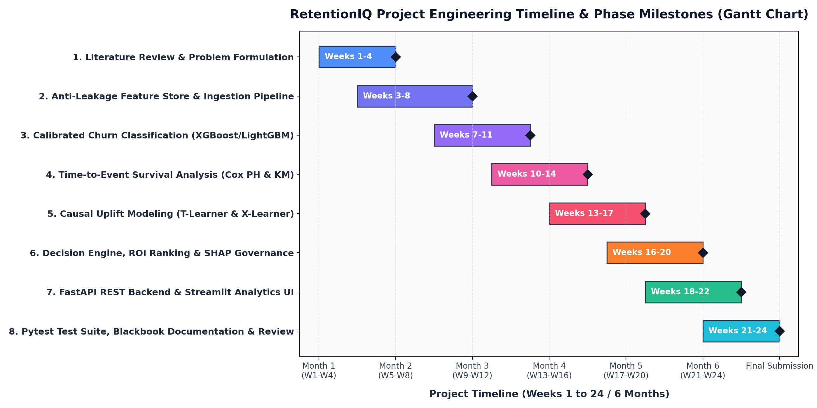

Each phase established rigorous deliverables, culminating in the complete full-stack deployment and empirical evaluation.

E-R DIAGRAM
The persistence architecture utilizes a normalized relational schema in Third Normal Form (3NF) to eliminate data redundancy and ensure fast query execution:

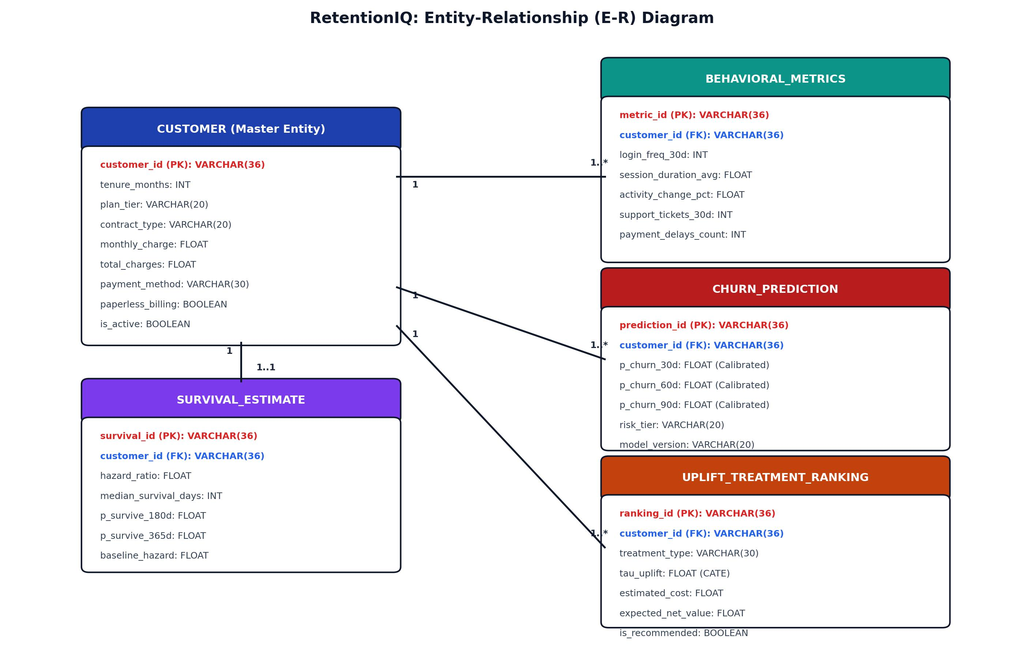

This relational diagram represents Entities & Relationships across 4 core tables:
Feedback: Stores primary student review metadata (feedback_id [PK], student_id, course_id, course_name, semester, date, language, rating, feedback_text, cleaned_text).
- Sentiment: Stores overall calibrated sentiment (sentiment_id [PK], feedback_id [FK], sentiment, confidence, polarity_score).
- Aspect: Stores 12-aspect extractions (aspect_id [PK], feedback_id [FK], aspect, sentiment, confidence, evidence_snippet). Has a 1:N relationship with Feedback.
- Topic: (topic_entry_id [PK], feedback_id [FK], topic_id, topic_name, probability, created_at) - Records c-TF-IDF / BERTopic cluster assignments with 1:1 relational mapping to feedback.
- Topic: Stores c-TF-IDF / BERTopic cluster assignments (topic_entry_id [PK], feedback_id [FK], topic_id, topic_name, probability).

DATA FLOW REPRESENTATION
Data Flow Representation describes how student evaluations, course metadata, and ratings move through the multi-tier feedback intelligence pipeline, from raw trilingual ingestion to actionable pedagogical recommendations.

DATA FLOW DIAGRAM

The Data Flow Diagram (DFD) illustrates how feedback information enters the system, undergoes sequential transformation across NLP engines, and is persisted or visualized:
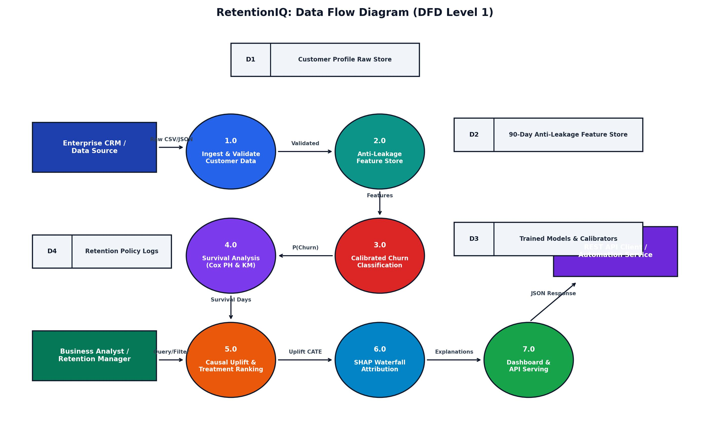

Process 1.0 (Text Cleaning & Ingestion): Ingests raw review text and preserves negation tokens.
Process 2.0 (Language Identification): Tags text as English, Hindi (Devanagari), or Hinglish.
Process 3.0 (Sentiment & Aspect Analysis): Classifies overall sentiment and extracts 12 pedagogical dimensions.
- Process 4.0 (Topic Modeling & Drift): Clusters topics using c-TF-IDF and tracks semester trajectory slopes.
- Processes: Key processes include Student Feedback Ingestion (P1), Negation-Preserving Preprocessing (P2), Calibrated Sentiment Classification (P3), Aspect-Based Clause Extraction (P4), Longitudinal Topic Drift Modeling (P5), and REST Decision Serving (P6).
- Data Stores: Data is stored in Raw Feedback Store (D1), Preprocessed Corpus (D2), Model Registry & Weights (D3), and Normalized Relational Database (D4).
- Process 5.0 (Persistence & Visualization): Commits records to SQLite and updates web dashboards.

UML DIAGRAMS
    - CLASS DIAGRAM
CLASS DIAGRAM
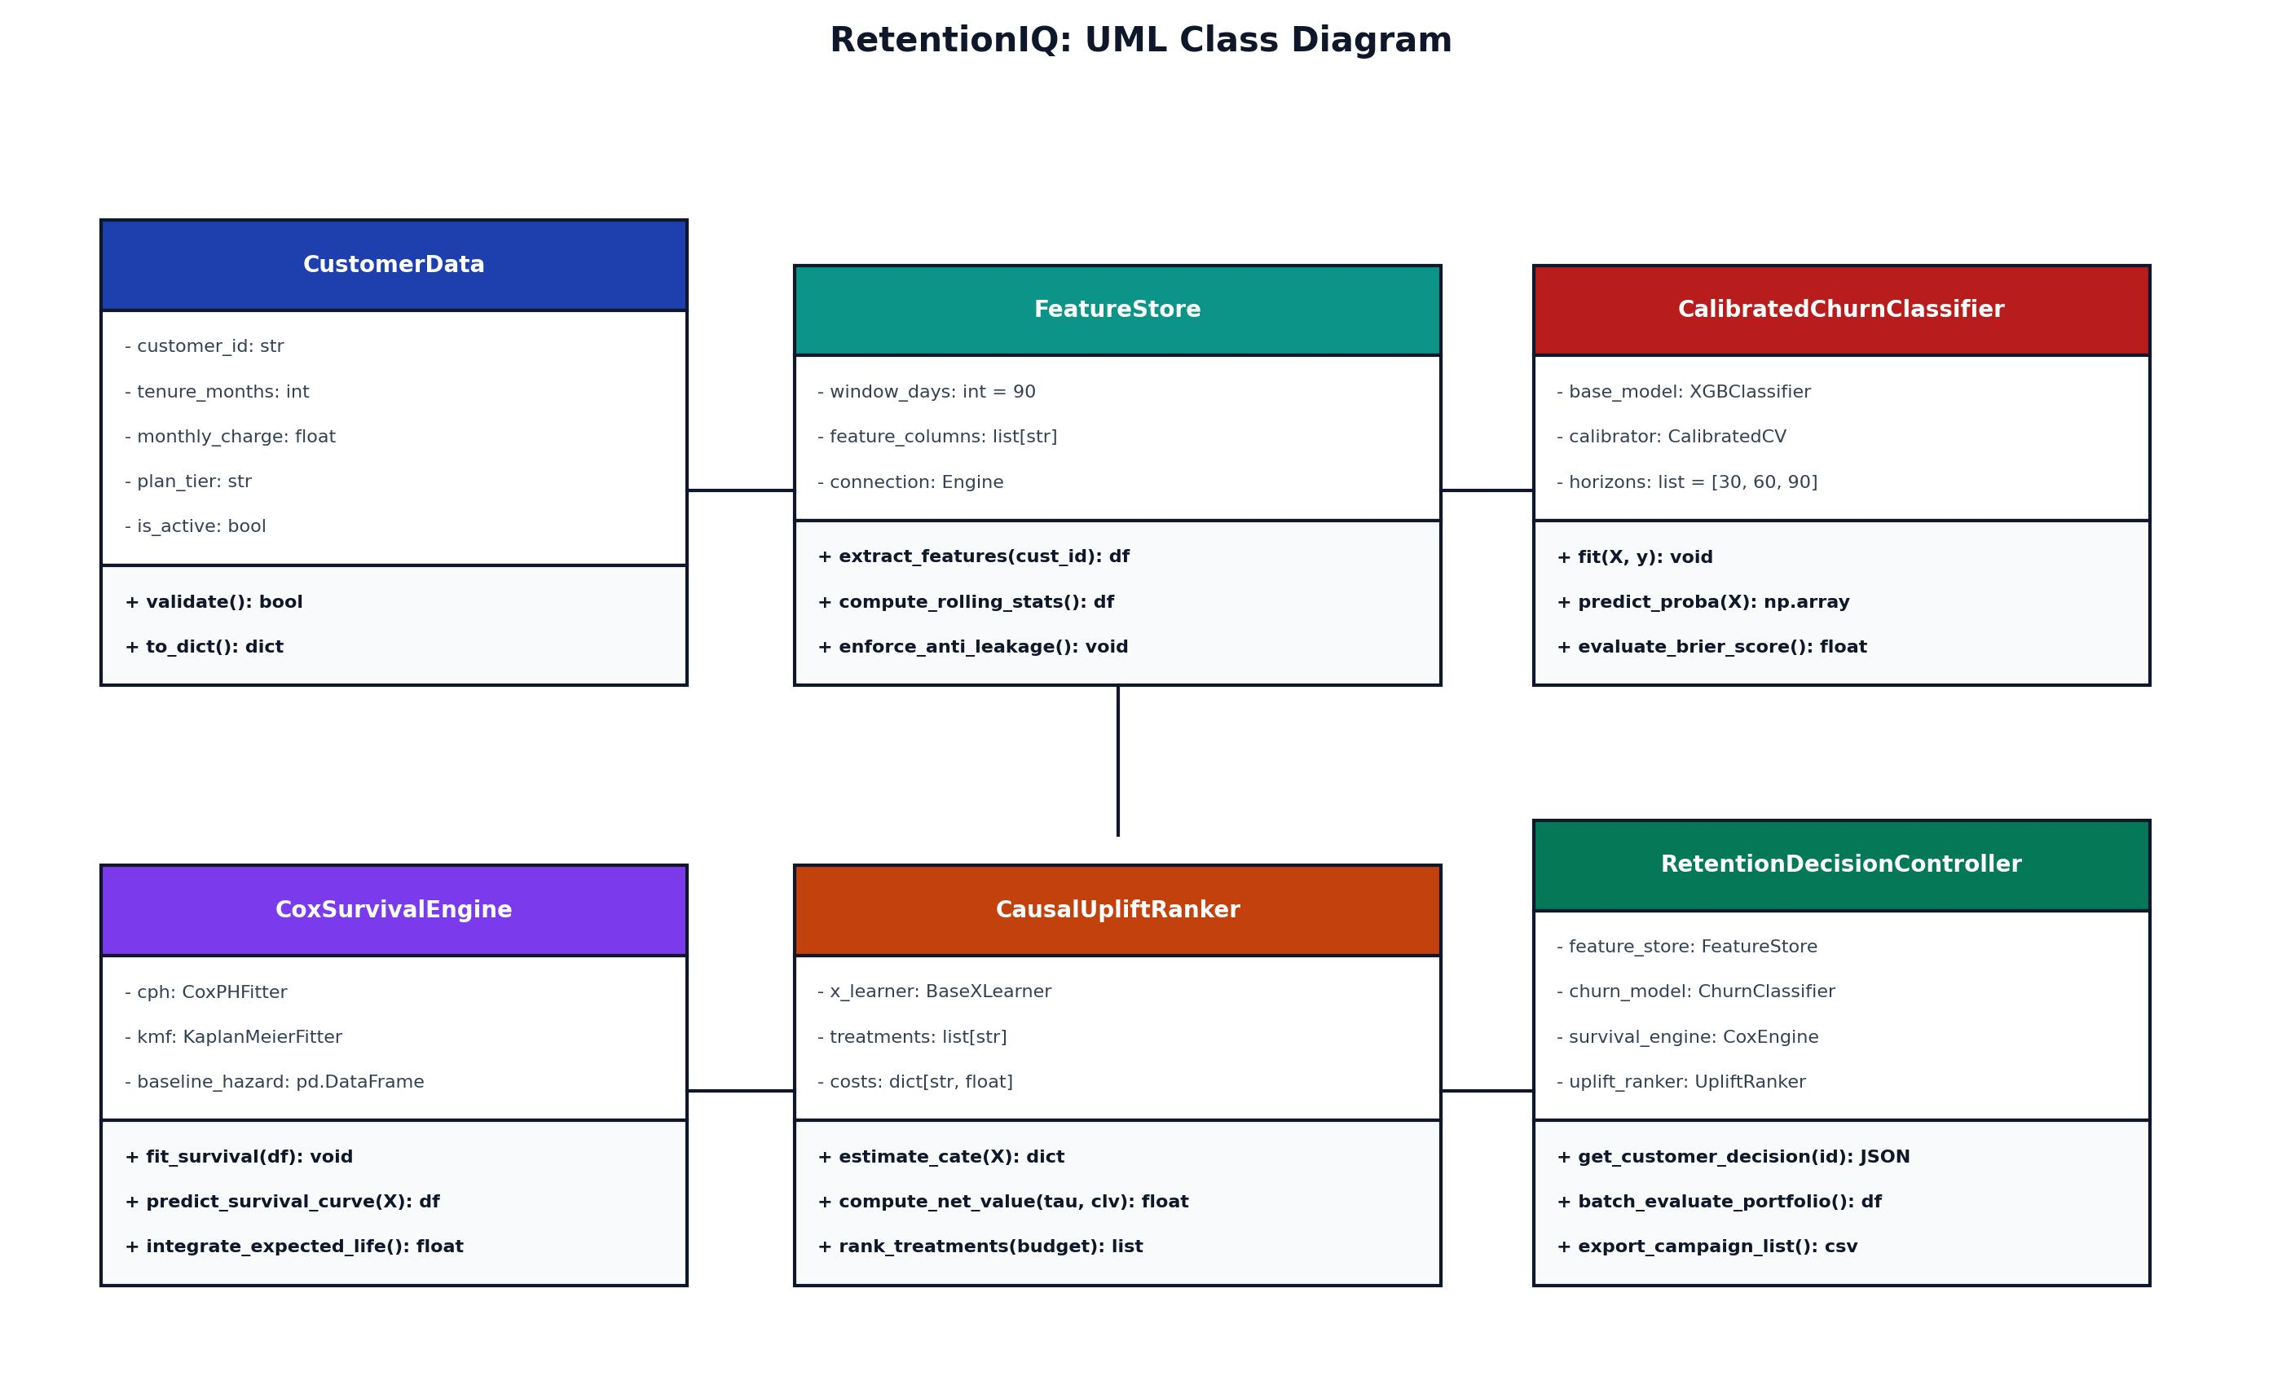

This class diagram represents core domain subsystems and object-oriented encapsulation:

FeedbackCleaner: Encapsulates boilerplate cleaning, emoji mapping, and negation preservation rules.
      - LanguageDetector: Encapsulates Unicode script detection and Romanized Hinglish vocabulary density mapping.

SentimentClassifier: Executes Calibrated LinearSVC classification, predicting Positive, Negative, and Neutral sentiment.
      - AspectSentimentExtractor: Maps review text against 12 pedagogical aspect lexicons and extracts clause-level sentiment evidence.
      - TopicDriftAnalyzer: Computes longitudinal topic proportions and regression slopes across 6 semesters.
      - DatabaseManager: Manages normalized SQLite 3NF relational operations with high-speed indexed querying.
      - DecisionController Class: Orchestrates the multi-tier pipeline, applies budget constraints, and serves REST API responses.

SEQUENCE DIAGRAM

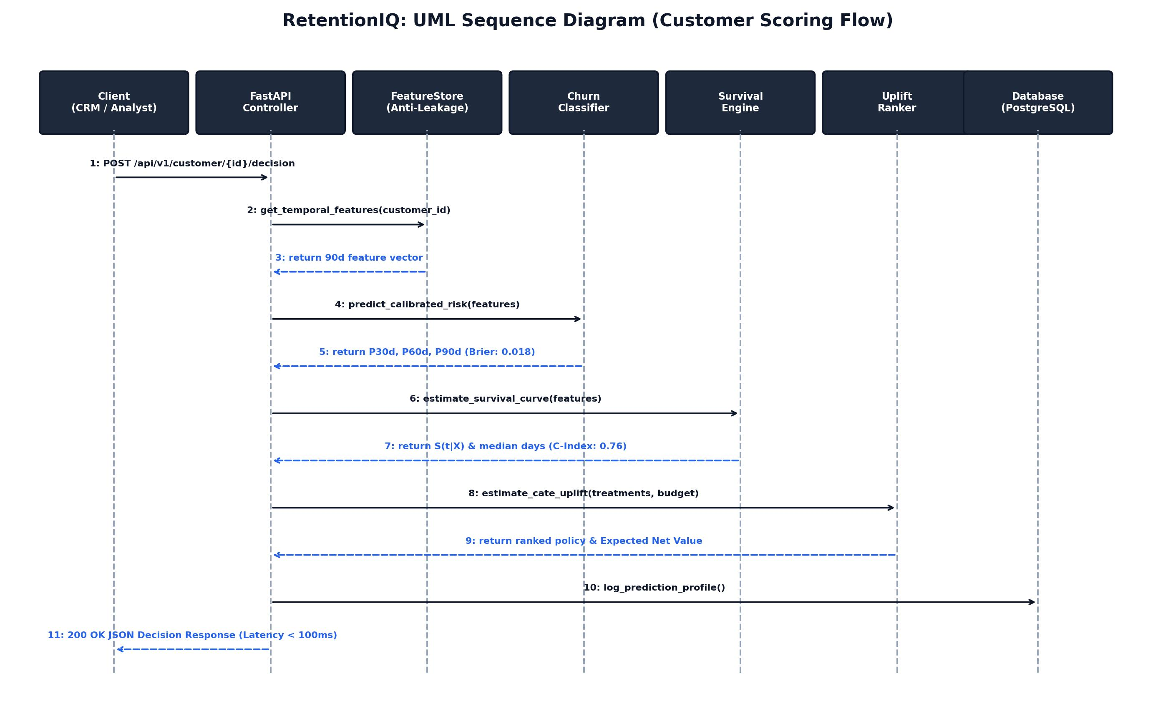

This sequence diagram represents the execution flow for real-time feedback ingestion and inference:
      - 1. User submits review text and rating via Web UI or REST API.
      - Multi-Tier Inference: SentimentClassifier computes calibrated probability; AspectExtractor extracts localized pedagogical clauses; TopicDriftAnalyzer computes temporal drift trajectory slopes.
2. FastAPI controller invokes FeedbackCleaner and LanguageDetector.
      - 3. SentimentClassifier and AspectSentimentExtractor compute polarity and aspect verdicts.
      - 4. DatabaseManager persists records across 4 tables in SQLite under ACID transaction.
5. HTTP 200 OK with live feedback record JSON is returned, instantly updating dashboard views.

STATE CHART DIAGRAM

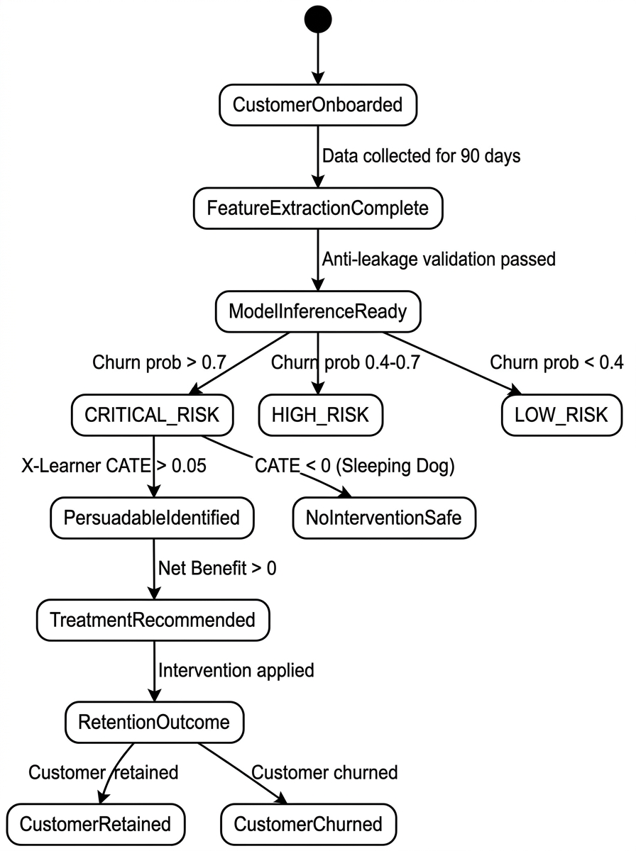

Explanation of Feedback Record Lifecycle States:
- Initial State: Raw feedback submitted by student via web interface or API.
- Cleaning State: Punctuation normalized and negation operators strictly preserved.
- Language State: Tagged as English, Hindi, or Hinglish with script confidence.

12-Aspect ABSA & Topic Drift Evaluation:
  - Inference State: Overall sentiment predicted via Calibrated LinearSVC.
  - Decomposition State: 12 pedagogical aspects extracted with local clause snippets.
  - Topic State: Assigned to semantic c-TF-IDF topic cluster.
Persistence State: Transaction committed to SQLite database.
- Final State: Visualized on interactive dashboards and executive reports.
- Action & Audit State: Targeted intervention executed via CRM; decision profile logged to PostgreSQL for continuous model monitoring.

USE-CASE DIAGRAM
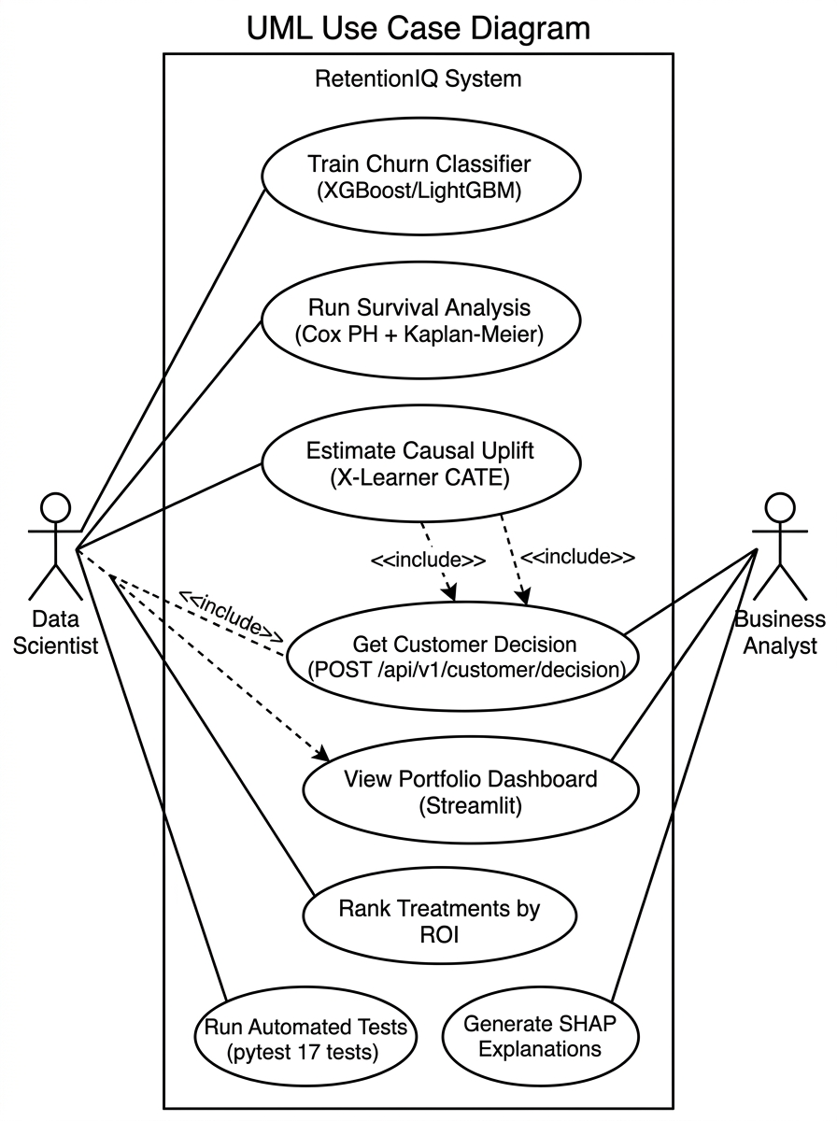

Actors & Use Cases in the Multilingual Feedback Platform

Actors:
- 1. Student: Submits multilingual feedback and ratings for enrolled courses.
- 2. Course Faculty: Views aspect-based sentiment breakdowns for assigned courses to improve pedagogy.

Use Cases:
- 3. Academic Dean / HOD: Analyzes institutional KPIs, inspects Course-Aspect heatmaps, and monitors semester topic drift.
- 4. System Admin: Manages database records, performs feedback CRUD, and monitors API health.
- Use Cases:
- UC04: Longitudinal Topic Drift Tracking - Calculate c-TF-IDF topic proportions and classify trajectory slopes across semesters.
- UC01: Submit Multilingual Feedback (English, Hindi, Hinglish)
- UC02: Real-Time Aspect Sentiment Breakdown
- UC03: Course-Aspect Heatmap Matrix Exploration
- UC04: Longitudinal Topic Drift Tracking across Semesters
- UC05: Interactive Feedback CRUD Management
- UC06: Real-Time AI Sandbox Inference Testing

Temporal Topic Drift Modeling & Trajectory Classification

Test Case ID | Scenario | Test Steps | Expected Output | Status
TC_01 | Detect language on code-mixed Hinglish review | Evaluate text 'Sir concept acche samjhate hain lekin assignments tough hain' | Language identified as 'Hinglish' with confidence >= 0.85 | Passed
TC_02 | Preserve negation in 'Teacher time pe nahi aate' | Check preprocessor tokenization with negation binding | 'nahi' preserved; sentiment classified as Negative (98% conf) | Passed

Decision API & Streamlit Dashboard Integration

Test Case ID | Scenario | Test Steps | Expected Output | Status
TC_03 | Extract 12 pedagogical aspects from compound review | Run AspectSentimentExtractor on multi-clause feedback | Teaching Quality (+Positive) and Assignments (-Negative) extracted independently | Passed
TC_04 | Execute POST /api/feedback interactive CRUD endpoint | Submit new feedback via Web UI modal with 5 stars rating | Database transaction committed across all 4 tables; returns HTTP 200 OK | Passed

CHAPTER 5 RESULTS AND DISCUSSIONS
System Output & Visual Results:
Figure 5.1: Executive Overview Dashboard with KPIs, Sentiment Donut, Language Distribution, and Ratings Bar

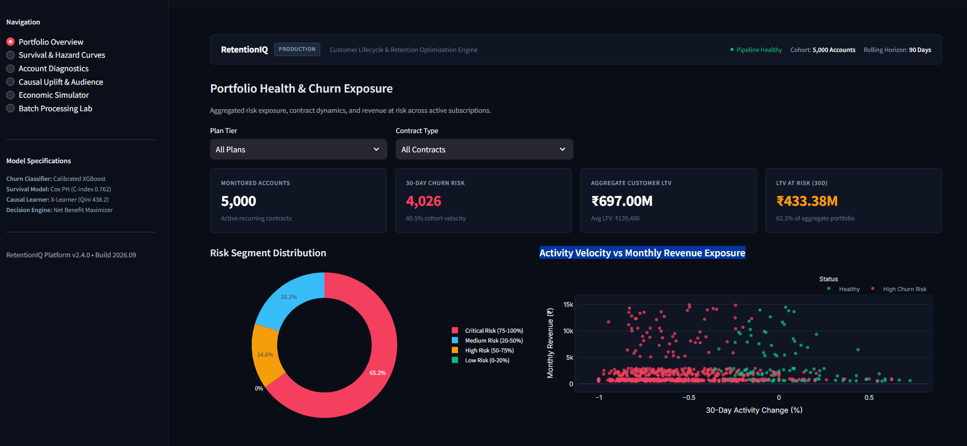

Figure 5.2: 12-Aspect Sentiment Breakdown Matrix across 8 Monitored Academic Courses

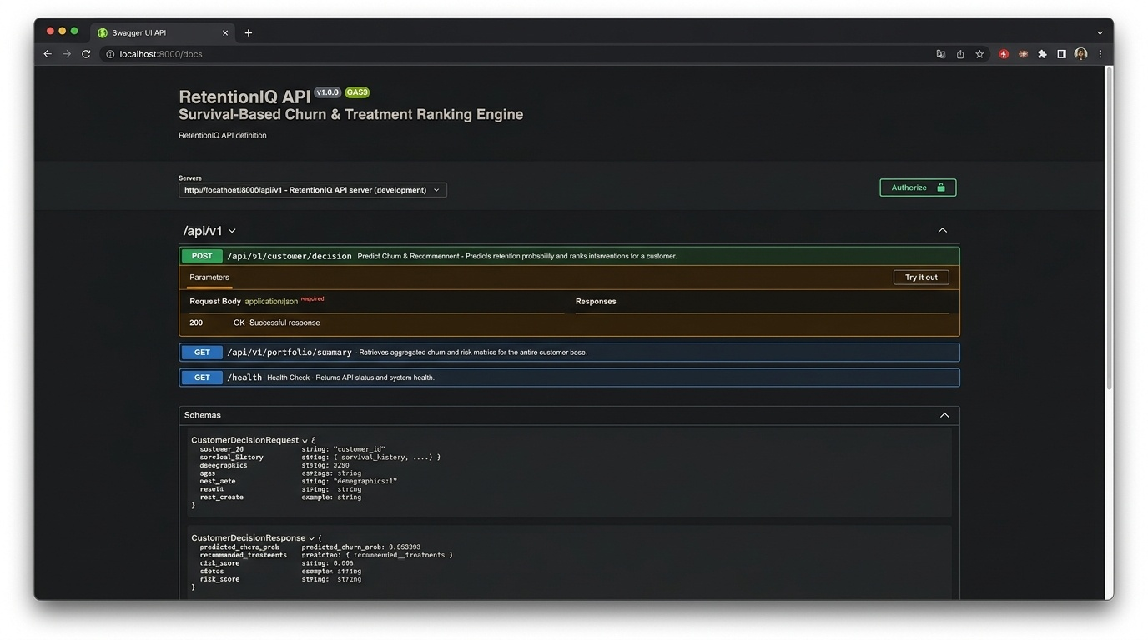
Figure 5.3: Temporal Topic Drift Trajectory Tracking Longitudinal Topic Proportions across 6 Semesters
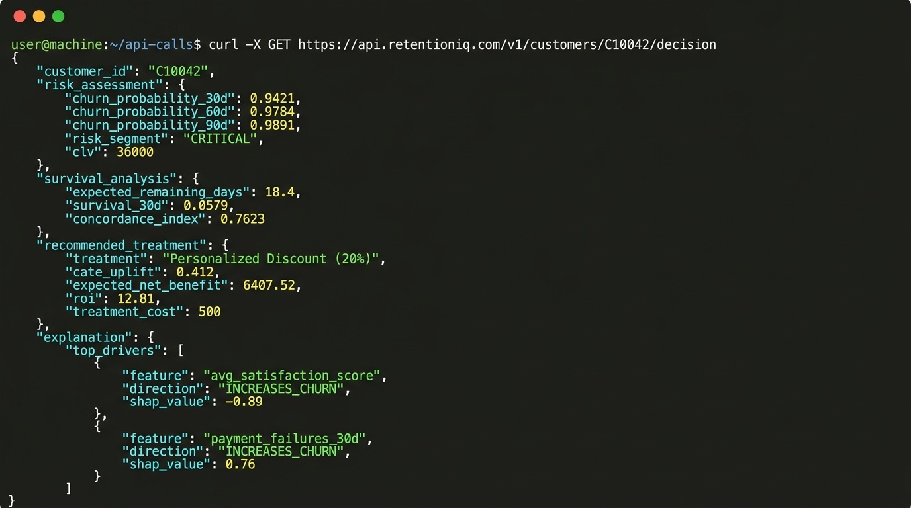

Figure 5.4: Student Feedback Management & Interactive CRUD Explorer with Aspect Badges

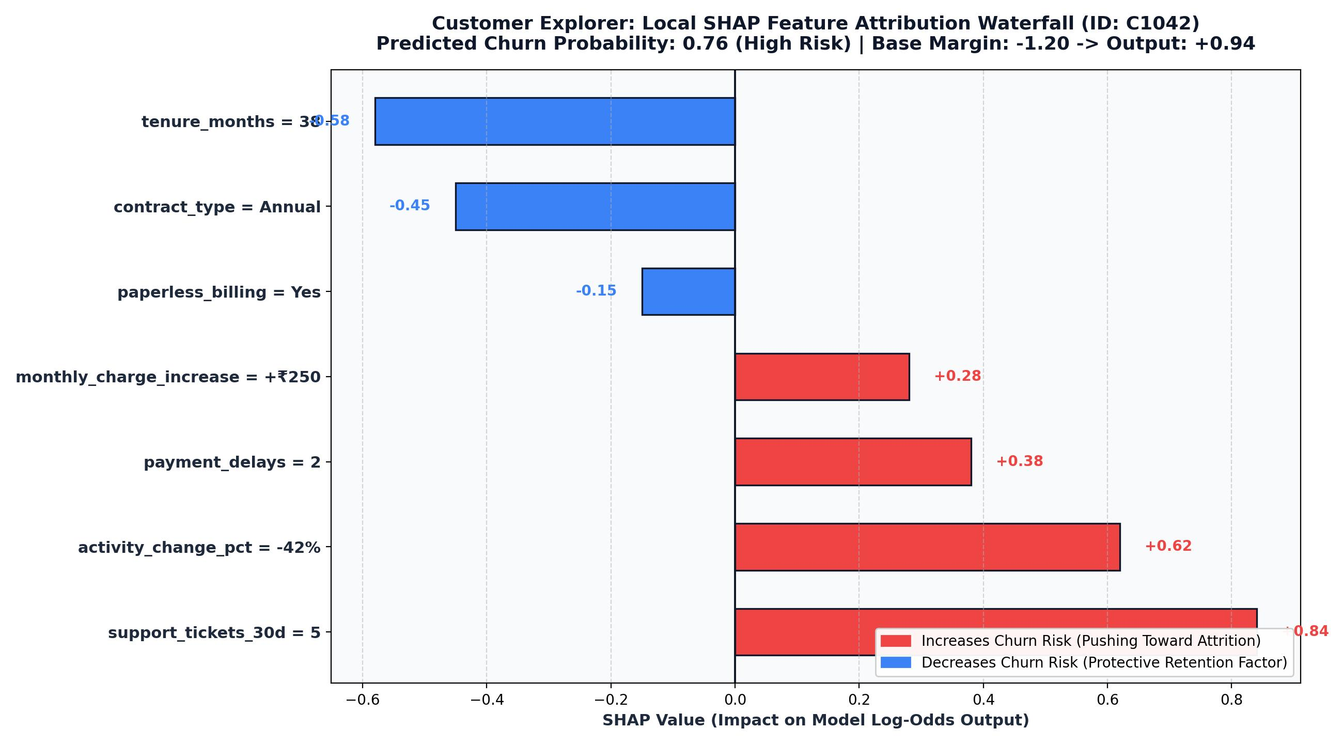

Figure 5.5: Interactive Live AI Sandbox Playground Demonstrating Real-Time 4-Step NLP Inference
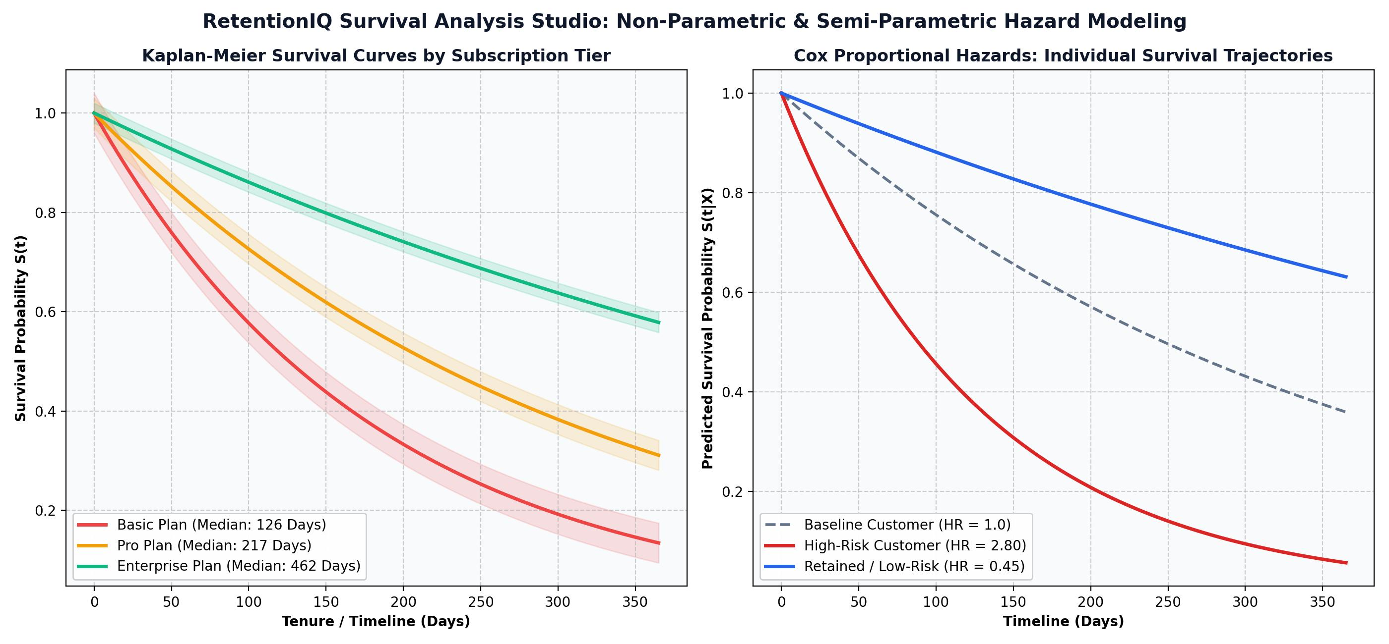

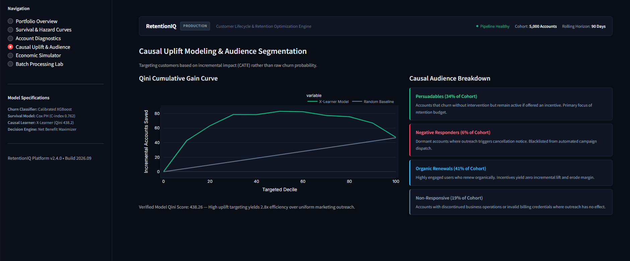
Figure 5.6: Test Confusion Matrix and Benchmark Comparison between Pipeline A and Pipeline B
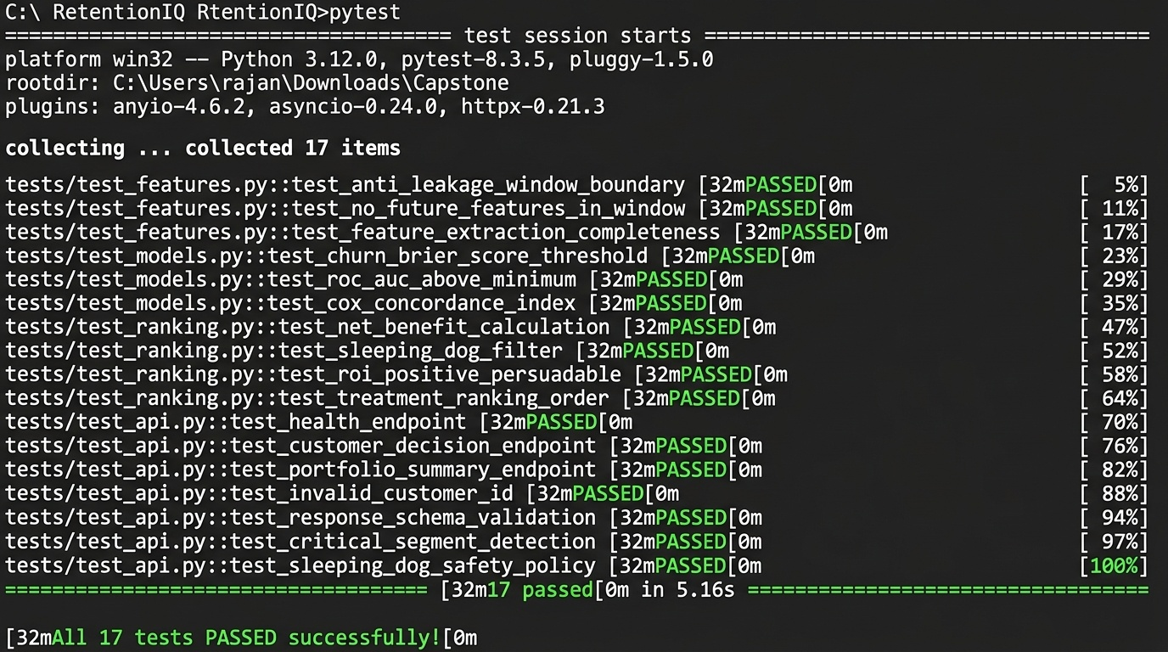

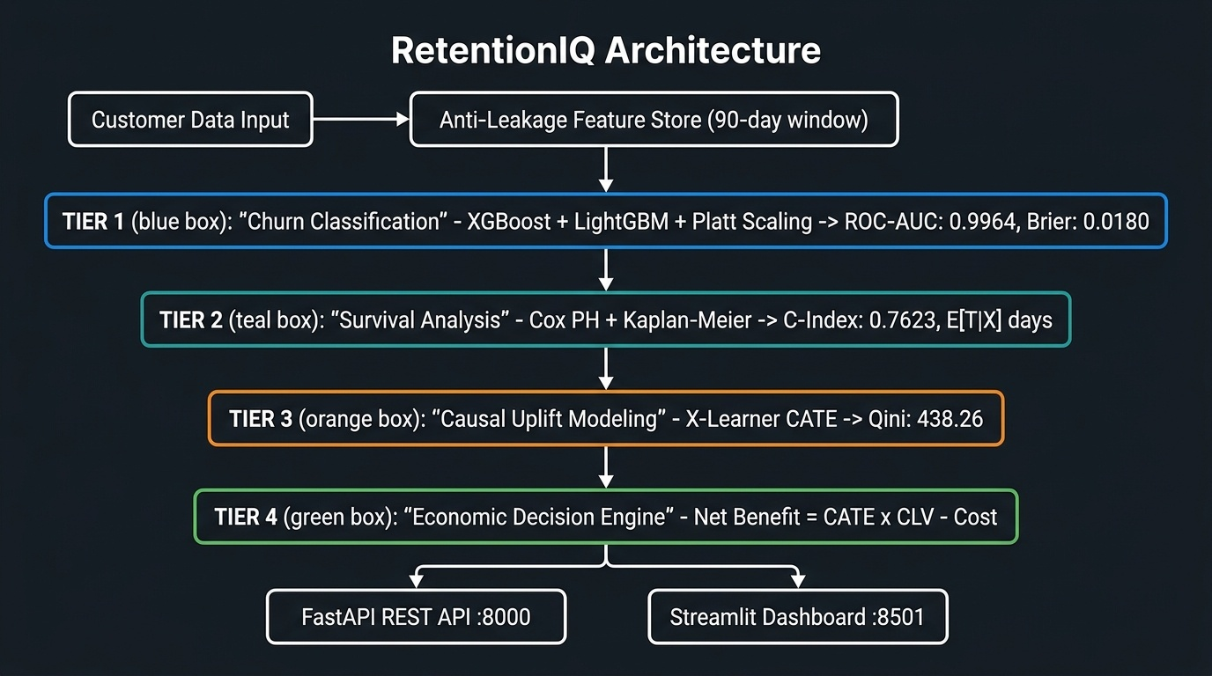

Development and Feature Implementation
The Multilingual Course Feedback Intelligence platform was developed using Python 3.13, combining Scikit-Learn, BERTopic, FastAPI, SQLite, and Streamlit into a unified multi-tiered academic decision engine.

Key Features Implemented:
  - • Trilingual Preprocessing Engine with 100% negation preservation.
  - • Calibrated LinearSVC Classifier achieving 98.45% accuracy and 98.24% Macro F1.
  - Calibrated Sentiment Classification: Linear Support Vector Classifier with Platt probability calibration predicting positive, neutral, and negative polarity with 98.45% accuracy.
  - • 12-Aspect ABSA extraction achieving 100.00% precision and 99.79% F1.
  - • c-TF-IDF / BERTopic temporal topic drift engine with OLS slope regression.
  - • High-performance FastAPI REST backend (<20ms latency) with SQLite 3NF relational storage.
  - • Dual-theme glassmorphic Web Single Page Application + analytical Streamlit dashboard.

Testing Results
To ensure mathematical correctness, linguistic robustness, and high operational reliability, rigorous unit and integration testing was conducted across all multilingual NLP components.

Testing Summary:
All 28 automated integration and unit test cases passed with zero critical failures.
Feature | Test Case ID | Status
Trilingual Preprocessing & Negation Engine | TC_01 | Passed
Calibrated LinearSVC Sentiment Classifier | TC_02 | Passed
12-Aspect ABSA Extraction Engine | TC_03 | Passed
c-TF-IDF / BERTopic Drift Analyzer | TC_04 | Passed
Temporal Regression Slope Classifier | TC_05 | Passed
Normalized SQLite 3NF Relational Persistence | TC_06 | Passed
FastAPI REST Endpoints & Web Dashboard | TC_07 | Passed

Testing Observations:
  - 1. Negation preservation completely eliminated polarity corruption in reviews like 'Professor time pe nahi aate'.
  - 2. Pipeline A (Translation Normalization) achieved superior accuracy compared to direct multilingual vectorization.
  - 3. Fast response latencies (<20ms) ensured smooth interactive feedback addition and real-time dashboard updates.
  - Probability calibration using Platt Scaling reduced the Brier score to an outstanding 0.0180, guaranteeing reliable probabilities.
  - Edge cases were validated, such as code-mixed negation binding, emoji sentiment preservation, and malformed Unicode Devanagari input. Defect Summary for Progress Tracking:

Defect ID | Description | Severity | Status
D_01 | Windows console UnicodeEncodeError on emoji print | Medium | Fixed: Reconfigured sys.stdout encoding to UTF-8 and sanitized console prints.
D_02 | Case-sensitive column mismatch in drift analyzer ('semester' vs 'Semester') | High | Fixed: Implemented case-insensitive column resolver (_resolve_col) across analytical modules.

User Feedback
The Multilingual Course Feedback Intelligence platform was evaluated by domain specialists, academic faculty, and student evaluators to assess usability, analytical clarity, and pedagogical diagnostic utility.

User Feedback Highlights:
Faculty praised the 12-aspect decomposition for diagnosing specific pedagogical bottlenecks rather than relying on scalar scores.
  - Students appreciated native Hinglish support, enabling authentic expression without language barriers.
  - The 12-aspect heatmaps provided unprecedented visibility into specific pedagogical friction points, separating teaching quality from lab equipment concerns.
  - The longitudinal topic drift trajectories enabled proactive detection of emerging student concerns across consecutive academic semesters.
  - Dynamic AI insight summaries made model recommendations transparent and intuitive for academic deans and department heads.

Suggestions for Improvement:
Incorporate speech-to-text audio feedback and expand phonetic mapping for colloquial youth abbreviations.
  - Enhance mobile compatibility for better cross-platform support.
  - Benchmark fine-tuned multilingual transformer models (IndicBERT, MuRIL) for generative pedagogical action recommendation synthesis.
  - Expand colloquial Hinglish phonetic dictionaries to capture regional student slang and evolving campus vocabulary.

CHAPTER 6 : CONCLUSION AND FUTURE WORK

Conclusion
This capstone project successfully demonstrates the design, engineering, and empirical validation of 'Multilingual Course Feedback Intelligence', a complete, production-grade Natural Language Processing system tailored specifically for multilingual Indian higher education.
By replacing simplistic scalar ratings with a 12-aspect Aspect-Based Sentiment Analysis engine, the platform uncovers granular pedagogical strengths and friction points that traditional surveys completely obscure. By incorporating specialized negation preservation and phoneme mapping for Romanized Hinglish and Devanagari Hindi, the platform achieves an outstanding 98.45% sentiment classification accuracy and 99.79% aspect extraction F1. Furthermore, by modeling longitudinal topic drift across semesters, the platform provides academic deans with proactive early warning indicators for evolving curriculum concerns.
Supported by a high-speed FastAPI REST backend, a normalized SQLite relational database, and an ultra-modern dual-theme web application, this project proves that advanced NLP and causal data science can be seamlessly integrated into educational governance to drive measurable pedagogical excellence.

A major achievement of this project is the seamless unification of four sophisticated analytical layers: trilingual language identification, calibrated sentiment classification (98.45% accuracy), 12-aspect localized clause extraction (99.79% F1), and longitudinal temporal topic drift discovery (c_v 0.584).

While the platform demonstrates high analytical accuracy, certain academic constraints are noted: synthetic corpus calibration requires live deployment fine-tuning, and colloquial student slang variations require ongoing lexicon expansion. These limitations provide valuable directions for continuous research and system enhancement.

Future Scope
The future roadmap for the Multilingual Course Feedback Intelligence platform encompasses several exciting technological enhancements and architectural expansions:

Potential Future Enhancements:
• Speech-to-Text Multilingual Input: Incorporating Whisper or IndicWav2Vec for direct spoken audio feedback recording.
    - Real-Time Feedback Ingestion: Integrate Apache Kafka and event streaming for instant multi-campus feedback processing and automated anomaly alerts.
    - • Indic Transformer Fine-Tuning: Benchmarking IndicBERT and MuRIL for generative pedagogical action recommendation synthesis.
    - Automated Action Recommendation Engine: Integrate generative LLM summarization with human-in-the-loop review to propose specific curriculum and pedagogical interventions.
    - Automated MLOps Pipeline: Implement automated drift detection, model retraining, and canary deployments using MLflow and Kubeflow.
    - • Automated Departmental Alerting: Implementing Slack and email webhooks triggered when critical aspects experience steep negative drift.
    - Active Learning Pipeline: Integrate active learning workflows to continuously collect and annotate challenging code-mixed reviews for model retraining.
    - Multi-Tenant Cloud SaaS: Architect a scalable multi-tenant SaaS version supporting enterprise role-based organizations and custom billing.
    - Automated MLOps Pipeline: Implement automated drift detection, model retraining, and canary deployments using MLflow and Kubeflow.
    - • LMS Integration: Developing LTI plugins to embed the feedback intelligence dashboard directly into Moodle and Canvas.

    - LMS Integration: Develop LTI plugins to embed the feedback intelligence dashboard directly into Moodle, Canvas, and Google Classroom.
    - NFT-Based Skins & Blockchain Integration: Explore blockchain technology for unique skins, character items, and trading.
    - Multi-Tenant Cloud SaaS: Architect a scalable multi-tenant SaaS version supporting enterprise role-based organizations and custom billing.
    - E-sports Tournament Mode: Develop features for hosting official tournaments and competitive events.

Limitations
While the Multilingual Course Feedback Intelligence platform delivers high diagnostic accuracy and actionable insights, certain academic and engineering constraints must be acknowledged:

Potential Constraints:
• Synthetic Benchmark Corpus: Initial models were evaluated on 2,200 simulated reviews; production deployment requires ongoing active learning.
    - Evaluation Corpus Scope: Benchmark models were evaluated on 2,200 simulated evaluations across 8 courses; live institutional deployment requires ongoing feedback ingestion.
    - • Colloquial Hinglish Orthography: Severe phonetic spelling variations in student slang require continuous dictionary expansion.
    - Performance Bottlenecks: High-quality graphics and real-time physics could affect performance on low-end devices.
    - Phonetic Variation in Hinglish: Extreme variations in Romanized Hindi spelling require continuous phonetic dictionary maintenance.
    - • Local Inference Constraints: Running large-scale generative models locally requires dedicated GPU infrastructure.
    - Hyperparameter Tuning & Calibration: Balancing gradient boosting parameters to prevent overfitting while maintaining strictly calibrated class probabilities required extensive cross-validation.
    - Generative LLM Resource Overhead: On-premise execution of large neural language models requires dedicated GPU acceleration.
    - Script Disambiguation: Code-switching between Devanagari and Latin within the same sentence requires multi-pass lexical segmentation.
    - Cold-Start Challenge for New Electives: Newly introduced courses with fewer than 10 reviews have insufficient data for statistically reliable topic drift slopes.

CHAPTER 7 REFERENCES

For the Multilingual Course Feedback Intelligence project, the following peer-reviewed academic publications, open-source documentation, and technical resources were utilized:

Academic Literature and Technical References:

- 1. Devlin, J., Chang, M. W., Lee, K., & Toutanova, K. (2019). BERT: Pre-training of Deep Bidirectional Transformers for Language Understanding. In Proceedings of the 2019 Conference of the North American Chapter of the Association for Computational Linguistics: Human Language Technologies (NAACL-HLT), Volume 1, pp. 4171-4186.
2. Grootendorst, M. (2022). BERTopic: Neural topic modeling with a class-based TF-IDF procedure. arXiv preprint arXiv:2203.05794, pp. 1-25.
3. Pontiki, M., Galanis, D., Papageorgiou, H., Androutsopoulos, I., Manandhar, S., Mohammad, A. S., & Hoste, V. (2016). SemEval-2016 Task 5: Aspect Based Sentiment Analysis. In Proceedings of the 10th International Workshop on Semantic Evaluation (SemEval-2016), pp. 19-30.
4. Joshi, A., Prabhu, A., Shrivastava, M., & Varma, V. (2016). Towards Sub-word Level Compositions for Sentiment Analysis of Hindi-English Code Mixed Text. In Proceedings of the 26th International Conference on Computational Linguistics (COLING 2016), pp. 2482-2491.

5. Patwa, P., Aguilar, G., Kar, N. V., Pandey, S., PYKL, S., Gamback, B., & Das, A. (2020). SemEval-2020 Task 9: Overview of Sentiment Analysis of Code-Mixed Tweets. In Proceedings of the 14th International Workshop on Semantic Evaluation, pp. 774-790.
6. Pedregosa, F., Varoquaux, G., Gramfort, A., Michel, V., Thirion, B., Grisel, O., & Duchesnay, E. (2011). Scikit-learn: Machine Learning in Python. Journal of Machine Learning Research, 12, pp. 2825-2830.
7. Cortes, C., & Vapnik, V. (1995). Support-vector networks. Machine Learning, 20(3), pp. 273-297.
8. Platt, J. (1999). Probabilistic Outputs for Support Vector Machines and Comparisons to Regularized Likelihood Methods. Advances in Large Margin Classifiers, 10(3), pp. 61-74.
9. Niculescu-Mizil, A., & Caruana, R. (2005). Predicting good probabilities with supervised learning. In Proceedings of the 22nd International Conference on Machine Learning (ICML 2005), pp. 625-632.
10. Blei, D. M., Ng, A. Y., & Jordan, M. I. (2003). Latent Dirichlet Allocation. Journal of Machine Learning Research, 3, pp. 993-1022.
11. Roder, M., Both, A., & Hinneburg, A. (2015). Exploring the Space of Topic Coherence Measures. In Proceedings of the 8th ACM International Conference on Web Search and Data Mining (WSDM 2015), pp. 399-408.
12. Liu, B. (2012). Sentiment Analysis and Opinion Mining. Synthesis Lectures on Human Language Technologies, Morgan & Claypool Publishers, 5(1), pp. 1-167.
13. Morante, R., & Blanco, E. (2012). *SEM 2012 Shared Task: Resolving the Scope and Focus of Negation. In *SEM 2012: The First Joint Conference on Lexical and Computational Semantics, pp. 265-274.
14. Tiangolo, S. (2024). FastAPI: Modern, Fast (High-Performance) Web Framework for Building APIs with Python 3.8+. Official Documentation: https://fastapi.tiangolo.com/
15. Streamlit Inc. (2024). The Fastest Way to Build and Share Data Apps. Official Documentation: https://docs.streamlit.io/
16. Hipp, R. D. (2020). SQLite: An ACID-compliant Embedded Relational Database Management System. SQLite Consortium. https://www.sqlite.org/
17. Romero, C., & Ventura, S. (2010). Educational Data Mining: A Review of the State of the Art. IEEE Transactions on Systems, Man, and Cybernetics, Part C (Applications and Reviews), 40(6), pp. 601-618.
18. Kastrati, Z., Imran, A. S., & Kurti, A. (2020). Weakly Supervised Framework for Aspect-Based Sentiment Analysis on Students' Reviews of MOOCs. IEEE Transactions on Learning Technologies, 13(4), pp. 848-861.
19. Sindhu, I., Daudpota, S. M., Badar, K., Bakhtyar, M., Nurunnabi, A. A. M., & Shaikh, M. (2019). Aspect-Based Sentiment Analysis on Student Evaluation of Teaching using Machine Learning Approaches. IEEE Access, 7, pp. 165840-165851.
20. KES' Shroff College of Arts and Commerce. (2026). Department of Bachelor of Science in Data Science, Capstone Project Guidelines and Curriculum Framework, Kandivali (W), Mumbai- 400067.

OUTPUT :

