1. Go to link <https://dev.mysql.com/downloads/file/?id=483326>
2. Download file name mysql-installer-web-community-8.0.14.0.msi
3. Open up the download file by double clicking it
4. When prompted to make changes to the device select yes
5. Choose standalone MySQL Server  
   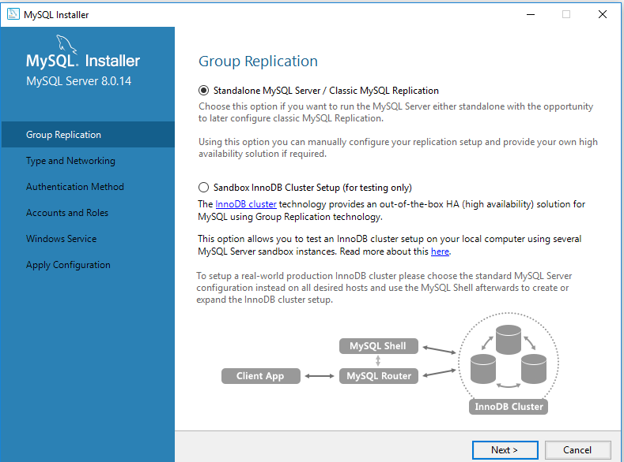
6. Choose development computer for config type  
   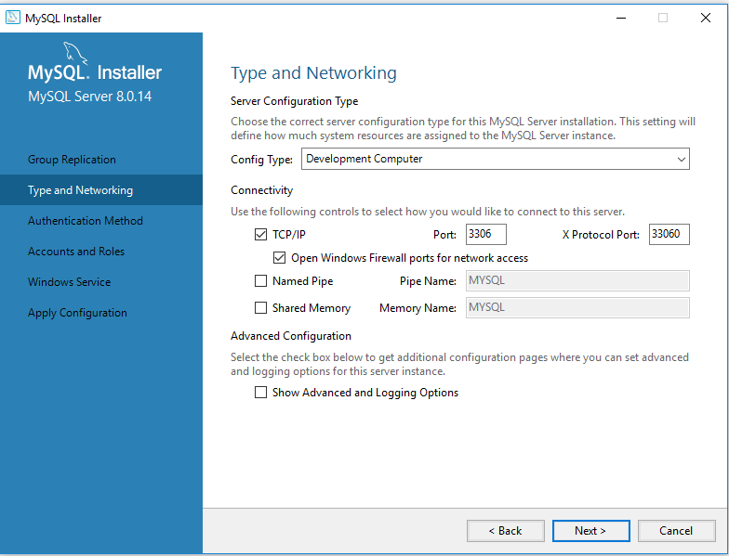
7. Select Strong password for authentication method  
   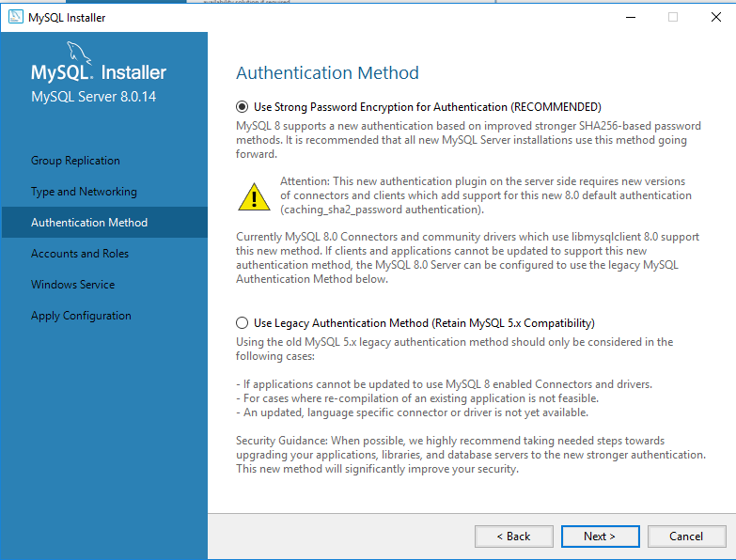
8. Create your password for authentication  
   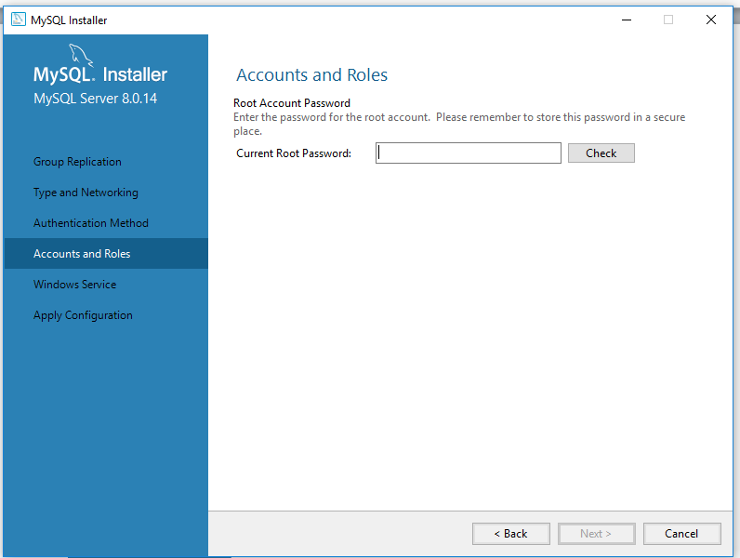
9. Select Standard system account  
   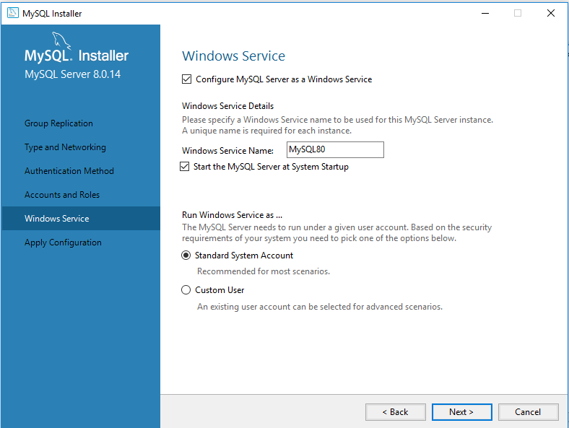
10. Apply configuration by clicking Execute  
    