COUNTDOWN TIMER PREMSAIDULLA

INITIAL PAGE :

* Starting page it displays a start button to start a timer when user clicks on it it directs to following adding timer page

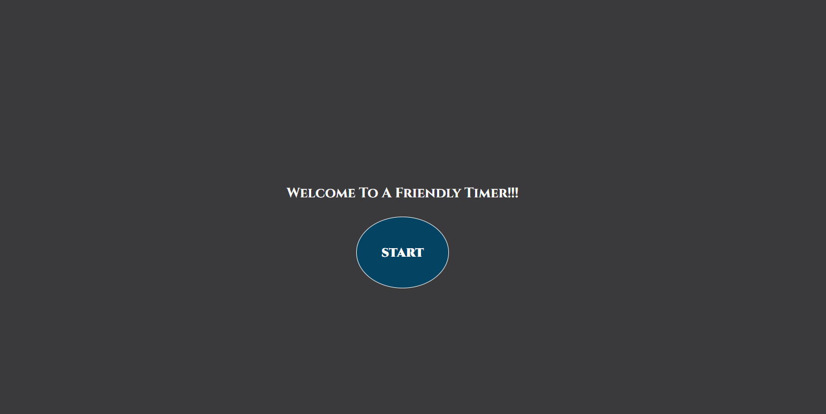

ADD TIMER ::

* Here user can add multiple timers by clicking add button
* if user clicks on timer he will directed to the followin time set-up page

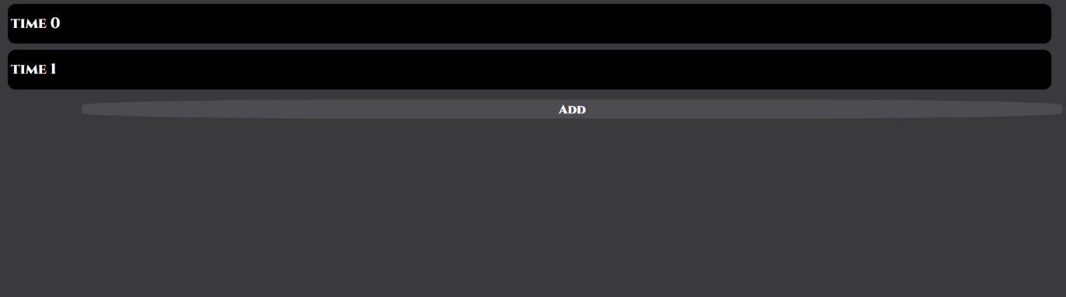

* Here when user enters a message for timer and time date in set-up page the required text is to be named for a timer like below

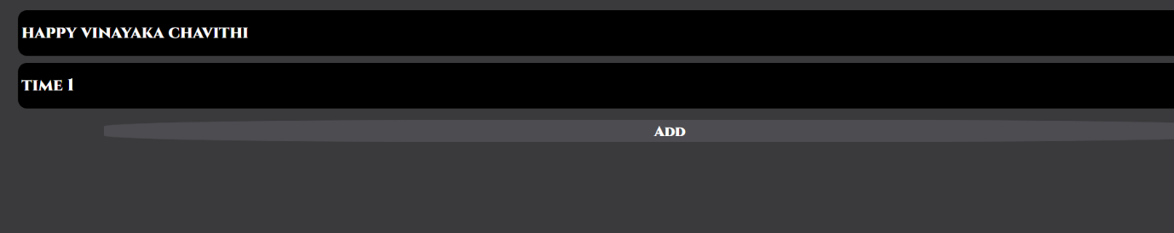

TIME SET-UP:

* This was the page when user has to set up target time and message for target time in specified format metioned in inputs …
* And when user clicks on save button it will set up to that time from now on back to initial page

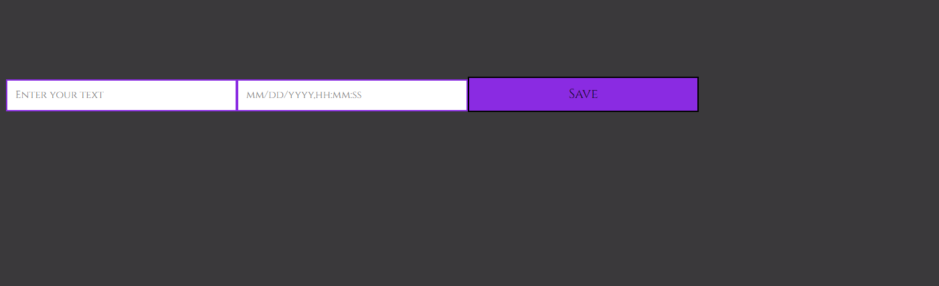

COUNTDOWN LAYOUT & DESIGN::

* Here if user set up target time then it will directs to countdown timer page when user clicks on timer otherwise it will take them to timer set-up page
* It calculates from now to future and displayed remaining time with some animation and stroke dash effect ..

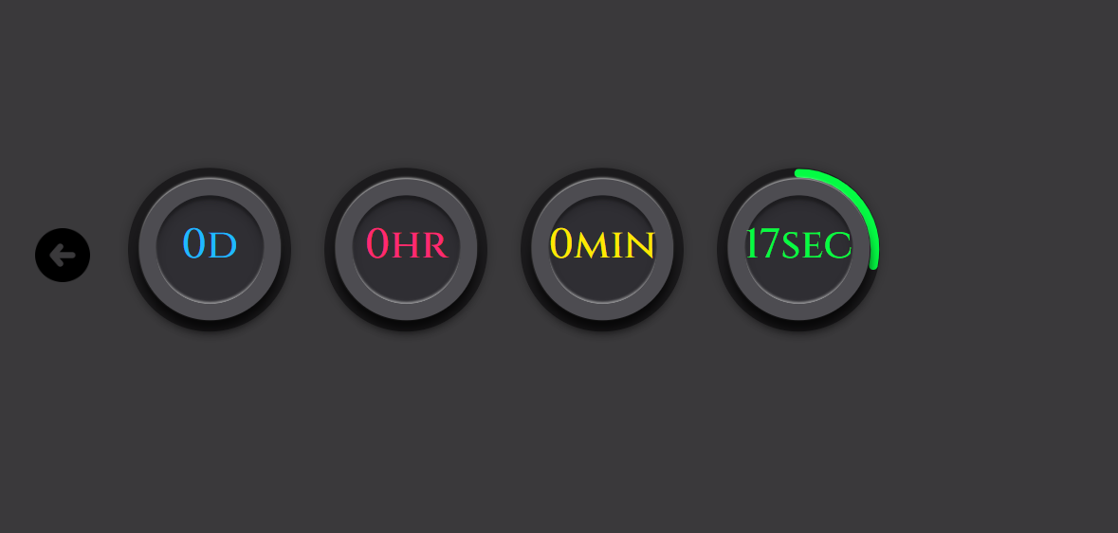

TIMES UP MESSAGE WITH SOUND :::

When times up It will displayed with message that user entered in time set-up page along with a stop button and an audio alert

* I had given around 3 – 4 alarm sounds for this it will played when times up like a alarm .. unfortunately I cant show u the sound ..

‘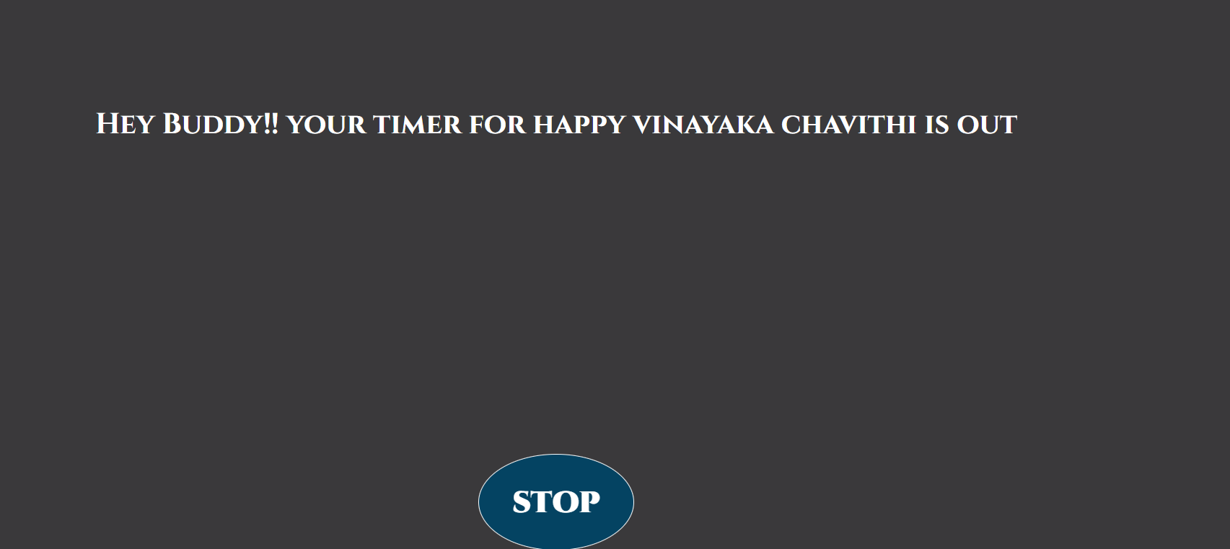

STOP BUTTON TO STOP THE TIMER ::

* Stop button ::
* Here user can able to stop timer by click on stop button if it done it stopped timer sound and get back to add timer page …

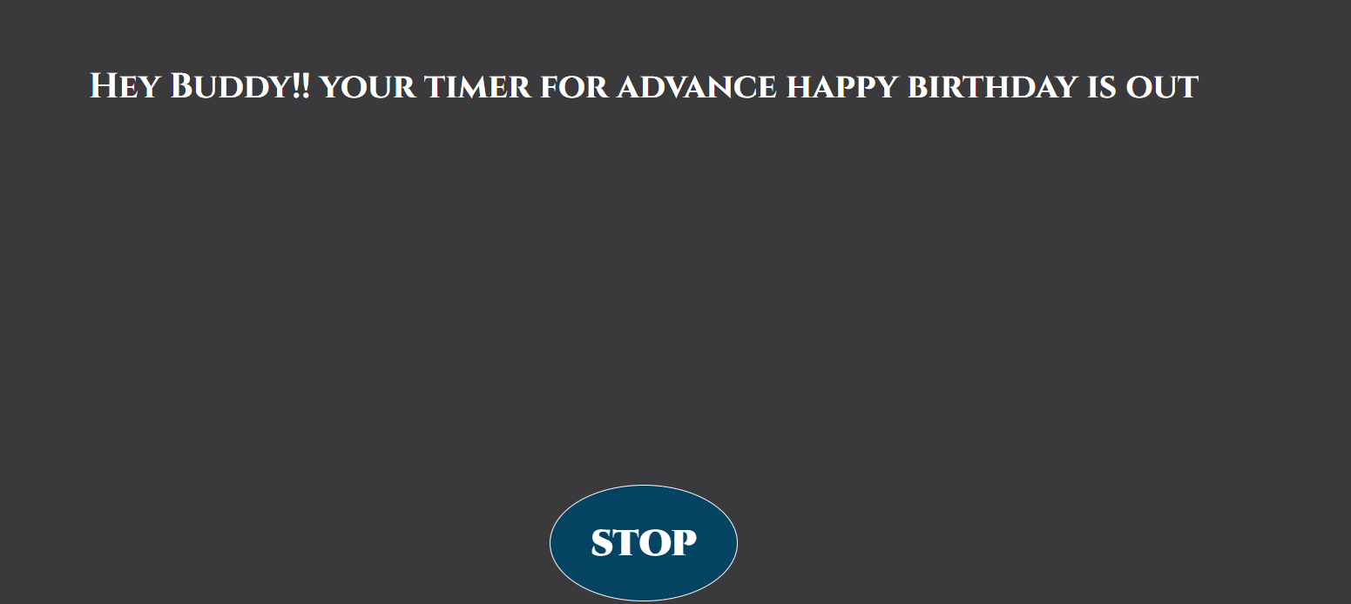

Thank u