Name : Prem Aher
Python and Bash
1. Grade Checker
Take a score as input and print the grade based on the following:
90+ : "A"
80-89 : "B"
70-79 : "C"
60-69 : "D"
Below 60 : "F"
here we used a basic if else statement to carry out marks and all.
Code
mark = int(input("Enter your marks: "))
if mark >= 90:
print("A")
elif mark >= 80:
print("B")
elif mark >= 70:
print("C")
elif mark >= 60:
print("D")
else:
print("F")
OUTPUT
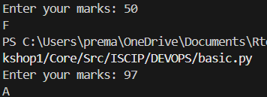
Explanation
- input() takes marks from the user.
- int() converts it to integer.
- if-elif-else checks conditions one by one.
- Based on score, grade is printed.
2 Student Grades
Create a dictionary where the keys are student names and the values are their grades. Allow the user to:
Add a new student and grade.
Update an existing student’s grade.
Print all student grades.
CODE :
student = {}
while True:
print("1.Add student \n 2.Update Student \n 3.print all student ")
choice = input("Enter the Choice :")
if choice =="1":
name = input("Enter the student name : ")
grade = input("Enter the Student grade :")
student[name] = grade
elif choice =="2":
name = input("Enter the Student Name :")
if name in student:
grade = input("Enter the student grade :")
student[name]= grade
else:
print("student not found")
elif choice =="3":
for name, grade in student.items():
print(name, ":", grade)
else:
print("invalid choice")
Explanation
- Dictionary students = {} stores name and grade.
- students[name] = grade adds or updates data.
- if name in students checks if student exists.
- for loop prints all student grades.

OUTPUT :
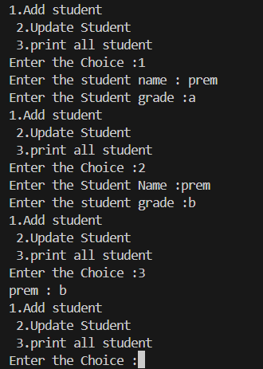

3.Write to a File
Write a program to create a text file and write some content to it.
Using file functions like write and open.

CODE :
file = open("sample.txt", "w")
file.write("hello good morning\n")
file.write("nice to meeet you ")
file.close()

Explanation
- open("sample.txt", "w") → opens file in write mode.
- "w" creates file if not exists.
- write() writes content.
- close() saves and closes file.

OUTUT :
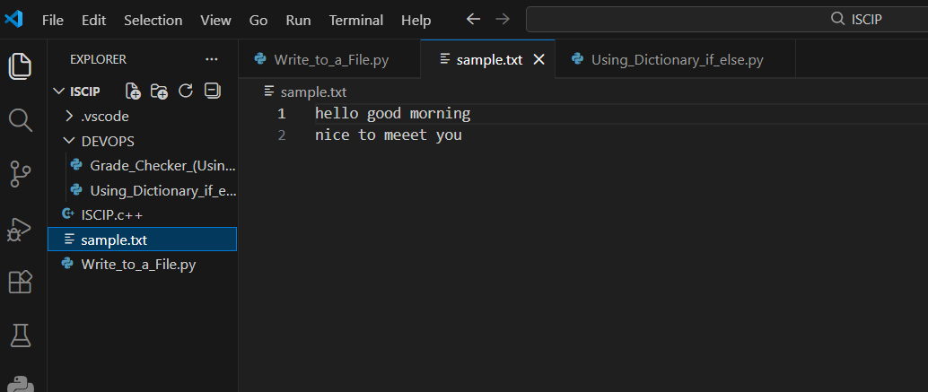

4. Read from a File
We used open in read mode and file.read to read and print to display.
CODE :
file = open("sample.txt","r")
content = file.read()
print(content)
file.close()

Explanation
- "r" mode opens file in read mode.
- read() reads entire content.
- Content is printed on screen.

OUTPUT :
