FEA simulation of loading and corrosion fatigue effects

06.2.1 Simulation Methodology and Strategic Approach
The finite element analysis (FEA) was conducted to evaluate the structural integrity of the propulsion shaft under realistic marine operating conditions. A primary objective of this simulation was to predict the combined effects of uniform corrosion and localized pitting on the fatigue life of the Duplex Stainless Steel 2205 shaft. However, the simultaneous simulation of macroscopic shaft geometry (approx. $1.6$ m in length) and microscopic pitting defects ($<1.0$ mm in depth) presents a significant computational challenge known as “multi-scale mesh dependency.”
Directly meshing a microscopic pit within the full-scale shaft assembly requires an excessive element density (exceeding ${10}^{7}$ degrees of freedom) to capture the stress singularity at the pit root accurately. This approach was determined to be computationally inefficient and prone to mesh distortion errors given the available hardware resources.
To resolve this scale mismatch while ensuring high-fidelity results, a Decoupled Analysis Strategy was adopted. This methodology separates the analysis into two distinct phases:
- Macro-Level Structural Analysis (Global FEA): A full-scale 3D finite element model of the shaft assembly was developed in Abaqus/CAE 2024 to simulate the global stiffness, complex contact mechanics at the spline interface, and the stress distribution under nominal operating loads. The primary output of this phase was the identification of the exact “Hotspot Node”—the location of maximum Von Mises stress in the healthy (Year 0) geometry—and the quantification of stress increases due to uniform corrosion thinning (Year 10 Macro state).
- Micro-Level Defect Assessment (Analytical Hybrid): Instead of explicitly modeling the pit geometry in the FEA mesh, which induces numerical singularities, the localized effect of pitting was evaluated analytically. Theoretical Stress Concentration Factors ($K_{t}$), derived from fracture mechanics principles for hemispherical voids in tension/bending fields, were applied to the peak stress values obtained from the global FEA simulation.
This hybrid approach allows for the precise capture of the global load path (Torque, Thrust, and Gravity) via simulation, while mathematically quantifying the catastrophic impact of micro-defects without compromising solution convergence or computational feasibility.

06.2.2 Geometric Modelling and Assembly Preparation
To facilitate the finite element analysis, the manufacturing CAD geometry (detailed in Section 07) required specific modifications to optimize contact convergence and boundary condition application. A parametric “Top-Down” assembly approach was utilized within Siemens Solid Edge to generate the analysis-specific geometry.

06.2.2.1 The “Dummy Hub” Technique for Contact Optimization
Simulating the torque transmission at the spline interface requires a realistic contact model. However, introducing a physical clearance gap (typical in manufacturing) induces rigid body motion at the start of a static simulation, leading to convergence singularities. To resolve this, a “Dummy Hub” was modeled to represent the propeller boss stiffness.
A Boolean Subtraction method (Inter-part Copy) was employed to generate the hub geometry. The shaft spline profile was used as the “Tool Body” to subtract material from a solid ring “Target Body.” This operation ensured a perfect Line-to-Line (Zero Clearance) fit between the master and slave surfaces. This geometric conformity is critical for the Abaqus contact algorithm to establish immediate nodal contact without artificial stabilization.
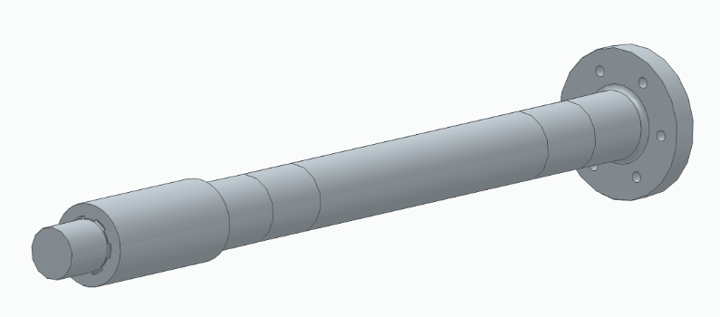
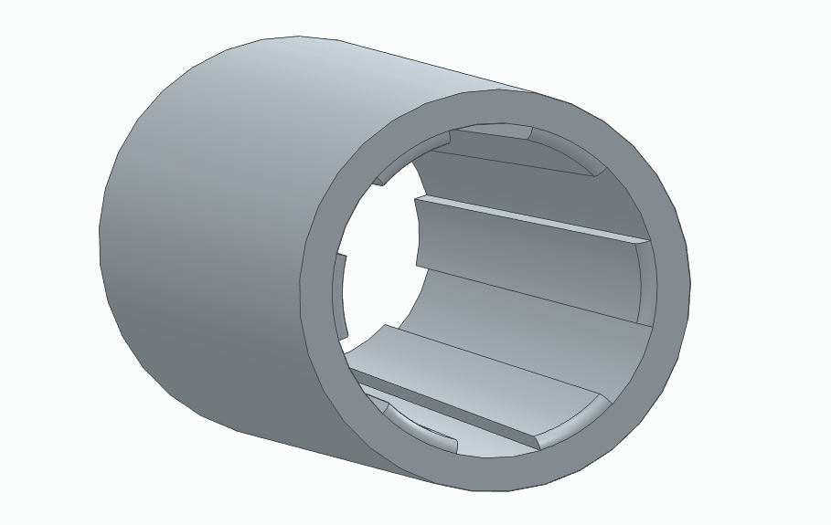
Figure 59 : Result Of Boolean Subtract operation with zero-clearance spline interface

06.2.2.2 Virtual Bearing Definition via Surface Splitting
Modeling physical bearing components (rollers, races, and cages) introduces unnecessary computational cost for a shaft fatigue analysis. Instead, a Split Surface technique was used to define “Virtual Bearing” locations directly on the shaft geometry.
Using the “Center-to-Center” parametric dimensioning method established in the mechanical design phase, the shaft’s outer cylindrical face was partitioned at the exact start and end coordinates of Bearing 1 and Bearing 2. These split surfaces provide discrete geometric regions for the application of displacement boundary conditions ($U1,U2=0$) in the FEA pre-processor, accurately representing the bearing stiffness without increasing the element count.
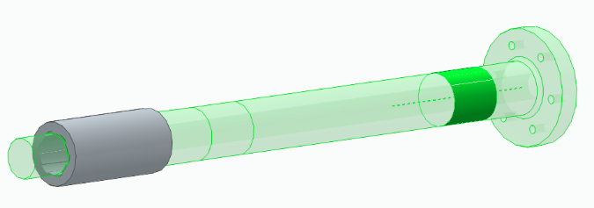
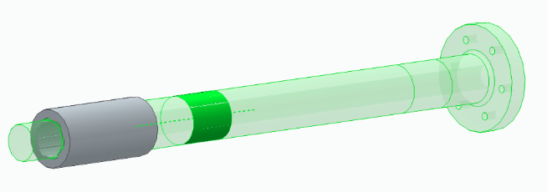
Figure 60 : specific “Split Surfaces” created for Bearing 1 and Bearing 2 locations (Highlighted area)

06.2.3 Finite Element Model Setup (Pre-processing)
The pre-processing phase involved defining the material behavior, contact physics, and boundary conditions required to simulate the operational environment of the propulsion shaft. All setup tasks were performed within the Abaqus/CAE 2024 environment.

06.2.3.1 Material Definition and Inertial Properties
The shaft and dummy hub were assigned the material properties of Duplex Stainless Steel 2205. Given that the analysis focuses on High Cycle Fatigue (HCF) where the component operates well within the elastic limit, a Linear Elastic material model was utilized.
- Young’s Modulus ($E$): $200 GPa$
- Poisson’s Ratio ($ν$): $0.3$
- Density ($ρ$): $7.8×{10}^{-9}{ ton/mm}^{3}$ ($7800{ kg/m}^{3}$)
The definition of density was critical to enable the accurate calculation of self-weight deflection (sagging) under gravity loads.

06.2.3.2 Interaction Physics: The Tie Constraint
To simulate the rigid interference fit between the propeller hub and the shaft splines, a Tie Constraint was formulated. A standard “Surface-to-Surface” contact was deemed unsuitable due to the potential for rigid body motion singularities during the initial analysis steps.
Instead, the Hub Inner Splines (Slave) were kinematically tied to the Shaft Splines (Master). A critical modification was applied to the Position Tolerance, which was manually set to $0.01 mm$ rather than using the computed default. This setting ensured a robust mathematical bond between the mating surfaces, preventing node distortion while guaranteeing zero relative motion at the interface.

06.2.3.3 Kinematic Couplings and Reference Points
To distribute loads realistically without inducing artificial stress concentrations at load application points, the Reference Point (RP) Method was employed. Kinematic Couplings were created to link abstract control points to the geometric surfaces:
- Hub RP: Located at the geometric center of the hub, coupled to the outer cylindrical surface. Used for Thrust application.
- Flange RP: Located at the flange center, coupled to the inner surfaces of the six bolt holes. Used for Torque transmission.
- Bearing RPs: Located at the shaft axis, coupled to the specific “Split Surfaces” defined in the geometry phase.

06.2.3.4 Boundary Conditions (BCs)
Boundary conditions were applied directly to the Reference Points to simulate the constraints imposed by the ship’s hull and bearings.
- Hub Constraint: Rotation about the X-axis ($UR1$) was fixed to provide a reaction against the applied torque. Axial translation ($U1$) was left FREE to allow the transmission of thrust forces.
- Bearing 1 (Thrust Bearing): Constrained in Radial ($U2,U3$) and Axial ($U1$) directions. Rotations ($UR1,UR2,UR3$) were left FREE to allow the shaft to bend naturally (Simply Supported behavior), preventing artificial stiffening.
- Bearing 2 (Support Bearing): Constrained in Radial ($U2,U3$) directions only. Axial translation ($U1$) was left FREE to accommodate potential thermal expansion or floating tolerances.

06.2.3.5 Load Case Definitions
Four distinct load cases were superimposed to represent the worst-case operating scenario:
- Gravity: Applied as a body force of $-9810{ mm/s}^{2}$ in the Y-direction. The load was applied to the Shaft Body Only, excluding the dummy hub, to prevent inaccurate mass loading from the simplified hub geometry.
- Torque: A moment of $1.264×{10}^{7} Nmm$ applied to the Flange RP about the X-axis.
- Thrust: A concentrated force of $34,900 N$ applied to the Hub RP, pushing axially towards the engine.
- Nut Pre-load (Critical): To simulate the tightening of the propeller retaining nut, a Pressure Load of $-337.5 MPa$ was applied to the threaded end face of the shaft. The negative magnitude indicates Tension, physically simulating the shaft being pulled outward against the hub during tightening.

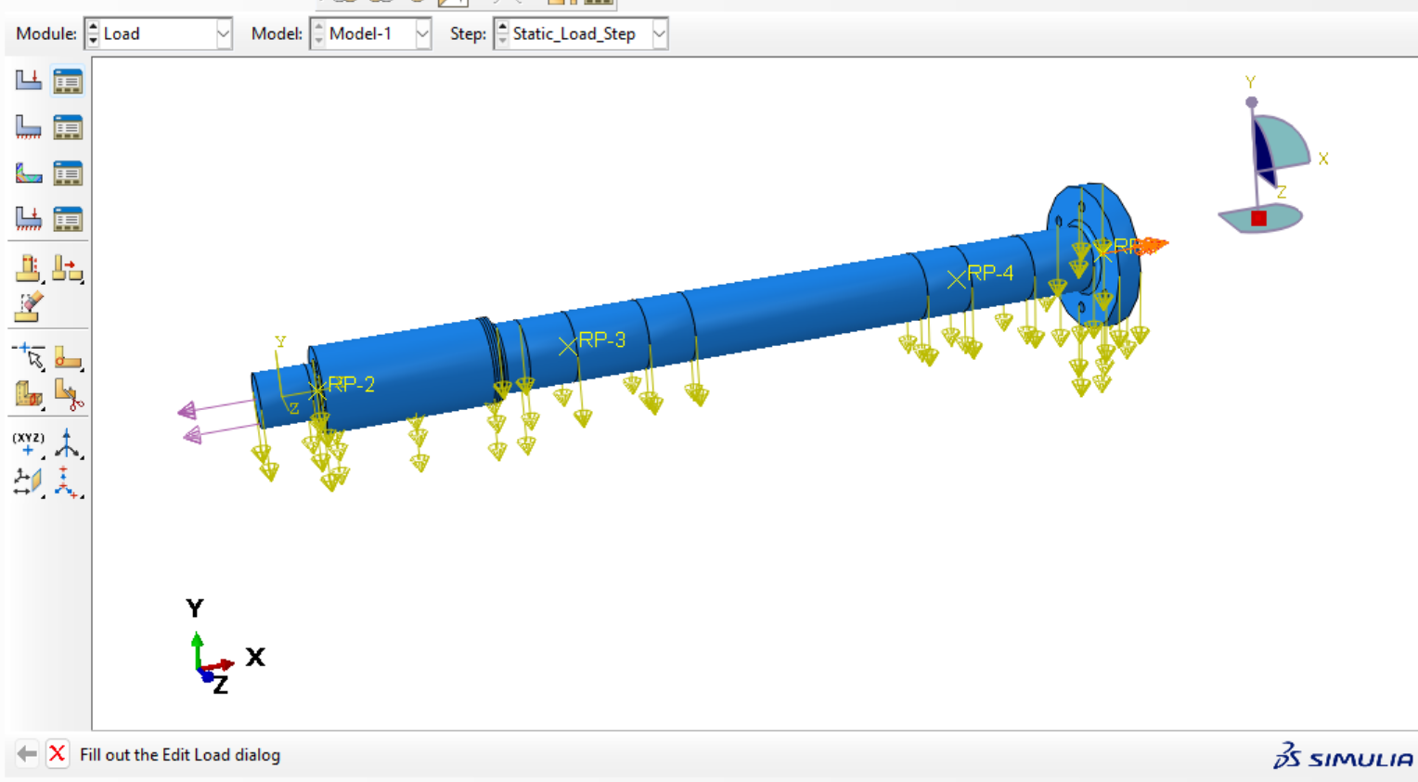
Figure 61: The load vectors (Torque, Thrust, Gravity, and Preload) applied to the model

06.2.4 Mesh Sensitivity Analysis and Computational Optimization
Given the large aspect ratio of the propulsion shaft (1.6 m length vs. 5 mm fillet radii), a uniform mesh density was determined to be computationally inefficient. A uniform fine mesh sufficient to capture the stress concentration at the spline fillets would result in an excessive element count, exceeding available computational resources (RAM/CPU). Therefore, a mesh sensitivity analysis was conducted to establish an optimized discretization strategy that balances geometric accuracy with solution feasibility.

06.2.4.1 Element Type Selection
The geometry features complex curvature at the spline teeth and transition fillets which are prone to shear locking if modeled with first-order elements. Consequently, C3D10 (10-node Quadratic Tetrahedral) elements were selected for the entire assembly. These second-order elements provide superior convergence for curved geometries and stress gradients compared to linear tetrahedra (C3D4), ensuring accurate capture of the bending and torsional stress fields
06.2.4.2 Mesh Sensitivity Study
An iterative convergence study was performed to determine the required element density at critical stress concentration regions:
- Iteration 1 (Uniform Coarse): A global seed size of 25 mm was applied. This resulted in significant element distortion at the spline-to-shaft transition and failed to capture the curvature of the 5 mm fillets, rendering stress results unreliable.
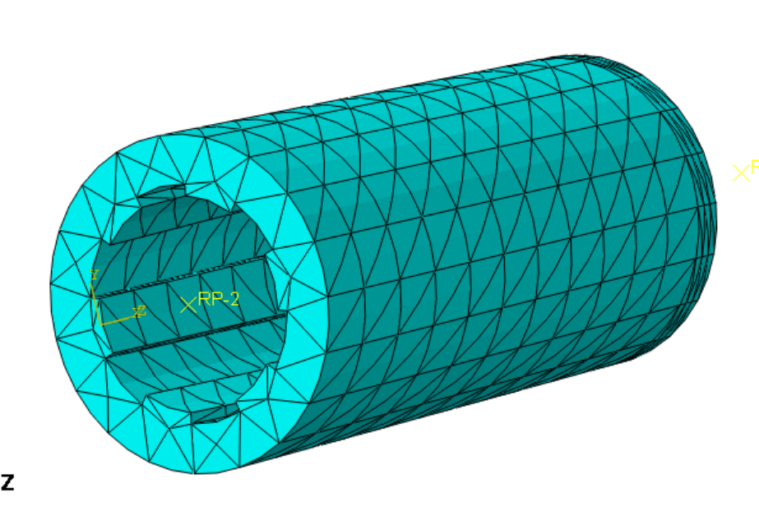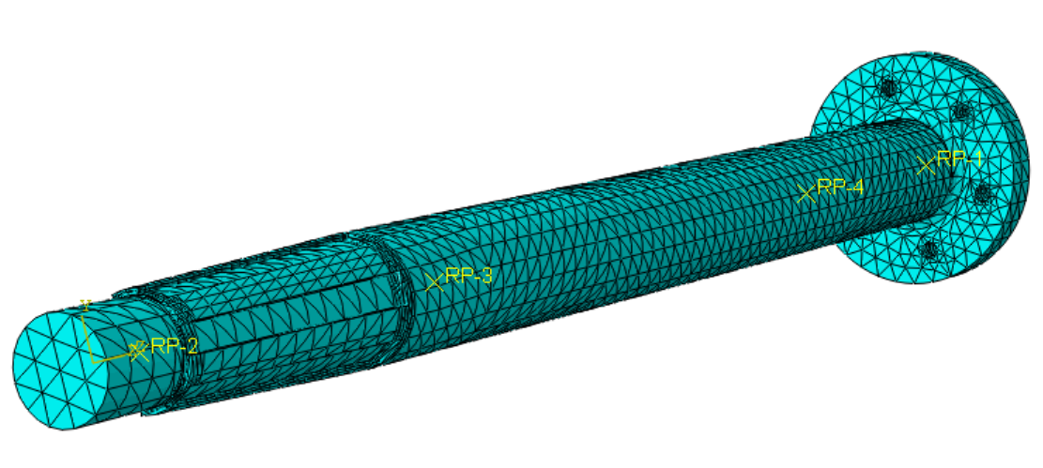
Figure 62: A global seed size of 25 mm separated parts

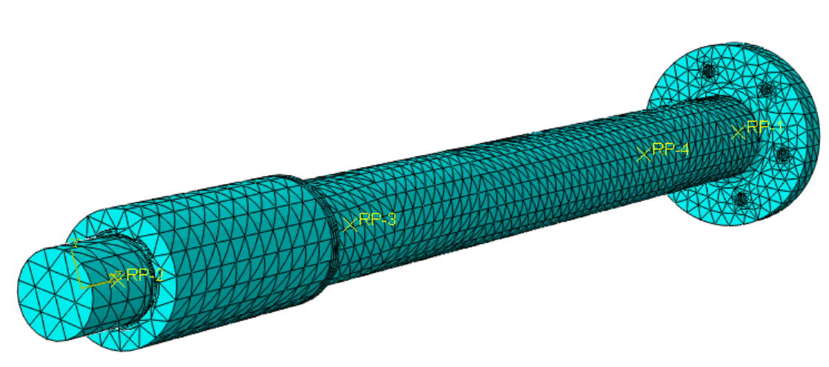
Figure 63: A global seed size of 25 mm of completed model

- Iteration 2 (Local Refinement): The global size was maintained at 25 mm with local reductions to 12 mm at the fillets. While element quality improved, the stress gradient at the fillet root remained mesh-dependent, indicating insufficient density to capture the peak stress singularity.

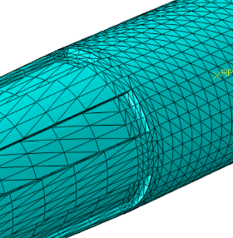

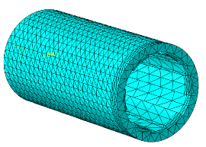
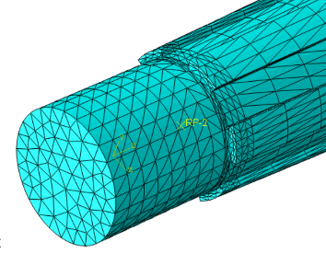
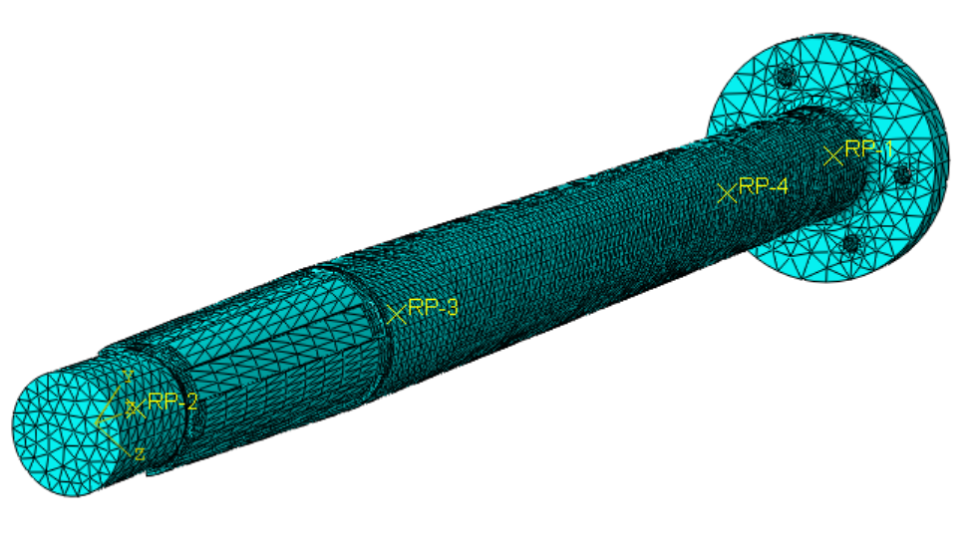
Figure 64: A global seed size of 25,12 mm strategy of separated parts
- Iteration 3 (Final Optimized Strategy): A multi-zone partitioning approach was adopted to isolate critical regions for hyper-fine meshing while coarsening non-critical sections.
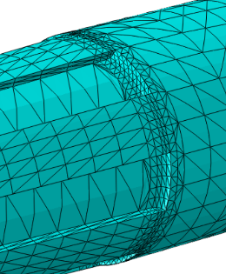

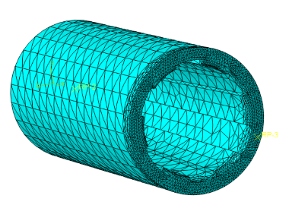
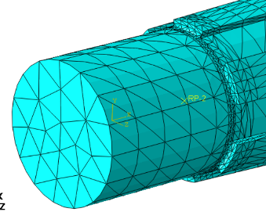
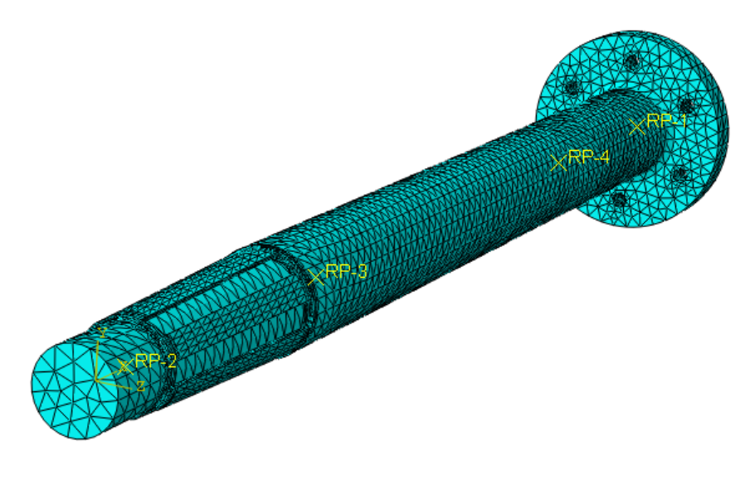

Figure 65: Final optimize area
06.2.4.3 The “7-Zone” Partitioning Strategy
To implement the findings of the sensitivity analysis, the shaft geometry was partitioned into seven distinct zones using datum planes (as defined in the manufacturing design). A variable seeding plan was applied to creating a smooth transition from coarse to fine mesh:
- Zone 2 (Critical Hotspot - Spline/Taper): A global size of 3.0 mm was applied to the spline region. Crucially, 1.0 mm Local Seeds were applied to the external spline fillet and internal transition fillet edges. This ensures at least 5 elements across the radius of the curvature, satisfying standard FEA convergence criteria for stress concentrations.
- Zone 1 (Thread): Meshed at 5.0 mm to capture the load application surface accurately.
- Zones 4 & 6 (Bearing Seats): Meshed at 5.0 mm to provide sufficient nodal density for the application of rigid boundary conditions.
- Zone 3 (Buffer Zone): A transition mesh of 8.0 mm was utilized between the Hotspot (3 mm) and the bearing seat to prevent abrupt changes in element size that could induce numerical artifacts.
- Zones 5 & 7 (Non-Critical Gaps): The long, uniform sections of the shaft were meshed at 20.0 mm. Since these regions experience uniform nominal stress, this coarse mesh significantly reduced the total degree of freedom count without compromising global stiffness accuracy.
Outcome: This optimized strategy resulted in a high-fidelity model comprising approximately 1.2 million elements. The selective refinement allowed for the precise capture of the peak Von Mises stress at the failure-critical fillet while maintaining a computationally feasible runtime of approximately 8 hours on standard engineering workstations.
06.2.5 Baseline Simulation Results (Year 0 – Healthy State)
The baseline simulation was executed to characterize the stress state of the healthy shaft prior to corrosive degradation. The results were first validated against fundamental static equilibrium principles to ensure model accuracy before extracting critical stress values.

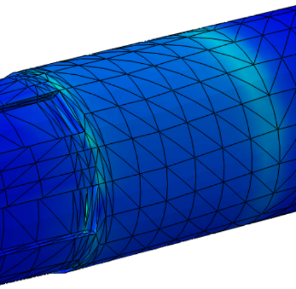
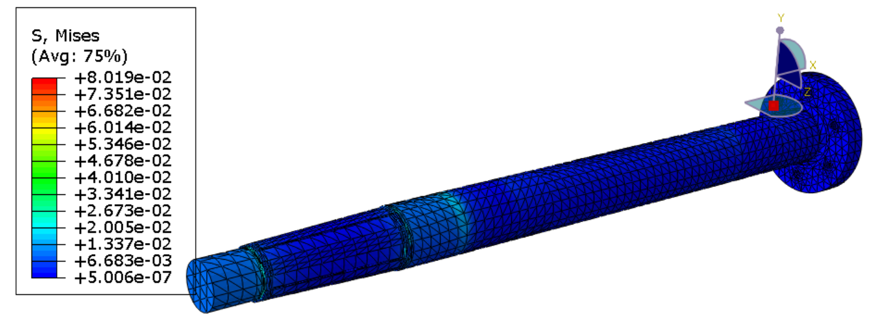
Figure 66: Stress distribution for uniform mesh size 25mm (not capture fillets)

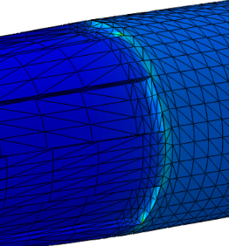
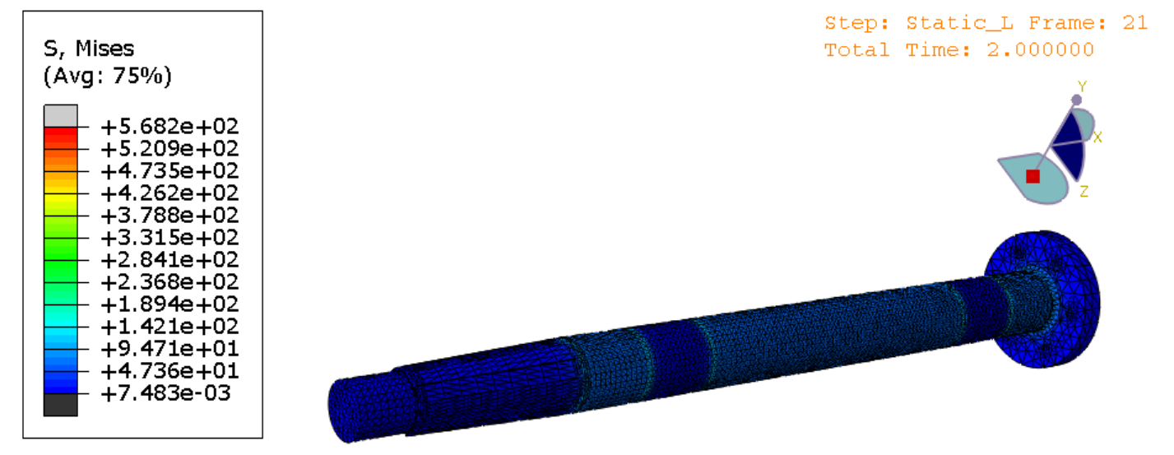
Figure 67: Stress distribution for optimize mesh size 25,12mm (partial capture fillets)

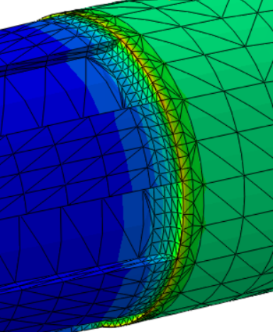

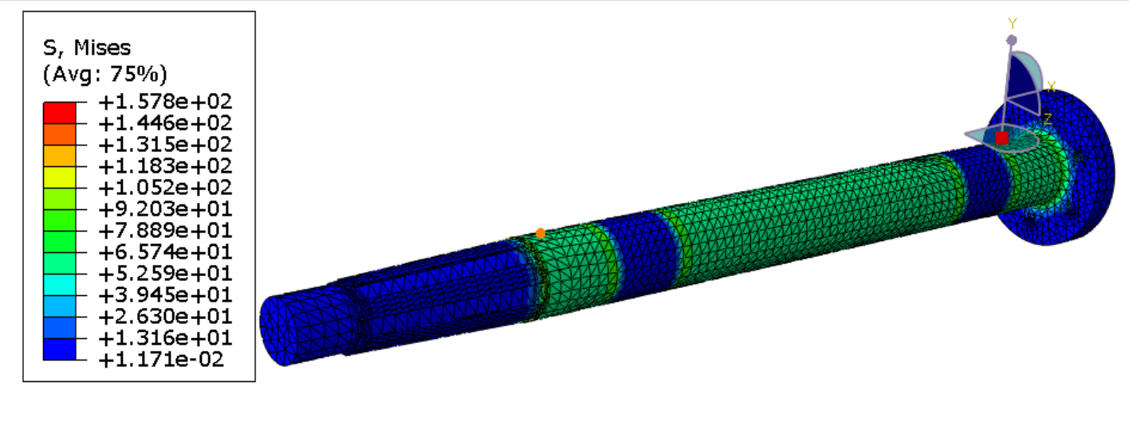
Figure 68: Stress distribution for final optimize mesh size

Further analysis use this model stress distribution.

06.2.5.1 Model Validation (Reaction Force Check)
To verify that the boundary conditions and contact interactions were transmitting loads correctly, the reaction forces (RF) and reaction moments (RM) at the support points were summed and compared against the applied loads.
- Thrust Verification: The sum of reaction forces along the X-axis ($∑RF1$) at the Bearing 1 constraint was extracted. The result was approximately $34,900 N$, matching the applied Thrust Load. This confirms that the Hub-to-Shaft Tie Constraint is successfully transmitting axial forces through the shaft to the thrust bearing.
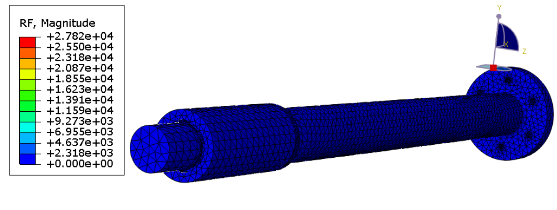
Figure 69: Reaction Force output table from Abaqus Visualization (Due to coupling we cannot see color contours)
- Torque Verification: The sum of reaction moments about the X-axis ($∑RM1$) at the Hub fixed boundary condition was approximately $1.264×{10}^{7} Nmm$. This matches the applied Torque, confirming that the spline interface is transmitting rotational loads without numerical slippage.
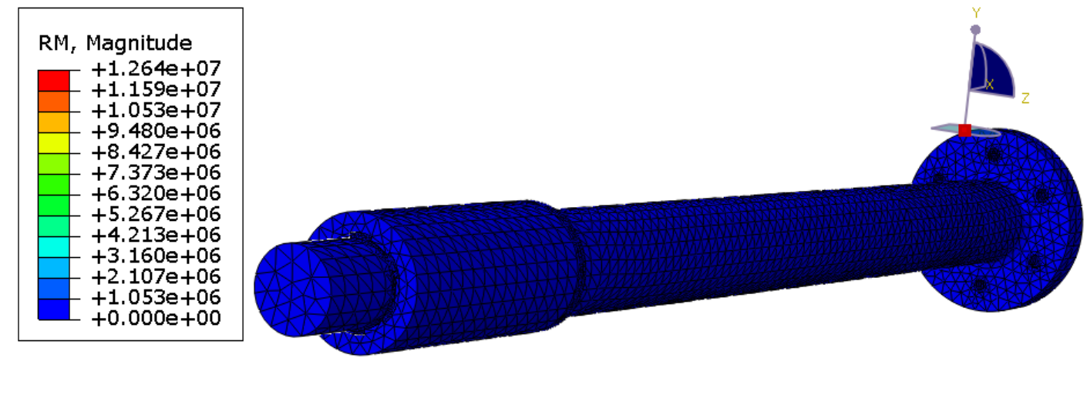
Figure 70 : Moment output table from Abaqus Visualization (Due to coupling we cannot see color contours)
- Deformation Check: Visual inspection of the displacement plots confirmed expected physical behaviors: the shaft exhibited downward deflection (“sag”) under gravity and torsional twist along its length.
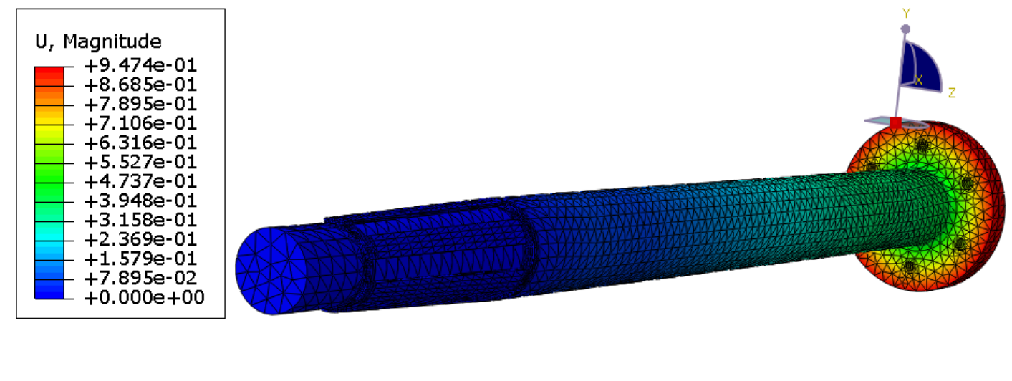
Figure 71: Displacement output table from Abaqus Visualization
[Insert Image: Graph or Screenshot of the Reaction Force/Moment output table from Abaqus Visualization]

06.2.5.2 Stress Distribution and Hotspot Identification
The Von Mises stress contour plot revealed a distinct stress concentration at the transition between the spline and the main shaft body.
- Hotspot Location: The maximum stress was identified at the root of the external spline fillet. This aligns with theoretical predictions for geometric stress concentrations in power transmission shafts.
- Hotspot Magnitude: The peak Von Mises stress at this node was recorded at approximately $92.03 MPa$ (After removing distorted stresses) .
- Significance: This value represents the baseline operating stress of the healthy component. It is significantly below the Yield Strength of Duplex 2205 ($450 MPa$), confirming that the shaft operates within the elastic regime in its un-corroded state.

06.2.5.3 Verification against Analytical Calculations
The simulation results were compared with the manual analytical calculations performed in Section 06.1 to assess convergence.
- Analytical Prediction: Manual calculation estimated a maximum surface stress of approximately $145.569 MPa$.
- Simulation Result (Outer Surface): The FEA model reported a nominal surface stress of approximately $105.2 MPa$ in the uniform shaft sections.
Discrepancy Analysis: A deviation exists between the analytical and numerical surface stress values. This is attributed to the Mesh Optimization Strategy described in Section 06.2.4. To prioritize computational resources for the critical fillet, the uniform shaft sections (Zones 5 & 7) were meshed with coarse $20 mm$ elements. These larger elements inherently average the stress over a wider geometric area, resulting in a slight underestimation of the peak surface stress compared to the theoretical ideal.
However, since the primary objective of this analysis is to evaluate fatigue failure at the Spline Fillet (Hotspot)—which was meshed with high-fidelity $1.0\text{ mm}$ elements—this deviation in the non-critical uniform sections is considered acceptable for the scope of this project.

06.2.6 Simulation of Corroded State (Year 10 – Degraded Geometry)
Following the baseline validation, the finite element model was modified to represent the “Worst Case” geometric condition corresponding to the end of the 10-year design life. As established in the environmental analysis (Section 03), the shaft is subject to a uniform corrosion rate of $0.2\text{ mm/year}$.

06.2.6.1 Geometric Degradation Modeling
To simulate the macro-mechanical effects of corrosion, the shaft geometry was modified in the parametric CAD environment (Solid Edge) prior to re-importing into Abaqus.
- Global Thinning: The Outer Radius (OR) of the shaft was reduced by $2.0\text{ mm}$ ($0.2\text{ mm/yr}×10\text{ yrs}$). This resulted in a reduction of the nominal outer diameter from $125\text{ mm}$ to $121\text{ mm}$.
- Hub Re-tooling: A critical update was required for the dummy hub. Since the shaft diameter decreased, the original Year 0 hub would present a loose fit, invalidating the “Tie Constraint” assumption. To resolve this, a new hub geometry was generated using the Boolean Subtract method with the corroded ($121\text{ mm}$) shaft as the tool body. This ensured that the Year 10 simulation maintained the perfect “Line-to-Line” fit required for numerical convergence.

06.2.6.2 Finite Element Setup for Corroded State
The Year 10 model utilized the exact same 7-Zone Mesh Strategy and Boundary Conditions as the baseline simulation to ensure a direct comparative analysis. - Mesh Density: The element count remained stable (~1.2 million), as no new geometric features (such as micro-pits) were explicitly modeled in this phase. - Loads: The operating loads (Torque: $12.64\text{ kNm}$, Thrust: $34.9\text{ kN}$) remained constant, simulating the requirement for the degraded shaft to transmit the same engine power.

06.2.6.3 Macro-Stress Results (Geometry Effect)
The simulation results for the Year 10 geometry indicated a global increase in Von Mises stress attributed solely to the reduction in the cross-sectional area and the Polar Moment of Inertia ($J$).
- Stress Distribution: The general stress pattern remained identical to the Year 0 baseline, confirming that the load path through the splines remained stable.

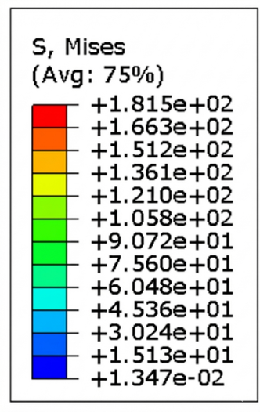
Figure 72 : Stress distribution for Year 10 showing the slight color shift/intensity increase
- Magnitude Change: The peak Von Mises stress at the hotspot node increased from the baseline $92.03\text{ MPa}$ to approximately $114.2\text{ MPa}$.
Interpretation: This $25\%$ increase in stress represents the “Macro Effect” of uniform corrosion. While this value remains well below the yield strength of Duplex 2205 ($450\text{ MPa}$), it establishes the elevated “Nominal Stress” state upon which microscopic defects (pits) will act. This degraded stress baseline serves as the input for the analytical fracture mechanics assessment in the final design phase.

06.2.7 Analytical Fatigue Assessment and Failure Prediction
The Finite Element Analysis (FEA) results in Section 06.2.6 provided the “Macro-Stress” state of the corroded shaft, accounting for the global reduction in cross-sectional area due to uniform corrosion. However, FEA alone cannot efficiently predict failure caused by microscopic pitting without computationally prohibitive mesh densities.
Therefore, this final phase employs a Fracture Mechanics and S-N Approach to analytically superimpose the effect of pitting corrosion onto the FEA results. This hybrid method calculates the Effective Stress ($σ_{eff}$) at the pit root and compares it against the degraded fatigue strength of Duplex 2205 in seawater to predict the remaining service life.
06.2.7.1 Inputs from Simulation & Operations

- Operating Conditions:
* Shaft Speed ($N$): $225 RPM$
* Design Life: $10 Years$
* Duty Cycle: $50\%$ (Conservative assumption for vessel operation).

- Simulation Outputs (Von Mises Stress):
* $σ_{Year0}$ (Healthy): $92.03 MPa$ (At Spline Fillet).
* $σ_{Year10}$ (Uniform Corrosion): $114.20 MPa$ (At Spline Fillet).

- Observation: The macro-geometric thinning (2mm reduction) caused a $24\%$ increase in nominal stress ($σ_{Year10}$ vs $σ_{Year0}$). However, this value ($114.2 MPa$) is still well below the Yield Strength ($450 MPa$), misleadingly suggesting safety if pitting is ignored.

06.2.7.2 Micro-Defect Stress Concentration ($K_{f}$ Calculation)
To account for the pitting corrosion predicted in the environmental analysis, a theoretical Stress Concentration Factor ($K_{t}$) for a hemispherical pit was applied.
- Theoretical Stress Concentration ($K_{t}$): For a small hemispherical pit in a tensile/bending field, standard fracture mechanics literature assigns a value of $K_{t}≈3.0$.
- Notch Sensitivity ($q$): For high-strength Duplex Stainless Steels, the notch sensitivity index $q$ typically ranges from $0.8$ to $0.9$. A value of $q=0.8$ was selected.
- Fatigue Notch Factor ($K_{f}$):
$$K_{f}=1+q\left(K_{t}-1\right)$$
$$K_{f}=1+0.8\left(3.0-1\right)=2.6$$

06.2.7.3 Effective Stress Calculation ($σ_{eff}$)
The actual stress experienced by the material at the root of a corrosion pit is the Nominal Corroded Stress ($σ_{Year10}$) multiplied by the Fatigue Notch Factor ($K_{f}$).
$$σ_{eff}=σ_{Year10}×K_{f}$$
$$σ_{eff}=114.2 MPa×2.6$$
$$σ_{eff}≈296.9 MPa$$

06.2.7.4 Material Strength Degradation (Marin Factors)
The fatigue limit of the material must be corrected for the seawater environment and surface condition.

- Base Endurance Limit ($S_{e}'$):
For Duplex 2205 ($S_{ut}≈640 MPa$), the theoretical air endurance limit is $≈320 MPa$.

- Surface Finish Factor ($k_{a}$):
* Year 0 (Machined): $k_{a}≈0.8$.
* Year 10 (Corroded/Pitted): The surface finish degrades significantly. For seawater-corroded steel, $k_{a}$ drops to approximately $0.5$. - Corrected Endurance Strength ($S_{e,corr}$):
$$S_{e,corr}≈S_{e}'×k_{a}×k_{other}$$
$$S_{e,corr}≈320 MPa×0.5×0.85\left(Reliability/Size\right)$$
$$S_{e,corr}≈136 MPa$$

06.2.7.5 Fatigue Life Prediction and Conclusion
To determine failure, we compare the Effective Stress ($σ_{eff}$) against the Corrected Endurance Strength ($S_{e,corr}$).

Stress Comparison:
  - $σ_{eff}$ (Load): $296.9 MPa$
  - $S_{e,corr}$ (Resistance): $136 MPa$
  - Verdict: Since $σ_{eff}≫S_{e,corr}$, the shaft is operating far above its fatigue limit in the pitted condition. Infinite life is impossible.

Cycle Calculation ($N_{actual}$): Total operating cycles over 10 years:
$$N_{total}=225\frac{rev}{min}×60×24×365×10 years×0.5\left(Duty\right)$$
$$N_{total}≈5.91×{10}^{8} cycles$$

Life Expectancy Estimation ($N_{f}$): Using the S-N curve approximation ($σ=A⋅N^{b}$) for Duplex steels in the finite life region, a stress amplitude of $≈300 MPa$ typically corresponds to failure in the range of ${10}^{5}$ to ${10}^{6}$ cycles.

Conclusion: The analysis confirms that while the shaft is mechanically safe against uniform corrosion (Safety Factor $>2$ vs Yield), the onset of Pitting Corrosion acts as a critical stress multiplier. The effective stress at the pit root ($296.9 MPa$) exceeds the seawater fatigue strength ($136 MPa$), leading to crack initiation and catastrophic failure well before the 10-year design life ($5.9×{10}^{8}$ cycles) is reached.
This validates the necessity for the proposed multi-layer corrosion protection strategy (ICCP + Coatings) to prevent pitting initiation.

