UNIVERSITY OF MORATUWA
Faculty of Engineering



Material Selection

Group Number: 01
Project Duration: July – November

Date of Submission:
November

Department of Materials Science and Engineering
Table of Contents

1. Introduction 3
1.1. Background and Design Requirement 3
1.2. Objective of Material Selection 3
2. Methodology 3
2.1. General Material Selection Strategy (Translate – Screen – Rank – Document) 3
2.2. Software Tool: ANSYS Granta EduPack 4
3. Design Requirements for Marine Propeller Shaft 5
3.1. Functional Requirements 5
3.2. Service Environment (Seawater Corrosion, Fatigue) 6
3.3. Constraints (Mechanical, Corrosion, Manufacturing) 6
3.3.1. Mechanical constraints: 6
3.3.2. Corrosion constraints: 6
3.3.3. Manufacturing constraints: 6
3.4. Objective (Safe, Cost-Effective, Durable Shaft) 6
4. Material Screening 7
4.1. Constraints Applied in Ansys Granta 7
4.2. Shortlisted Materials after Screening 8
5. Material Ranking 12
5.1. Use of Material Indices (Strength/Density, Corrosion Resistance) 12
5.2. Performance Comparison of Candidates 13
6. Results and Discussion 15
6.1. Comparison Table of Top Candidates (316L, Duplex 2205, NiCrMo Alloy) 15
6.2. Recommended Material 17
7. Conclusion 18
8. Reference 19
9. Annexes 21
9.1. Annex A – ANSYS Granta Selection Report 21
9.2. Annex B – ANSYS Material Datasheet (Duplex Stainless Steel 2205) 22

- Introduction
  - Background and Design Requirement
Marine propeller shafts operate in a harsh environment: cyclic mechanical loads from torque and bending, exposure to saline water (leading to corrosion, pitting, crevice corrosion, stress corrosion cracking), and sometimes elevated temperatures or variable loads. The shaft must transmit torque reliably, resist fatigue failure and corrosion over long service life, yet remain manufacturable and cost-effective.
  - Objective of Material Selection
The objective is to find a material that balances the competing demands of strength, durability, corrosion resistance, and cost. We employ a structured methodology (translate → screen → rank → document) using ANSYS Granta (Granta EduPack or similar) to filter and compare candidate materials. [1]
The final goal is to make a justified recommendation (with supporting data).
- Methodology
  - General Material Selection Strategy (Translate – Screen – Rank – Document)
The methodology used in this study follows a structured, multi-stage approach to material selection based on the framework popularized by Ashby and employed in engineering design practice. The four main steps are:
- Translate: convert real-world design requirements (loads, environment, geometry, constraints) into quantitative functions, constraints, objectives, and free variables.
- Function describes what the component must do (e.g. transmit torque, resist corrosion).
- Constraints are nonnegotiable property limits (e.g. minimum yield strength, maximum allowable corrosion rate).
- Objectives are performance measures to maximize or minimize (e.g. minimize mass or cost, maximize fatigue life).
- Free variables are the design parameters the engineer may vary (e.g. cross-section, thickness).
This translation step ensures that subsequent filtering and ranking are rooted in the physics and usage context of the component.
- Screen (or Reject): apply the constraints to eliminate materials that cannot meet the basic requirements. This reduces the candidate set to only those feasible for the application. Common constraints include yield strength, fatigue strength, corrosion resistance, manufacturability, cost ceilings, etc. Materials failing any of these constraints are removed. The screening step uses property charts or database filters.

- Rank (or Select / Compare): among the screened materials, compute performance indices (also known as merit indices) based on the objectives and free variables. These indices (combinations of material properties) allow direct ranking of materials (higher is better, or lower if minimizing). You may also handle multiple objectives via trade-offs, coupling equations, or multi-stage ranking. Materials are sorted, compared, and candidates are selected.

- Document (or Support): prepare a record of the reasoning, data sources, assumptions, and comparisons. Provide a justification of the selected material relative to alternatives. Include raw data, charts, decision paths, sensitivity analyses, and any caveats.
This “Translate → Screen → Rank → Document” paradigm helps maintain clarity, traceability, and rational decision making. In real cases, iteration is often necessary: if the ranking yields no satisfactory solution, one must revisit the translation step (relax or re-interpret constraints, adjust objectives) or consider alternate designs. [1], [2], [3], [4]
  - Software Tool: ANSYS Granta EduPack
ANSYS Granta EduPack (formerly CES EduPack) is a materials and process selection tool widely used in engineering education and early-stage design.
Key features:
- Material and Process Databases: a large, curated database of materials (metals, polymers, composites, ceramics) and manufacturing processes, with associated mechanical, thermal, chemical, and environmental properties.
- Graphical Selection (Charts / Stages): the ability to plot property charts (Ashby-style) and overlay selection lines to visually screen materials. User can set axes (e.g. strength vs density) and selection criteria (regions above, below, left, right).
- Stage-Based Filtering: supports creation of multiple “stages” (sequential filters) to apply constraints and refine selection gradually.
- Material Indices / Performance Indices Tools: it allows the definition of custom indices (e.g. combining strength, density, cost) and calculation/ranking accordingly.
- Traceability and Reporting: as user apply filters, stages, and selections, the tool maintains traceable records and lets user export summary reports and datasheets.
- Tutorials & “Getting Started” Guides: EduPack includes step-by-step tutorials and exercise guides for new users.
- Education Focus: the tool is optimized for teaching materials decisions, showing links between properties, processing, cost, and performance. [5]
In this project, we will use EduPack to:
- Input the translated constraints (yield strength, fatigue strength, corrosion metrics, manufacturability)
- Filter the full database via stages to screen out infeasible materials.
- Define and apply performance indices to rank the remaining materials.
- Export the final selection report and material datasheet.
- Design Requirements for Marine Propeller Shaft
  - Functional Requirements
The propeller shaft transmits torque from the engine to the propeller, while also resisting bending forces from propeller thrust, hydrodynamic loading, and shaft misalignment. The component must:
- Carry a design torque corresponding to the vessel’s power without yielding (minimum yield > 66 MPa for 100 mm dia).
- Resist cyclic torsional stresses over long service life (≥ 10⁷ cycles).
- Maintain alignment and stiffness (torsional twist and bending deflection within tolerances).
- Operate reliably under combined torque, bending, and thrust loading.
  - Service Environment (Seawater Corrosion, Fatigue)
- Seawater at ~25 °C with high salinity is highly aggressive. Shaft material must resist pitting, crevice corrosion, and stress-corrosion cracking (SCC).
- Corrosion fatigue is the dominant failure mode: cyclic stresses in chloride environment accelerate crack initiation and growth.
- Potential galvanic coupling with propeller (bronze, Ni-Al-bronze) or couplings must be considered.
- Surface durability (resistance to wear, corrosion at bearings and seals) is essential.
  - Constraints (Mechanical, Corrosion, Manufacturing)
    - Mechanical constraints:
- Yield strength ≥ 50 ksi (345 MPa) → for 100 mm shaft: ≥ 66 MPa minimum requirement satisfied.
- Fatigue strength ≥ 30 ksi (207 MPa) at 10⁷ cycles.
- Adequate stiffness (Young’s modulus ~200 GPa typical for steels).
    - Corrosion constraints:
- Pitting Resistance Equivalent Number (PREN) ≥ 30.
- SCC: not or slightly susceptible in chloride environment.
- Seawater resistance: acceptable/excellent rating required.
    - Manufacturing constraints:
- Hot forming: acceptable/excellent.
- Weldability: good/excellent (repair and fabrication).
- Machinability sufficient for large-diameter shaft finishing.
- Material available in large bar/forging stock.
  - Objective (Safe, Cost-Effective, Durable Shaft)
The selected material must:
- Maximize service life by combining high fatigue strength and corrosion resistance in seawater.
- Minimize cost per unit strength (balance between corrosion-resistant Ni alloys and affordable steels).
- Ensure manufacturability with forging, machining, and welding compatibility.
- Survive pitting and SCC risks through adequate PREN and duplex/austenitic alloy design.
[1], [2], [3]
Candidate materials surviving screening: 316L stainless, Duplex 2205. Subsequent ranking (by cost/strength and PREN) will determine the optimum.
- Material Screening
  - Constraints Applied in Ansys Granta
The Stage-2 screening in Ansys Granta used the following constraints (as configured in your selection file): yield strength ≥ 50 ksi; fatigue strength at 10⁷ cycles ≥ 30 ksi; metal hot forming = acceptable/excellent; weldability = good/excellent; salt water durability = acceptable/excellent; PREN ≥ 30; SCC susceptibility = not/slightly susceptible.
To visualize the outcome of the applied constraints, the yield strength vs. density Ashby chart generated in ANSYS Granta is presented in Figure 1. The shaded gray region indicates the initial pool of metals before screening, while the highlighted zones show the remaining feasible materials after all constraints were applied. As seen, the majority of alloys fall outside the acceptable limits, leaving only about 25 candidate materials that satisfy the required mechanical, corrosion, and manufacturability conditions. Among these, the two promising candidates—Austenitic Stainless Steel AISI 316LVM (cold-worked) and Duplex Stainless Steel AISI 2205 (annealed)—occupy the favorable region of the chart, combining adequate yield strength with moderate density. This figure visually supports how the database was refined to the final shortlist used for ranking in the subsequent stage.
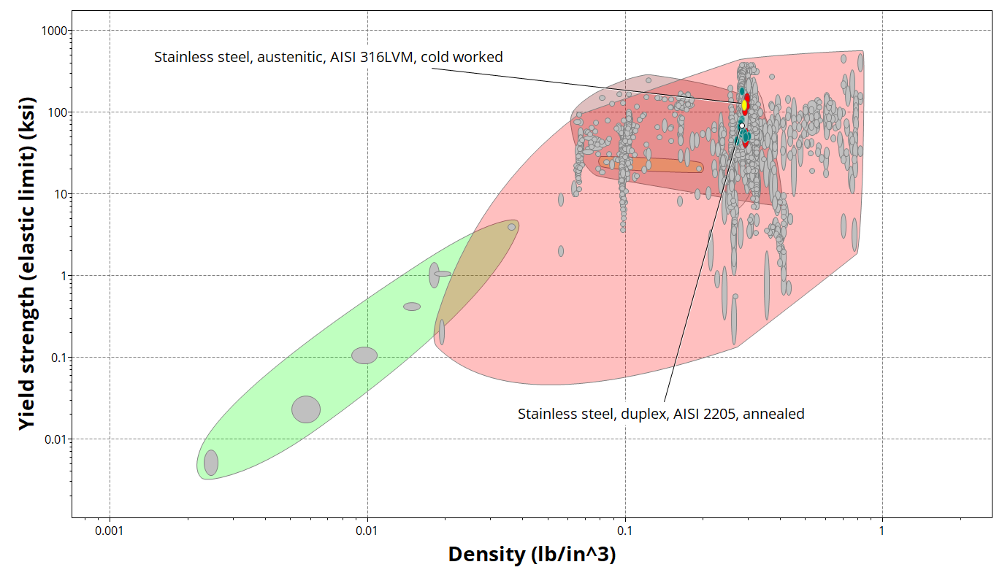
Figure 1 : Yield strength vs. density chart showing screened with filtered materials in gray colour. [6]

  - Shortlisted Materials after Screening
The first chart visualizes the distribution of metallic materials by yield strength and density. This show higher strength have 316LVM also higher density while AISI have lower strength and density.
Figure 2 : Yield strength vs. density chart showing after removed filtered materials. It shows ASI 316LVM have highest yield strength. [6]

This plot compares stiffness among the remaining materials. Both 316LVM and 2205 occupy the upper zone, showing AISI 2205 have lighter high stiffness.
Figure 3 : Young’s Modulus vs. Density [6]

Since torsion control depends on shear rigidity, next chart confirms that both shortlisted steels exhibit similar shear modulus (~80 GPa equivalent), meaning both can maintain shaft twist within allowable limits during operation. But AISI 2205 have higher torsion control with lighter.
Fatigue behavior under cyclic torque is critical. Next plot showing, 316LVM clearly leads with higher fatigue strength (≈60 ksi) compared to 2205 (≈40 ksi), but both exceed the design threshold of 30 ksi. This confirms their capability to withstand long-term service loading.
Figure 4 : Fatigue Strength vs. Density[6]

Next plot demonstrates the corrosion resistance advantage of Duplex 2205, which maintains a PREN above 30, indicating strong resistance to chloride-induced pitting and crevice corrosion. In contrast, 316LVM lies near the lower limit, implying the need for additional corrosion control measures.
Figure 5 : Pitting Resistance (PREN) vs. Density [6]

Finally, the cost-performance plot shows that both alloys lie in the same moderate cost range, well below that of Ni-based alloys. Duplex 2205 achieves its corrosion advantage without significant cost increase, making it the most balanced option.
Figure 6 : Price per Unit Volume vs. Density [6]

These visual comparisons confirm that AISI 316LVM offers superior strength, while AISI 2205 provides better corrosion resistance and overall design balance. The summarized data for these shortlisted materials are presented in Table 1 below.
Table 1: A concise comparison (from Stage-4 comparison table in Ansys Granta see annex A) [6]
Attribute | 316LVM (50% CW) | Duplex 2205 (annealed) | Ni-Cr-Mo (ILLIUM 98, cast)
Yield strength (ksi) | 107–141 | 66.7–74 | 37–46.4
Young’s modulus (10⁶ psi) | 28 – 29 | 29 – 30 | 27 – 28
Shear modulus (10⁶ psi) | 10.7 – 11.2 | 11.3 – 11.6 | 10 – 10.4
Fatigue strength @10⁷ (ksi) | 58.5–68.2 | 37.9–41.9 | 18.9–29.7
PREN | 24.4–31.2 | 30.5–37.8 | (High 30s–40s class)
SCC Resistance | Slightly susceptible | Not susceptible | Not susceptible
Cost per unit strength (relative)* | 0.080–0.096 | 0.089–0.102 | 0.429–0.598
*As reported in the Granta “Cost per unit of strength” field. Data sources for each row: mechanical properties and durability from the comparison pages; PREN and SCC notes from the corrosion section.
Interpretation for the next stage (Ranking): 316LVM delivers the strongest mechanical performance but only marginal PREN margin; Duplex 2205 balances strength with robust chloride resistance and benign SCC behavior; Ni-Cr-Mo excels in pitting/crevice resistance but at significant penalties in strength and cost. These trade-offs will be formalized with performance indices in Section 5.
- Material Ranking
  - Use of Material Indices (Strength/Density, Corrosion Resistance)
Once screening is complete, the shortlisted materials must be ranked. Ranking is not done by single properties but by material indices — combinations of properties that best measure performance for the given function.
For a propeller shaft under torsion:
- Strength-limited torsion index (minimum mass design) is:
$$P=\frac{σ_{f}^{2/3}}{ρ}$$
where $σ_{f}$ = fatigue strength at 10⁷ cycles, $ρ$ = density. Materials with higher values give lighter shafts for the same safe torque.
- Stiffness-limited torsion index (control of angle of twist) is:
$$P=\frac{G^{1/2}}{ρ}$$
where $G$ = shear modulus, $ρ$ = density. Higher values mean reduced twist per unit mass.
- Corrosion resistance index: for marine shafts, the Pitting Resistance Equivalent Number (PREN) is used. Ranking by PREN ≥ 30 ensures minimum seawater resistance, and higher PREN provides greater safety against pitting and crevice corrosion.
- Cost-weighted indices: Cost per unit strength and cost per unit stiffness adjust the above indices by material price. This highlights trade-offs between corrosion performance and economic viability.
Thus, final ranking must consider both mechanical performance indices and corrosion indices, with cost as a secondary objective. [7]
  - Performance Comparison of Candidates
To better understand the trade-offs among candidate materials, the Ansys Granta material charts were examined. These maps visualize how the shortlisted alloys compare in terms of cost, mass efficiency, and corrosion resistance under torsional loading conditions. The first chart relates cost per unit strength to mass per unit strength, revealing which alloys provide lightweight and economical performance for cyclic loading in a shaft.
A second chart plots pitting resistance equivalent number (PREN) against cost per unit strength, highlighting the corrosion–cost trade-off between the candidates. Materials in the upper-left region combine high corrosion resistance with acceptable cost, representing ideal choices for seawater service.
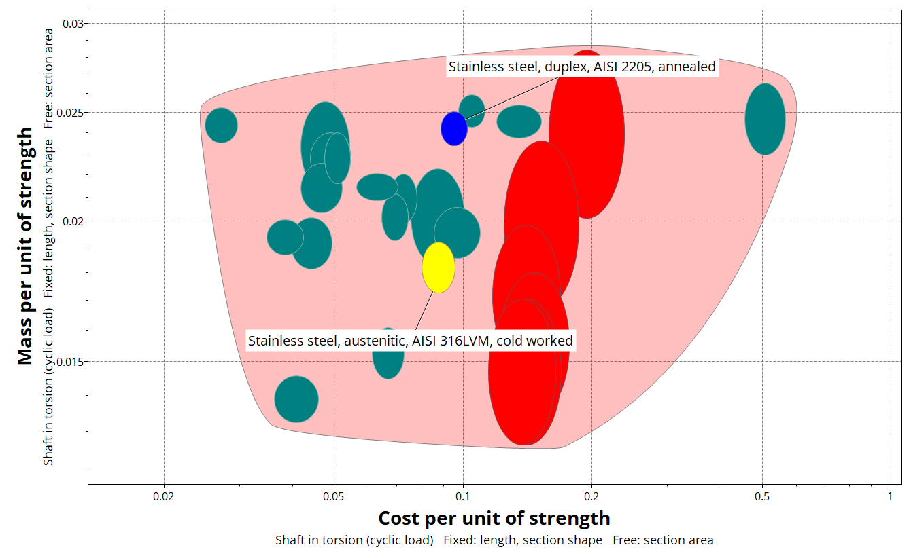
Figure 7 : Material performance map showing the relationship between cost per unit strength and mass per unit strength for marine shaft materials under cyclic torsion. 316LVM and Duplex 2205 occupy the most favorable region, balancing mass efficiency with moderate cost, while Ni-Cr-Mo alloys lie in the high-cost range. [6]

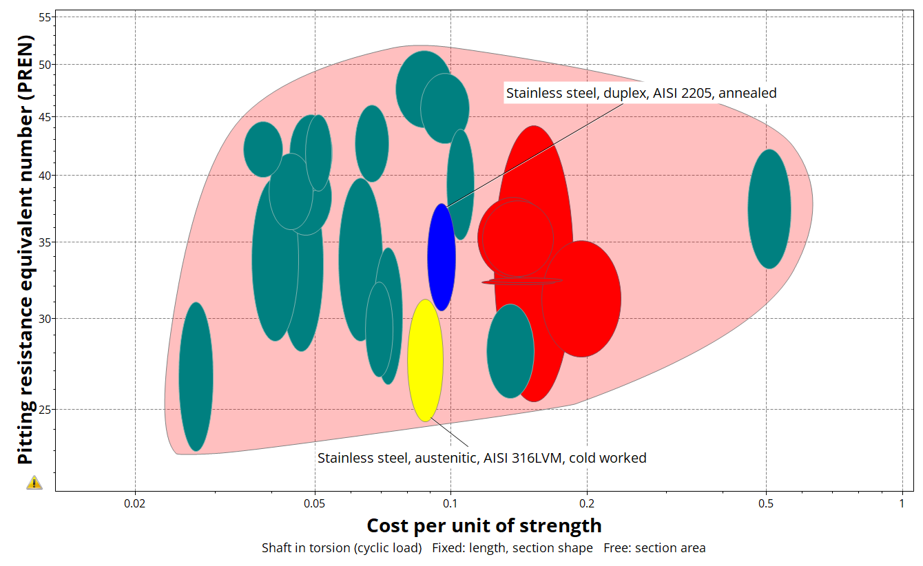
Figure 8 : Material performance map of PREN versus cost per unit strength. Duplex 2205 offers the best compromise of corrosion resistance and cost, 316LVM sits near the minimum acceptable corrosion threshold, and Ni-Cr-Mo alloys provide superior protection at a significant cost penalty. [6]
Table 2 : From the Granta comparison table (See annex A) [6]
Property / Index | 316LVM (CW) | Duplex 2205 (Annealed) | Ni-Cr-Mo (ILLIUM 98, cast)
Fatigue Strength @10⁷ (ksi) | 58.5–68.2 | 37.9–41.9 | 18.9–29.7
Density (lb/in³) | 0.287–0.290 | 0.282–0.283 | 0.300–0.303
Strength/Density (Index) | ≈200–230 MPa/(Mg/m³) | ≈135–150 MPa/(Mg/m³) | ≈60–100 MPa/(Mg/m³)
PREN | 24.4–31.2 (borderline) | 30.5–37.8 (safe margin) | ~35–40+ (very high)
SCC Resistance | Slightly susceptible | Not susceptible | Not susceptible
Cost per unit strength | 0.080–0.096 | 0.089–0.102 | 0.429–0.598

Interpretation:
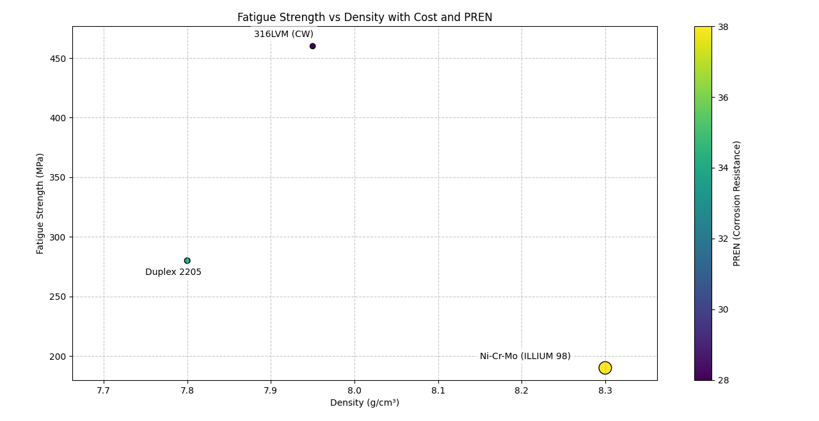
Figure 9 : Ashby-style comparison of shortlisted marine shaft materials showing fatigue strength versus density, with color representing pitting resistance (PREN) and marker size representing relative cost. 316LVM offers the highest strength but marginal corrosion margin; Duplex 2205 provides balanced strength, corrosion resistance, and cost; Ni-Cr-Mo (ILLIUM 98) exhibits excellent corrosion resistance but low strength and high cost.

- 316LVM leads in mechanical strength and fatigue index but barely meets the corrosion requirement (PREN near the cutoff). Risk of pitting in long-term seawater service.
- Duplex 2205 achieves a strong balance: adequate fatigue strength, excellent SCC resistance, PREN comfortably above 30, and only slightly higher cost than 316LVM.
- Ni-Cr-Mo alloy (ILLIUM 98) offers the best corrosion resistance (PREN high 30s–40s) but suffers from poor strength and 4–6× cost penalty, making it impractical for large shafts.
Ranking outcome:
- 1st choice: Duplex 2205 (optimum balance of fatigue, corrosion, cost).
- 2nd choice: 316LVM (higher strength but corrosion borderline).
- 3rd choice: Ni-Cr-Mo alloy (overkill corrosion resistance, uneconomical).
- Results and Discussion
  - Comparison Table of Top Candidates (316L, Duplex 2205, NiCrMo Alloy)
Table 3 : Summarized from the Granta comparison table and corrosion resistance database see annex A [6]
Attribute | 316LVM (Austenitic, CW) | Duplex 2205 (Annealed) | Ni-Cr-Mo Alloy (ILLIUM 98, Cast)
Yield Strength (ksi) | 107 – 141 | 66.7 – 74 | 37 – 46.4
Fatigue Strength @10⁷ (ksi) | 58.5 – 68.2 | 37.9 – 41.9 | 18.9 – 29.7
Density (lb/in³) | 0.287 – 0.290 | 0.282 – 0.283 | 0.300 – 0.303
PREN (Pitting Resistance Eq. No.) | 24.4 – 31.2 (borderline) | 30.5 – 37.8 (safe) | ~35 – 40+ (very high)
Stress Corrosion Cracking | Slightly susceptible | Not susceptible | Not susceptible
Cost per Unit Strength | 0.080 – 0.096 | 0.089 – 0.102 | 0.429 – 0.598
Weldability | Excellent | Good | Good
Hot Forming | Excellent | Acceptable | Unsuitable
Seawater Resistance | Good | Good/High | Excellent

Engineering Interpretation (Strength vs Corrosion vs Cost)
- 316LVM:
Mechanically the strongest, with yield > 100 ksi and fatigue strength > 60 ksi, making it attractive for high torque capacity and long fatigue life. However, its PREN only just exceeds 30, meaning in warm, chloride-rich seawater it is on the edge of acceptable resistance. Pitting and crevice corrosion remain risks for long-term immersion. [8]
- Duplex 2205:
A balanced candidate. Its yield and fatigue strengths are safely above the design constraint (≥ 66 MPa yield, ≥ 30 ksi fatigue). While not as strong as 316LVM, its duplex microstructure provides high resistance to stress corrosion cracking and PREN consistently above 30. Manufacturing and welding are feasible, and its cost per unit strength is close to 316LVM. This alloy is widely adopted in marine shafting because it balances mechanical and corrosion requirements without major economic penalty. [9], [10]
- Ni-Cr-Mo Alloy (ILLIUM 98):
Corrosion-wise, this alloy is superior, with PREN in the high 30s–40s, effectively immune to seawater pitting. However, its yield and fatigue strengths are the lowest of the three, and its cost per unit strength is 4–6× higher. For large-diameter shafts, this cost is prohibitive. Thus, while technically robust against corrosion, it is impractical for full-shaft applications and is better suited for smaller, high-corrosion components (e.g., impellers, pump housings). [11]
  - Recommended Material
Based on the performance indices (strength/density, stiffness/density, cost/strength) and corrosion resistance considerations:
- Duplex Stainless Steel 2205 is recommended as the optimal material for the marine propeller shaft.
It provides:
- Adequate mechanical strength for torque and fatigue loading,
- High resistance to chloride-induced pitting and complete immunity to stress corrosion cracking,
- A reasonable cost level compared with Ni-based alloys,
- Proven service record in marine shafts and structural components.
316LVM remains a viable backup if cost and availability of Duplex 2205 become issues, but only with careful corrosion protection strategies (cathodic protection, coatings).
Ni-Cr-Mo alloy is eliminated on cost/strength grounds despite superior corrosion performance.
- Conclusion
The material selection process for the marine propeller shaft was conducted using the structured methodology of Translate – Screen – Rank – Document. Key constraints were applied to ensure mechanical strength (yield ≥ 66 MPa, fatigue ≥ 30 ksi), manufacturability (weldability, hot forming), and corrosion resistance (PREN ≥ 30, SCC not susceptible).
From over 1900 candidate materials in the Ansys Granta database, 25 survived screening. The proposed options – 316L stainless steel, Duplex 2205, and Ni-Cr-Mo alloys – were confirmed in this shortlist.
Ranking using performance indices (strength/density, stiffness/density, cost/strength) combined with corrosion metrics (PREN) revealed:
- 316LVM: very high strength but borderline corrosion resistance.
- Ni-Cr-Mo alloy: superior corrosion resistance but weak and uneconomical.
- Duplex 2205: strong balance between strength, fatigue resistance, PREN (>30), immunity to SCC, and moderate cost.
Recommended material: Duplex Stainless Steel 2205 (UNS S31803/S32205) is the optimal choice for the propeller shaft, offering durability, safety, and cost-effectiveness in seawater immersion conditions. (To see the data sheet of selected material go to annex B)

- Reference
[1] M. F. Ashby, Ed., Materials selection in mechanical design, 2nd ed. Oxford, OX Boston, MA: Butterworth-Heinemann, 2010. Accessed: Oct. 14, 2025. [Online]. Available: https://www.utc.fr/~hagegebe/UV/MQ12/CORRECTIONS_TD/%5BASHBY99%5D%20-%20Materials%20Selection%20In%20Mechanical%20Design%202Ed.pdf

[2] M. F. Ashby, H. Shercliff, and D. Cebon, Materials: engineering, science, processing and design, 1. ed., Reprinted. Amsterdam Heidelberg: Elsevier Butterworth-Heinemann, 2008. Accessed: Oct. 19, 2025. [Online]. Available: https://maktabkhooneh.org/media/uploads/%D8%B9%D9%84%D9%85_%D9%85%D9%88%D8%A7%D8%AF_%D8%A7%D8%B4%D8%A8%DB%8C.pdf

[3] M. F. Ashby, Materials selection in mechanical design, 3. ed., Reprint. Amsterdam Heidelberg: Elsevier, 2010. Accessed: Oct. 19, 2025. [Online]. Available: https://ferrosos.wordpress.com/wp-content/uploads/2010/10/material-selection-in-mechanical-design.pdf

[4] B. N. Bhat, Ed., Aerospace Materials and Applications. Reston ,VA: American Institute of Aeronautics and Astronautics, Inc., 2018. doi: 10.2514/4.104893.

[5] Ansys, Inc, “Getting Started with Granta EduPack,” ansysinfo@ansys.com, Jan. 2025, Accessed: Oct. 20, 2025. [Online]. Available: https://www.ansys.com/content/dam/web/academic/education-resources/2025r1/getting-started-with-granta-edupack-25r1-en.pdf

[6] Ansys, Inc, Exported ANSYS Granta Selection Report. (2025). Ansys, Inc. Accessed: Sept. 10, 2025. [Windows]. Available: https://www.ansys.com

[7] K. Tyler and H. Parnell, “Ansys Academic Development Team,” 2022, Accessed: Oct. 01, 2025. [Online]. Available: https://www.ansys.com/content/dam/amp/2021/august/webpage-requests/education-resources-dam-upload-batch-6/performance-indices-booklet-bokpeien22.pdf

[8] “316LVM stainless steel.” Accessed: Oct. 14, 2025. [Online]. Available: https://fwmetals.com/what-we-do/materials/stainless-steel/316lvm-stainless-steel?utm_source=chatgpt.com

[9] “Duplex Stainless Steels – A Simplified Guide – British Stainless Steel Association.” Accessed: Oct. 14, 2025. [Online]. Available: https://bssa.org.uk/bssa_articles/2-duplex-stainless-steels-a-simplified-guide-2/
[10] “Alloy 2205 (Plate),” Langley Alloys. Accessed: Oct. 14, 2025. [Online]. Available: https://www.langleyalloys.com/products/alloy-2205/

[11] B. Todd, “Nickel-Containing Materials in Marine and Related Environments,” Tor. Oni, Accessed: Oct. 14, 2025. [Online]. Available: https://nickelinstitute.org/media/1734/nickel_containingmaterialsinmarineandrelatedenvironments_10011_.pdf

- Annexes
  - Annex A – ANSYS Granta Selection Report

  - Annex B – ANSYS Material Datasheet (Duplex Stainless Steel 2205)

