UNIVERSITY OF MORATUWA
Faculty of Engineering



Environmental Analysis

Group Number: 01
Project Duration: July – December

Date of Submission:
December

Department of Materials Science and Engineering
Table of Contents

1. Environmental Analysis of the Marine Operating Environment 3
1.1. Seawater Constituents 3
1.2. Effect of Dissolved Gases 7
1.3. Seawater pH 8
1.4. Calcareous Deposits 11
1.5. Effect of Seawater Temperature 14
1.6. Effect of Depth 16
1.7. Fouling, Macro- and Microorganisms 19
1.8. Effect of Velocity 22
1.9. Seawater Resistivity 25

- Environmental Analysis of the Marine Operating Environment
Seawater covers approximately 70% of the Earth’s surface and represents one of the most chemically and biologically complex natural environments. It contains nearly every element in the periodic table, along with a vast diversity of living organisms, earning it the description of a “living” medium. Due to its aggressive nature, seawater is widely regarded as one of the most corrosive environments encountered in engineering applications. This chapter explores the critical environmental parameters of seawater that influence material degradation, especially corrosion. These factors are essential for understanding and predicting material performance in marine systems such as ships, offshore platforms, pipelines, and submerged components. The subsections below examine key characteristics including salinity, dissolved gases, pH, biological activity, temperature, depth, flow velocity, and electrical resistivity—all of which collectively define the corrosive nature of seawater.
  - Seawater Constituents
Seawater is widely recognized as one of the most chemically aggressive environments for metallic materials, primarily due to its complex composition. Although sodium chloride (NaCl) is often cited as the main source of corrosivity, the actual corrosion behavior is influenced more significantly by other constituents — particularly dissolved oxygen (DO) and pollutants such as sulfides. These components critically affect the electrochemical conditions at the metal–seawater interface.
The total salt content of seawater is expressed as salinity, which refers to the mass of total dissolved solids (TDS) in one kilogram of seawater, after oxidation of organic matter and replacement of bromine and iodine by chlorine. A related and analytically more accessible parameter is chlorinity, which includes the chloride ion concentration as well as the equivalent amount of bromide and iodide. The relationship between the two is defined by the empirical equation:
$$Salinity = (1.80655 × Chlorinity) + 0.03$$
Both salinity and chlorinity are commonly reported in grams per kilogram (g/kg) or parts per thousand (ppt or %). To convert these to parts per million (ppm), the values are multiplied by 1,000. Salinity is also considered equivalent to TDS and may be expressed in mg/L (ppm).
Seawater properties vary significantly depending on geographical location, season, and water depth. Influencing factors include:
- River discharge
- Evaporation and rainfall
- Melting of polar ice
- Wind and wave activity
For instance, littoral (coastal) waters often exhibit lower salinity due to freshwater influx and may also contain high levels of sediment and organic/inorganic pollutants, leading to brackish conditions.
The average salinity of open ocean water is typically 32–36 ppt, and the corresponding chlorinity is approximately 18–20 ppt. By contrast, extreme environments such as the Dead Sea exhibit salinities more than ten times higher, reaching 322,000 ppm, as shown in Table 1. [1]
Table 1 : Approximate TDS (ppm) of Various Seas and Oceans [2]
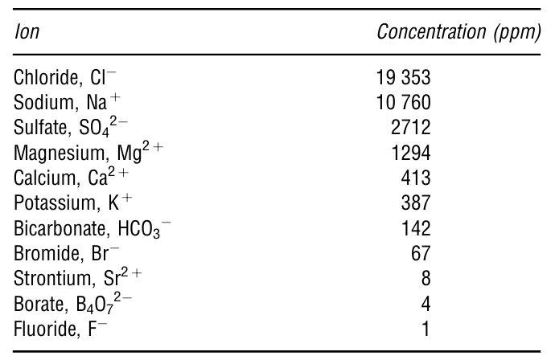
Table 2 : Table 2 : Major Ionic Constituents in Seawater (35 ppt Salinity) [2]
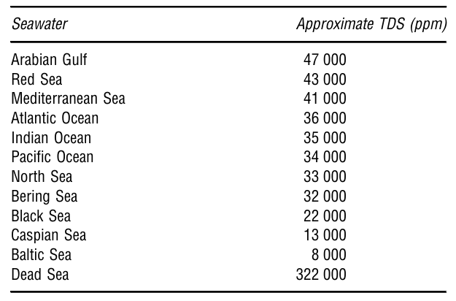
The average chemical composition of open-ocean seawater with 35 ppt salinity is detailed in Table 2. From a corrosion standpoint, chloride ions (Cl⁻) are especially aggressive, as they interfere with the formation and stability of passive oxide films on metals, particularly stainless steels and aluminum alloys. Sulfate ions (SO₄²⁻), though less directly corrosive, support the activity of sulfate-reducing bacteria (SRB) under anaerobic conditions, potentially leading to severe microbial corrosion.
In addition to these ions, seawater contains organic matter that supports biological activity. Elements such as carbon, oxygen, hydrogen, nitrogen, and phosphorus are involved in forming polysaccharides, lipids, and proteins. While carbon, oxygen, and hydrogen are abundant, nitrogen and phosphorus compounds (e.g., nitrates and phosphates) often act as limiting nutrients.
In coastal areas, nutrient loading from river discharge, sewage, and fertilizer runoff can significantly increase the concentrations of these nutrients. This process leads to eutrophication, characterized by excessive plant and algae growth, which depletes dissolved oxygen and may result in large-scale marine life die-off — commonly seen in phenomena like red tides.
Additionally, industrial waste and heavy metal discharge can enhance seawater's corrosivity. For example:
- Copper ions may adversely affect aluminum alloys
- Sulfides and ammonia can increase the corrosion rate of copper alloys
- Sulfur compounds are particularly aggressive toward steels
Design Relevance of Seawater Constituents
The chemical composition of seawater, particularly the concentration of aggressive ions—plays a central role in shaping the corrosion behavior of materials used in marine propulsion shafts. In our project, the shaft operates under continuous exposure to seawater immersion and splashing at an average temperature of 25 °C, where both galvanic and pitting corrosion are critical threats. Understanding seawater constituents helps us make informed decisions regarding material selection, protection strategies, and service life prediction.
Key Impacts on Shaft Design:
- High Chloride Content (~19,000 ppm Cl⁻):
- Chloride ions are the primary drivers of pitting corrosion, especially in passive alloys like SS316L or Duplex 2205. [1]
- They degrade protective oxide films, making them highly relevant in areas such as the splash zone and shaft surface crevices.
- This supports the selection of duplex or NiCrMo alloys with high PREN (Pitting Resistance Equivalent Number) values for critical locations.
- Bicarbonate and Calcium Ions (HCO₃⁻, Ca²⁺):
- These ions contribute to calcium carbonate (CaCO₃) scale formation, particularly in heated or moving components. [1]
- While thin scales can reduce general corrosion by limiting DO diffusion, they also create risks for under-deposit corrosion and reduce heat transfer at bearing interfaces.
- Sulfate Ions and Nutrient Loading (SO₄²⁻, PO₄³⁻, NO₃⁻):
- Sulfates support the growth of sulfate-reducing bacteria (SRB), a common cause of microbiologically influenced corrosion (MIC) in stagnant or shielded zones.
- In our rotating shaft, regions near keyways, couplings, and seals may experience localized stagnation, increasing MIC risk if not properly sealed or coated.
- Pollutants and Organics (e.g., Sulfides, Ammonia, Heavy Metals):
- In littoral or industrial waters, pollutant-induced corrosion acceleration is a serious concern.
- Our shaft may be deployed in nearshore environments during docking or maintenance, where exposure to these contaminants could compromise protective systems.
- Justification for Synthetic Seawater (3.5% NaCl):
- In simulations and lab-scale testing, a 3.5% NaCl solution effectively replicates the average ionic strength and aggressiveness of open-ocean seawater. [1]
- This standardization allows us to reliably test the corrosion performance of candidate materials, coatings, or cathodic protection schemes under controlled conditions.
  - Effect of Dissolved Gases
Dissolved gases, particularly dissolved oxygen (DO), are among the most critical factors influencing corrosion behavior in seawater. In the context of our marine propulsion shaft — which operates in aerated seawater at 25 °C under splashing and immersion conditions — the role of oxygen is directly linked to corrosion initiation, propagation, and even protection system effectiveness.
Key Impacts on Shaft Design:
- Dissolved Oxygen Accelerates Corrosion:
  - DO acts as the primary cathodic reactant in electrochemical corrosion cells. It facilitates the reduction reaction that balances metal dissolution at the anodic sites.
  - This makes the splash zone and areas near the waterline, where oxygen access is highest, particularly susceptible to general corrosion, pitting, and crevice corrosion — all critical for shaft surfaces and couplings.
- DO Concentration Varies with Temperature and Salinity:
  - DO levels decrease with increasing temperature and salinity, both relevant in our case (25 °C and ~35 ppt salinity). Despite lower oxygen solubility, turbulent flow around the rotating shaft maintains high DO transport, sustaining corrosion activity.
  - Figures from the source show this relationship, reinforcing the need to simulate realistic DO levels in lab testing.
- Effect of Flow and Splashing (High Velocity):
  - The high-speed rotation of the shaft (1200 RPM) creates significant water turbulence, enhancing oxygen diffusion to metal surfaces.
  - While this may benefit passivation in duplex or NiCrMo alloys, it also amplifies localized corrosion risk if passive films break down, especially in areas prone to erosion-corrosion or debris entrapment.[3]
- Biological Oxygen Demand (BOD) and Stagnant Zones:
  - In partially stagnant areas like keyways, seal interfaces, or coupling recesses, biological activity can deplete oxygen locally, setting up differential aeration cells.
  - The oxygen-rich outer surface becomes cathodic, while the shielded zone becomes anodic, promoting pitting and crevice corrosion — especially relevant if stainless steels like SS316L are used.
- Gas Byproducts of Bioactivity (e.g., H₂S, NH₃):
  - Anaerobic zones within or near the shaft can also host sulfate-reducing bacteria (SRB), which generate hydrogen sulfide (H₂S) — a highly corrosive gas that destabilizes passive films and can lead to MIC (Microbiologically Influenced Corrosion).
  - Seawater pH
Natural seawater is slightly alkaline, with a typical pH range of 8.0 to 8.3, depending on temperature, salinity, biological activity, and atmospheric interactions. The carbonate system in seawater — involving carbon dioxide (CO₂), carbonic acid (H₂CO₃), bicarbonate (HCO₃⁻), and carbonate (CO₃²⁻) — is the principal buffer that stabilizes the pH of seawater.
This system is governed by the following reactions:
- CO₂ (g) ⇌ CO₂ (aq)
- CO₂ (aq) + H₂O ⇌ H₂CO₃
- H₂CO₃ ⇌ H⁺ + HCO₃⁻
- HCO₃⁻ ⇌ H⁺ + CO₃²⁻
The combination of these equilibria provides seawater with its significant buffering capacity. This buffering resists abrupt pH shifts when acids or bases are introduced, thus maintaining relatively stable pH values in oceanic waters. [4]
In open-ocean conditions, this system is very effective. However, in coastal regions, especially semi-enclosed basins, the buffering capacity can be overwhelmed by the influx of:
- Organic material
- Agricultural runoff
- Industrial discharge
- Biological productivity (eutrophication)
In such areas, local reductions in pH (acidification) are possible. This has significant consequences for:
- Marine organisms, especially calcifiers
- Electrochemical processes on metal surfaces
- Corrosion protection systems
In addition to pH, dissolved oxygen (DO) plays a key role in the corrosion process. DO levels in seawater vary with temperature and salinity and are closely linked to pH stability and corrosion severity. Two key relationships are illustrated in the following figures:
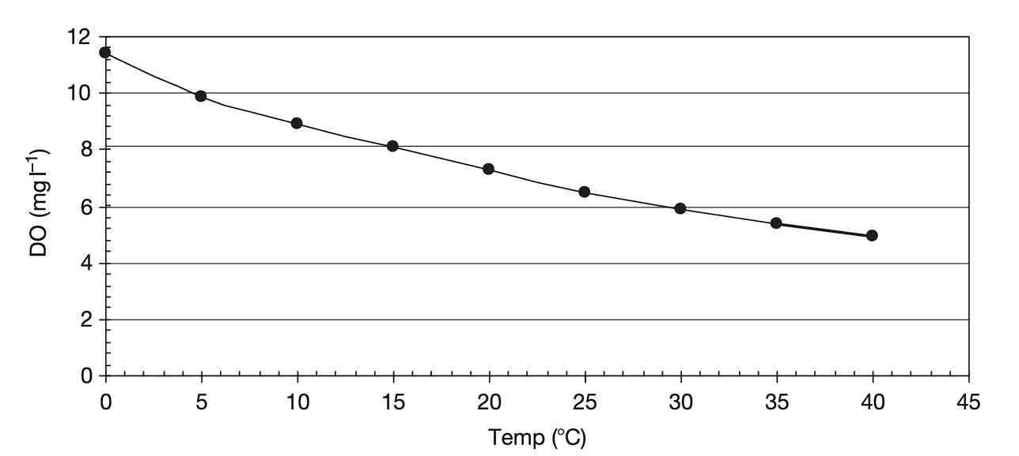
Figure 1 : Dissolved Oxygen vs. Temperature [2]
This figure shows the inverse relationship between DO concentration and temperature in natural seawater (35‰ salinity at 1 atm). As temperature increases, the capacity of seawater to hold oxygen decreases. This has implications for electrochemical reactions at metal surfaces, particularly in tropical marine environments.
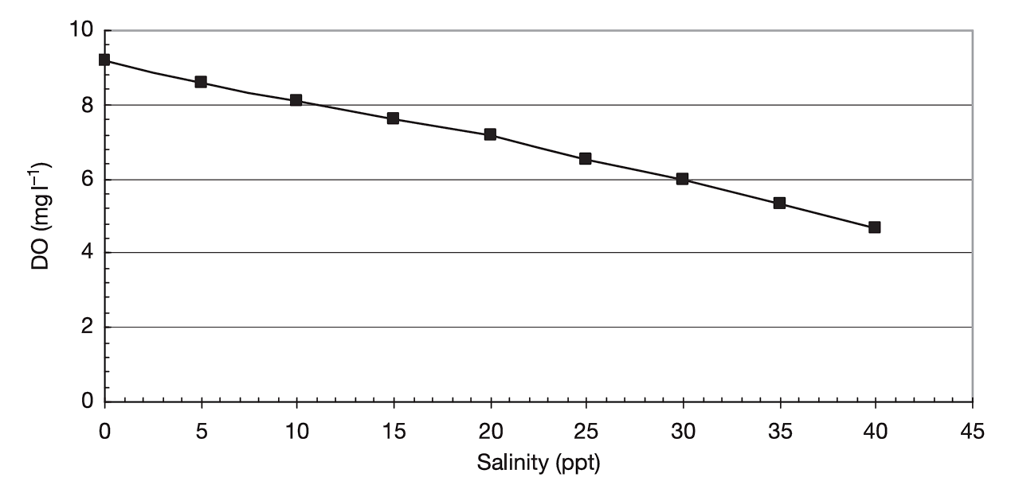
Figure 2 : Dissolved Oxygen vs. Salinity [2]
This figure illustrates how DO decreases as salinity increases in synthetic seawater at 20 °C and 1 atm. Higher salinity reduces oxygen solubility, which can influence both corrosion rates and microbial activity in marine systems.

While the bulk seawater pH tends to remain stable, sharp local reductions in pH can occur directly at the metal–solution interface—especially in stagnant or restricted areas such as:
- Crevices
- Under deposits
- Inside microbially active zones
In these micro-environments, the hydrolysis of metal ions during anodic dissolution leads to an accumulation of H⁺ ions, significantly lowering the local pH (sometimes to values below 4). This creates aggressive conditions, especially for passive materials like stainless steel, which rely on a stable, high-pH environment to maintain their protective oxide layers.
Such drops in pH are often the precursor to pitting and crevice corrosion and are particularly concerning in:
- Bolted assemblies
- Seals
- Shaft couplings
- Shaft-hull interfaces
Relevance to Shaft Design
In the context of our marine propulsion shaft, which is exposed to splashing and immersion in seawater at 25 °C, the stable bulk pH of around 8.1 supports the passivity of high-performance alloys like Duplex 2205 and NiCrMo grades.
However, specific shaft features including keyways, flanges, sealing zones, and stagnant fluid traps are prone to localized acidification. This makes them vulnerable to crevice corrosion, especially if materials like SS316L are used without enhanced protection. The issue is further exacerbated by biofouling or microbial activity, both of which can reduce local pH and oxygen levels.[4]
From a corrosion protection perspective:
- Cathodic protection systems increase surface alkalinity, promoting calcareous deposit formation, but require surrounding waters to maintain sufficient buffering.
- In environments where acidification from eutrophication or pollution is possible, coating systems may offer more consistent performance than CP.
Finally, for corrosion simulation and material testing, it is essential to replicate realistic pH conditions, especially for evaluating behavior in tidal and splash zones.
  - Calcareous Deposits
When metals are subjected to cathodic protection in seawater, either through impressed current systems or sacrificial anodes, calcareous deposits typically form on their surfaces. These deposits consist mainly of:
- Calcium carbonate (CaCO₃)
- Magnesium hydroxide (Mg(OH)₂)
They are produced as a consequence of the electrochemical reactions that occur at the protected (cathodic) metal surface. Specifically, the cathodic reduction of oxygen or water leads to an increase in local hydroxyl ion (OH⁻) concentration, raising the pH near the metal interface. This localized alkalinity promotes the precipitation of calcium and magnesium salts, naturally present in seawater.
The sequence of reactions can be outlined as follows:
At the cathodic surface:
- O₂ + 2H₂O + 4e⁻ → 4OH⁻
- Or: 2H₂O + 2e⁻ → H₂ + 2OH⁻ (in less aerated zones)
Precipitation occurs as:
- Ca²⁺ + CO₃²⁻ → CaCO₃ ↓
- Mg²⁺ + 2OH⁻ → Mg(OH)₂ ↓ [5]
The extent and rate of deposit formation depend on several factors:
- Water composition, especially the concentrations of Ca²⁺, Mg²⁺, and CO₃²⁻
- pH at the surface, which is influenced by current density and flow conditions
- Temperature (solubility decreases with increasing temperature)
- Velocity of the surrounding seawater
In general, calcium carbonate is the more prominent deposit in areas with moderate flow, while magnesium hydroxide tends to dominate in low-flow or stagnant areas due to its higher solubility threshold.
These deposits form a secondary barrier to corrosion by:
- Physically blocking the transport of oxygen and aggressive ions (e.g., Cl⁻)
- Further raising the surface pH
- Enhancing the current efficiency of cathodic protection systems
However, the presence of deposits also introduces certain design considerations:
- They can crack or detach in high-velocity zones, exposing bare metal
- They may reduce heat transfer in thermally active components
- In poorly buffered waters, deposition may be incomplete or irregular
Calcareous deposits have been widely studied in connection with offshore structures, pipelines, and ship hulls. They are especially beneficial for passive metals like steel, which otherwise corrode rapidly in the absence of protection. The buildup of such layers can significantly extend the service life of submerged structures and components.
Relevance to Shaft Design
For marine propulsion shaft particularly if cathodic protection (CP) is considered as a corrosion prevention strategy understanding the role of calcareous deposits is essential.
In our design context:
- The shaft operates in 25 °C seawater, a temperature that favors carbonate precipitation
- The seawater contains sufficient calcium and magnesium ions (as shown in Section 2.1), supporting deposit formation
- The rotational speed (1200 RPM) creates flow velocities that may limit deposit stability on certain surfaces
Key areas where CP may be applied (e.g., at shaft supports, through-hull penetrations, or stern tube interfaces) must be designed to accommodate deposit formation. Proper selection of current density, anode placement, and surface finish will influence the formation and adherence of protective layers.
Furthermore, Duplex 2205, if used, may benefit from the dual action of passivation and calcareous deposit formation, further reducing corrosion risk. However, in turbulent zones or splash areas, deposits may be unstable—indicating a need to combine CP with coatings or design features that minimize exposure.
In summary, effective use of cathodic protection in our shaft design must account for:
- Deposit formation dynamics
- Water chemistry and flow conditions
- Material compatibility and surface design
These considerations help ensure the long-term durability and reliability of the propulsion system under marine operating conditions.
  - Effect of Seawater Temperature
Temperature is one of the most influential environmental factors in the corrosion behavior of metals immersed in seawater. It directly affects both the physicochemical properties of seawater and the electrochemical kinetics of corrosion reactions. Generally, an increase in temperature accelerates corrosion rates, particularly for active metals and alloys.
Several key temperature-dependent effects are observed:
- Increased Corrosion Reaction Rates
Elevated temperatures enhance the rate of electrochemical reactions by increasing ion mobility and decreasing solution viscosity. According to the Arrhenius relationship, a 10 °C rise in temperature can double the corrosion rate of many metals.
- Reduction in Dissolved Oxygen (DO) Solubility
As temperature rises, the solubility of DO in seawater decreases, potentially limiting the availability of oxygen at the metal surface. However, in natural systems, turbulence and replenishment often compensate for this reduction, especially in high-flow conditions.
- Acceleration of Localized Corrosion
Localized forms of corrosion—such as pitting and crevice corrosion—are particularly sensitive to temperature. Many stainless steels exhibit a critical pitting temperature (CPT), above which passive films break down rapidly. Therefore, even modest increases in temperature can shift materials from safe operation to active corrosion zones.
- Influence on Bioactivity
Higher temperatures promote the growth and metabolic activity of marine organisms, increasing the risk of biofouling and microbiologically influenced corrosion (MIC). Warm, nutrient-rich waters are especially susceptible to biofilm formation.
- Effect on Deposit Formation and Solubility
The solubility of salts such as calcium carbonate and magnesium hydroxide decreases with increasing temperature, which can enhance calcareous deposit formation on cathodically protected surfaces. However, if flow velocity is high, deposits may be washed away before they adhere.
The seawater temperature varies by location, season, and depth. Surface waters in tropical regions can reach 30 °C or higher, while polar regions remain below 5 °C. Seasonal fluctuations of up to 15 °C are common in temperate zones. Moreover, industrial discharge, power plant outfalls, and shallow enclosed basins can cause localized thermal elevation, creating corrosion “hot spots” for submerged structures. [6]
Relevance to Shaft Design
In our project, the marine propulsion shaft is designed to operate in seawater at an average temperature of 25 °C, placing it within the moderate to high-temperature range for typical marine environments. This has several implications:
- The selected material must withstand enhanced corrosion kinetics. For example, Duplex 2205 offers significantly better critical pitting temperature (CPT) performance than SS316L, making it a more robust choice in warmer seawater.
- Elevated temperature can accelerate localized corrosion in crevices, such as those found around keyways, couplings, and seal interfaces. These areas must be carefully designed and, if needed, protected with coatings or cathodic protection.
- Reduced DO solubility at higher temperatures may shift corrosion control mechanisms. However, the rotational speed (1200 RPM) of the shaft promotes continuous oxygen replenishment through turbulence, maintaining corrosion potential.
- Temperature-driven bioactivity can promote biofouling and MIC. This reinforces the need for anti-fouling strategies, especially near low-flow regions or during long idle periods.
- If cathodic protection is employed, elevated temperature could enhance calcareous deposit formation, aiding in corrosion resistance—provided that local flow conditions do not strip away forming layers.
Given these factors, material selection, geometry design, and protection strategies must all be tailored to accommodate the thermal characteristics of the shaft’s operating environment.
  - Effect of Depth
The depth at which a metallic structure is submerged in seawater has a significant influence on its surrounding environment and, consequently, on its corrosion behavior. This is due to depth-related variations in multiple parameters, including:
- Temperature
- Dissolved oxygen (DO)
- Salinity
- pH
- Hydrostatic pressure
- Light penetration
- Biological activity
These changes affect not only the corrosion rate but also the biofouling tendency and performance of protection systems.

Temperature and DO Profiles with Depth
As depth increases, temperature typically decreases, especially beyond the thermocline—a transitional layer in the ocean where temperature drops rapidly. Dissolved oxygen (DO), which is highest at the surface due to atmospheric exchange and photosynthetic activity, generally decreases with depth due to biological consumption and lack of light. However, in deep ocean zones, DO may increase again due to cold, oxygen-rich water circulation from polar regions. [2], [7]
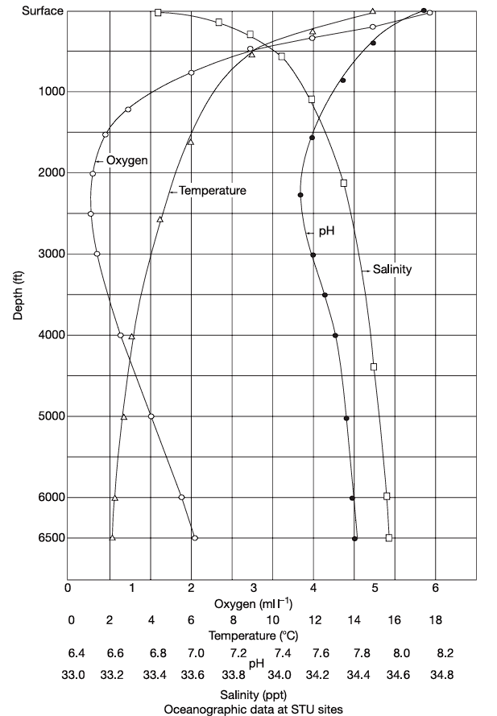
Figure 3 : Variations in dissolved oxygen, temperature, pH and salinity at a corrosion test site in the Pacific Ocean [2]
This figure illustrates how DO, temperature, pH, and salinity vary with depth at a real-world corrosion testing site. It shows:
- A sharp drop in temperature between 50 m and 500 m
- A significant decrease in DO over the same range
- A slight pH drop with depth
- A gradual increase in salinity with increasing depth
These interdependent changes underscore how environmental aggressiveness shifts with depth, influencing material degradation.
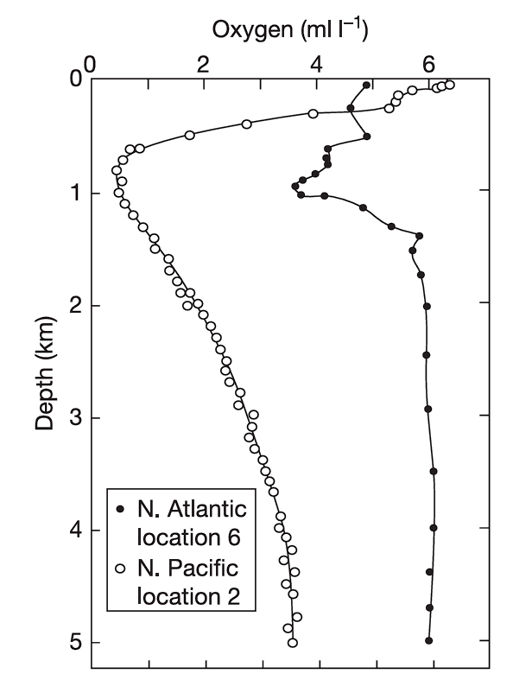
Figure 4 : DO-depth profiles at two specific open ocean test sites [2]
Figure 4 compares the dissolved oxygen profiles across depth at two different oceanic locations. It highlights:
- The difference in DO depletion patterns depending on geographic and oceanographic conditions
- How minimum oxygen zones (oxygen minimum layers) occur at intermediate depths (typically 200–1000 m)
- Implications for localized corrosion behavior under oxygen-limited conditions
Pressure and Other Effects
- Hydrostatic pressure increases by ~1 atm every 10 m of depth. While it does not significantly affect corrosion directly, it influences gas solubility, electrochemical potential, and the behavior of coatings and seals.
- Salinity and pH are generally more stable in the open ocean but can vary in coastal or stratified waters.
- Light attenuation limits photosynthesis and fouling activity beyond 200–300 meters, reducing biofouling and microbial corrosion risk at greater depths. [2]
Relevance to Shaft Design
In our marine propulsion shaft application, the shaft is located at or near the sea surface—specifically within the immersion and splash zone, typically no deeper than 1.5–2.0 meters. Based on the data in Figures 3 and 4, this places the shaft within the zone of:
- Maximum temperature
- Highest DO concentration
- Active biofouling and microbial colonization
- Strongest hydrodynamic effects
These conditions correspond to peak corrosion risk in the marine environment. Unlike submerged pipelines or deep-sea installations, our shaft receives no mitigating benefits from depth. In fact, it experiences the most corrosive and biologically active conditions, making material selection, geometry optimization, and protection strategy design absolutely critical.
The data shown in Figure 3 helps support simulation and FEA boundary condition development by providing realistic environmental gradients. Likewise, Figure 4 reinforces the role of DO in corrosion control systems such as cathodic protection, where oxygen availability affects current demand and deposit formation.
  - Fouling, Macro- and Microorganisms
Marine fouling refers to the accumulation of biological material—such as microorganisms, algae, and larger aquatic organisms—on submerged surfaces. Fouling occurs in two distinct stages:
- Microfouling – involving bacteria, diatoms, and protozoa
- Macrofouling – involving barnacles, mussels, tubeworms, algae, and other visible marine organisms
These biological colonizers influence corrosion processes in multiple ways and can severely affect the performance and maintenance of marine structures.
Microfouling
The first stage of fouling begins with the formation of a biofilm, typically within minutes to hours after a clean metal surface is submerged. This film consists primarily of bacteria and extracellular polymeric substances (EPS) secreted by microbial communities.[8]
Key characteristics:
- Creates a differential aeration cell, leading to localized anodic and cathodic regions
- Can cause oxygen concentration cells under the film, promoting crevice corrosion
- Traps ions and organic molecules, altering the local chemistry
- Facilitates the onset of microbiologically influenced corrosion (MIC)
Microfouling is a major contributor to localized corrosion, particularly pitting, and accelerates degradation in stagnant or shielded zones, such as inside crevices, under gaskets, or beneath scale.
Macrofouling
Over time, the biofilm enables the attachment of larger organisms. This macrofouling layer increases drag, mass, and turbulence on marine components, and can physically trap water and debris against the surface.
Common macrofoulers include:
- Barnacles
- Tubeworms
- Mussels
- Macroalgae [8]
Effects of macrofouling:
- Induces under-deposit corrosion by creating stagnant micro-environments beneath colonies
- Blocks or disturbs coating adhesion and cathodic protection efficiency
- Increases maintenance costs, especially in dynamic systems (e.g., shafts, propellers)
Biological and Environmental Factors
Fouling intensity varies with:
- Temperature – warmer waters promote faster growth
- Salinity – many fouling species prefer full-strength seawater (~35 ppt)
- Flow velocity – high turbulence may reduce fouling adhesion but won’t prevent initial biofilm formation
- Depth – fouling is concentrated in shallow waters, typically <100 m, where light and nutrients are abundant [9]
Seasonal variation also affects fouling activity, with peak growth often occurring in spring and summer.
Relevance to Shaft Design
Our marine propulsion shaft operates in the uppermost zone of the marine environment—within immersion and splash zones—where biofouling activity is most aggressive. Key implications for design:
- Biofilm formation on the shaft surface, especially near couplings, keyways, and seal areas, can create oxygen-deficient zones, promoting crevice corrosion and MIC.
- If SS316L is used, its lower resistance to localized corrosion under biofouled conditions becomes a concern. Duplex 2205, with higher pitting and crevice resistance, is more suitable.
- Macrofouling organisms such as barnacles may colonize low-flow or idle areas, increasing shaft imbalance, surface roughness, and wear at bearings or seals.
- Anti-fouling coatings or cathodic protection should be considered—though biofilms may interfere with both. Surfaces must be designed for easy cleaning or resistance to organism adhesion.
- The 1200 RPM shaft speed may help reduce large-scale macrofouling on dynamic surfaces but will not prevent initial microbial colonization.
Ultimately, biofouling is both a corrosion initiator and a mechanical threat. Its impact must be accounted for in material selection, surface treatment, seal design, and maintenance planning for long-term shaft performance.
  - Effect of Velocity
The velocity of seawater flow over a metallic surface significantly affects its corrosion behavior. Flow conditions influence corrosion by:
- Altering the rate of oxygen and ion transport to and from the metal surface
- Changing the concentration of corrosion products
- Influencing biofilm and deposit stability
Flow-induced effects can be both beneficial and detrimental, depending on the flow regime, material type, and environmental conditions.
Beneficial Effects of Moderate Velocity
Under moderate flow rates, velocity generally helps by:
- Enhancing oxygen transport to the cathodic regions of the metal surface
- Removing corrosion products, which could otherwise accumulate and cause differential aeration
- Preventing the formation of stagnant layers, thus reducing localized corrosion risk
This results in more uniform corrosion and may improve the performance of cathodic protection systems, as electrical current is distributed more evenly in clean, fast-flowing environments.[10]

Detrimental Effects of High Velocity
At high velocities, flow can become abrasive, especially if solid particles (sand, silt) are suspended in the seawater. This leads to:
- Erosion-corrosion, where the protective oxide layer or corrosion product layer is physically removed
- Mechanical damage to coatings, biofilms, and calcareous deposits
- Loss of surface passivity in materials like stainless steel and aluminum alloys
Materials in fast-flowing environments often show signs of localized attack at welds, crevices, and other microstructural inhomogeneities.
Velocity Limits and Material Sensitivity
Each material has a critical velocity threshold, above which corrosion accelerates due to flow-induced damage. For example:
- Mild steel is more prone to erosion at relatively low velocities
- Stainless steels may withstand higher velocities but still suffer if pitting initiates under deposits or scaling
These thresholds vary with environmental parameters such as temperature, salinity, and particulate content.
Field Data Illustration
Figure 3, originally included to describe vertical environmental variation, also supports the discussion on velocity. The site data indicate how surface conditions—where water is turbulent and oxygen-rich—create aggressive corrosion zones due to the combination of:
- High flow
- Elevated DO
- Warm temperatures
This aligns with typical shaft operating environments.
Velocity and Biofouling
Higher flow rates can suppress the settlement of macro-organisms like barnacles and mussels. However, microbial biofilms often develop even in moving water, especially in crevices or shielded zones. In such cases, MIC may still occur even under dynamic conditions.[10]
Relevance to Shaft Design
Our marine propulsion shaft rotates at 1200 RPM, introducing significant relative velocity between the shaft surface and seawater. Key implications include:
- The increased flow velocity enhances oxygen transport, which supports cathodic reactions and passive film formation—beneficial in general.
- However, this also means the shaft is subject to erosion-corrosion, especially at leading edges, seal interfaces, and sharp transitions.
- If calcareous deposits or protective coatings are applied, high flow may cause mechanical stripping, reducing their effectiveness.
- The design must account for hydrodynamic effects at features like keyways, couplings, and shaft shoulders, where flow separation and turbulence can create local stagnation or intensified wear.
- For materials like SS316L, increased velocity may aggravate pitting or crevice corrosion if passive films are disturbed. Duplex 2205, with better erosion resistance and higher repassivation rates, is preferable.
Overall, velocity is a double-edged sword—enhancing protection in some areas while increasing damage risk in others. The shaft’s material, surface finish, and geometry must be optimized to handle the specific flow conditions it will experience.

  - Seawater Resistivity
Electrical resistivity is a critical parameter in understanding the electrochemical behavior of seawater and its impact on corrosion and cathodic protection. Resistivity represents the opposition to the flow of electric current through the electrolyte (in this case, seawater), and is typically expressed in ohm-centimeters (Ω·cm).
In marine corrosion science, low resistivity indicates high ionic conductivity, meaning that seawater can readily support galvanic currents, corrosion cells, and cathodic protection currents. Seawater, due to its high salinity and ion content, is one of the most conductive natural electrolytes.[11]
Factors Affecting Resistivity
The resistivity of seawater depends on several key variables:
- Salinity
  - As the concentration of dissolved salts increases, more ions (e.g., Na⁺, Cl⁻, Mg²⁺, SO₄²⁻) are available to carry electrical current.
  - Therefore, higher salinity = lower resistivity.
- Temperature
  - Increasing temperature improves ion mobility, further reducing resistivity.
  - Warmer water conducts electricity more efficiently than cold water.
- Pollutants and Organic Matter
  - Industrial discharges or biological activity may introduce ions or alter pH, slightly modifying resistivity.

Typical Resistivity Values
In typical open-ocean seawater (salinity ~35 ppt), the resistivity ranges between 20 and 30 Ω·cm. Table 3 in the source text shows resistivity values as a function of salinity and temperature, indicating the following trends:
Table 3 : Seawater Resistivity (Ω·cm) as a Function of Salinity and Temperature [2]
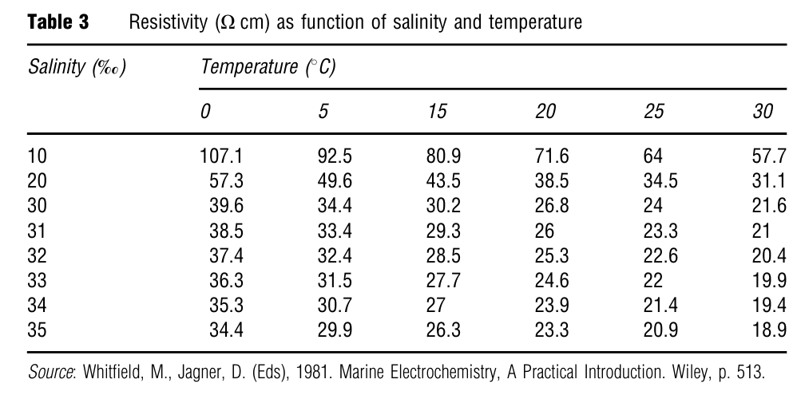
This table demonstrates that seawater at 35 ppt salinity and 25–30 °C—conditions similar to your design environment—has resistivity between 22–26 Ω·cm, indicating a very conductive medium.
Engineering Implications
- Low resistivity promotes galvanic corrosion, especially between dissimilar metals.
- It also supports efficient current flow for cathodic protection systems, reducing anode consumption and improving protection coverage.
- Conversely, in high-resistivity environments (e.g., freshwater, deionized water), more current is required, and protection may be less effective.
Relevance to Shaft Design
In our marine propulsion shaft design, the shaft is immersed in warm, highly saline seawater (~35 ppt at 25 °C)—conditions that yield a low resistivity of approximately 25 Ω·cm.
This has multiple implications:
- The risk of galvanic corrosion is high, especially if dissimilar metals are in contact (e.g., shaft and coupling or seal materials). Proper material matching or electrical insulation is essential.
- If cathodic protection (CP) is implemented (e.g., sacrificial anodes or impressed current), the low resistivity ensures efficient current distribution, reducing energy and anode consumption.
- However, overprotection must be avoided, as it may lead to hydrogen embrittlement, especially in high-strength alloys or duplex stainless steels.
- In FEA or corrosion simulation, seawater resistivity must be correctly specified to model CP behavior, anode spacing, and current distribution along the shaft or its interfaces.
Given the low resistivity of the operating environment, the shaft is exposed to aggressive electrochemical conditions, requiring thoughtful material selection (e.g., Duplex 2205, NiCrMo alloys), proper electrical isolation at joints, and—if used—a carefully engineered CP system.

