Install Git

1. Download Git from the official website: [Git - Downloads](https://git-scm.com/downloads)-version control software
2. Install and download it on the local Machine.
3. After installation,verify it by running .Open Terminal and type git –version 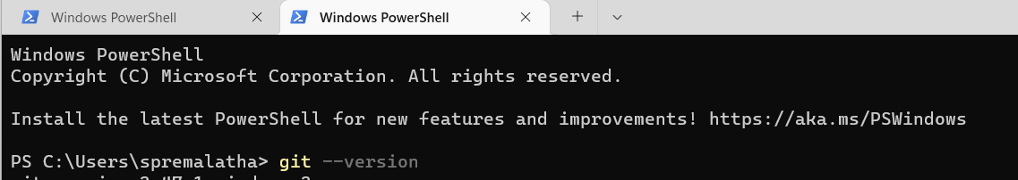

Create a account in Github

1. Go to GitHub website [GitHub](https://github.com/) and click on create an account

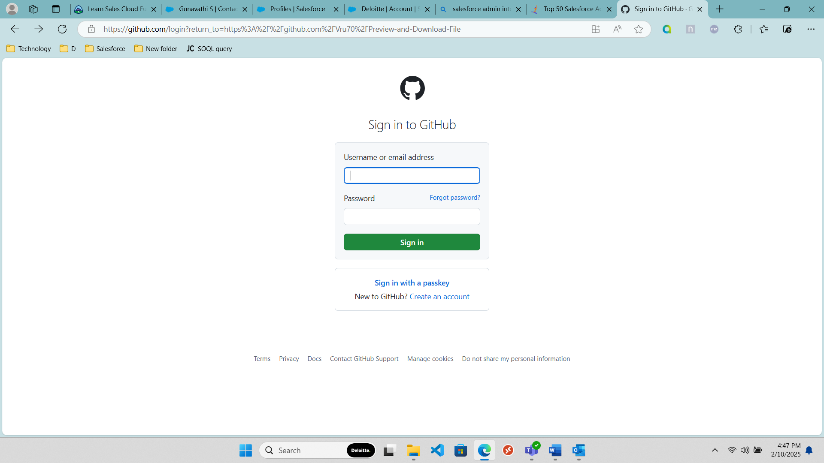

1. Enter details and click continue and Verify account with opt sent to mail.

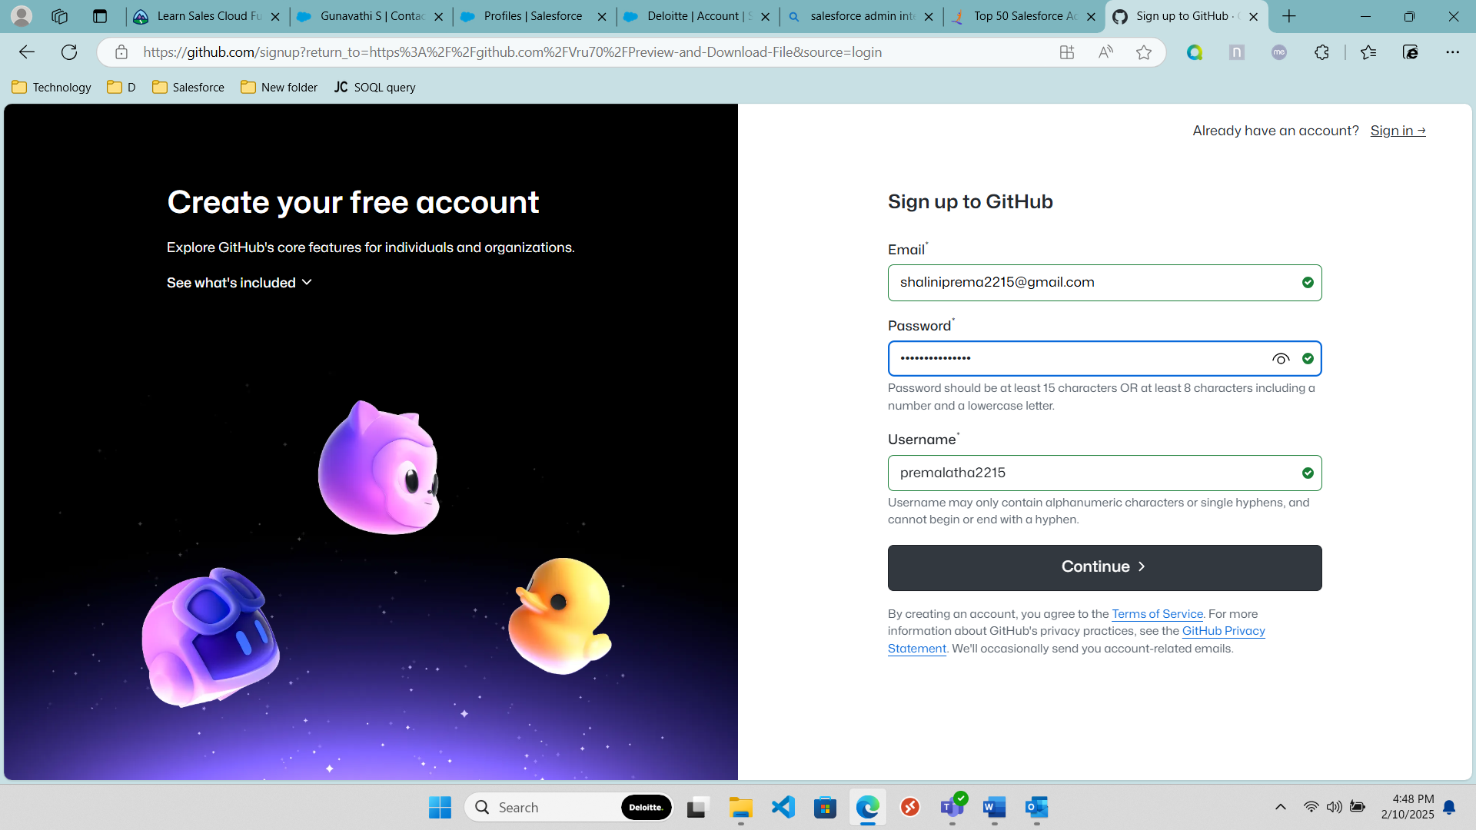

1. Sign in using the credential

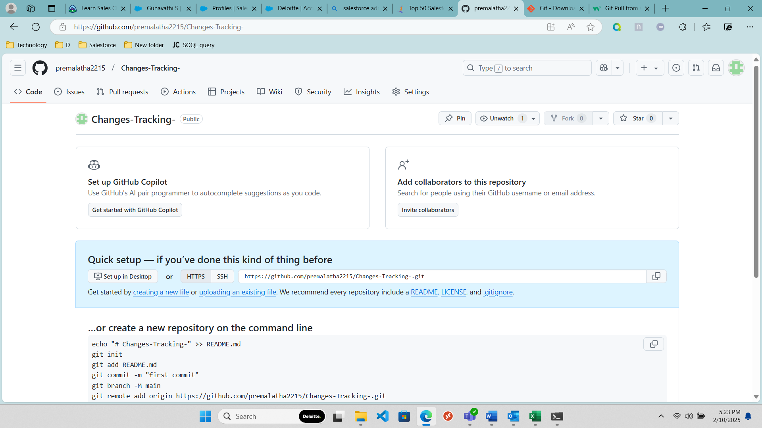

Creating Repository

1. Click the "+" in the top-right corner → New repository.

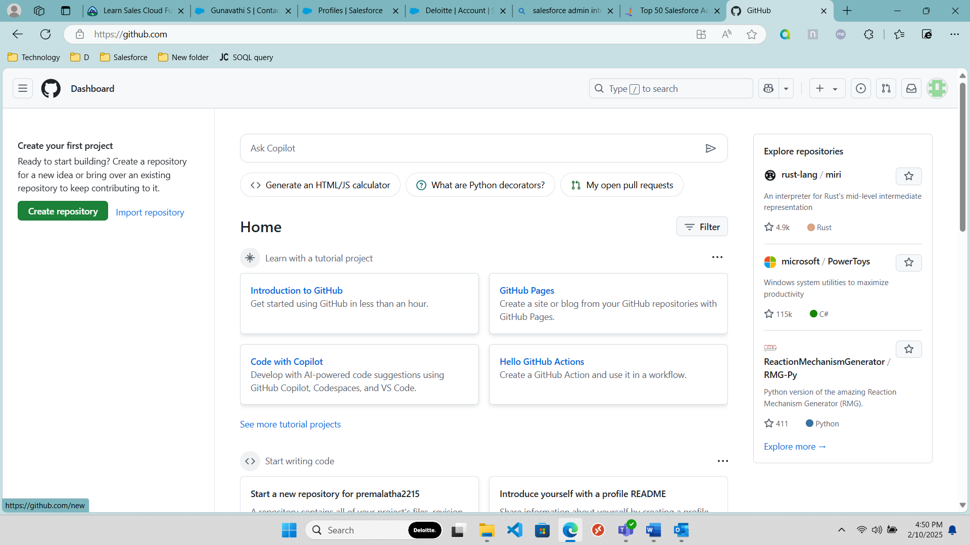

2. Name your repository (time-study or any name), Select Public or Private and create repository

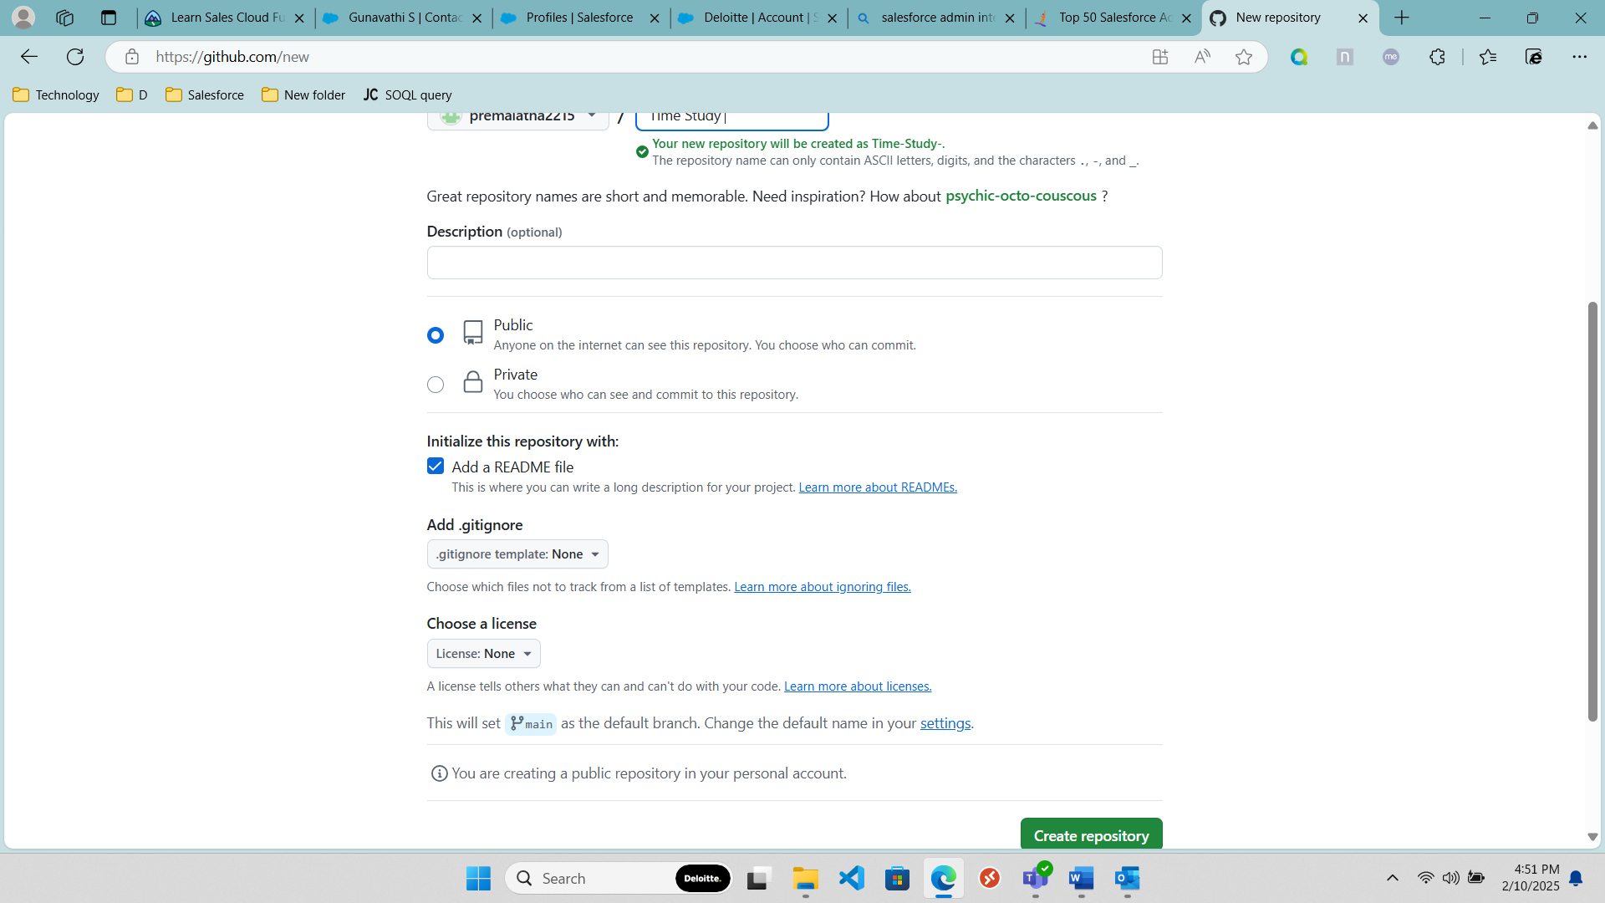

Setting Up a Local Repository

1. Create a folder on your local machine, then right click on it and select “open terminal”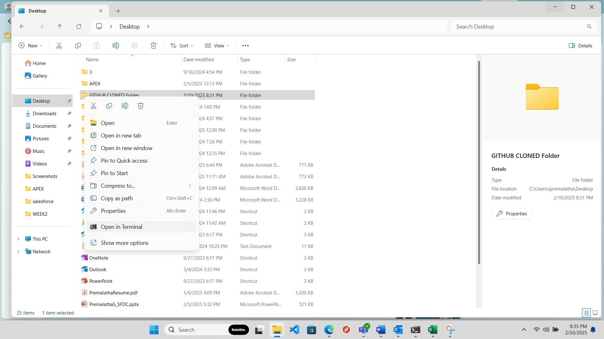
2. Go repository and copy the Repository url in quicksetup -<https://github.com/premalatha2215/Sample-Respository.git>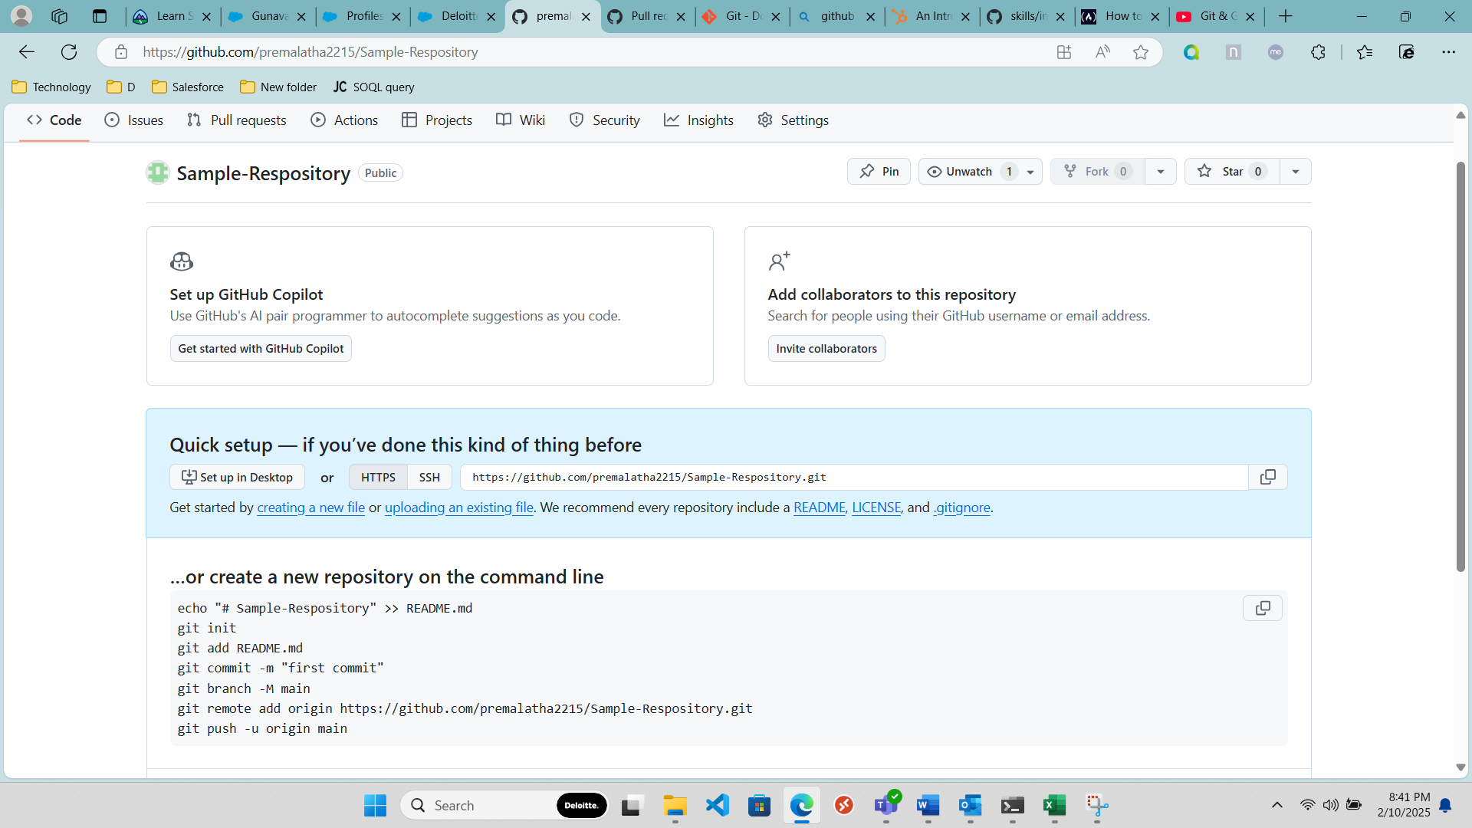
3. Configure it using the below Command in terminal

git config --global user.name "Your Name"

git config --global user.email [your-email@example.com](mailto:your-email@example.com)

Clone the Repository using the CMD- git clone repository url(paste the url copied in step 2)

git clone https://github.com/premalatha2215/Sample-Respository.git

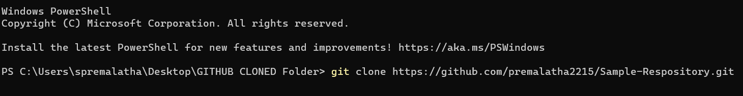

1. Go to folder and verify the sample repository is created or not . If it is created cloning is successfully completed(Don’t delete the folder (git) inside the sample repository that helps to connect the local to cloud repository)

“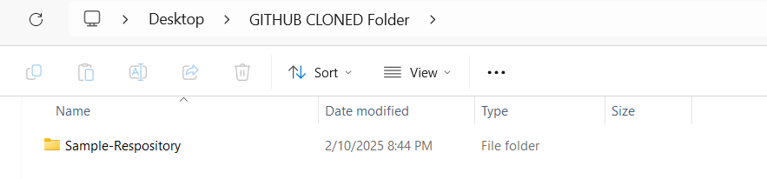

1. For staging use -git add 
2. For commit use the cmd – git commit

Get Converstional. commit to work on commit messages

Commit Trash is the unique number created while committing based on the Commit details

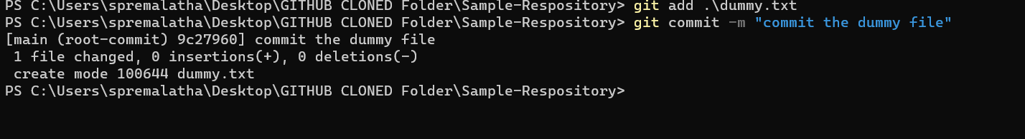

1. Push to cloud- Git push

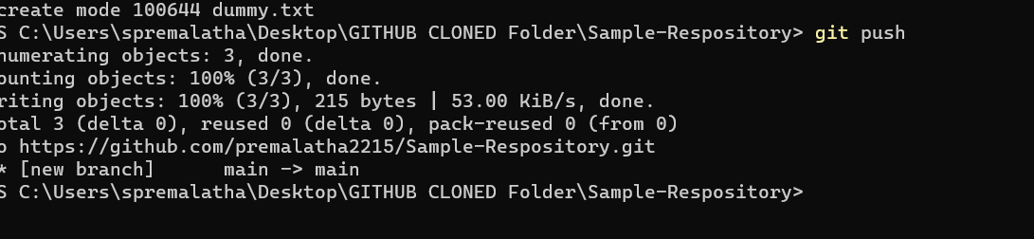

1. Retrieve the code from the cloud- git pull

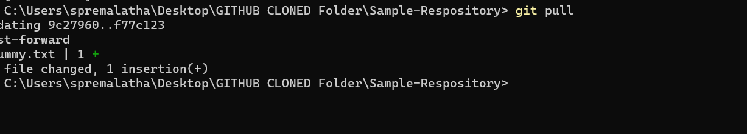

Fast forward is the merging technique to merge the changes of the other and try to retrieve with that changes

1. Git Status CMD – to check the status of the files in the folder

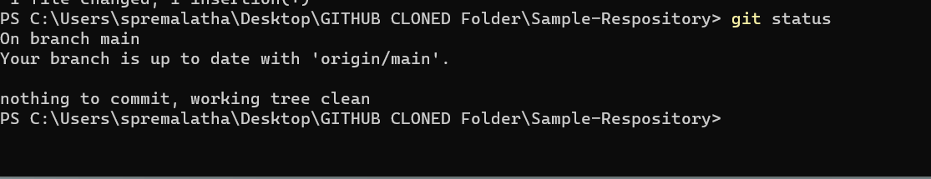

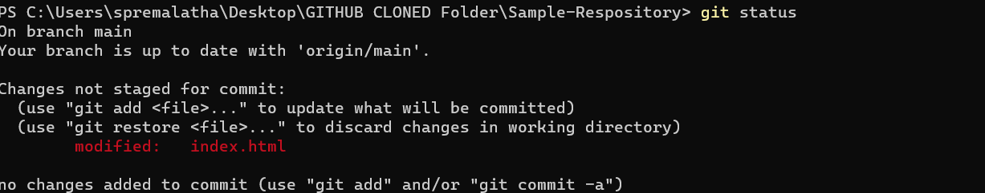

10.GIT DIFF CMD-will give u modified changes in the files

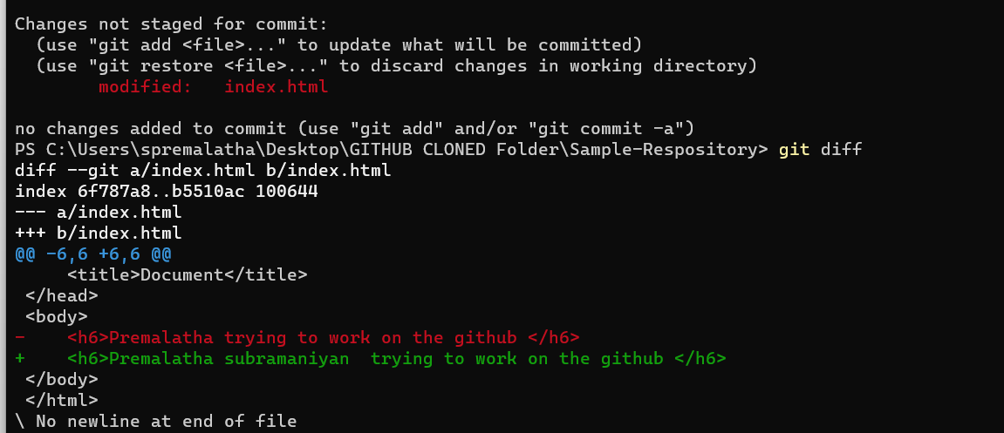

11.Git add . Cmd -every file in the folder will be stagged

12. Branching

Git branch cmd- will give u a current branch

Create a new branch(no spaces)

Git checkout -b “branchname”



To go back to main branch

Git checkout main

While pushing mention the branch name

Git push origin frontend

PULL REQUEST

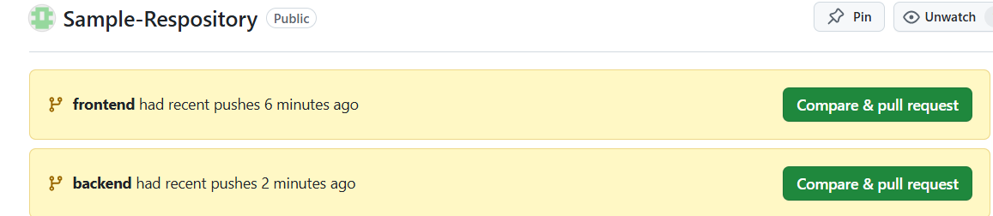

Merge Conflict: happen when u and other made changes to the same file then remove one changes and resolved

GIT STASH -like recycle bin

Git stash pop

How to change the branch name -M(rename)

Git branch -M newname

GIT branch -a(use to see the branches in the cloud)

Git log -used to see all the person commit(to exist use q word)

Readme.md is a file which is used to give description