**Kathmandu University**

School of Engineering

**Department of Electrical & Electronics Engineering**

**Industrial Internship Report**



*A fourth-year industrial internship report submitted in partial fulfilment of the requirement for the degree of Bachelor in Electrical and Electronics Engineering.*

**SUBMITTED** **BY**:

Premanand Pathak (019048)

**SUBMITTED TO:**

Asst. Professor Pramish Shrestha

Department of Electrical and Electronics Engineering

**June 2025**

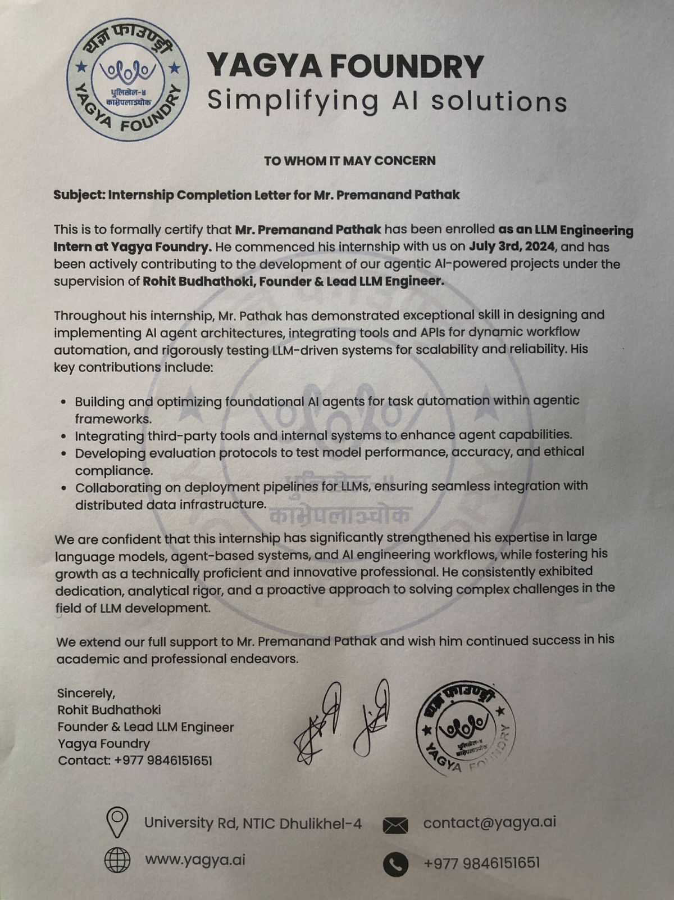

# ABSTRACT

This internship report documents the comprehensive learning experience and contributions during my internship at Yagya foundry ,from May 12, 2025, to June 05, 2025, I completed a 21-day educational industrial internship. This report highlights the technical skills acquired and the challenges encountered during the internship.

Mr Rohit Bhudhathoki, a team supervisor at Yagya foundry , supervised me during my internship. I got the opportunity to study about IOT based Project , Model creation and determining the working equipment.

# ACKNOWLEDGMENT

I would like to express my sincere gratitude to everyone who supported and guided me throughout my internship at Yagya foundry . I would particularly like to express my gratitude to the Department of Electrical and Electronics Engineering at Kathmandu University for setting up the Industrial Internship course and enabling us to participate in the internship. I would like to express my gratitude to the head of the department, Dr. Ram Kaji Budhathoki, for his continuous encouragement, advice, and guidance. Additionally, I would like to thank our Undergraduate Coordinator, Asst. Professor Pramish Shrestha, for his excellent suggestions, time, and assistance in keeping us on course.

Special thanks to my supervisors, especially Mr Rohit Bhudhathoki, team leader atYagya.ai, who had faith in me and allowed me to work as an intern. Being part of such a great team was an unforgettable experience.

**TABLE OF CONTENTS**

ABSTRACT III

ACKNOWLEDGMENT IV

List of Figures VI

List of Table VII

SYMBOLS AND ABBREVIATIONS VIII

Chapter 1: BACKGROUND AND INTRODUCTION 1

1.1. History 1

1.2. Vision 1

1.3. Mission 1

1.4. Goal 1

1.5. Ongoing projects of Kibot 2

CHAPTER 2: INTERNSHIP DETAILS 4

2.1. Internship Activities 4

2.1.1. Study of IoT Circuit Diagrams and Instructions 4

2.1.2. Component Verification and Quality Checks 4

2.1.3. Arduino Programming and Testing 5

2.1.4. Circuit Simulation and Debugging 5

2.1.5. Documentation and Reporting 5

2.2. Components and Techniques 6

2.2.1. Electronic Components 6

Two-Winding Transformer 6

2.2.2. Software and Communication Tools 9

CHAPTER 3: CONCLUSION 12

REFERENCES 13

Appendix 14

# List of Figures

**S.N Figures Page No.**

Figure 1:Smart Agriculture System 2

Figure 2: Lab View of STEAM Education 3

Figure 3:Circuit Testing For Inverter Automation 7

Figure 4:Arduino UNO board 8

Figure 5:NodeMCU ESP8266 board 9

Figure 6:Testing of Home Automation Setup 11

# List of Table

**S.N Figures Page No.**

Table 1: Summary of Task and Time Allocation 6

# SYMBOLS AND ABBREVIATIONS

**Symbol                   Full Form**

**IOT**                         Internet of Things

**V**                         Volts

**A**                         Ampere

**PCB**                       Printed Circuit Board

**MCU** Microcontroller Unit

# Chapter 1: BACKGROUND AND INTRODUCTION

## History

Yagya.ai was established in 2024 as a private company focused on advancing electronics, AI/ML and IoT-based solutions., the company specializes in the design, development, and manufacturing of innovative AI systems, including sensor-based circuits and IoT applications integrated with AI . Since its inception has aimed to provide cutting-edge solutions for industrial and consumer in area of Software AI/ML and leveraging modern technologies like microcontrollers and wireless communication modules. Over the years, Yagya.ai has grown to support various projects in the IoT domain, AI/ML, contributing to advancements in automation and smart systems.

## Vision

To become a nationally recognized leader in robotics, automation, AI/ML and technology-based education and solutions.

## Mission

To develop innovative and sustainable electronics and IT solutions that enhance productivity, learning, and human potential.

## Goal

To be at the forefront of providing engineering solutions.

* Promote robotics and AI education
* Provide reliable electronics products
* Encourage innovation and research.

## Ongoing projects of Yagya.ai

* **Smart Agriculture System:** yagya.ai is developing an IoT-based system for precision agriculture, integrating sensors to monitor soil moisture, temperature, and light intensity. The system uses NodeMCU modules to transmit data to farmers’ devices, enabling informed decisions to improve crop yield and resource efficiency.

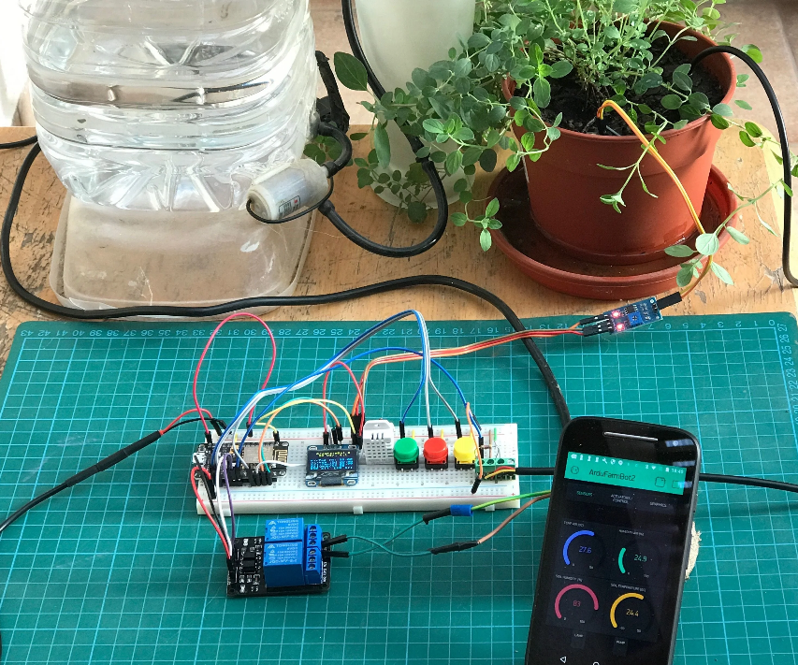

Fig 1**: Smart Agriculture System**

* **Environmental Monitoring Solution:** yagya.ai is working on a project to deploy IoT devices for real-time environmental monitoring, including air quality, temperature, and humidity tracking. This project uses sensors such as LDRs and temperature sensors to collect data, which is transmitted via Wi-Fi modules to cloud platforms for analysis and reporting.
* **STEAM Education:** Yagya.ai is actively working on a STEAM education project to promote hands-on learning in Science, Technology, Engineering, Arts, and Mathematics. This initiative involves developing interactive electronics kits and IoT-based learning modules for students, incorporating components like Arduino, NodeMCU, and sensors (e.g., IR, LDR, ultrasonic). The project aims to foster technical skills and innovation among young learners through practical workshops and training programs in collaboration with academic institutions.

Fig 2: Lab View of STEAM Education

# CHAPTER 2: INTERNSHIP DETAILS

During my 21-day internship at yagya.ai, from 12/05/2025 to 05/06/2025, I worked on AI -based project and sensor-based projects under the supervision of Rohit Bhudhathoki. The internship was structured into three weeks, with each week focusing on specific tasks to develop skills in AI , testing Model, Arduino programming, circuit simulation, and documentation. The following sections outline the key activities performed, organized into six topics to provide a comprehensive overview of my contributions and learning outcomes.



## Internship Activities

### Study of IoT Circuit Diagrams and Instructions

In the first week, I began by studying IoT-based circuit diagrams and written instructions to understand their structure and functionality. This involved analyzing schematics to identify connections between components such as resistors, sensors, and integrated circuits (ICs). The objective was to build a foundational understanding of how IoT systems are designed and how components interact within a circuit. I spent 5 hours reviewing diagrams and instructions, which helped me interpret technical schematics accurately. This task was critical for preparing me to assemble and test circuits in subsequent weeks.

### Component Verification and Quality Checks

Also in the first week, I performed manual quality checks on electronic components, including resistors, sensors, and ICs, to ensure they met operational standards. Using visual inspection and basic tools, I verified component values and functionality, spending 6 hours on this task. This process taught me the importance of component reliability in ensuring circuit performance. Accurate verification was essential before assembling circuits, as it minimized errors during setup and testing.

### Arduino Programming and Testing

Through all three weeks, I programmed Arduino microcontrollers to test circuit functionality and sensor outputs. In Week 1, I uploaded simple Arduino codes to verify basic circuit outputs (3 hours). In Week 2, I wrote codes for sensor-based projects to collect and display data (4 hours). In Week 3, I programmed a NodeMCU/ESP8266 module for a mini IoT project to enable data transmission and control (4 hours). Testing involved observing outputs on a serial monitor, which helped me confirm the accuracy of the circuits and sensors. This task improved my programming and troubleshooting skills.

### Circuit Simulation and Debugging

In the second and third weeks, I used Proteus software to simulate and verify circuit designs before physical assembly (4 hours in Week 2). I also debugged circuit errors, particularly for the ultrasonic sensor in Week 2 (5 hours) and the IoT project in Week 3 (3 hours). Debugging involves using a multimeter to check voltage and continuity and resolving issues like complex wiring or Wi-Fi module configuration, often with supervisor guidance. These tasks, totaling 12 hours, taught me how to identify and fix errors systematically, ensuring reliable circuit performance.

### Documentation and Reporting

Throughout the internship, I maintained detailed records of component usage and project progress in Excel sheets, which were submitted to my supervisor. In Week 1, I documented basic component details (3 hours). In Week 2, I recorded sensor project components (3 hours). In Week 3, I prepared a comprehensive report for the IoT project, including all components used (3 hours). Additionally, I spent 2 hours in Week 3 discussing project outcomes with my supervisor. This documentation, totaling 11 hours, emphasized the importance of clear and organized reporting in engineering projects.

**Table 1: Summary of Tasks and Time Allocation**

|  |  |  |  |
| --- | --- | --- | --- |
| **Topic** | **Description** | **Time (Hours)** | **Week** |
| 2.1.1 | Study of IoT circuit diagrams and instructions | 5 | Week 1 |
| 2.1.2 | Component verification and quality checks | 6 | Week 1 |
| 2.1.3 | Arduino programming and testing | 11 | Weeks 1, 2, 3 |
| 2.1.4 | Circuit simulation and debugging | 12 | Weeks 2, 3 |
| 2.1.5 | Documentation and reporting | 11 | Weeks 1, 2, 3 |

## Components and Techniques

The components and techniques used during the internship to design, assemble, test, and verify IoT and sensor-based systems. These tools and methods were critical to achieving the project objectives and ensuring reliable circuit performance.

### Electronic Components

#### Transformer

A transformer is a static electric machine which changes the level of voltage and current in the circuit without changing the power and supply frequency. The electrical transformer works on the principle of mutual inductance.

Based upon the number of windings used in the transformer, they can be grouped into two different categories:

* Two-winding transformer (or typical transformer or conventional transformer)
* Autotransformer

## Two-Winding Transformer

A two-winding transformer or conventional transformer is one which consists of two magnetically coupled windings (primary and secondary) which are electrically insulated and electrical transfers energy from one circuit to another at the same frequency but different voltage and current.

A Transformer can have multiple types of construction. Transformers do not have any electrical connection from one side to another; Still, the two electrically independent coils can conduct the electricity by electromagnetic flux. A transformer can have multiple coils or windings on the primary side as well as on the secondary side. In several cases, multiple primary sides, where two coils are connected in series, often called a center tapped. This center tapped condition can also be seen on the secondary side.

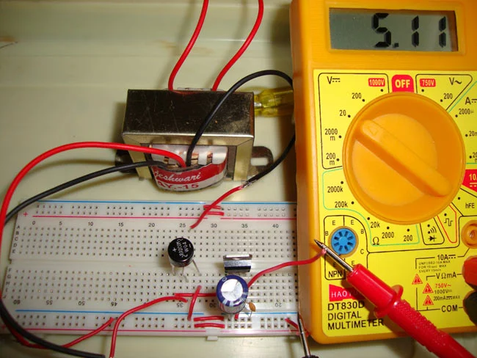

Fig 3: Circuit Testing for Inverter Automation

#### Arduino UNO

The Arduino UNO is a standard board of Arduino. Here UNO means 'one' in Italian. It was named as UNO to label the first release of Arduino Software. It was also the first USB board released by Arduino. It is considered as the powerful board used in various projects. Arduino.cc developed the Arduino UNO board.

Arduino UNO is based on an ATmega328P arduino. It is easy to use compared to other boards, such as the Arduino Mega board, etc. The board consists of digital and analog Input/Output pins (I/O), shields, and other circuits.

The Arduino UNO includes 6 analog pin inputs, 14 digital pins, a USB connector, a power jack, and an ICSP (In-Circuit Serial Programming) header. It is programmed based on IDE, which stands for Integrated Development Environment. It can run on both online and offline platforms. The IDE is common to all available boards of Arduino.

Figure 4: Arduino UNO board

#### NodeMCU ESP8266

The NodeMCU ESP8266 module enables microcontrollers to connect to 2.4 GHz Wi-Fi, using IEEE 802.11 bgn. It can be used with ESP-AT firmware to provide Wi-Fi connectivity to external host MCUs, or it can be used as a self-sufficient MCU by running an RTOS-based SDK. The module has a full TCP/IP stack and provides the ability for data processing, reads and controls of GPIOs.

There are several package types for the NodeMCU. The fundamental feature which is shared by all of the designs is ESP8266 core. Design based on the architecture has the same 30 pin configuration. Some designs have narrow footprints while some designs have wide footprints, which is an important thing to note. The two of the most popularly used NodeMCU models are Amica and LoLin. Amica is based on narrow pin spacing while LoLin is based on wider pin spacing and it also has a larger board. Since NodeMCU is open source, new variations and developments are being done constantly to its design.

Figure 5: NodeMCU ESP8266 board

### Software and Communication Tools

#### Node.js

A Node.js app runs in a single process, without creating a new thread for every request. Node.js provides a set of asynchronous I/O primitives in its standard library that prevent JavaScript code from blocking and generally, libraries in Node.js are written using non-blocking paradigms, making blocking behavior the exception rather than the norm.

When Node.js performs an I/O operation, like reading from the network, accessing a database or the filesystem, instead of blocking the thread and wasting CPU cycles waiting, Node.js will resume the operations when the response comes back.

This allows Node.js to handle thousands of concurrent connections with a single server without introducing the burden of managing thread concurrency, which could be a significant source of bugs.

#### MongoDB

MongoDB is an open-source NoSQL database management program. NoSQL (Not only SQL) is used as an alternative to traditional relational databases. NoSQL databases are quite useful for working with large sets of distributed data. MongoDB is a tool that can manage document-oriented information, store or retrieve information.

MongoDB is used for high-volume data storage, helping organizations store large amounts of data while still performing rapidly. Organizations also use MongoDB for its ad-hoc queries, indexing, load balancing, aggregation, server-side JavaScript execution and other features.

Structured Query Language (SQL) is a standardized programming language that is used to manage relational databases. SQL normalizes data as schemas and tables, and every table has a fixed structure.

Instead of using tables and rows as in relational databases, as a NoSQL database, the MongoDB architecture is made up of collections and documents. Documents are made up of Key-value pairs -- MongoDB's basic unit of data. Collections, the equivalent of SQL tables, contain document sets. MongoDB offers support for many programming languages, such as C, C++, C#, Go, Java, Python, Ruby and Swift.

#### Socket.io

Socket.IO is a JavaScript library that enables real-time, bidirectional communication between clients and servers. Built on top of WebSockets, it also includes fallback mechanisms like long polling to ensure consistent connectivity across various network conditions and browser environments. Socket.IO allows developers to emit and listen to custom events, making it especially useful for applications that require instant data updates, such as chat apps, live notifications, multiplayer games, and collaborative tools. It simplifies many of the challenges of managing real-time communication by handling connection retries, broadcasting messages to multiple clients, and organizing users into rooms or namespaces for more efficient communication. Its event-driven architecture and robust support for both client and server-side JavaScript make it a powerful tool for building dynamic, interactive web applications.

Fig 6: Testing of Home Automation Setup

# CHAPTER 3: CONCLUSION

During my internship at Yagya.ai . provided me with valuable hands-on experience in the field of AI/ML and electrical and electronics engineering, specifically in the design , assembly, and testing of IoT-based and sensor-based systems. Through tasks such as studying circuit diagrams, verifying components, assembling circuits, programming Arduino microcontrollers, simulating designs with Proteus software, and documenting project progress, I developed practical skills that are directly applicable to my academic and professional growth. The challenges faced, such as debugging complex wiring in the ultrasonic sensor circuit and configuring the Wi-Fi module for the IoT project, taught me the importance of perseverance and systematic problem-solving. Working with components like the NodeMCU, sensors, and ICs, and utilizing tools like multimeters and Proteus enhanced my technical proficiency and understanding of IoT systems. The internship also emphasized the significance of accurate documentation and collaboration with supervisors, which are essential for successful project execution. Overall, this experience has strengthened my ability to apply theoretical knowledge to real-world applications and prepared me for future challenges in electronics engineering.

# REFERENCES

1. Amol Hatwar, Chetan Shende, Anshika Kolhe, Mrs. Vedanti Hardas
2. Jen-Hao Teng, Chia-Hung Hsieh, Chia-Hung Hsieh, Bo-Ren Lan, Yun-Fang Li
3. [images (275×183) (gstatic.com)](https://encrypted-tbn0.gstatic.com/images?q=tbn:ANd9GcSHncQEj3qxnIjurKttVdUh1lsQyVyL187Qpw&s)
4. [nodemcu-pinout-functions.jpg (800×539) (make-it.ca)](https://www.make-it.ca/wp-content/uploads/2021/09/nodemcu-pinout-functions.jpg)
5. [upload.wikimedia.org/wikipedia/commons/d/d9/Node.js_logo.svg](https://upload.wikimedia.org/wikipedia/commons/d/d9/Node.js_logo.svg)
6. [mongodb.u2.jpg (750×1000) (redbubble.net)](https://ih1.redbubble.net/image.156314206.8326/bg,f8f8f8-flat,750x,075,f-pad,750x1000,f8f8f8.u2.jpg)

# Appendix