| 2026

IEEE Pune Section
IEEE Eu-Reka-2026
Inspire...Empower...Encourage...Engrave…!

A Technology Dissemination movement for Students….!
Organized By |  | Sponsoring IEEE Unit | Sponsored By
 |  | 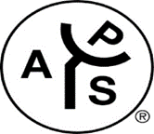 | 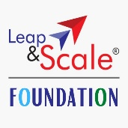 | 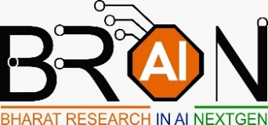
Supported By
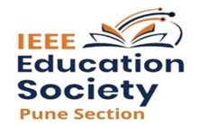 | 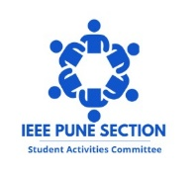 |  | 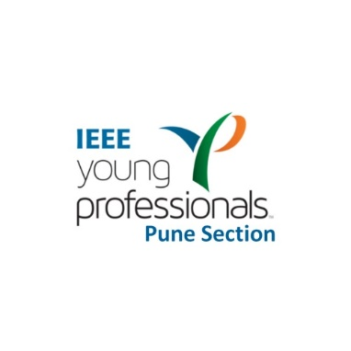  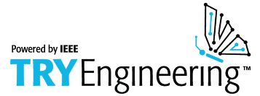
 |  | 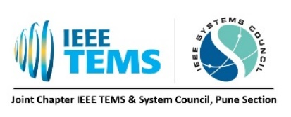 |  | 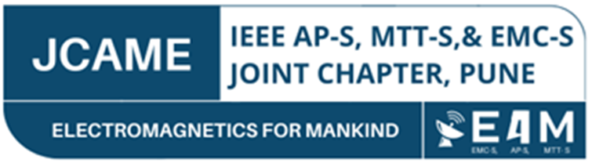

Index

Sr. No. | Particular |  | Page No.
1. | IEEE Eu-Reka: Why and What? |  | 3
2. | Aim |  | 4
3. | Objectives |  | 5
4. | Eu-Reka 2025: Timeline |  | 5
5. | Eu-Reka Rules and Regulations |  | 6
 | A. | Eligibility | 6
 | B. | Prerequisite | 6
 | C. | Disqualification Norms | 8
 | D. | Preparation before School Visit and Interaction | 8
 | E. | During School Visit and Interaction | 9
 | F. | After School Visit and Interaction | 9
6. | Assessment Process: |  | 10
 | A. | Round-1 (Elimination Round): Super-30 | 10
 | B. | Round 2 (Selection Round): Finalists (Top-15) | 11
 | C. | Round 3: Final Presentation | 12
7. | Outreach |  | 12

- IEEE Eu-Reka: Why and What?

India is all set to become the world's third-largest economy surpassing many other developed countries. IEEE believes that Science and Technology is the fuel, and education the driver for this economic growth. IEEE EU-REKA is the initiative taken up by IEEE Pune Section as part of the national exercise to meet this goal.

IEEE EU-REKA proposes to achieve this goal through the joint involvement of many IEEE sections, volunteers, experts and mentors from Industry and Academia, Educational Institutions, and children from rural and urban high schools. The program follows a framework enabling colleges, companies, and communities to infuse curiosity, creativity, and self confidence in school children – by exposing them to advanced state of the art technologies and mentoring them in making informed decisions about their future education path.

IEEE EU-REKA is in alignment with the Nation’s Educational policy by following practices encompassing Diversity, Equity, and Inclusion (D, E &I) in the country --- breaking the gender barrier, and shrinking the rural/Urban division. This initiative has won acclaims from eminent personalities like - Dr Kasturirangan, Chief Architect of National Education Policy, Dr Sahasrabudhe, Former Chairman, All India Council of Technical Education, Mr Deepak Mathur, Vice-President - MGA-2025, Prof. Saifur Rahaman, President & CEO-IEEE 2023 and many more.

IEEE Eu-Reka plans to meet the following educational needs for the nation:

- Inclusivity: In India, rural literacy currently stands at around 73.5% (cite source: National Statistical Office, 2023). While this represents progress, it still lags the global average literacy rate of approximately 86% (cite source: UNESCO Institute for Statistics, most recent year available). There is a glaring gap of 14.2% between urban and rural literacy in India. This highlights the continued need for targeted interventions to improve literacy rates in rural areas for achieving inclusive growth and overall development.

- Equity: While precise current all-India dropout rates for girls in secondary education are evolving, older data indicates a significant concern. A recent study estimated that around 17.3% of girls drop out by the time they reach Class X (cite: UDISE+ Data). This number is concerning, and contributing factors often include socio-economic pressures and persistent gender inequalities that can affect girls' confidence and aspirations. To combat this, initiatives like EU-REKA aim to address these issues

As the Solution: As part of EU-REKA, teams of college students will go to Urban / rural high schools and conduct interactive programs related to a STEM/STEAM topics that can raise interest and curiosity among the school students’ community. Hence, EU-REKA promotes United Nations- 17 Sustainable Development Goals (UN- 17-SDG) as

- Goal 4: Quality Education - Ensure inclusive, equitable, and quality education for all, promoting lifelong learning opportunities.
- Goal 5: Gender Equality - Achieve gender equality and empower all women and girls.
- Goal 10: Reduced Inequalities - Reduce inequalities within and among countries to foster social, economic, and political inclusion.

- Aim
IEEE Eu-Reka is an Initiative to raise the level of literacy of STEM/STEAM through empowering and encouraging the ‘Young Generation’ as ‘Ambassadors of Education’.

This year IEEE EU-REKA would be focusing on the following themes:
- Technologies for Agriculture & Food Processing
- Technologies for Environment, Climate Change, Sustainability & Natural Disasters
- Technologies for Virtual Education in Science, Technology, Engineering, Art, and Mathematics
- Technologies for Rural & Urban Development
- Technologies for Health, Wellbeing & Sports
- Technologies for Women’s Welfare

- Objectives

Exposure: To motivate school children to take up higher studies in STEM/STEAM by giving a flavor of advanced state-of-the-art technologies.

Gender Equality: Promote gender equality by motivating & encouraging girls in high schools for higher education

Inclusiveness: Promote educational inclusiveness and bridge urban-rural literacy gaps in high schools

Reduce Drop-outs: Encourage high school children to pursue science & technology studies, thereby reducing drop-out rates

Knowledge Sharing: Facilitate college students' interactions with urban and rural high schools to share knowledge about advanced technologies
- Personality Development: To foster the growth of confidence, self-esteem, and aspiration levels among college students, enabling them to realize their full potential.
- Promote National Contribution: To cultivate a sense of responsibility and encourage college students to actively contribute to the nation’s growth, even while pursuing their academic journey

- Eu-Reka 2025 Timeline
Sr. No. | Activity | Start Date | End Date
1. | Registration | 01 April 2026 | 30 April 2026
2. | Initiate School Visit, Interaction, and Survey | The day team receives confirmation from the EU-REKA Team
3. | Completion of school visit, and Upload/Submission of Reports and Videos | 01 April 2026 | 10 July 2026
4. | Assessment Round-01 (Super 30) | 21 June 2026 | 05 August 2026
5. | Assessment Round-2 (Top-15) | 08 August 2026
6. | Result of Round 2 | 09 August 2026
7. | Assessment Round-3 (In-Person) | 29 August 2026
8. | Valedictory | 29 August 2026
9. | IEEE PuneCon 2026 Special Session | In December

- Eu-Reka Rules and Regulations
EU-REKA is an ethical and fair competition based on the following rules and regulations which shall be obligatory for all the participating teams:

A. Eligibility:
- Teams must have minimum 2 and maximum 4 participants.
- At least one team member must be an IEEE Student Member.
- There must be at least one female student in the team.
- A student can only participate in one team.
- Team members must be full-time students pursuing a bachelor’s degree in engineering/technology/BCA/BBA-CA/Science from a recognized institution.
- Each team must have a professional mentor.

B. Prerequisite:
- Identify a minimum of four schools (at least 2 urban and 2 rural) with students in 8th to 10th standards for technology dissemination.
- Develop a research problem based on one of this year's themes. You may refer to the examples provided below, but feel free to define your own problem statement:
- Technologies for Agriculture & Food Processing
Precision Agriculture for Sustainable Crop Management: Investigate the use of drone-based monitoring and IoT sensors to optimize water usage, pesticide application, and crop growth in precision farming, ensuring sustainability and reducing environmental impact.
AI and Machine Learning in Food Quality Control: Explore how artificial intelligence and machine learning algorithms can be implemented to monitor food quality, detect contamination, and enhance the shelf-life of processed foods through automated systems.
- Technologies for Environment, Climate Change, Sustainability & Natural Disasters
Smart Grid and Renewable Energy Integration: Research methods to integrate smart grid technologies with renewable energy sources, focusing on energy storage, grid stability, and real-time optimization to reduce carbon emissions and improve sustainability.
Disaster Prediction and Mitigation using Big Data: Investigate the application of big data analytics and AI to predict natural disasters such as floods, earthquakes, and hurricanes, and develop better early warning systems to mitigate the impact on communities.
- Technologies for Virtual Education in Science, Technology, Engineering, Art, and Mathematics
AI-Powered Personalized Learning Systems: Explore the development of AI-driven platforms that can adapt course material and learning styles in real-time based on student performance, fostering more personalized and effective learning experiences in STEM fields.
Augmented Reality (AR) for Immersive STEM Education: Investigate the application of AR in virtual classrooms to provide immersive, hands-on learning experiences in science, engineering, and mathematics, improving engagement and comprehension.
- Technologies for Rural & Urban Development
IoT-Enabled Smart City Solutions for Urban Sustainability: Research the use of IoT sensors and data analytics to improve urban infrastructure, such as waste management, energy efficiency, and traffic flow, contributing to more sustainable urban living.
Affordable Renewable Energy Solutions for Rural Areas: Investigate cost-effective solar or wind power systems that can be deployed in rural areas, providing a sustainable energy supply for farming, health facilities, and local communities.
- Technologies for Health, Wellbeing & Sports
Wearable Health Devices for Real-Time Monitoring: Explore the development of advanced wearable devices that can monitor vital signs such as heart rate, blood pressure, and glucose levels, enabling real-time health data analysis for better disease management.
AI in Sports Analytics and Injury Prevention: Research the use of AI to analyze athletes' performance, predict injuries, and optimize training regimens to enhance recovery and overall health outcomes in sports.
- Technologies for Women’s Welfare
Mobile Health Applications for Maternal Care: Investigate the development of mobile applications that provide real-time maternal health monitoring, guidance, and education to improve prenatal and postnatal care, especially in rural or underserved areas.
AI-Based Empowerment Platforms for Women Entrepreneurs: Explore AI-powered platforms that can support women entrepreneurs by providing tailored business advice, financial management tools, and access to a global marketplace, improving their chances of success in business.
- Write a paper proposing solution to the defined problem statement, following the IEEE Conference Format. The paper should be between 4 to 6 pages.
- Prepare educational material (PPTs, Handouts, Models, Videos etc.) highlighting the research process and research outcomes to be presented to the school children during the visits.
- Teams must have a mentor to help define the problem statement, write a paper and prepare the educational material. The mentor should be any expert from the team’s institution, local industry, or any expert in the locality.
- The mentor’s role is to guide and advise, but they should not be present during the school visits or interactions.

C. Disqualification Norms:
The team will be disqualified, if:
- There is no IEEE Student Member.
- There is no female student in the team.
- The team has less than 2 or more than 4 members.
- The team does not visit and interact with 4 schools (2 urban and 2 rural).
- The mentor participates in school visits or interactions.
- A team member is a graduate or part-time student in any of the listed bachelor’s degree programs.
- The high-school feedback is incomplete, unclear, or suspicious.

D. Preparation before School Visit and Interaction:
- Register for EU-REKA 2025 and get auto-confirmation.
- Schedule visits and interactive sessions at mutually convenient times with the school.
- Confirm the following checklist for the visit:
    - School Feedback Format which includes a digital feedback form (Google Form) and a hardcopy acknowledgment form.
    - Recording and photography facilities for sessions
    - Technology dissemination materials and equipment
    - Availability of ICT infrastructure
- The technology materials should include:
    - A common banner with the "IEEE Eu-Reka 2025 Empower, Encourage, Engrave" tagline (teams can design their own banner).
    - Digital materials like PPTs with a welcome page, thankyou page and interaction date.
    - Handouts, working model demonstrations and other innovative materials can be used.
- Start your visits and interactions with identified schools.

E. During School Visit and Interaction:
- The team will interact with students and ensure technology dissemination through various methods.
- Ensure good teamwork and coordination with the school.
- Collect school feedback in both digital form and a physical acknowledgment form, signed and sealed by the competent authority.

F. After School Visit and Interaction:
  - Create a 15–20-minute summary video of your visits, highlighting key findings of your research, snippets of the activities and interactions with respective school names.
  - Adding subtitle in the video will be an advantage for vernacular activities.
  - Upload:
- Link of video stored on your local drive or published on YouTube and making it visible to all
- School Feedback Acknowledgement
- A research paper on the defined problem statement
- PPT presented in the schools
- Duly filled and signed IEEE Release form

- Assessment Process
The evaluation of submissions will be conducted by a distinguished panel of juries, who will assess each entry based on a set of predefined criteria. Each jury member will receive unique login credentials, granting them access to the team’s recordings, reports, feedback, presentation slides, and release forms. Team submissions will undergo a thorough evaluation process across three distinct rounds, as outlined below:

A. Round-1(Elimination Round): Super-30:
- Details of the evaluation scheme is as follows:
Sr. No. | Parameter | Points
1 | Quality of Research Paper, Relevance of Problem Statement, and Impact of the Suggested Solution | 40 Points
2 | Alignment of the topic with Aim and Objectives of Eu-Reka | 10 Points
3 | Use of Pedagogical tools (such as Videos / Models / Demo/ PPT/ DIY etc.) | 10 Points
4 | Use of IEEE educational resources (such as Try Engineering /Learning Network/Data port etc.) | 10 Points
5 | Other points covered in the session (Scope for follow-up / Benefits for rural areas/Women empowerment / Benefits to differently abled etc.) | 10 Points
Total (A) |  | 80 Points
6 | School Feedback
a | School Feedback-01 | 5 Points
b | School Feedback-02 | 5 Points
c | School Feedback-03 | 5 Points
d | School Feedback-04 | 5 Points
Total (B) |  | 20 Points
Grand Total (A+B) |  | 100 Points

- Following the Jury's evaluation, the Super-30 teams will be selected from all initial submissions. An email will be sent to the team leader of each selected team.

B. Round 2(Selection Round): Finalists (Top-15)
- Super-30 teams shall be assessed by a Jury member.
- This round will be a presentation round via virtual mode.
- Details of the evaluation scheme is as follows:
Sr. No. | Parameter | Points
1 | Innovation and Creativity in Research Work  Clarity and Structure of the Presentation | 30 Points
2 | Alignment of the topic with Aim and Objectives of Eu-Reka | 10 Points
3 | Visual Aids and Presentation Tools  Relevance and Depth of Content in Presentation  Use of Pedagogical tools (such as Videos / Models / Demo/ PPT/ DIY etc.) | 10 Points
4 | Engagement and Communication Skills  Time Management | 10 Points
5 | Use of IEEE educational resources (such as Try Engineering /Learning Network/Data port etc.)  Use of Data and Supporting Evidence | 10 Points
6 | Response to Questions and Interaction  Professionalism and Overall Presentation | 10 Points
7 | Score of Round 1 reduced to scale of 20  (For Example: If the score of round is 75/100, then it shall be considered as 15/20 in this round) | 20 Points
Total |  | 100 Points

- After Round 2 Evaluation, 15 Finalists will be selected from the Super-30 Teams. An email will be sent to the team leader of each selected team.

C. Round 3: Final Presentation
- It is mandatory for Top-15 teams to physically participate in the final round of Eu-Reka at Pune.
- The time slot for each team to present their idea and experience is as follows:
Sr. No. | Presentation Activity | Time
1 | Idea and Experience Presentation | 07 Mins
2 | Question and Answer | 03 Mins
Total |  | 10 Mins
- Teams shall deliver their work in front of Jury members, and IEEE Pune Section Members.
- EU-REKA Winners shall get the following prizes in various categories:
Sr. No. | Category | Prize (in ₹) | Accompanied with
1 | Winner | 25,000/- | Trophy, and Certificates for each member
2 | 1st Runner Up | 20,000/- | Trophy, and Certificates for each member
3 | 2nd Runner Up | 15,000/- | Trophy, and Certificates for each member
4 | Top 12 | NA | Medal, and Certificates for each member
5 | Super 30 | NA | Certificate of Appreciation
6 | Participating Schools (on request) | NA | Certificate of Valuable Contribution
7 | The Best Ambassadors (3) | NA | Certificate of Appreciation

D. Miscellaneous:
- It is expected that the shortlisted team shall make their own travel and accommodation arrangement. They can reach out to their respective section for support.
- The snacks/lunch/dinner shall be arranged at the venue

- Outreach
  - Ambassadors will be appointed to raise awareness about IEEE EU-REKA and assist in team registrations, ensuring smooth participation for all.
  - A nationwide awareness campaign will be launched through digital platforms, including social media (Instagram, Twitter, LinkedIn, YouTube) and email newsletters, to highlight the event’s educational benefits and success stories.
  - The official website, eu-reka.org, will serve as a hub for event updates, goals, and school visit details, while participants will be encouraged to share their experiences using specific event hashtags and social media challenges.
  - Outreach efforts will include targeted email invitations to schools, regular updates to stakeholders, and local media engagement, alongside partnerships with local tech organizations to boost event visibility.
  - The event’s impact will be measured using pre-and post-event surveys, engagement metrics, and follow-up assessments to gauge the influence on students' interest in STEM careers and tech education. For registration, visit the submission platform at eu-reka.in.

- Conflict of Interest (CoI) Guidelines

- Team Mentors associated with participating teams are not permitted to serve as jury members at any stage of the evaluation process.

- IEEE Eu-Reka Ambassadors are allowed to participate as team members, provided their role does not grant them access to confidential evaluation or decision-making processes.

- Volunteers or organizing members involved in the execution and management of IEEE Eu-Reka are not eligible to participate in the competition to prevent any potential conflict of interest.

