Toward Price-Transmission-Aware Decision Support for Corn Belt Farmers: An Empirical Diagnosis
Mayanglambam Premananda Singh
National Institute of Electronics & Information Technology
premanan.mayang@proton.me

Abstract—Farmers and elevators in non-hub Corn Belt states cannot easily tell whether a price move in a dominant hub market such as Iowa is a signal worth acting on, or whether a current gap between their local price and the hub price will close. Treating the wrong one as true — ignoring a real signal, or assuming a gap will revert when it will not — is a real financial mistake. This is an information gap, not a missing app: any decision-support advisory built to close it would first need to know, for a given market pair, which of these two judgments can be made safely. This paper reports that empirical diagnosis. Using 137 months (2015–2026) of USDA NASS price-received data for Iowa, Ohio, and Nebraska, we show that Iowa leads both Ohio and Nebraska with no detectable monthly lag (k*=0, ρ up to 0.92) and Granger-predicts their returns 8–12 months ahead — so the ‘is this signal worth acting on’ judgment can be made safely and generally. But a stable long-run price relationship, the basis an advisory would need to promise reversion, holds only for the same-transport-corridor Iowa–Nebraska pair (cointegration p=0.008) and not for Iowa–Ohio (p=0.15, unstable across rolling windows). We conclude that the second judgment cannot be made safely without knowing a pair's corridor alignment, and we scope — without building — the minimal interface a future advisory would need to communicate that distinction honestly.
Index Terms—price transmission, decision support, cointegration, Granger causality, agricultural markets, corn markets
I. INTRODUCTION
Farmers and elevators in non-hub Corn Belt states cannot easily tell whether a price move in a dominant hub market such as Iowa is a signal worth acting on, or whether a current gap between their local price and the hub price will close. Treating the wrong one as true — ignoring a real signal, or assuming a gap will revert when it will not — is a real financial mistake. This is an information gap, not a missing app: existing market-information services report current prices, but few make the underlying transmission properties — how fast a signal travels, in which direction, and whether the long-run relationship is stable — visible to the farmer at all.
This paper does not propose or build a deployed system. It reports the empirical diagnosis that any future price-transmission-aware advisory would need before it could safely answer the two questions above for a given market pair, and it uses an explicit contrast between two real state pairs to show that the second question — will the gap close — cannot be answered the same way everywhere.
Our contributions are: (1) a decomposition of ‘is this hub-market signal worth acting on’ and ‘will this price gap close’ into two separate, separately-testable judgments, rather than one price forecast; (2) an empirical analysis of Iowa–Ohio and Iowa–Nebraska corn prices (2015–2026), validated on a held-out period, showing the first judgment can be made safely and generally while the second cannot; and (3) a scoped, explicitly-not-yet-built description of the minimal interface a future advisory would need to communicate that distinction honestly, left as future work.
II. RELATED WORK
The theoretical basis for price-transmission analysis is the Law of One Price, under which arbitrage should eliminate persistent cross-market price differentials in the long run even as short-run rigidities persist [1]. Fackler and Goodwin's survey distinguishes testing transmission speed from testing long-run equilibrium, noting the two need not coincide [2]; a more recent review confirms this remains an open, context-specific empirical question in agricultural markets [7].
On the systems side, several institutional tools already convert agricultural price signals into warnings. FAO's Global Information and Early Warning System on Food and Agriculture (GIEWS) monitors cereal markets and issues an Indicator of Price Anomalies based on compound growth rates [8], [9]. The Food Security Portal's Excessive Food Price Volatility Early Warning System flags periods of abnormal price variability against a statistical threshold [10]. Recent work has also applied attention-based deep learning to multi-commodity price forecasting and anomaly detection for small agricultural enterprises [11]. Separately, Jensen's study of South Indian fisheries showed that farmer and fisher access to market-price information via mobile phones measurably reduced price dispersion and improved welfare [12] — direct evidence that transmission-relevant information, delivered to the right audience, changes outcomes.
None of these tools separate a short-run synchronization judgment from a long-run equilibrium judgment, and none condition their confidence on whether the underlying market pair is known to share a transport corridor. The diagnosis in Sections IV–V is aimed at closing that specific gap, as a prerequisite for any future advisory rather than as a system in itself.
III. WHAT A PRICE-TRANSMISSION-AWARE ADVISORY WOULD NEED TO KNOW
Any future advisory aimed at this information gap would need to answer two separate questions for a given hub–local market pair, and would need to get the separation between them right rather than collapsing them into a single forecast.
The first question is whether a hub-market move is worth acting on at all — whether it reaches the local market quickly and whether the hub's price history carries predictive content the local market's own history does not. This is answerable from the short-run diagnostics in Section IV: a near-zero optimal lag with a tight confidence interval, and a significant, non-reversed Granger relationship.
The second question is whether a currently observed price gap between the two markets will close. This is answerable, in principle, from the long-run diagnostics in Section IV: a stable cointegrating relationship implies the gap should mean-revert; an unstable or absent one means it may simply drift. Section V shows these two questions do not have the same answer across market pairs (Fig. 1) — which is precisely why no single, corridor-agnostic rule for the second question would be honest to give a farmer, whatever form a future interface for it might take.

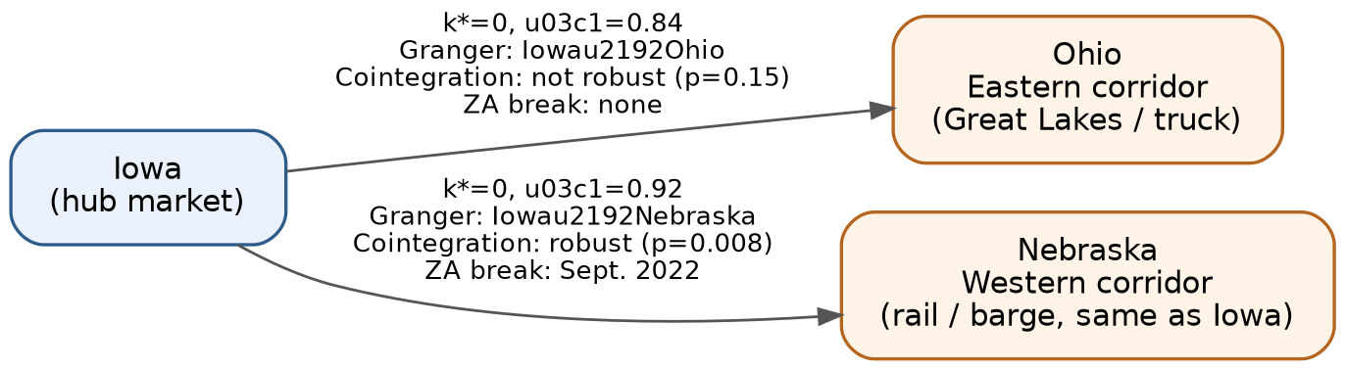
Fig. 1. Iowa's short-run leadership extends to both neighboring states, but a stable long-run equilibrium appears only for the same-corridor Iowa–Nebraska pair — the reason the second judgment below cannot be answered the same way for every market pair.

IV. ANALYTICAL ENGINE: DATA AND METHODS
A. Data
Monthly ‘Price Received’ corn series (dollars per bushel) for Iowa, Ohio, and Nebraska were obtained from the USDA NASS QuickStats API [13], covering January 2015 to May 2026 (137 months, no gaps, verified via NASS's get_counts endpoint prior to analysis). Iowa is treated as the hub market on the basis of its production share and its status as a reference-price market; Ohio is a Corn Belt state on a distinct (eastern, Great Lakes/truck) transport corridor, while Nebraska shares Iowa's western rail/barge corridor and export orientation.
B. Methods
Augmented Dickey-Fuller tests confirmed price levels are non-stationary (I(1)) while month-over-month returns are stationary, so returns feed the short-run tests and levels feed the long-run tests. Time-lagged cross-correlation (±12-month window, 1,000-resample bootstrap CI on the optimal lag k*) and Granger causality (both directions, lags 1–12, VAR(k) specification) constitute the short-run module. Engle-Granger two-step cointegration — both full-period and a rolling 60-month specification — and a Zivot-Andrews endogenous structural break test on the price spread constitute the long-run module.
All estimates were validated by re-running the full pipeline on a January 2015–December 2023 training split and comparing against full-period (through May 2026) results; the 2024–2026 window is too short to support an independent ±12-month TLCC, so this is a stability check on parameter estimates rather than an out-of-sample forecast test.
V. RESULTS
Iowa and Ohio (and separately, Iowa and Nebraska) corn returns synchronize with no detectable monthly lag: k*=0 with a bootstrap 95% CI of exactly [0,0] in both pairs, and peak correlation of ρ=0.84 (Iowa–Ohio) and ρ=0.92 (Iowa–Nebraska). Iowa Granger-causes Ohio at lags 1–8 (min p=0.0089) and Nebraska at all 12 tested lags (min p<0.001); the reverse direction is not supported in either pair. Both results are stable across the train/full-period split, so the first judgment — is a hub-market move worth acting on — can be made safely and consistently across market pairs.
The long-run picture diverges sharply by pair. The full-period Engle-Granger test finds no cointegration for Iowa–Ohio (p=0.1545); a rolling 60-month version finds significance in only 20 of 78 windows (26%), flickering across the 5% threshold rather than reflecting a stable regime (Fig. 2), and a Zivot-Andrews test on the spread finds no structural break (p=0.82). Iowa–Nebraska, by contrast, is robustly cointegrated (p=0.0082, stable across the backtest split) and exhibits a significant structural break in September 2022 (p<0.001) — evidence of a shift within an already mean-reverting relationship, not a transition into one. Table I summarizes this contrast.

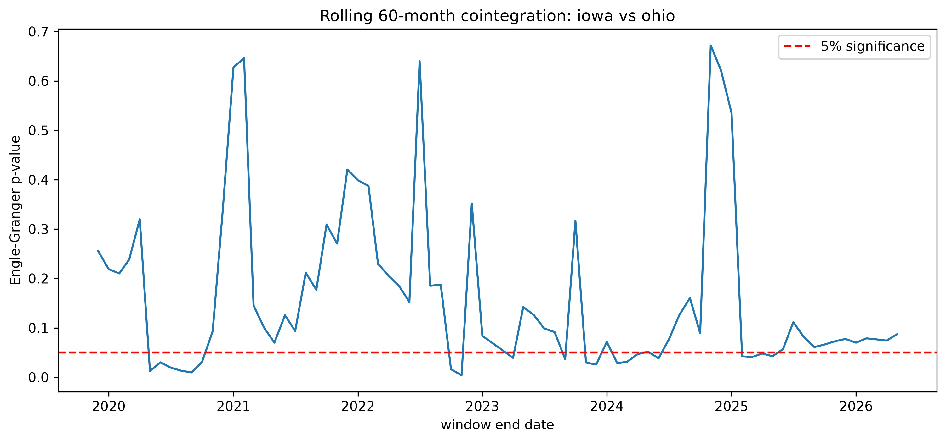
Fig. 2. Rolling 60-month Engle-Granger cointegration p-values, Iowa vs. Ohio. The series crosses the 5% threshold repeatedly rather than settling into stable regimes — the empirical basis for treating the gap-closure judgment as corridor-conditional, not universal.
Table I. Short-run vs. long-run contrast, Iowa–Ohio and Iowa–Nebraska.
Metric | Iowa–Ohio | Iowa–Nebraska
k* / peak ρ | 0 / 0.840 | 0 / 0.918
Iowa→ Granger sig. lags | 1–8 | 1–12
Cointegration p (full) | 0.1545 | 0.0082
Stable across backtest? | No | Yes
ZA structural break | None (p=0.82) | Sept. 2022 (p<0.001)

VI. IMPLICATIONS FOR A FUTURE ADVISORY
This contrast has a direct consequence for anyone designing such an advisory later: it cannot give a single, corridor-agnostic answer to ‘will this gap close.’ For same-corridor pairs like Iowa–Nebraska, where cointegration is robust and stable, a confident reversion message is empirically supported. For cross-corridor pairs like Iowa–Ohio, where the rolling test flickers across significance and no structural break is detectable, the same confident message would be actively misleading — the honest answer is that the gap may simply drift, and any future interface would need to communicate that uncertainty rather than suppress it.
Practically, this means a future advisory would need some way of knowing — or estimating — whether a given market pair shares a transport corridor before it answers the second question at all. The first question, by contrast, needed no such qualification: both short-run diagnostics replicated cleanly across both pairs, suggesting it generalizes across corridor structure in a way the second question does not. We leave the design of that corridor-awareness check, and of any user-facing interface built on top of these diagnostics, to future work (Section VII).
VII. CONCLUSION AND FUTURE WORK
We reported the empirical diagnosis a future price-transmission-aware advisory would need before it could safely tell a Corn Belt farmer whether a hub-market signal is worth acting on, and whether a current price gap will close. Iowa leads both Ohio and Nebraska with no detectable monthly lag, so the first judgment travels well across market pairs. The second does not: a stable long-run equilibrium holds only for the same-corridor Iowa–Nebraska pair, so any future advisory would need to know a pair's corridor alignment before answering it.
Immediate next steps require no new data source: Illinois, Minnesota, and Wisconsin are already verified in NASS with the same complete 137-month corn series, so extending both diagnostics to these pairs — and to soybeans on the same states — is a same-pipeline rerun that would let us test the corridor hypothesis with more than one example on each side. We have not yet built any user-facing interface; the natural next step is a minimal one — a query that returns the two judgments above in plain language for a chosen market pair — built on top of the existing, already-working analytical pipeline, and tested with farmers and extension officers during the school and community visits this project already involves. Longer term, daily USDA AMS cash price data would let the short-run diagnostic resolve transmission lags below one month.
REFERENCES
[1] M. Ravallion, "Testing market integration," American Journal of Agricultural Economics, vol. 68, no. 1, pp. 102–109, 1986.
[2] P. L. Fackler and B. K. Goodwin, "Spatial price analysis," in Handbook of Agricultural Economics, vol. 1, B. L. Gardner and G. C. Rausser, Eds. Elsevier, 2001, pp. 971–1024.
[3] Iowa Farm Bureau Federation, "Ethanol industry in Iowa and the U.S.," 2023. [Online]. Available: iowafarmbureau.com/Article/Ethanol-Industry-in-Iowa-and-the-US
[4] E. Zivot and D. W. K. Andrews, "Further evidence on the great crash, the oil-price shock, and the unit-root hypothesis," Journal of Business & Economic Statistics, vol. 10, no. 3, pp. 251–270, 1992.
[5] Iowa Farm Bureau Federation, "Tight supplies caused unusual basis levels in 2021 and 2022," Sept. 2022. [Online]. Available: iowafarmbureau.com/Article/Tight-Supplies-Caused-Unusual-Basis-Levels-in-2021-and-2022
[6] USDA National Agricultural Statistics Service, "QuickStats API," 2026. [Online]. Available: quickstats.nass.usda.gov/api
[7] S. von Cramon-Taubadel and B. K. Goodwin, "Price transmission in agricultural markets," Annual Review of Resource Economics, vol. 13, pp. 65–84, 2021.
[8] Food and Agriculture Organization of the United Nations, "Global Information and Early Warning System on Food and Agriculture (GIEWS)." [Online]. Available: openknowledge.fao.org
[9] Food and Agriculture Organization of the United Nations, GIEWS Food Price Monitoring and Analysis, "Developing a price warning indicator as an early warning tool — a compound growth approach." [Online]. Available: fao.org/giews/food-prices
[10] IFPRI Food Security Portal, "Excessive Food Price Volatility Early Warning System." [Online]. Available: foodsecurityportal.org/tools/excessive-food-price-variability-early-warning-system
[11] E. Sediyono, K. D. Hartomo, C. Arthur, I. Utami, R. Prabowo, and R. Chiong, "An integrated framework for multi-commodity agricultural price forecasting and anomaly detection using attention-boosted models," Journal of Agriculture and Food Research, art. 102021, 2025.
[12] R. Jensen, "The digital provide: information (technology), market performance, and welfare in the South Indian fisheries sector," Quarterly Journal of Economics, vol. 122, no. 3, pp. 879–924, 2007.
[13] M. Ahmed and N. Singla, "Spatial market integration, price transmission and transaction costs in major onion markets of India," Margin: The Journal of Applied Economic Research, 2023, doi: 10.1177/00194662231159851.

