Short-Run Synchronization Without Long-Run Equilibrium:
Price Transmission and Cointegration in U.S. Corn Belt Markets, 2015–2026
National Institute of Electronics & Information Technology
Mayanglambam Premananda Singh
email: premanan.mayang@proton.me
July 2026
Data: USDA NASS QuickStats. Code: https://github.com/premananda-cloud/price_latency

Abstract
This paper examines price transmission dynamics between Iowa and Ohio corn markets using monthly price-received data from the USDA National Agricultural Statistics Service (NASS) spanning January 2015 to May 2026 (137 months). Employing time-lagged cross-correlation (TLCC), Granger causality testing, Engle-Granger cointegration analysis, and a Zivot-Andrews structural break test, we find that the two markets exhibit strong same-month price synchronization (k* = 0, ρ = 0.84, bootstrap 95% CI [0, 0]) with an asymmetric Granger causality structure in which Iowa's price history significantly predicts Ohio's returns at lags 1–8 months, while the reverse direction is not supported. These short-run findings are stable across a train/holdout validation split. However, Iowa and Ohio do not exhibit a robust long-run equilibrium relationship: rolling 60-month cointegration tests find significance in only 26% of windows (20/78), with results flickering rather than reflecting stable regimes, and a Zivot-Andrews test detects no statistically significant structural break (p = 0.8224). A robustness comparison with the Iowa–Nebraska pair confirms the short-run synchronization and Granger asymmetry pattern, while Nebraska — a structural near-twin of Iowa on the same transport corridor — exhibits robust cointegration (p = 0.0082) and a significant structural break in September 2022 (p < 0.001). The contrast between pairs suggests that transport corridor alignment determines long-run equilibrium in U.S. Corn Belt markets, while short-run price leadership is a broader feature of Iowa's market position independent of corridor.
Keywords: spatial price transmission, Granger causality, cointegration, corn markets, USDA NASS, market efficiency

1. Introduction
A central question in agricultural economics is how quickly and completely price information moves between geographically separated commodity markets. Where markets are well integrated, a price shock at one location should appear rapidly at others; where they are segmented, shocks may propagate slowly or incompletely, creating persistent arbitrage opportunities and unequal welfare outcomes for producers and consumers in different regions. The speed and fidelity of price transmission is therefore both a measure of market efficiency and a diagnostic for infrastructure, institutional, and information frictions.
The U.S. Corn Belt offers an unusual empirical setting for this question. Iowa and its neighboring states are among the most productive agricultural regions in the world, and their corn markets are tightly linked to exchange-traded futures prices on the Chicago Mercantile Exchange (CME). At the same time, states within the Corn Belt are not structurally identical: they differ in their proximity to ethanol processing facilities, export terminals, and feed-demand centers, all of which generate local basis differentials — the gap between a state's cash price and the relevant futures price. Whether these basis differentials generate measurable inter-state transmission lags, and whether they imply a stable long-run equilibrium between state-level price series, are open empirical questions at monthly resolution.
This paper addresses those questions using monthly corn price-received data for Iowa and Ohio from January 2015 to May 2026, obtained from the USDA NASS QuickStats API. Iowa is the largest U.S. corn-producing state and is treated here as the hub or price-setting market; Ohio is a smaller producer on a geographically and logistically distinct transport corridor. We apply a systematic four-method empirical framework: time-lagged cross-correlation (TLCC) to detect the optimal transmission lag, Granger causality to test for directional information flow, Engle-Granger cointegration to assess long-run equilibrium, and a Zivot-Andrews structural break test to detect discrete changes in the spread relationship. We validate all findings against a held-out 2024–2026 period not used in model development, and confirm robustness using a second state pair (Iowa–Nebraska).
Our results reveal a combination that is not commonly emphasized in the spatial price transmission literature: strong, stable short-run synchronization alongside the absence of a robust long-run cointegrating relationship. We document that this pattern differs systematically between state pairs that share a transport corridor (Iowa–Nebraska) and those that do not (Iowa–Ohio), providing evidence that corridor alignment is a key determinant of long-run price integration even when short-run dynamics are similar.

2. Literature Review
The theoretical foundation for spatial price transmission analysis is the Law of One Price (LOP), which holds that in competitive, integrated markets, identical goods should sell at the same price across locations after adjusting for transfer costs. Deviations from LOP are possible in the short run due to transactions costs, information delays, and transportation capacity constraints, but arbitrage should eliminate persistent differentials in the long run. Ravallion (1986) formalized these dynamics in a dynamic model separating short-run price rigidities from long-run integration, establishing the methodological framework on which much subsequent empirical work has built.
Fackler and Goodwin (2001) provide a comprehensive review of spatial price analysis methods, distinguishing between testing for price transmission speed (the question TLCC and Granger causality address) and testing for long-run equilibrium (the question cointegration addresses). They note that the two are related but distinct: markets can be tightly synchronized in the short run while failing to maintain a stable spread in the long run, particularly when local demand or supply conditions create time-varying basis differentials. This distinction is directly relevant to our findings.
Within the U.S. agricultural context, the structure of corn markets adds a layer of complexity beyond simple transfer costs. Iowa's corn market is heavily shaped by in-state ethanol processing demand: in recent years, approximately 50–70% of Iowa's corn production has been consumed by the state's ethanol industry, compared to roughly 35–40% nationally (Iowa Farm Bureau, 2023). This structural difference in local absorption rates creates a persistent basis differential between Iowa and more deficit-oriented states, and makes Iowa's cash price less purely tied to export-terminal or Chicago delivery dynamics than a simple surplus-export model would suggest.
The spatial transmission literature for U.S. commodity markets has generally found high levels of integration at the national level, with price shocks propagating across regions within days to weeks in daily cash price data. At the monthly frequency used here — the finest resolution available from USDA NASS QuickStats for price-received series — transmission occurring within a single month would appear as k* = 0 by construction. The relevant empirical question at monthly resolution therefore shifts from 'how fast' to 'how stable,' making cointegration analysis the more informative test for the data available.
On the question of structural breaks, Zivot and Andrews (1992) developed an endogenous break test allowing for a unit root under the null, which avoids the problem of pre-selecting a break date and inflating the test statistic. We apply their method to the spread series rather than price levels, following the logic that a break in the structural relationship between two markets should appear as a break in the spread, not necessarily in either individual series.

3. Data

3.1 Source and Series
Price data are from the USDA National Agricultural Statistics Service (NASS) QuickStats API (quickstats.nass.usda.gov/api). We use the monthly 'Price Received' series for corn at STATE aggregation level, for Iowa and Ohio, covering January 2015 through May 2026 (137 months). The NASS price-received series reports the average price received by farmers in dollars per bushel for the reference month, weighted by the volume of sales occurring in that month. It is not a futures price or a terminal-market quotation; it reflects the blend of pre-harvest forward contracts, harvest-time cash sales, and post-harvest storage-delivery sales occurring in each month.

3.2 Commodity and State Selection
Commodity and geography were not assumed but verified empirically before data collection. NASS's get_counts endpoint was queried across seven Corn Belt states (Iowa, Illinois, Indiana, Nebraska, Minnesota, Ohio, Wisconsin) and multiple commodities, confirming that corn and soybeans both yield 137 complete monthly price-received observations per state over 2015–2026 with no gaps. Fresh produce commodities, which motivated an earlier incarnation of this research design, are available only at annual frequency in NASS and cannot support a sub-annual transmission analysis. Corn was selected for its deeper spatial price literature and its status as the primary product of both target states.
Iowa was designated the hub market on the basis of its position as the largest U.S. corn producer and its treatment as a reference price market in the agricultural economics literature. Ohio was selected as a second Corn Belt state on a distinct transport corridor: Iowa corn moves primarily via rail and barge toward Gulf Coast export terminals and western ethanol facilities, while Ohio corn moves primarily toward eastern feed and export markets via truck, rail, and Great Lakes routes. This corridor difference provided a structural basis for expecting some persistent spread, even if not necessarily a transmission lag.

3.3 Data Quality
The raw NASS records were processed through a dedicated cleaning pipeline (clean.py) that parses the year and reference_period_desc fields into a datetime index, converts the Value field to float while treating NASS suppression codes ((D), (NA), (Z)) as missing values rather than zero, filters to ALL CLASSES / TOTAL rows to avoid duplicate-date collisions from sub-class reporting, and aligns both states onto a shared complete monthly index. No missing months were detected in either series. A single-month spread anomaly in September 2023 — Iowa's price fell sharply from $5.77 to $5.22 per bushel while Ohio held near-flat at $5.50, temporarily inverting the spread — was verified against raw NASS values and confirmed as a genuine market divergence, not a data artifact.

4. Methodology

4.1 Panel Construction and Returns
The cleaned per-state price series are merged into a panel with columns for monthly price levels and month-over-month percentage returns for each state, plus a spread column defined as the Ohio price minus the Iowa price in dollars per bushel. Returns are used for TLCC and Granger causality tests; levels are used for Engle-Granger cointegration; the spread is used for the Zivot-Andrews structural break test. This assignment follows directly from the stationarity requirements of each method.

4.2 Stationarity Testing
We apply Augmented Dickey-Fuller (ADF) tests to price levels and to returns for both states before any lag or causality analysis. Price levels are expected to be non-stationary (I(1) processes) in commodity markets; applying TLCC or Granger tests to non-stationary levels would produce spurious correlations. Returns (first differences of log prices, approximated here by month-over-month percentage changes) are expected to be stationary and are the appropriate input for TLCC and Granger tests.

4.3 Time-Lagged Cross-Correlation (TLCC)
TLCC is computed on returns over a lag window of ±12 months. The optimal lag k* is defined as the lag at which cross-correlation is maximized; positive k* indicates the hub (Iowa) leads the local state by k* months. A bootstrap 95% confidence interval on k* is obtained by resampling the paired series 1,000 times with replacement and recomputing k* on each resample. The lag window is set to ±12 months rather than the wider windows used in daily analyses because the full sample is only 137 months — a wider window would rapidly deplete degrees of freedom.

4.4 Granger Causality
Granger causality tests are run in both directions (Iowa→Ohio and Ohio→Iowa) on returns at lags 1 through 12. The implementation (statsmodels grangercausalitytests) tests a VAR(k) model at each lag k, asking whether including up to k months of the candidate cause series significantly improves prediction of the effect series beyond the effect series' own history. Significance at lag k therefore reflects cumulative predictive content from lags 1 through k, not the isolated predictive power of lag k alone. We report p-values for all 12 lags and apply a conservative multiple-comparisons interpretation: an isolated significant result among non-significant neighbors at α = 0.05 is consistent with a false positive rate of ~0.6 per 12 tests and is not treated as evidence of causality.

4.5 Engle-Granger Cointegration
Cointegration analysis addresses a fundamentally different question from TLCC and Granger tests: not how fast prices co-move in the short run, but whether they share a stable long-run equilibrium relationship. Two non-stationary I(1) series are cointegrated if a linear combination of them is stationary — equivalently, if the spread between them is mean-reverting. We apply the Engle-Granger two-step test to price levels. We additionally compute rolling 60-month Engle-Granger tests stepped monthly across the full sample to assess whether cointegration, if present in any sub-period, is stable or localized to particular windows. The 60-month window provides 5 years of data per test, giving Engle-Granger reasonable power while being short enough to detect regime changes at sub-decade timescales.

4.6 Structural Break Test
We apply the Zivot-Andrews (1992) endogenous structural break test to the spread series to detect whether any single break point can account for apparent instabilities in the long-run relationship. Unlike a Chow test, ZA does not require nominating a break date in advance; it searches over the interior 70% of the sample (trim = 0.15 at each end) and reports the date at which the unit-root null is most strongly rejected. The test is applied to the spread rather than to price levels, since a change in the structural relationship between two markets should manifest as a level shift or trend change in the spread. The p-value, not the candidate date, determines whether the result is meaningful.

4.7 Validation
To verify that findings are not artifacts of the specific sample period used for analysis, we split the full panel at January 2024 into a training set (January 2015 to December 2023, 108 months) and treat January 2024 to May 2026 (29 months) as a holdout. The full analytical pipeline (Sections 4.2–4.5) is rerun on the training set alone, and the resulting estimates are compared against full-period results. Because the holdout window is too short to support a standalone ±12-month TLCC — 29 monthly observations yield only 17 overlapping pairs at lag 12, below our minimum threshold of 24 — the comparison is training-only versus full-period rather than training versus holdout in isolation. This design is therefore a stability check on parameter estimates rather than a true out-of-sample forecast test; we use the term 'holdout' in that limited sense throughout. Agreement between the two indicates robustness; disagreements are reported explicitly rather than smoothed over.

5. Results

5.1 Stationarity
ADF test results for price levels and returns are reported in Table 1. Price levels for both states are non-stationary at the 5% level (Iowa: ADF = −1.601, p = 0.4829; Ohio: ADF = −1.823, p = 0.3691), consistent with the standard finding that commodity price series follow near-unit-root processes. Returns are strongly stationary for both states (Iowa: ADF = −7.532, p < 0.001; Ohio: ADF = −8.020, p < 0.001). This confirms that TLCC and Granger analyses conducted on returns are methodologically valid.
Table 1
Augmented Dickey-Fuller Stationarity Tests
Series | ADF Statistic | p-value | Stationary at 5%?
Iowa price (level) | −1.601 | 0.4829 | No
Ohio price (level) | −1.823 | 0.3691 | No
Iowa returns | −7.532 | <0.001 | Yes
Ohio returns | −8.020 | <0.001 | Yes
Note. ADF tests use automatic lag selection. Price levels are expected to be non-stationary; returns must be stationary for TLCC and Granger analyses to be valid.

5.2 Time-Lagged Cross-Correlation
The TLCC analysis identifies k* = 0 months as the optimal lag, with a peak cross-correlation of ρ = 0.840. The bootstrap 95% confidence interval on k* is [0, 0] — both bounds are exactly zero, indicating that same-month co-movement is not a sampling artifact. Iowa and Ohio corn price returns move together within the same reporting month with no detectable lead or lag at monthly resolution. Secondary correlation peaks at lags ±1 are nearly symmetric (approximately 0.40 in both directions), consistent with autocorrelation bleed-through from the ρ = 0.84 contemporaneous signal rather than a secondary transmission mechanism.
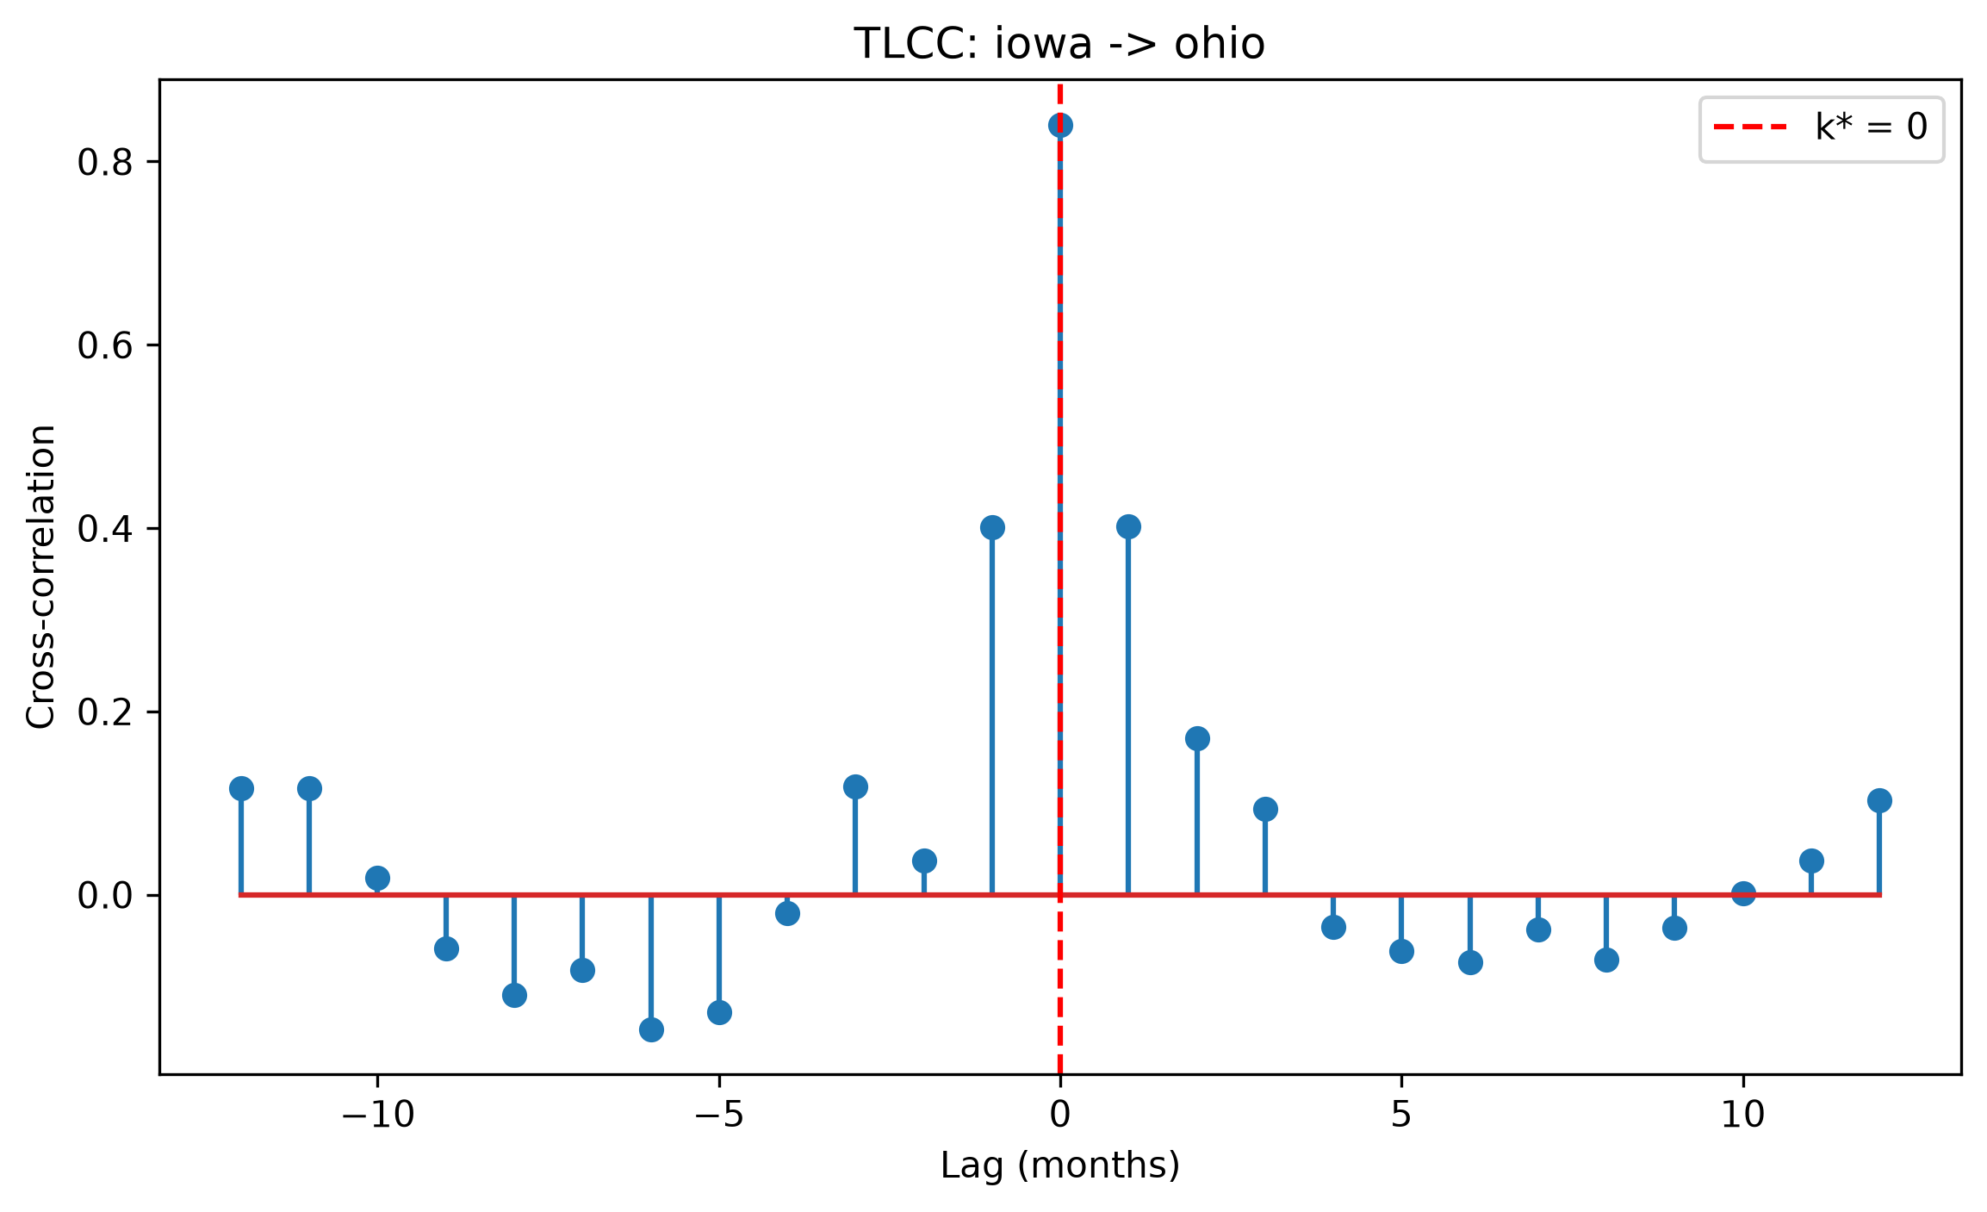
Figure 1. Time-lagged cross-correlation between Iowa and Ohio corn returns. The peak occurs at lag 0 (ρ = 0.840, k* = 0), with the bootstrap 95% CI collapsing to [0, 0].
The k* = 0 result should not be interpreted as evidence of instantaneous transmission in a physical sense. Monthly NASS price-received series aggregate all transactions within a calendar month; any transmission occurring within a month, including within hours or days, would produce k* = 0 at this resolution. The result is more precisely interpreted as: no lag detectable at monthly granularity, consistent with two markets that price off a shared CME/CBOT reference signal within the same reporting period.

5.3 Granger Causality
Iowa Granger-causes Ohio (Iowa→Ohio) at all tested lags from 1 through 8 months (minimum p = 0.0089 at lag 1, maximum p = 0.0452 at lag 8), with significance weakening at lags 9–12 (lag 9: p = 0.054). The result is consistent across the VAR(k) model sequence, indicating that Iowa's price history carries cumulative predictive information for Ohio's returns beyond Ohio's own history, across a window of approximately eight months.
Ohio does not Granger-cause Iowa (Ohio→Iowa) at any lag. The sole exception — lag 8 (p = 0.047) — is an isolated significant result surrounded by non-significant neighbors (lag 7: p = 0.080, lag 9: p = 0.052). With 12 simultaneous tests at α = 0.05, approximately 0.6 false positives are expected by chance. We treat this isolated hit as a multiple-comparisons artifact rather than evidence of reverse price leadership.
The Granger asymmetry — Iowa predicts Ohio, but not vice versa — is directionally consistent with Iowa's position as the largest corn-producing state and a dominant price-setting market. It does not contradict the TLCC finding of k* = 0: TLCC identifies the lag at which contemporaneous correlation peaks, while Granger causality tests whether lagged values of one series add predictive power over the other series' own history. Both can simultaneously be true when a price leader and price follower are tightly synchronized month-to-month but the leader's history carries forward-looking information that the follower's history does not.

5.4 Cointegration
The full-period Engle-Granger test finds no cointegration between Iowa and Ohio corn price levels (EG score = −2.836, p = 0.1545), failing to clear even the 10% critical value (−3.076). Rolling 60-month cointegration tests across 78 windows (December 2019 through May 2026) find significance at 5% in only 20 of 78 windows (26%). Critically, significance does not hold for extended stretches; it flickers in and out across adjacent windows, with many p-values sitting close to the 0.05 threshold (e.g., 0.052, 0.072, 0.057). This pattern is inconsistent with a cointegrating relationship that held for some sub-period and subsequently broke; it is more consistent with a marginally non-cointegrated relationship whose test statistic moves across the significance threshold on small perturbations.
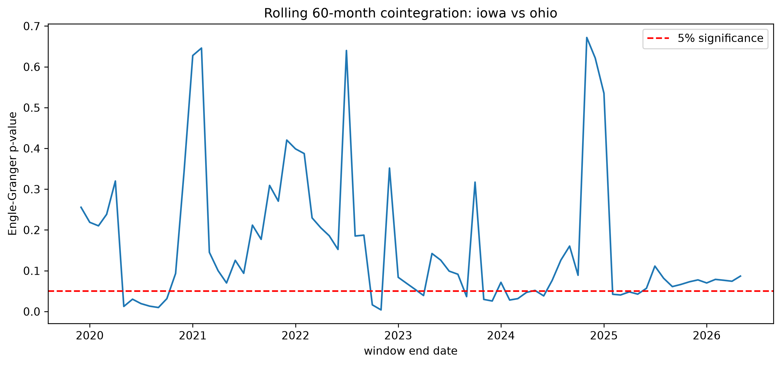
Figure 2. Rolling 60-month Engle-Granger cointegration p-values, Iowa vs. Ohio. The dashed line marks the 5% significance threshold; the series crosses it repeatedly rather than settling into distinct significant and non-significant regimes.
The train-only cointegration result (p = 0.0004) is dramatically stronger than the full-period result (p = 0.1545), and initially appears to suggest a structural break around the training period boundary. However, the Zivot-Andrews test addresses this directly.

5.5 Structural Break Test
The Zivot-Andrews test on the Iowa–Ohio spread finds no statistically significant structural break (ZA statistic = −3.241, p = 0.8224). The candidate break date returned by the test (September 2024) should not be reported as a real event; it is the least-bad candidate from a search that found no convincing break point. The strong train-only cointegration result is therefore not explained by a discrete structural shift occurring after the training period. Instead, in combination with the rolling-window results, it reflects Engle-Granger's sensitivity to window placement when the underlying relationship is marginal: particular sample windows happen to include configurations of the spread that produce significant test statistics, without those windows corresponding to a genuinely cointegrated regime.
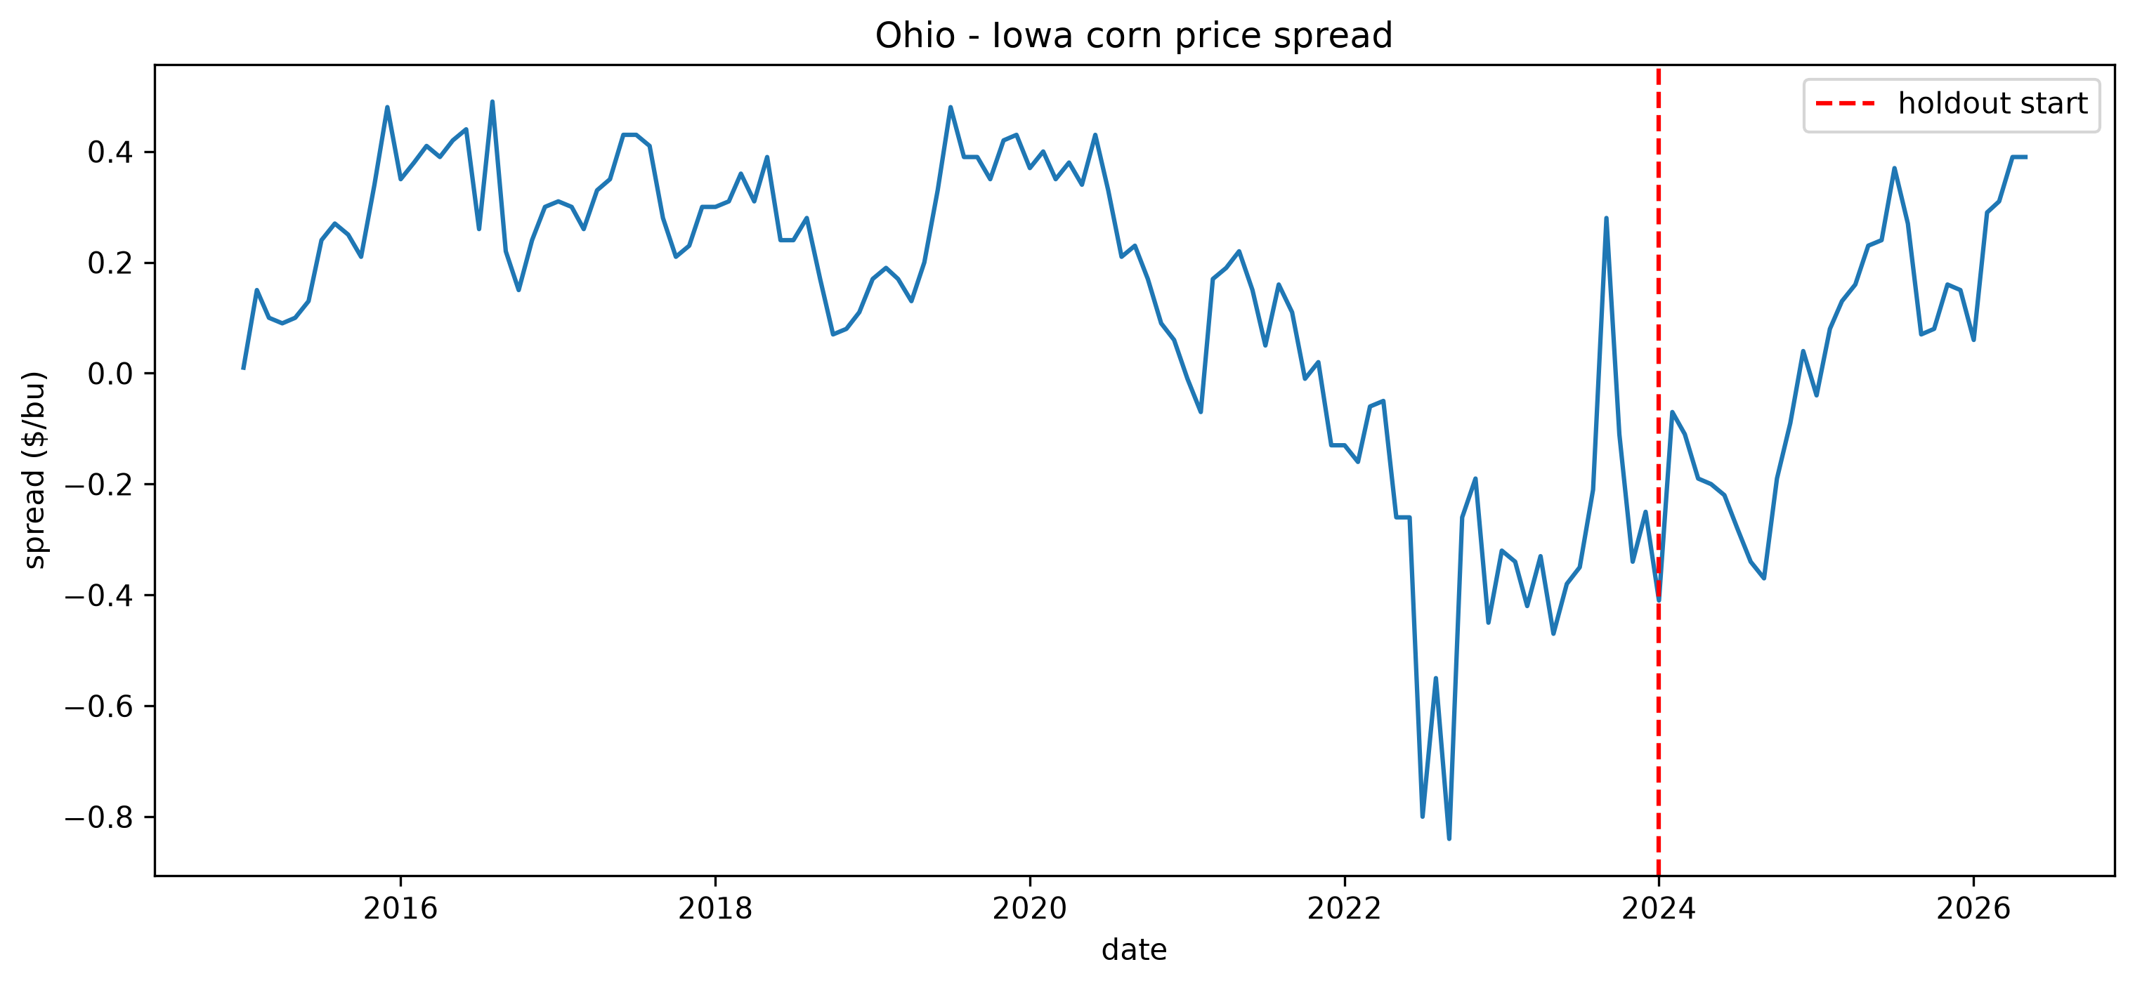
Figure 3. Ohio − Iowa corn price spread, 2015–2026. The dashed line marks the start of the 2024–2026 holdout period used for backtest validation. The spread drifts across an extended range rather than reverting to a stable mean, and shows a brief sign inversion around the September 2023 divergence.

5.6 Backtest Validation
Table 2 reports the train-only versus full-period comparison. The headline short-run findings — k* = 0, CI = [0, 0], peak correlation, and Iowa→Ohio Granger asymmetry — are stable across both samples. The cointegration p-value shifts substantially (0.0004 training vs. 0.1545 full period), but this instability is itself the finding and is reported as such rather than treated as a failure of robustness.
Table 2
Backtest: Train-Only vs. Full-Period Results (Iowa–Ohio)
Metric | Train (2015–2023) | Full (2015–2026)
k* (months) | 0 | 0
Peak correlation (ρ) | 0.847 | 0.840
k* 95% CI | [0.0, 0.0] | [0.0, 0.0]
Min p, Iowa→Ohio Granger | 0.0045 | 0.0089
Cointegration p-value | 0.0004 | 0.1545
Note. Train period: January 2015 – December 2023 (108 months). Full period includes holdout January 2024 – May 2026. Granger minimum p is the lowest p-value across lags 1–12.

5.7 Robustness: Iowa–Nebraska Pair
Table 3 compares results for the Iowa–Ohio pair against a second pair, Iowa–Nebraska. Nebraska is structurally different from Ohio: it is a major corn-producing surplus state on the same western rail and barge corridor as Iowa, with similar ethanol industry penetration and similar export-terminal orientation. This makes the Iowa–Nebraska pair a structural near-twin comparison, in contrast to the Iowa–Ohio corridor-divergent comparison.
The short-run findings replicate fully. Iowa–Nebraska shows k* = 0 with CI = [0, 0] and a higher peak correlation (ρ = 0.918 vs. 0.840). Iowa Granger-causes Nebraska at all 12 tested lags (minimum p < 0.001), with even stronger significance than in the Iowa–Ohio case. Nebraska does not Granger-cause Iowa at any lag, with p-values reaching as high as 0.995 — a definitive non-result with no isolated artifacts.
The long-run results diverge sharply. Iowa–Nebraska is robustly cointegrated: full-period EG score = −3.958, p = 0.0082, and the result is stable across the backtest split (training p = 0.0415, full p = 0.0082, both significant). The Zivot-Andrews test on the Iowa–Nebraska spread detects a statistically significant structural break at September 2022 (ZA statistic = −7.124, p < 0.001). This is in stark contrast to the Iowa–Ohio spread, where no significant break was found.
This combination — a cointegrated spread that also registers a significant Zivot-Andrews break — warrants a note on interpretation. The ZA null hypothesis is that the series contains a unit root with no break; rejecting it, as we do here, is evidence against a unit root and is consistent with (not contradictory to) the Engle-Granger finding that the Iowa–Nebraska spread is stationary. The break is therefore best read not as a transition from non-stationary to stationary behavior, but as a shift in the mean or parameters of an already mean-reverting relationship — i.e., a change in the cointegrating relationship itself around September 2022, rather than a change in whether a long-run equilibrium exists at all.
Table 3
Comparison of Iowa–Ohio and Iowa–Nebraska Results
Metric | Iowa–Ohio | Iowa–Nebraska
k* (months) | 0 | 0
Peak correlation (ρ) | 0.840 | 0.918
k* 95% CI | [0.0, 0.0] | [0.0, 0.0]
Iowa→ Granger sig. lags | 1–8 | 1–12
←Iowa Granger (reverse) | Not sig. | Not sig.
Cointegration p (full period) | 0.1545 | 0.0082
Cointegration stable in backtest? | No | Yes
ZA break p-value | 0.8224 | <0.001
ZA candidate break date | n.s. | Sept. 2022
Note. Iowa–Nebraska analysis uses the same pipeline, data range, and parameters as Iowa–Ohio. ZA candidate date for Iowa–Ohio is not reported (p = 0.8224, non-significant).

6. Discussion

6.1 Short-Run Synchronization as a Market Efficiency Signal
The k* = 0 finding, robust across both state pairs and stable across the train/holdout split, indicates that corn price movements in Iowa appear in Ohio and Nebraska within the same calendar month. At monthly resolution, this is consistent with efficient price discovery: both states price off a shared CME/CBOT reference signal, and any inter-state arbitrage occurring at finer time scales — daily or intra-day — is invisible to the monthly NASS series. This is not surprising for exchange-traded commodities in well-connected markets, but it is an empirically confirmed result rather than an assumption, and the bootstrap CI of [0, 0] gives it unusual precision for a k* estimate.
The asymmetric Granger structure — Iowa predicts the other states, not vice versa — is consistent with Iowa's position as the dominant price-setting market. Iowa's price history carries information about future Ohio and Nebraska returns beyond what those states' own histories contain, even though the contemporaneous correlation is already very high. One interpretation is that Iowa's market, as the largest and most liquid in the Corn Belt, incorporates new supply and demand signals slightly ahead of smaller or less liquid markets. This would be consistent with a market microstructure in which price discovery occurs first in the largest market and propagates outward, even when the propagation is fast enough to be invisible at monthly resolution.

6.2 The Short-Run / Long-Run Divergence
The most notable finding of this study is the combination of strong short-run synchronization and absent long-run cointegration in the Iowa–Ohio pair. This combination is less commonly discussed in the spatial price transmission literature, which often treats short-run synchronization and long-run cointegration as complementary indicators of market integration. Our results suggest they need not be.
The rolling cointegration analysis is particularly informative here. If Iowa and Ohio had a cointegrating relationship that broke at some identifiable point, we would expect extended sub-periods of significance in the rolling test followed by extended sub-periods of non-significance. Instead, the test flickers across the threshold repeatedly, with many p-values near 0.05 in both directions. Combined with the Zivot-Andrews non-result (p = 0.8224), this pattern is more consistent with a marginally non-cointegrated relationship whose test statistic is sensitive to window placement than with a break in a previously stable equilibrium.
The structural background for this result likely lies in the different local demand structures of the two states. Iowa's price is heavily influenced by in-state ethanol and feed demand — approximately 50–70% of Iowa's corn is processed domestically for ethanol alone (Iowa Farm Bureau, 2023) — while Ohio's price is more oriented toward eastern feed markets and Great Lakes export routes. When national conditions shift (commodity price cycles, export demand changes, energy market fluctuations affecting ethanol economics), these different demand structures cause the Iowa–Ohio spread to drift in ways that do not self-correct reliably, preventing a stable long-run equilibrium from forming even as short-run co-movement remains strong.

6.3 Corridor Alignment and Long-Run Equilibrium
The Iowa–Nebraska comparison provides a natural control that clarifies the role of transport corridor alignment in long-run price integration. Nebraska shares Iowa's western corridor orientation, its status as a large corn-producing surplus state, and its high ethanol industry penetration. The Iowa–Nebraska pair is robustly cointegrated (p = 0.008) and this result is stable across the backtest split, suggesting a genuine and persistent long-run equilibrium rather than a window-sensitive artifact.
This contrast supports a straightforward interpretation: states on the same transport corridor, selling into the same set of end-use markets and facing similar freight cost structures, maintain a stable long-run price relationship because the same external shocks (export demand, barge and rail rates, Gulf terminal prices) affect their basis differentials symmetrically. States on different corridors, selling into different end-use markets, face corridor-specific shocks that drive their spreads apart without a reliable self-correcting mechanism.
The September 2022 structural break in the Iowa–Nebraska spread (ZA p < 0.001) is a genuine empirical finding that warrants further investigation. September 2022 falls within a period of documented unusual basis behavior across the Corn Belt, characterized by tight corn and soybean supplies keeping cash prices elevated above futures prices for extended periods — a departure from pre-2021 patterns in which cash prices tracked futures consistently (Iowa Farm Bureau, 2022). Whether this break reflects a supply-shock-induced shift in the Iowa–Nebraska basis relationship, a change in transportation cost structures, or another mechanism is not determined by this analysis and is an appropriate subject for further research.

7. Conclusion
This paper finds that Iowa and Ohio corn markets exhibit strong, stable short-run price synchronization — k* = 0 months, ρ = 0.840, with a bootstrap CI of exactly [0, 0] — and directionally asymmetric Granger causality in which Iowa's returns predict Ohio's returns across a window of approximately eight months. Both findings are robust across a held-out validation period and replicate cleanly in a second state pair (Iowa–Nebraska). Iowa's position as the dominant price-setting market in the Corn Belt is supported by both the Granger asymmetry and the higher peak correlations observed when pairing Iowa with Nebraska than with Ohio.
The long-run findings present a more nuanced picture. Iowa and Ohio do not exhibit robust cointegration over the full 2015–2026 sample, with rolling-window tests finding significance in only 26% of windows and no clean regime structure. This contrasts with Iowa–Nebraska, which is stably cointegrated. We interpret this difference as reflecting the role of transport corridor alignment in long-run price integration: states on the same corridor maintain stable equilibria, while states on different corridors do not, even when their short-run dynamics are similarly tight.
These results have implications for how researchers interpret state-level agricultural price data. The assumption that short-run synchronization implies long-run cointegration is not reliable across all market pairs; corridor structure matters for the long-run relationship even when it does not affect the short-run lag. Studies that treat cointegration as a sufficient condition for market integration, or that rely on a single state pair, may reach conclusions that do not generalize.
Several limitations constrain the scope of these conclusions. The monthly frequency of NASS price-received data means that any transmission occurring within a month is undetectable; daily cash price data from USDA AMS Market News would allow more precise characterization of short-run dynamics, including whether the Granger asymmetry observable at monthly lags also appears at daily lags. The analysis is limited to one commodity and two state pairs; extension to soybeans and to additional corridor-defined pairs (e.g., Ohio–Indiana as a same-corridor pair) would allow more systematic testing of the corridor hypothesis. The September 2022 structural break in the Iowa–Nebraska spread remains unexplained and warrants dedicated investigation.

References
Fackler, P. L., & Goodwin, B. K. (2001). Spatial price analysis. In B. L. Gardner & G. C. Rausser (Eds.), Handbook of Agricultural Economics (Vol. 1, pp. 971–1024). Elsevier.
Iowa Farm Bureau. (2022, September 8). Tight supplies caused unusual basis levels in 2021 and 2022. Iowa Farm Bureau Federation. https://www.iowafarmbureau.com/Article/Tight-Supplies-Caused-Unusual-Basis-Levels-in-2021-and-2022
Iowa Farm Bureau. (2023). Ethanol industry in Iowa and the U.S. Iowa Farm Bureau Federation. https://www.iowafarmbureau.com/Article/Ethanol-Industry-in-Iowa-and-the-US
Ravallion, M. (1986). Testing market integration. American Journal of Agricultural Economics, 68(1), 102–109.
USDA National Agricultural Statistics Service. (2026). QuickStats API. U.S. Department of Agriculture. https://quickstats.nass.usda.gov/api
Zivot, E., & Andrews, D. W. K. (1992). Further evidence on the great crash, the oil-price shock, and the unit-root hypothesis. Journal of Business & Economic Statistics, 10(3), 251–270.

