Assignment – 1

• Install Power BI Desktop and share the final screenshot of the report view page which appears when power desktop starts.

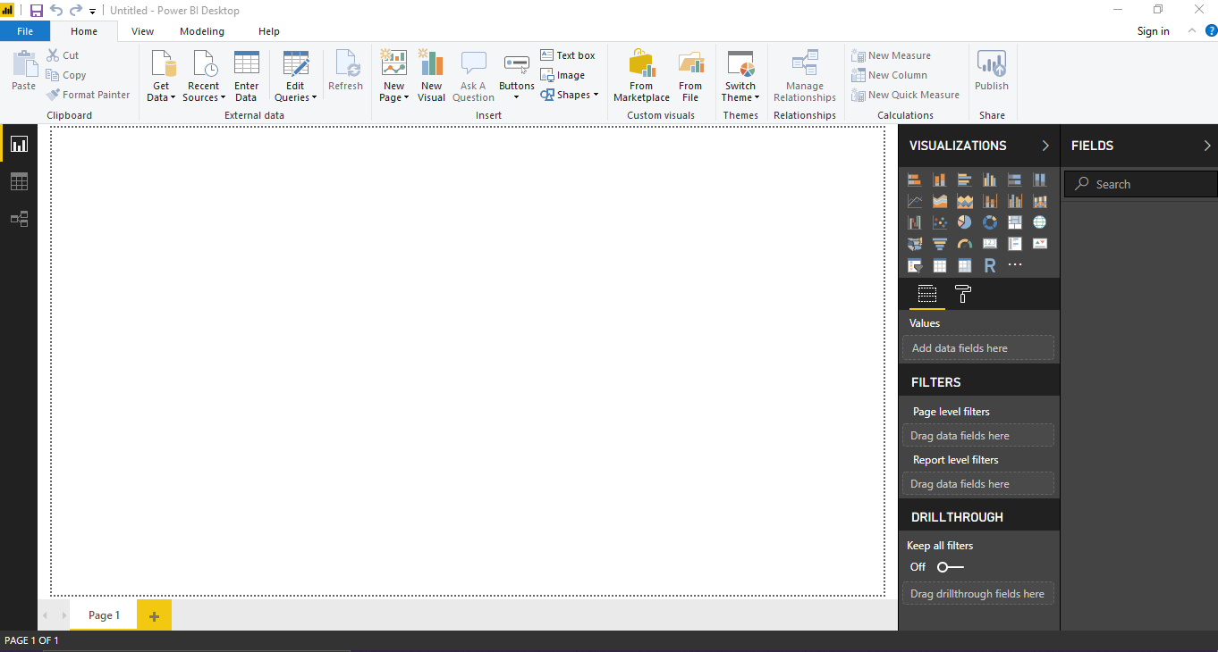

• Prepare a document and with the following screenshot

− Report View

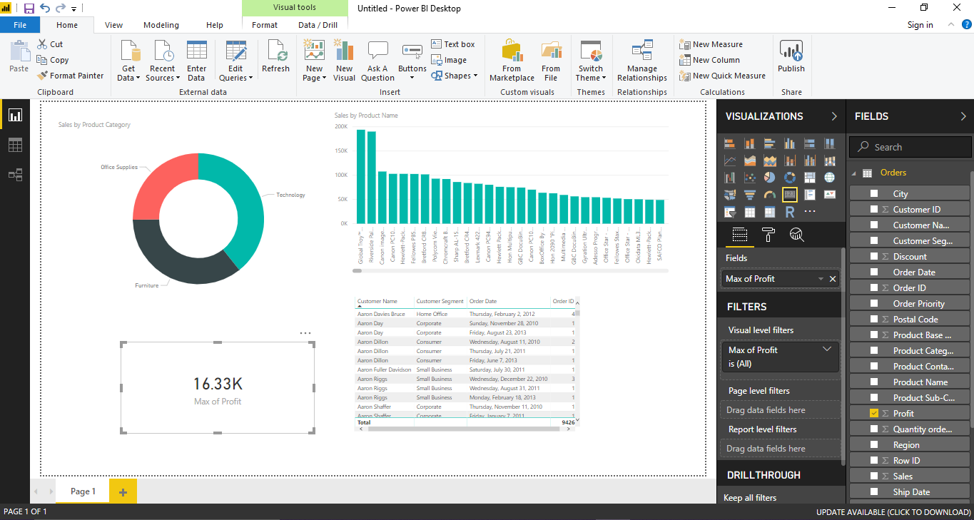

− Data View

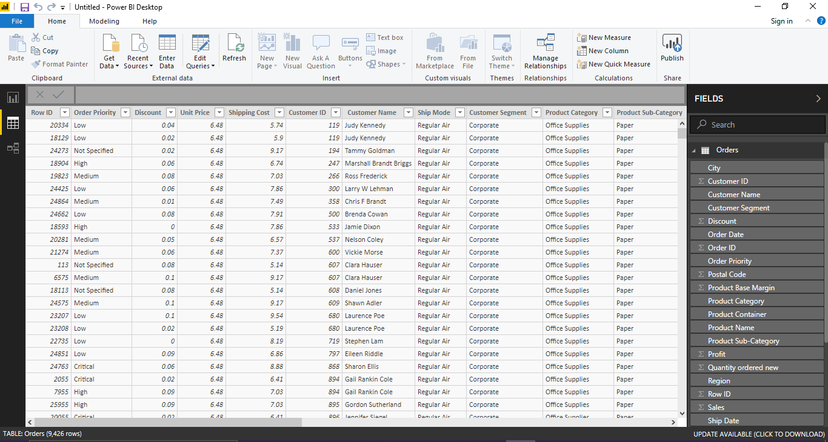

− Model View

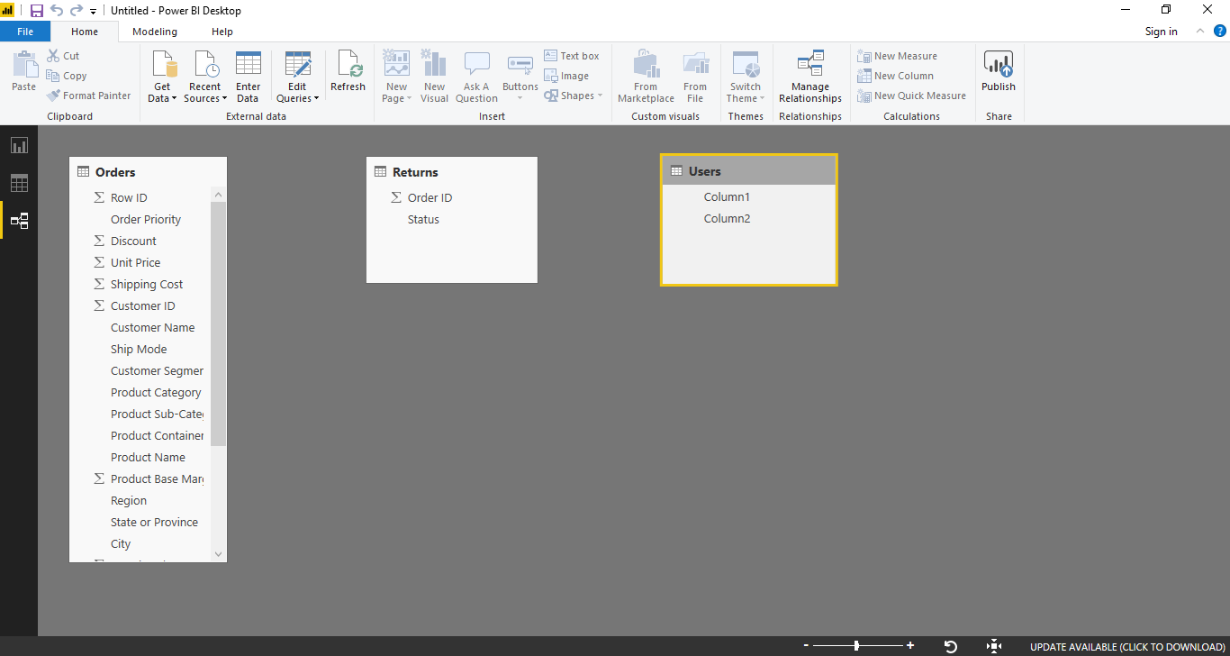

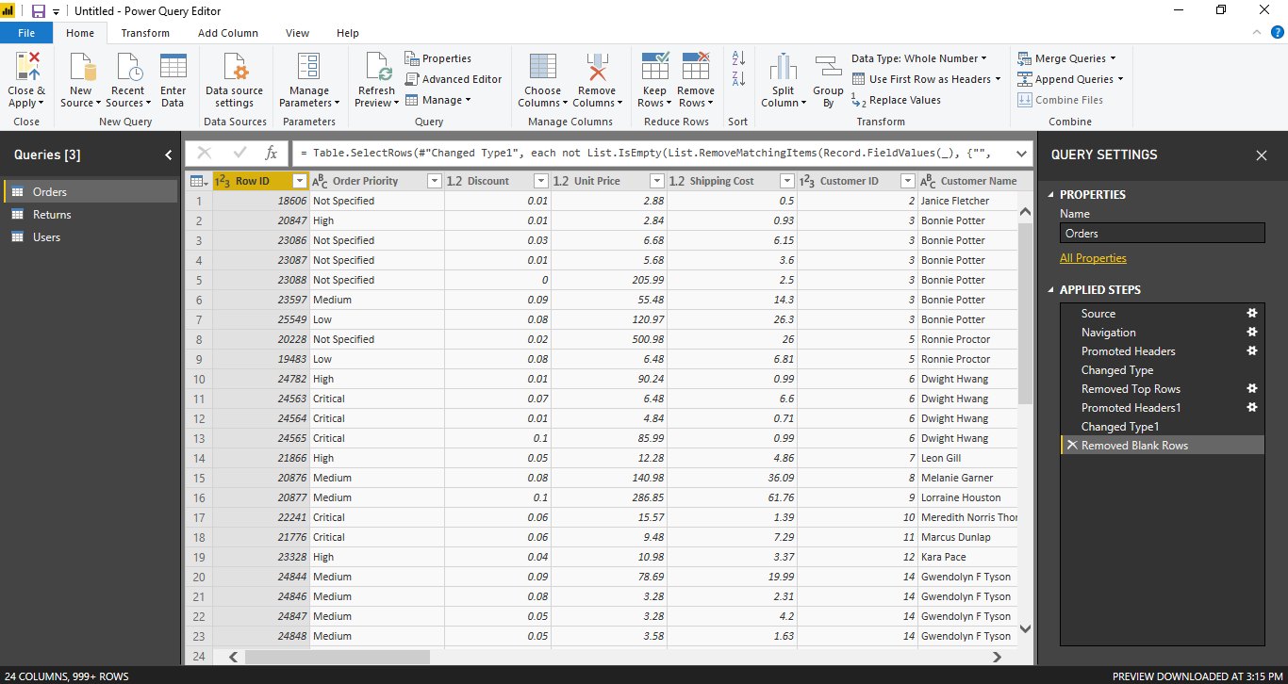− Power Query Editor

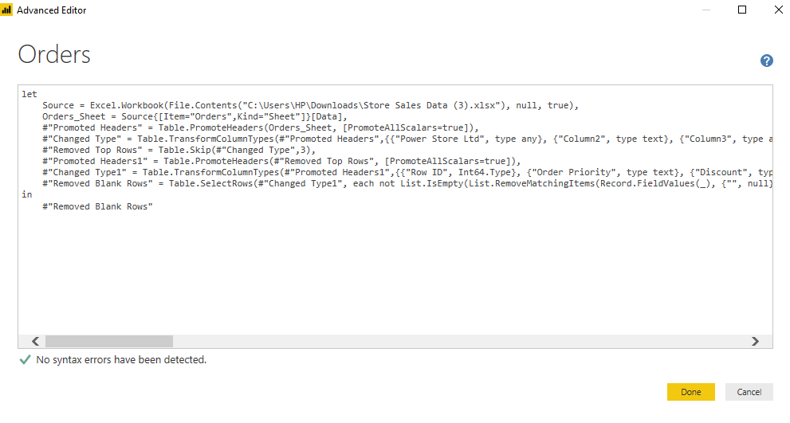 − Advance Editor

• Prepare a document with details of the following along with their price

− Power BI Desktop

Power BI Desktop is the free version of Power BI that we can install on our local computer as a program. All of Power BI’s basic features - cleaning and preparing data, connectors to data sources, custom reports, visualizations and exports to Microsoft apps are included in Power BI Desktop.

* Auto-detect that finds and creates data relationships between tables and formats
* Export your reports to CSV, Microsoft Excel, Microsoft PowerPoint and PDF
* Python support
* Save, upload and publish your reports to the Web and the full Power BI service
* Storage limit of 10 GB per user
* Can’t share created reports with non-Power BI Pro users
* No App Workspaces
* No API embedding

Suitable for,

* Companies without a business intelligence or data science budget.
* Businesses with less data to analyze, possibly only a handful of data sets.
* Small businesses and solo entrepreneurs.

− Power BI Pro

Power BI Pro is the full, licensed based version, which means it comes with complete capability for building dashboards, reporting and importantly sharing reports (which is not available on desktop). The biggest difference of Power BI Pro vs. Free is the fact that with Pro you have the option and the ability to share the data, reports, and dashboards with a large number of other users that also have a Power BI Pro license

* Ability to embed Power BI visuals into apps (Powernap’s, SharePoint, Teams, etc.)
* Native integration with other Microsoft solutions (Azure Data Services
* Share datasets, dashboards and reports with other Power BI Pro user
* Can create App Workspaces and peer-to-peer sharing

Power BI Pro cost

The Pro plan costs $9.99/user/month. It includes data collaboration, data governance, building dashboards with a 360-degree real-time view and the ability to publish reports anywhere. Users can try it a free trial for 60 days before purchasing the subscription

Suitable for,

Medium and large-scale business.

Corporations with big data and data scientists.

Multi-location businesses.

− Power BI Premium

Power BI Premium is the most expensive tier of Power BI currently available and very distinct from the other two versions available on the market. Can be purchased Premium in a range of capacity sizes that offer different numbers of memory and virtual cores that can scale as your data analysis requirements change.

* Increased data capacity limits and maximum performance
* Access to one API surface
* Ability to embed Power BI visuals into apps (Powernap’s, SharePoint, Teams, etc.)
* Larger storage sizes for extended deployments

Power BI Premium Cost

The Premium plan starts at $4,995 a month per dedicated cloud compute and storage resource. This does not include the cost of licensing for individual Pro and Free licenses required for each user in your organization.

Suitable for,

Large scale businesses with huge data sets.

Corporations with big data and data scientists.