CSA0381 – DATA STRUCTURES FOR DEPTH FIRST SEARCH
PRACTICAL EXAMINATION PROGRAMS
PREMARUBHA N
192525020

- MATRIX MULTIPLICATION

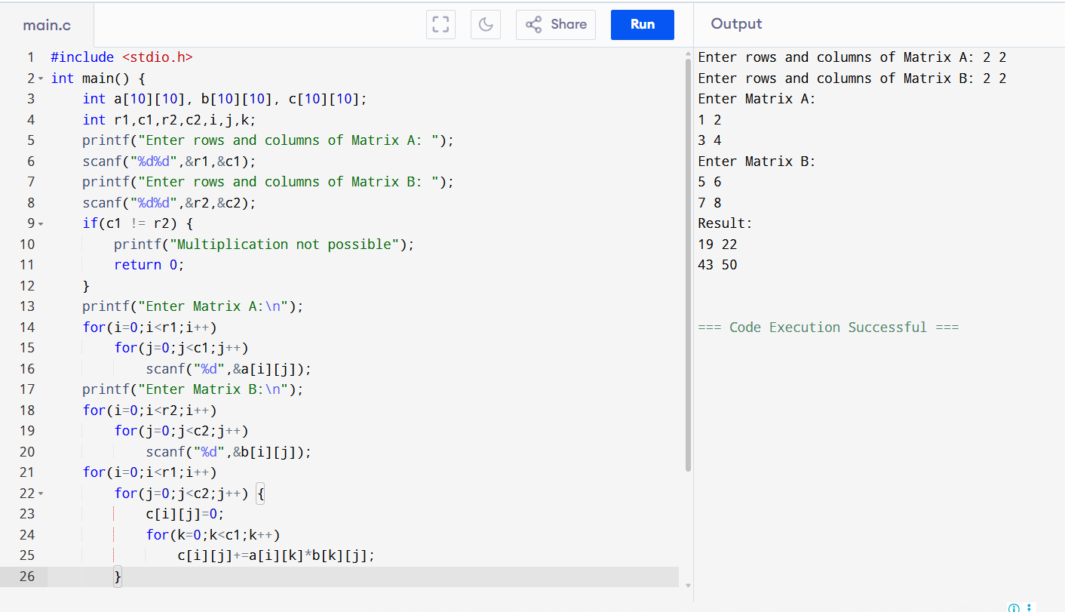

- ODD OR EVEN NUMBER
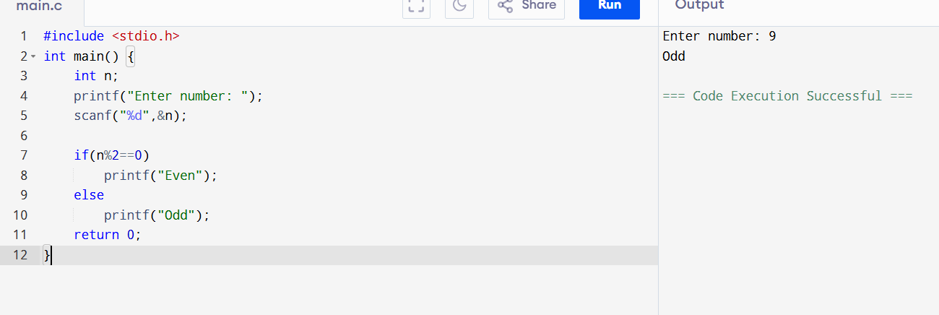

- FACTORIAL WITHOUT RECURSION
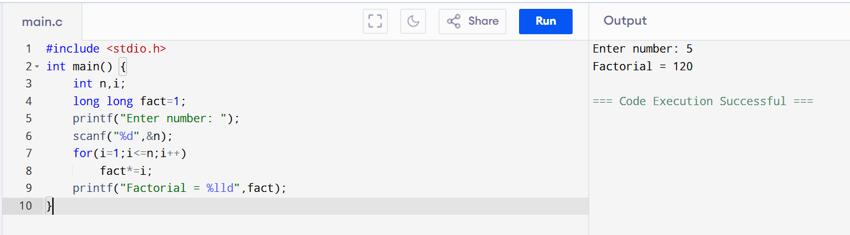

- FIBONACCI WITHOUT RECURSION
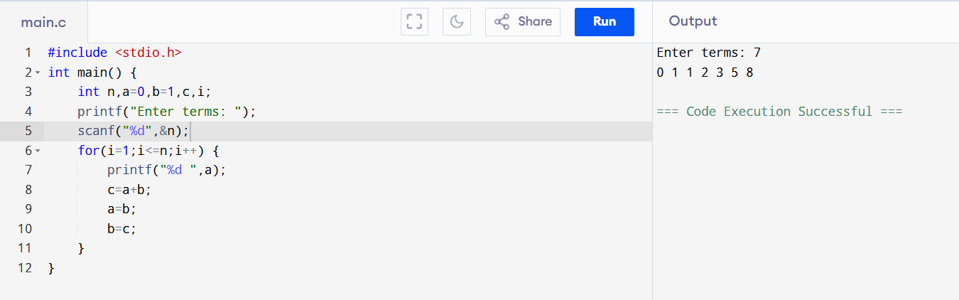

- FACTORIAL USING RECURSION

