**Task 2:**

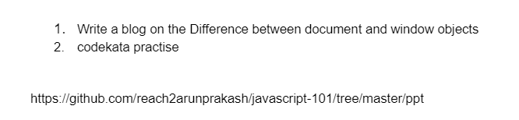

1. **Write a blog on Difference between document and window objects.**

|  |  |  |
| --- | --- | --- |
| **No** | **Window** | **document** |
| **1.** | **Window is the parent, under this object**  **Following objects are constructed.**  **1.DOM 🡪 Document Object Model**  **2.BOM 🡪 Browser Object Model.** | **document is inside of Window object.**  **document (DOM) is the child of Window (Parent)** |
| **2.** | **It’s a global Object** | **It’s a child Object** |
| **3.** | **It’s a browser window document.** | **It’s a html tree document** |
| **4.** | **Before rendering a web page, window object is available in the browser.** | **Only after the response web page is rendered, document object is available inside the window object.** |
| **5.** | **Properties and methods are available**  **For window object** | **Properties and methods are available**  **For DOM object.** |
| **6.** | **Window object manages user-window**  **Interactions.** | **Document object manages html and css of web page content manipulation.** |
| **7.** | **Window object is the Top Root.** | **Document** **object is the child of Window object.** |
| **8.** | **It represents a browser window or frame that displays the contents of the webpage.** | **It represents any HTML document or web page that is loaded in the browser.** |
| **9.** | **It is the very first object that is loaded in the browser.** | **It is loaded inside the window.** |
| **10.** | **It is the object of the browser.** | **It is the object of window property.** |
| **11.** | **Global objects, functions, and variables of JavaScript are members of the window object.** | **All the tags, elements with attributes in HTML are part of the document.** |
| **12.** | **We can access the window from the window only. i.e. window. window** | **We can access the document from a window using the window. document** |
|  | **Properties of the window object cannot be accessed by the document object.**  **window. innerHeight: will return the height of the content area of the browser** | **Properties of document objects such as title, body, cookies, etc can also be accessed by a window like this**  **window. document. title** |

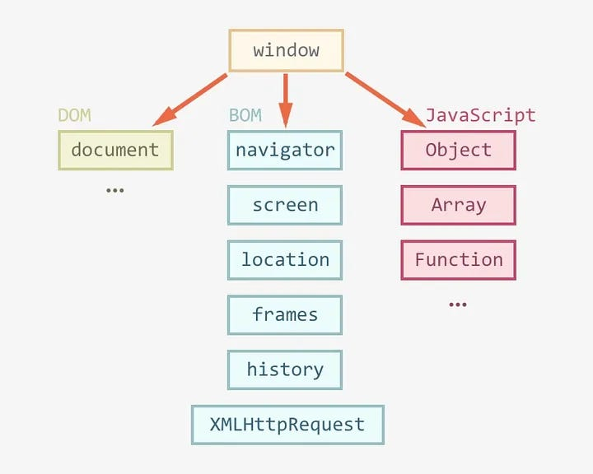

**This blog explores the differences between Document and Window object in JavaScript, focusing on their roles, scopes, and functionalities, as they are essential components of the Document Object Model (DOM) for efficient web development.**

**Window Object**

**The Window object is a global object in client-side JavaScript, representing the browser window containing a DOM document and acting as the root of the document object model.**

**The window object, supported by all browsers, represents the browser’s window and automatically includes global JavaScript objects, functions, and variables as members.**

**The Window object is responsible for managing global variables, functions, and objects, providing methods for browser interaction and managing properties related to frames, tabs, or windows, such as alert(), confirm(), setTimeout(), and setInterval().**

**Few Window Object Properties**

|  |
| --- |
| ***window. innerHeight - the inner height of the browser window (in pixels)*** |
| ***window. innerWidth - the inner width of the browser window (in pixels)*** |

**Few Window Object Methods**

|  |
| --- |
| ***window. open () - open a new window*** |
| ***window. close () - close the current window*** |
| ***window. moveTo () - move the current window*** |
| ***window. resizeTo () - resize the current window*** |

# **Document Object**

**The Document object is the HTML document that appears in the browser window and serves as an interface for interacting with the web page’s content. The browser generates a Document Object Model of a web page upon loading it.**

***The W3C Document Object Model (DOM) is a platform-neutral interface that enables dynamic access and updating of a document’s content, structure, and style by programs and scripts.***

**The DOM is a logical tree in a document, with methods allowing programmatic access to change its structure, style, or content.**

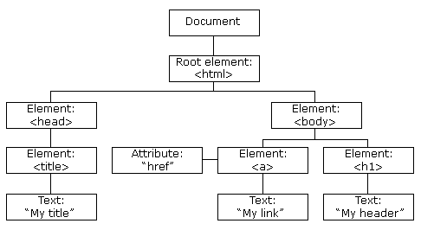

**Document Object Model**

**The DOM manipulation tool offers methods to access and manipulate the structure and content of a document, such as getElementById (), querySelector (), createElement (), and innerHTML. It represents the entire HTML document as a node tree, with the Document object as the root node. It allows dynamic updates and interactions with web page content.**

**Few properties and methods of Document Object Model,**

**Few DOM Properties**

**element. innerHTML = new html content/*/Change the inner HTML of an element***

**element. attribute = new value*//Change the attribute value of an HTML element***

**Few DOM Methods**

**document. createElement (element*//Create an HTML element***

**document. removeChild(element)*//Remove an HTML element***