Name : Prem Vinod Bansod
Roll No : 41310
Assignment No : 02 (ICS)

Title: S-AES

Problem Statement: To implement a Simplified Advanced Encryption Standard (S-AES) algorithm.

Objective:
- The Basic Concepts of S-AES
- General structure of S-AES
- Logical implementation of S-AES

Theory:

Introduction:
S-AES is to AES as S-DES is to DES. In fact, the structure of S-AES is exactly the same as AES. The differences are in the key size (16 bits), the block size (16 bits) and the number of rounds (2 rounds). Here is an overview:
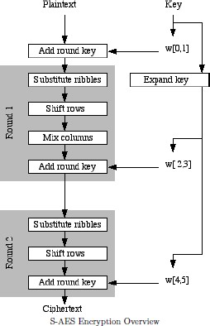

Substitute nibbles Instead of dividing the block into a four by four array of bytes, S-AES divides it into a two by two array of ―nibbles‖, which are four bits long. This is called the state array and is shown below

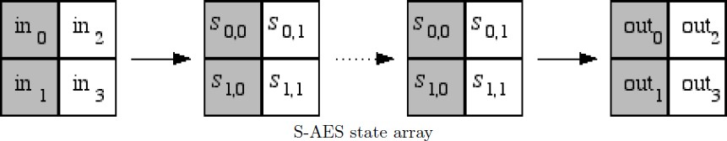
In the first stage of each encryption round, an S-box is used to translate each nibble into a new nibble. First we associate the nibble b 0 b 1 b 2 b 3 with the polynomial b 0 x 3 + b 1 x 2 + b 2 x + b 3 . This polynomial is then inverted as an element of GF(16), with the ―prime polynomial‖ used being.x 4 + x + 1. Then we multiply by a matrix and add a vector as in AES.
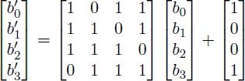

Remember that the addition and multiplication in the equation above are being done modulo 2 (with XOR), but not in GF(16). Since a computer would do the S-box substitution using a table lookup, we give the full table for the S-box here.

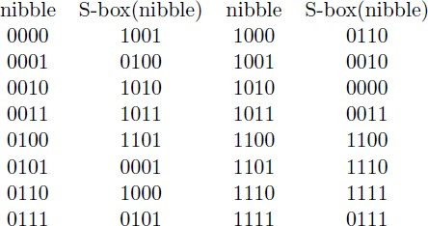

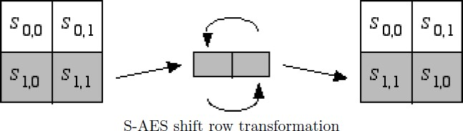
Shift Rows The next stage is to shift the rows. In fact, the first row is left alone and the second row is shifted.

Mix Columns After shifting the rows, we mix the columns. Each column is multiplied by the Matrix
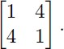

These operations are done in GF(16), so remember that the 1 corresponds to the polynomial 1 and the 4 corresponds to the polynomial x 2 . Thus this matrix could also be written as,

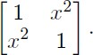

Don‘t forget to reduce modulo x 4 + x + 1.
The mix column transformation is omitted in the last round, in order to simplify the decryption.
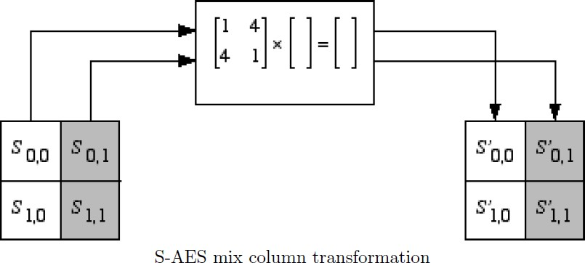
Add Round Key The last stage of each round of encryption is to add the round key. (In fact, this is also done before the first round.) Before the first round, the first two words (W 0 and W 1 ) of the expanded key are added. In the first round, W 2 and W 3 are added. In the last round, W 4 and W 5 are added. All additions are done modulo 2, that is, with XOR.
Key Expansion Key expansion is done very similarly to AES. The four nibbles in the key are grouped into two 8-bit ―words‖, which will be expanded into 6 words. The first part of the expansion, which produces the third and fourth words, is shown below. The rest of the expansion is done in exactly the same way, replacing W 0 and W 1 with W 2 and W 3 , and replacing W 2 and W 3 with W 4 and W 5 .
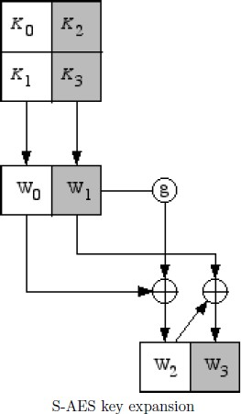

The g function is shown in the next diagram. It is very similar to AES, first rotating the nibbles and then putting them through the S-boxes. The main difference is that the round constant is produced using x j+2 , where j is the number of the round of expansion. That is, the first time you expand the key you use a round constant of x 3 = 1000 for the first nibble and 0000 for the second nibble. The second time you use x 4 = 0011 for the first nibble and 0000 for the second nibble.
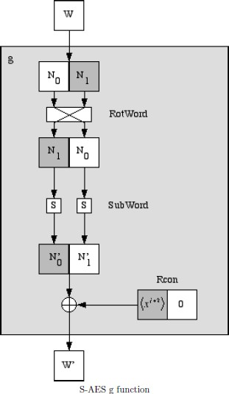

CONCLUSION: Hence, S-AES algorithm was successfully Implemented.

