Roll No. : 41310
Name : Prem Vinod Bansod
Assignment No.: 04 (SCOA)

Problem Statement :
Implement basic logic gates using Mc-Culoch-Pitts or Hebbnet neural networks

Objective :
- The student will be able to obtain the fundamentals and different architecture of neural networks.
- The student will have a broad knowledge in developing the different algorithms for neural networks.

Software and Hardware Requirement :
- 32/64 bit PC
- Ubuntu OS
- Python

Theory :
Neural network was inspired by the design and functioning of human brain and components.

Definition:
―Information processing model that is inspired by the way biological nervous system (i.e the brain) process information, is called Neural Network.‖
Neural Network has the ability to learn by examples. It is not designed to perform fix/specific task, rather task which need thinking (e.g. Predictions).
ANN is composed of large number of highly interconnected processing elements (neurons) working in unison to solve problems. It mimics human brain. It is configured for special application such as pattern recognition and data classification through a learning process. ANN is 85-90% accurate.

Basic Operation of a Neural Network:
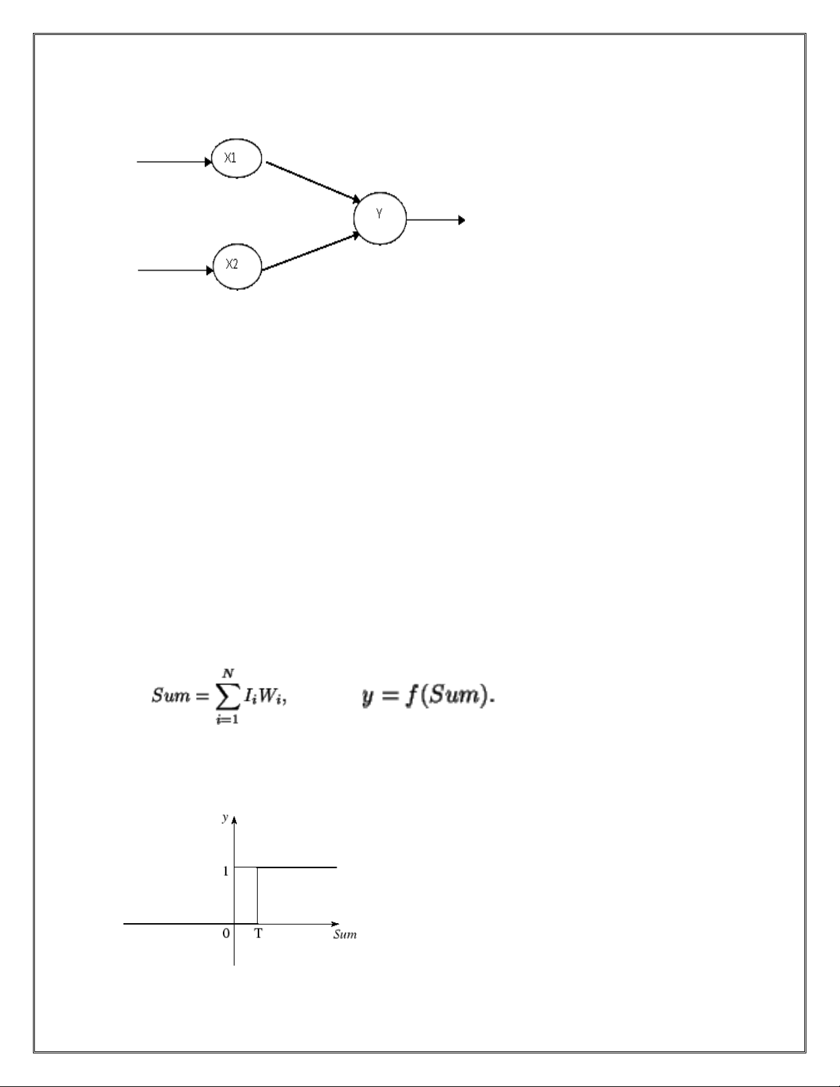
X1 and X2 – input neurons.
Y- output neuron
Weighted interconnection links- W1 and W2.
Net input calculation is :
Yin= x1w1+x2w2
Output is :
y=f(Yin) Output=
function

The McCulloch-Pitts Model of Neuron:
- The early model of an artificial neuron is introduced by Warren McCulloch and Walter Pitts in 1943.
- The McCulloch-Pitts neural model is also known as linear threshold gate. It is a neuron of a set of
- inputs I1,I2,I3…Im and one output y . The linear threshold gate simply classifies the set of inputs into
- two different classes. Thus the output y is binary. Such a function can be described mathematically

using these equations:

W1,W2…Wm are weight values normalized in the range of either (0,1) or (-1,1) and associated with each input line, Sum is the weighted sum, and T is a threshold constant. The function f is a linear step function at threshold T as shown in figure

Conclusion :
Mc-Culloch pits Model is implemented for XOR function by using the thresholding activation function. Activation of M-P neurons is binary (i.e) at any time step the neuron may fire or may not fire. Threshold plays major role here.

