CARTCHECK
FOOD DELIVERY FEES AND DISCOUNT ANALYSIS
A DATA ANALYTICS PROJECT REPORT SUBMITTED IN PARTIAL
FULFILMENT OF THE REQUIREMENTS FOR THE AWARD OF
THE DEGREE OF
MASTER
OF
COMPUTER APPLICATIONS
ARTIFICIAL INTELLIGENCE AND MACHINE LEARNING
Submitted by
Prathamesh Prabhakar Bodhale (25MCI10270)
Supervisor
Mrs. Deepali Saini
University Institute of Computing
Chandigarh University

University Institute of Computing
Chandigarh University
November 2026

CERTIFICATE
This is to certify that Prathamesh Prabhakar Bodhale, UID 25MCI10270, a student of Master of Computer Applications in Artificial Intelligence and Machine Learning at Chandigarh University, has prepared the Data Analytics project titled CartCheck Food Delivery Fees and Discount Analysis for academic evaluation.
This project is submitted as part of the MCA curriculum at the University Institute of Computing, Chandigarh University. It demonstrates the use of Excel formulas, lookup functions, PivotTables, charts, statistical summaries and data quality checks to analyse food delivery bills.
CartCheck uses 100 simulated orders from three fictional platforms. The report explains the input data, bill calculations, fee distribution, findings, testing and limitations. It includes an editable fee planner for demonstrating changes to a hypothetical order.
The certificate is to be completed and signed by the project guide after review of the project report and workbook.
Project Guide Mrs. Deepali Saini
Designation ___________________________________
Signature _____________________________________
Date _________________________________________
University Institute of Computing
Chandigarh University

ACKNOWLEDGEMENT
I would like to thank Chandigarh University and the University Institute of Computing for the opportunity to prepare the Data Analytics project CartCheck Food Delivery Fees and Discount Analysis.
I am grateful to Mrs. Deepali Saini and the teaching faculty for the course instruction and academic support that helped me understand Excel formulas, PivotTables, data visualisation and statistical interpretation. These topics provided the basis for the analysis presented in this report.
I also thank my classmates, friends and family for their encouragement and support during my academic work.
Preparing this project helped me connect raw input data with calculated measures, grouped summaries and charts. It also showed the importance of checking data quality, explaining the comparison baseline and stating the limits of a simulated dataset.
Prathamesh Prabhakar Bodhale
UID 25MCI10270
MCA Artificial Intelligence and Machine Learning
Chandigarh University

INDEX
Sr No | Contents | Page No
1 | Abstract | 5
2 | Chapter 1 Introduction | 6
 | Project overview problem statement and objectives | 6
3 | Chapter 2 System Analysis | 7
 | Existing approach proposed system and requirements | 7
4 | Chapter 3 Methodology and Implementation | 8
 | 3.1 Methodology and workbook design | 8
 | 3.2 Dataset and input dictionary | 9
 | 3.3 Calculated fields and controls | 10
 | 3.4 Bill calculations and worked examples | 11
 | 3.5 Logical formulas and lookups | 12
 | 3.6 Conditional summaries and named ranges | 13
 | 3.7 Native PivotTables | 14
 | 3.8 Statistical analysis | 15
 | 3.9 and 3.10 Dashboard interface | 16 to 17
 | 3.11 Fee planner | 18
5 | Chapter 4 Testing and Results | 19
 | Quality checks findings fee analysis and demonstration | 19 to 22
6 | Chapter 5 Conclusion and Future Scope | 23
7 | Chapter 6 Project Files and References | 24
8 | Appendix Syllabus Coverage | 25
9 | Appendix Input and Formula Walkthrough | 26

ABSTRACT
CartCheck is an Excel-based Data Analytics project that evaluates the difference between advertised discounts and the final amount paid for food delivery orders. It analyses 100 simulated orders using formulas, conditional summaries, three native PivotTables and six editable charts. A separate fee planner demonstrates how a changed fee or discount affects one hypothetical bill.
The study contains INR 6,750 in discounts and INR 7,634 in extra charges. The final bills total INR 34,904 against listed food subtotals of INR 34,020. Net saving is therefore negative INR 884. Forty orders have positive net saving, two break even and 58 have negative net saving. Four orders exceed the upper fee fence of INR 128.875. These findings describe the simulated dataset and do not establish actual platform pricing performance.
The workbook supports a reproducible classroom demonstration. The report explains the data, formulas, aggregation rules, statistical interpretation, live-input tests and operating instructions. The implementation follows the Excel component of the supplied syllabus.

Chapter 1 Introduction

1.1 Project Overview
A food delivery discount reduces the listed price of an order, but the checkout bill may include delivery, packaging, platform and other charges. Looking only at the discount can give an incomplete picture of the amount paid. CartCheck makes these components visible and measures their combined effect for each order.

Problem statement
How much of a listed discount remains after extra charges are added, and how does this change across the orders, months and fictional platforms in the study? The analysis must retain positive, zero and negative outcomes so that a bill above the listed subtotal is not presented as a saving.
The comparison baseline is the food subtotal recorded for that order. The workbook has no matched restaurant prices, competitor quotes, distance records or service-quality measurements. It can explain the bill arithmetic and the composition of recorded fees. It cannot identify the cheapest real provider for an identical meal.

Objectives
- Calculate total extra charges, final bill, net saving and percentage measures for each order.
- Summarise charges by platform, month and saving outcome with formulas and native PivotTables.
- Describe the fee distribution using mean, median, frequency counts and quartiles.
- Identify unusually high extra charges with an explicit upper IQR fence.
- Present the findings in charts and demonstrate a changed input through an independent fee planner.
- Check missing inputs, duplicate IDs, platform mappings, dates and arithmetic reconciliations.

Project scope
The delivered implementation is Excel-only. It includes descriptive analysis and bill-level diagnostic explanation. The fee planner is a deterministic calculator with fixed assumptions. It does not train a forecasting, NLP or deep learning model. SQL and Tableau are outside the agreed workbook implementation.

Chapter 2 System Analysis

2.1 Existing Approach
A basic bill review may compare the food subtotal with the discount while treating delivery and other charges separately. Manual calculations and scattered order records make it harder to compare results consistently, identify unusually high fees or reconcile total spending. This is the comparison problem addressed by CartCheck; it is not a claim about the design of any real delivery platform.

2.2 Proposed System
CartCheck organises each order in a structured Excel table and calculates extra charges, final bill, net saving and saving percentages. Formula summaries and three native PivotTables support platform, month and outcome comparisons. Six charts present the results. A separate fee planner supports a live input demonstration, and Data Quality checks the study inputs and arithmetic.
Requirement | Implemented feature
Store and inspect order records | OrdersData table with 100 simulated orders.
Calculate bill measures | Editable Excel formulas in Orders columns L to V.
Summarise and compare | Analysis formulas and three native PivotTables.
Present results | Dashboard with six editable charts.
Demonstrate changed inputs | Independent Fee Planner worksheet.
Review completeness and consistency | Nine Data Quality checks and row-level review.

2.3 System Requirements
The project runs as an Excel workbook. The presentation computer needs Microsoft Excel with support for PivotTables, charts and the documented formulas. A keyboard and a readable display are sufficient for the demonstration. The report PDF can be opened in a PDF reader. No web server, database service, programming runtime or internet connection is required to use the delivered workbook.

Chapter 3 Methodology and Implementation

3.1 Methodology and Workbook Design
The workflow keeps source inputs, calculations, summaries and checks easy to trace. One row in Orders represents one order. Formula columns calculate the bill measures, Analysis aggregates those measures, and Dashboard links to the completed summaries. The Fee Planner uses separate inputs so a classroom demonstration does not alter the study dataset.
Worksheet | Purpose | Main evidence
Dashboard | Presents the main findings | Six headline measures and six charts
Fee Planner | Calculates a hypothetical bill | Editable inputs C8:C13 and C15
Analysis | Owns statistical and grouped summaries | Formula summaries and three native PivotTables
Orders | Stores source inputs and row calculations | OrdersData table A7:T107; review columns U and V
Data Quality | Reviews inputs and reconciliations | Nine summary checks and 100 row reviews
Project Guide | Explains workbook use and scope | Formula examples, refresh steps and extension rules

Analysis steps
- Preserve the 100 source orders and apply consistent numeric, currency and date formats.
- Calculate each order bill and assign its saving outcome and high-fee flag.
- Aggregate using the correct measure: sums for spending, counts for orders and averages for charges.
- Inspect central tendency and the upper fee tail, retaining unusual orders in the totals.
- Display the findings and check representative input changes and reconciliation identities.

Refresh behaviour
Ordinary formulas recalculate from their referenced cells. The first three dashboard charts read native PivotTable result cells and need a PivotTable refresh after an order edit. The remaining charts use formula summaries. Choosing Data > Refresh All after editing Orders keeps the presentation consistent [7, 8].
Data Quality is a terminal review sheet. It reads the inputs and analysis but does not supply assumptions or suppress records in the business calculations. A review warning therefore remains visible without silently removing a bill from the results.

3.2 Dataset and Input Dictionary
The dataset contains 100 simulated orders dated from 1 July to 23 October 2026. There are 34 QuickBite orders, 33 MealCart orders and 33 DineDrop orders. Each month contains 25 records. The platform names are fictional. The data supports a classroom demonstration rather than a survey of customers or live delivery services.
Col | Input and type | Meaning
A | Order ID text | Unique identifier such as CC-001.
B | Order date date | Numeric Excel date displayed as day, month and year.
C | Platform code text | QB, MC or DD; mapped to a fictional platform name.
D | Meal category | Breakfast, Lunch, Dinner or Snack.
E | Food category category | The recorded food category, such as Indian or Pizza.
F | Food subtotal numeric | Listed food amount before discount and extra charges.
G | Discount numeric | Discount deducted from the subtotal.
H | Delivery fee numeric | Recorded delivery charge.
I | Packaging fee numeric | Recorded packaging charge.
J | Platform fee numeric | Recorded platform charge.
K | Other charges numeric | Additional recorded charges not in H to J.

Units and data rules
Bill amounts are stored as numbers in INR. Currency symbols are number formatting. Order IDs and platform codes remain text. Food subtotal must be greater than zero. Discounts and fee inputs must be non-negative. Zero is a valid discount or fee and is not treated as a missing value.
The dataset does not contain customer names, addresses or payment details. The other-charges field has no tax breakdown, so it is not interpreted as a tax measure. No real platform names or empirical market claims are inferred from the synthetic records.

3.3 Calculated Fields and Controls
Orders columns L to T calculate the analysis measures. U and V provide visible row checks beside the source table. The original input records remain in A to K. The source table for the PivotTables is OrdersData in A7:T107.
Col | Calculated field | Purpose
L | Platform | Returns the name for the platform code.
M | Extra charges | Adds delivery, packaging, platform and other charges.
N | Final bill | Subtotal minus discount plus extra charges.
O | Net saving | Discount minus extra charges.
P | Net saving percentage | Net saving divided by the food subtotal.
Q | Discount percentage | Discount divided by the food subtotal.
R | Month | Displays a month and year key for grouping.
S | Saving outcome | Positive, Break-even or Negative.
T | Fee flag | High fee if extra charges exceed the upper fee fence.
U | Input check | Reviews completeness and numeric bill inputs.
V | Charge review | Highlights negative saving or an unusually high fee.

Input controls
Amber cells identify editable order and planner inputs. Formula cells use a neutral fill. Platform code, meal and food category have dropdown lists. Numeric validation restricts the subtotal to positive values and the discounts and fees to non-negative values. Conditional formatting highlights negative net saving, high fees and input warnings.
The lookup mapping is visible in Orders W8:X10. Exact matching prevents a mistyped code from silently selecting a different platform. Pasting can bypass input validation, which is why the independent Data Quality review is part of the workflow.

Filtering and sorting
Use the filter buttons in OrdersData to select a platform, saving outcome or fee flag. Sort the full table rather than an isolated column so each order remains one coherent record. A useful demonstration is filtering Fee flag to High fee and inspecting the four resulting orders.

3.4 Bill Calculations and Worked Examples

Extra charges in M8
=SUM(H8:K8)
This sum includes all four recorded fee components. For CC-001, the values 20, 10, 5 and 10 produce extra charges of INR 45.

Final bill in N8
=F8-G8+M8
For a subtotal of INR 200 and a discount of INR 60, the final bill is 200 - 60 + 45 = INR 185.

Net saving in O8
=G8-M8
The same order saves INR 15 relative to its listed subtotal. Equivalently, net saving is food subtotal minus final bill. Negative saving is retained when fees exceed the discount.

Net saving rate in P8
=IFERROR(O8/F8,"n.a.")
For CC-001, the result is 7.5 percent. A zero subtotal is invalid input. The formula returns n.a. rather than a numeric saving rate when division is unavailable; the input check also identifies the invalid subtotal.
Order | Subtotal | Discount | Fees | Final bill | Net saving
CC-001 | 200 | 60 | 45 | 185 | 15
CC-002 | 250 | 40 | 60 | 270 | -20
CC-003 | 300 | 50 | 50 | 300 | 0

These examples cover all three outcome classes. A large discount is not sufficient to establish positive saving: the relevant comparison is discount against the complete fee amount. All values in the table are INR.

3.5 Logical Formulas and Lookups

Exact platform lookup in L8
=VLOOKUP(C8,$W$8:$X$10,2,FALSE)
C8 supplies the code. The fixed range contains the mapping, column 2 returns the name, and FALSE requires an exact match [4].

Nested IF for outcome in S8
=IF(O8>0,"Positive",IF(O8<0,"Negative","Break-even"))
The zero boundary is tested explicitly. A zero result therefore appears as Break-even rather than a positive or negative outcome.

AND for input review in U8
=IF(AND(COUNTA(A8:K8)=11,COUNT(F8:K8)=6,
F8>0,MIN(G8:K8)>=0),"Valid","Review input")
Every required condition must hold: complete inputs, six numeric bill fields, a positive subtotal and non-negative discounts and fees.

OR for charge review in V8
=IF(OR(O8<0,T8="High fee"),"Review charges","Within checks")
Either a negative net saving or an unusually high fee is enough to prompt a review. This is an explanatory flag, not a fraud classification.

NOT in Data Quality G21
=IF(NOT(AND(C21=1,D21="Mapped",E21="Valid",
F21="In period")),"Review","OK")
NOT reverses the combined valid-record condition. A row needs review if its ID, code, bill inputs or study date fails the corresponding check.

Percentages and date grouping
Q8: =IFERROR(G8/F8,"n.a.")
R8: =TEXT(B8,"mmm yyyy")
The month label is a grouping field. The original date remains numeric in column B so that chronological dates are still available for sorting and inspection.

3.6 Conditional Summaries and Named Ranges
Conditional summaries provide a direct way to trace each grouped result to its source records. The same source ranges are used consistently for criteria and amounts. The functions below are actual workbook formulas, not example results typed over the analysis.

Count platform orders in Analysis C7
=COUNTIF('Orders'!$L$8:$L$107,B7)
The first platform is QuickBite and its count is 34.

Average platform fees in Analysis D7
=AVERAGEIF('Orders'!$L$8:$L$107,B7,
'Orders'!$M$8:$M$107)
The result is INR 73.7647 before display rounding.

Sum monthly fees in Analysis E14
=SUMIF('Orders'!$R$8:$R$107,B14,
'Orders'!$M$8:$M$107)
The July result is INR 1,859. SUMIF adds the amount cells whose corresponding month matches the criteria cell [5].

Count a fee band in Analysis I54
=COUNTIFS('Orders'!$M$8:$M$107,">=0",
'Orders'!$M$8:$M$107,"<50")
The lower boundary is included and the upper boundary excluded, so a fee of exactly 50 belongs to the next band.
Named range | Refers to
FoodSubtotal | 'Orders'!$F$8:$F$107
ExtraCharges | 'Orders'!$M$8:$M$107
NetSavings | 'Orders'!$O$8:$O$107
PlatformCodes | 'Orders'!$W$8:$W$10

Analysis I26 uses =SUM(FoodSubtotal). Project Guide B81 uses CONCATENATE to combine the first order ID, platform and meal into a readable label. The names and label can be inspected during the demonstration.

3.7 Native PivotTables
The workbook contains three native Excel PivotTables on one Analysis worksheet. Each uses the OrdersData table. Their result cells also supply the first three dashboard charts. Average, sum and count answer different questions and are intentionally used for different measures [7].
PivotTable and result range | Rows field | Values field and aggregation
FeesByPlatform  B32:C36 | Platform | Extra charges  Average
MonthlyFinalBills  B42:C47 | Month | Final bill  Sum
SavingOutcomeCounts  B53:C57 | Saving outcome | Order ID  Count

Reproduce the first PivotTable
- Select a cell in OrdersData, then choose Insert > PivotTable.
- Place the PivotTable in a clear area of a worksheet. Use Platform in Rows and Extra charges in Values.
- Open Value Field Settings and select Average. Format the value as INR.
- Use Month with Sum of Final bill for monthly spending, and Saving outcome with Count of Order ID for outcome frequency.

Monthly grouping
The implemented monthly PivotTable groups records using the Month helper produced by TEXT in Orders R. Its four labels run from July to October 2026. This is explicit month-key grouping. The workbook does not claim a separate native date-grouping hierarchy or a built-in slicer.

Refresh and inspect
After changing an order, select Data > Refresh All, or right-click a PivotTable and select Refresh. A PivotTable reads a cache of its source data, so changing an input does not guarantee that an existing PivotTable view immediately updates [8].
Click inside Analysis B32:C36 to show the PivotTable controls. The expected grand averages and totals are INR 76.34 average extra charges, INR 34,904 total final bills and 100 orders. Reconcile those values to the formula summaries before presenting.

3.8 Statistical Analysis
The statistical analysis describes Extra charges in Orders M8:M107. Mean and median use this same variable. The mode exercise uses Delivery fee in H8:H107 and is labelled accordingly. Comparing a delivery-fee mode directly with the extra-charge mean would mix two different measures.
Measure | Result | Interpretation
Mean extra charges | INR 76.34 | Total fees divided by 100 orders.
Median extra charges | INR 69.00 | Middle of the sorted fee distribution.
Mode delivery fee | INR 20.00 | Most frequent listed delivery fee; 15 orders.
First quartile Q1 | INR 55.75 | Lower quartile of extra charges.
Third quartile Q3 | INR 85.00 | Upper quartile of extra charges.
Interquartile range | INR 29.25 | Q3 minus Q1.
Upper fee fence | INR 128.875 | Q3 plus 1.5 times the IQR.

Quartiles and upper outliers
Analysis I10: =QUARTILE('Orders'!$M$8:$M$107,1)
Analysis I11: =QUARTILE('Orders'!$M$8:$M$107,3)
Analysis I12: =I11+1.5*(I11-I10)
The workbook retains the inclusive, compatibility QUARTILE calculation [6]. The high-fee rule applies a strict greater-than comparison against the unrounded fence. The displayed value 128.88 is rounded for reading, not used as a replacement cutoff.
Orders T8: =IF(M8>'Analysis'!$I$12,"High fee","Within range")
The 1.5 IQR fence follows the standard exploratory box-plot method [10]. CartCheck uses the upper fence to review unusually high costs. It does not remove them, and it does not label a high fee as an error or fraud. The mean exceeds the median because the upper tail contains several large fee values.

Mode frequency table
Analysis H30:I40 lists the delivery-fee denominations and their counts. I9 uses INDEX and MATCH to return the denomination with the largest count. The list must be extended when new denominations appear. If modes tie, this formula returns the first listed one.

3.9 Dashboard Overview
The dashboard puts the main bill measures above the comparison charts. It separates total spending from net saving, and it keeps the denominator and baseline explicit. The screenshot below is rendered from the delivered workbook.
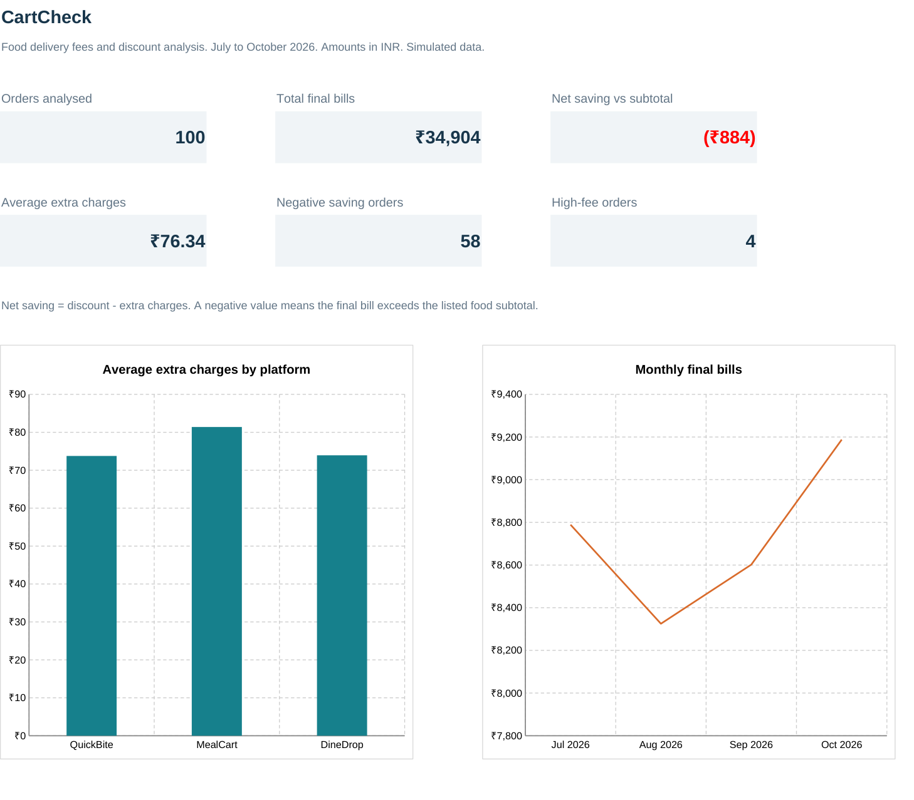
Figure 1 Headline measures, platform average fees and monthly final bills from the saved workbook.
The platform chart compares average extra charges rather than total fees, because the platform order counts differ slightly. Its bar axis begins at zero. The monthly line chart presents the four available months in chronological order. Its narrower labelled value scale is appropriate for showing the change in monthly totals.
A total negative net saving of INR 884 means the total final bills exceed the total listed food subtotals by that amount. It is not a loss relative to an independently observed restaurant or competitor price.

3.10 Dashboard Comparisons
The remaining charts compare outcome counts, average net saving, charge components and fee bands. Each chart answers a different question and reads workbook source cells.
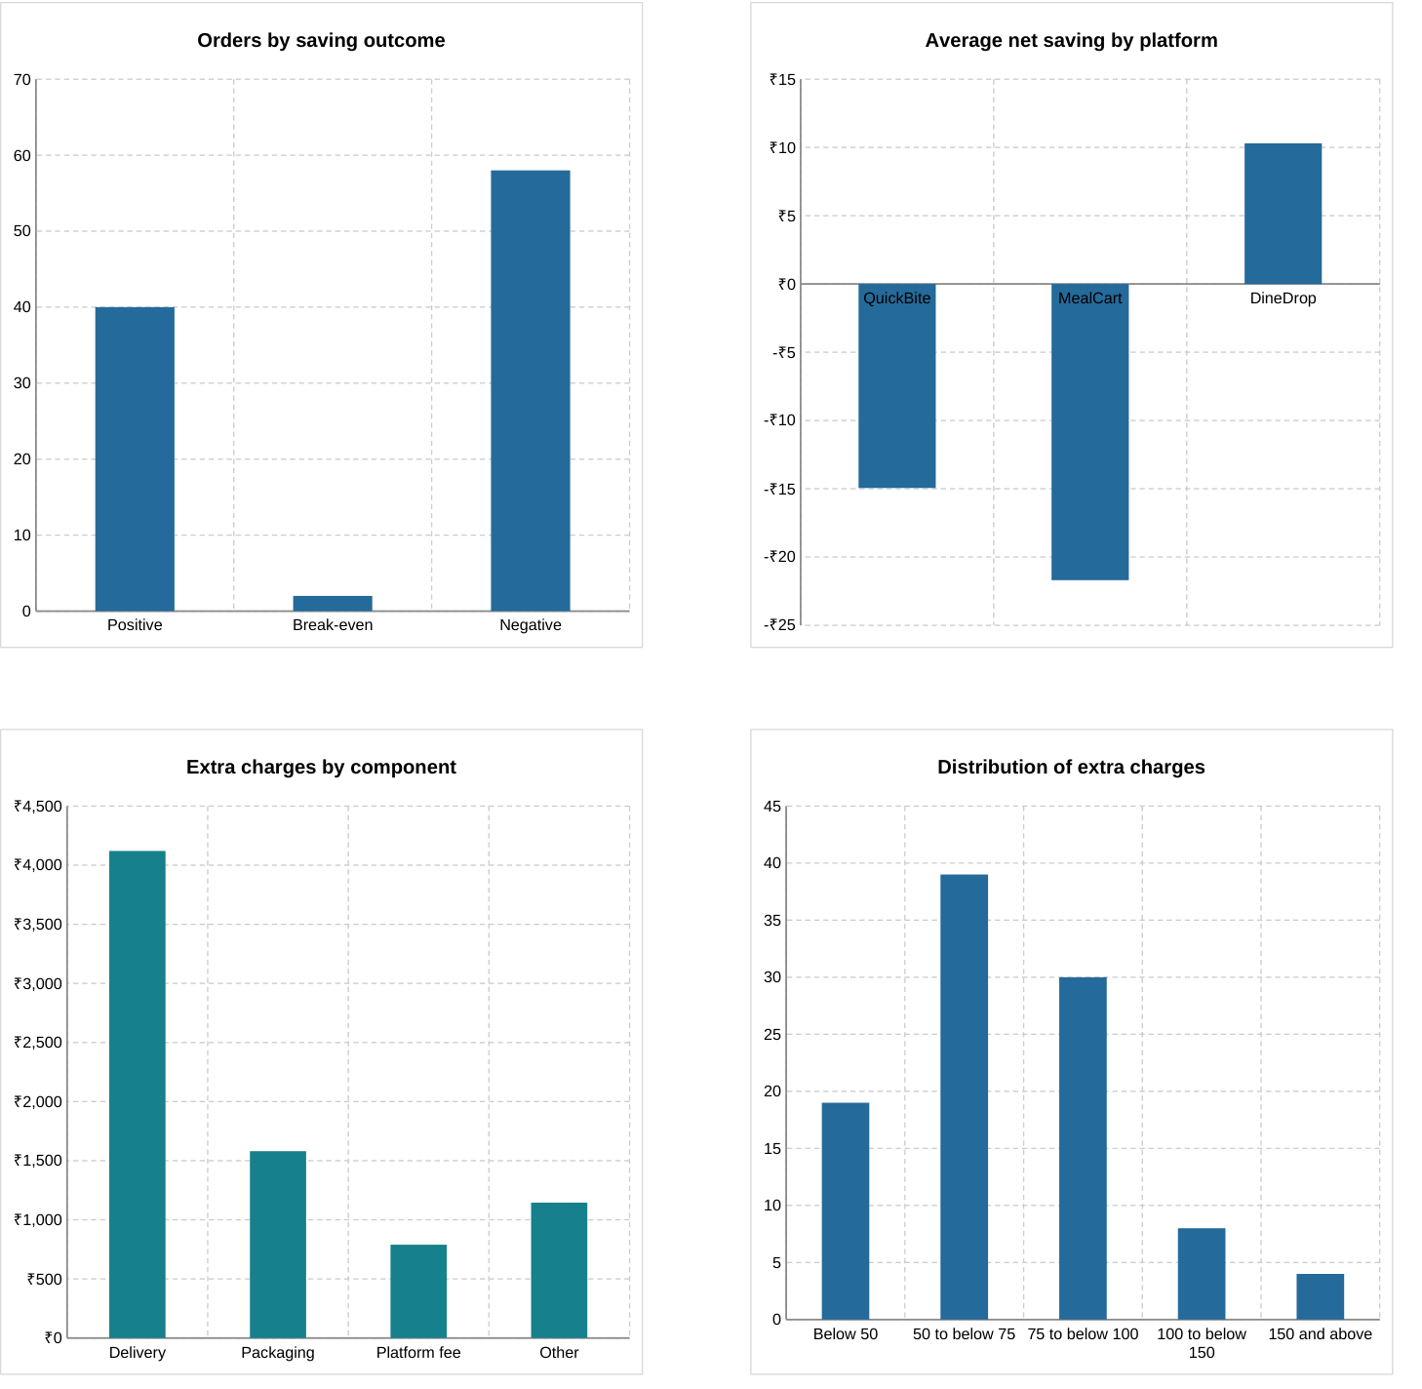
Figure 2 Saving outcomes, platform net saving, fee components and fee distribution.
The outcome chart makes the 58 negative-saving orders visible. The net-saving chart retains negative values on its scale. The component chart shows where the total fees arise. The band chart uses non-overlapping fee intervals so the 100 observations can be reconciled.

3.11 Fee Planner
Fee Planner provides an independent, editable bill example. The amber cells contain the subtotal, discount, four fees and a target net saving. The workbook study remains unchanged when these calculator inputs change.
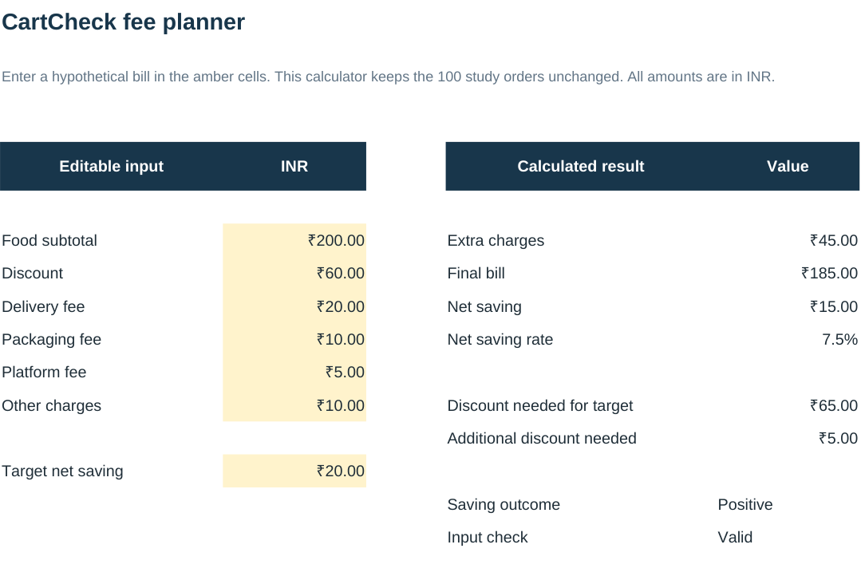
Figure 3 Editable hypothetical inputs and calculated bill measures.
G8 extra charges: =SUM(C10:C13)
G9 final bill: =C8-C9+G8
G10 net saving: =C9-G8
G13 discount needed for target: =G8+C15
G14 additional discount needed: =MAX(0,G13-C9)
The starting fees are INR 45. A target saving of INR 20 requires a discount of INR 65. The current discount is INR 60, so the gap is INR 5. This result assumes the subtotal and fees stay fixed. It does not imply that an additional coupon is available.
Change | Final bill INR | Net saving INR
Starting example | 185 | 15
Delivery fee 20 to 30 | 195 | 5
Discount 60 to 80 with starting fees | 165 | 35

Restore the original planner inputs after demonstrating the changes. A discount equal to fees produces break-even net saving. A discount below the fees produces a negative value.

Chapter 4 Testing and Results

4.1 Quality Checks and Calculation Tests
The workbook preserves all 1,100 original input cells. Data Quality provides nine independent issue counts or reconciliation differences. The saved submission has zero for every check.
Check | Saved result
Missing raw input cells | 0
Rows with duplicate order IDs | 0
Unmapped platform codes | 0
Invalid bill input rows | 0
Dates outside the July to October window | 0
Bill reconciliation difference | 0.00
Outcome count difference | 0
Fee-band count difference | 0
Delivery-denomination frequency difference | 0

Executed calculation checks
Test | Observed behaviour
Orders H8 changed from 20 to 30 | Fees 55, final bill 195, saving 5.
Planner delivery fee changed from 20 to 30 | Same expected bill changes.
Planner discount set to 45, 40 and 80 | Break-even, negative and positive results.
Order subtotal temporarily set to zero | Rate returns n.a.; input check flags review.
Second order temporarily given first order ID | Two affected rows counted as duplicates.
Delivery fee temporarily changed to 21 | Frequency coverage check detects one unlisted fee.

Every temporary edit was restored. The exported workbook was independently reopened to check formulas, tables, names, validations, charts and PivotTable definitions. Formula recalculation and visual checks also used LibreOffice. Microsoft Excel desktop was not available in the preparation environment, so rehearse the demonstration in Excel before submitting.

4.2 Findings and Comparisons
Overall measure | Value
Orders analysed | 100
Food subtotals | INR 34,020
Discounts | INR 6,750
Extra charges | INR 7,634
Final bills | INR 34,904
Net saving | Negative INR 884
Positive / break-even / negative orders | 40 / 2 / 58

The bill identity reconciles exactly: 34,020 - 6,750 + 7,634 = 34,904. Fees equal 113.1 percent of the total discounts and 22.4 percent of the total food subtotals. The aggregate net-saving rate is negative 2.6 percent. This rate uses the ratio of totals rather than an unweighted average of individual order percentages.

Platform comparison
Platform | Orders | Avg fees | Avg discount | Avg net saving
QuickBite | 34 | 73.76 | 58.82 | -14.94
MealCart | 33 | 81.39 | 59.70 | -21.70
DineDrop | 33 | 73.94 | 84.24 | 10.30

Amounts above are INR per order. DineDrop has positive average net saving in this dataset. Different baskets and discount patterns can produce the difference. The result does not establish which platform would be cheaper for a matched order.

Monthly comparison
Month | Orders | Final bills INR | Net saving INR
Jul 2026 | 25 | 8,789 | -469
Aug 2026 | 25 | 8,325 | -165
Sep 2026 | 25 | 8,602 | 18
Oct 2026 | 25 | 9,188 | -268

October has the largest final-bill total. September is the only month with a positive aggregate net saving. The balanced synthetic monthly counts do not support claims about customer demand or seasonal trends.

4.3 Fees and Unusually High Charges
Fee component | Total INR | Share of fees
Delivery | 4,120 | 54.0%
Packaging | 1,580 | 20.7%
Platform fee | 789 | 10.3%
Other | 1,145 | 15.0%

Delivery is the largest recorded fee component. This suggests a useful bill-review priority within the study, but does not show that the charge is avoidable or unreasonable. Service distance and pricing rules are absent.
Extra-charge band INR | Orders | Share
Below 50 | 19 | 19%
50 to below 75 | 39 | 39%
75 to below 100 | 30 | 30%
100 to below 150 | 8 | 8%
150 and above | 4 | 4%

Sixty-nine orders have extra charges from 50 to below 100. The bands are presentation categories, while the statistically defined high-fee cutoff is 128.875. A fee can therefore be high under the IQR rule without belonging to the 150-and-above band in a different dataset.

Orders above the upper fee fence
Order ID | Extra charges INR | Review flag
CC-079 | 286 | High fee
CC-095 | 263 | High fee
CC-018 | 255 | High fee
CC-047 | 238 | High fee

These four fee values total INR 1,042, about 13.6 percent of all extra charges. All remain included in the analysis. Inspecting them is a diagnostic step. Further explanation would require itemised billing information beyond the fields supplied.

4.4 Demonstration and Maintenance

Five minute demonstration
- Open Dashboard and state the question: does the discount still save money after all recorded fees?
- Open Orders and point to A to K as inputs. Explain the first order: subtotal 200, discount 60 and total fees 45.
- Click M8, N8 and O8. Read the formulas in the formula bar. Use Formulas > Show Formulas when asked to display the worksheet code [9].
- Open Fee Planner. Change C10 from 20 to 30 and explain the updated final bill and saving. Restore C10 to 20.
- Open Analysis. Show average fees by platform and explain why a count, sum and average are different.
- Select a native PivotTable. If Orders changed, choose Data > Refresh All and reconcile its total.
- Show Data Quality and explain why unusual fees are retained even when they need review.
- Return to Dashboard and explain the negative INR 884 aggregate net saving and the four high-fee orders.

Adding or replacing data
The current submission deliberately uses 100 records in rows 8 to 107. When adding records, expand OrdersData and fill down all calculated columns. Extend the named ranges, the Analysis formulas and Data Quality ranges. Add new month labels to monthly summaries and extend chart sources if the number of months changes. Refresh the PivotTables afterward.
The delivery-fee frequency list must include any new denomination. Check that its counts still sum to the number of orders before relying on the mode. The five-largest-fee display can repeat the first matching ID when values tie. Filter the complete Orders table to obtain every high-fee record.

Files to submit
Submit the Excel workbook and the report in the format your department accepts. The CSV is a copy of the raw inputs for inspection. The demonstration and viva guide supports preparation. The formulas in the workbook are the source logic of this Excel project; there is no required Python program or VBA macro to run.

Chapter 5 Conclusion and Future Scope

Interpretation
CartCheck shows why a complete bill is a better basis for describing the effect of a coupon than the discount amount alone. Across the study, extra charges exceed discounts by INR 884. This arithmetic explains the negative aggregate saving. At the order level, however, results differ: 40 orders still have positive saving and two break even.
The project also demonstrates that a useful summary depends on the question. Total final bills describe spending, average fees describe the typical fee burden per platform order, and the fee-band chart describes distribution. None of these measures is interchangeable with a matched-price comparison.

Limitations
- The 100 records and platform names are simulated. They cannot establish real market behaviour.
- Order baskets differ. The analysis does not control for restaurant, item, distance or delivery service quality.
- The data covers four months and contains 25 orders per month by construction. It supports no forecasting or seasonal-demand claim.
- Some summaries use fixed ranges and explicit lists. New rows, months and fee denominations require the documented maintenance steps.
- High-fee flags are exploratory cost warnings. Their causes require additional billing evidence.

Future work
A practical extension would use consented, anonymised bills with consistent fee definitions and matched baskets. That would permit a more credible comparison of providers. A larger dataset could use maintained dynamic ranges and additional date grouping. SQL or Tableau could be added as separate implementations if the course requires them. Customer-review NLP would require a new text dataset and separate evaluation; it is not part of the current workbook.

Conclusion
The final workbook combines editable inputs, traceable formulas, native PivotTables, charts, a fee planner and data quality review. It answers the stated bill-analysis question and makes the limitations visible. The strongest finding is specific to the study: INR 7,634 in extra charges outweigh INR 6,750 in discounts, producing negative net saving of INR 884 against the listed food subtotals.

Chapter 6 Project Files and References
The project is delivered as an Excel workbook, an input CSV, a formula reference, a report and a demonstration guide. The workbook contains the source formulas and analysis. The complete set is included in CartCheck_Final_Submission.zip.
1. CartCheck study dataset. 100 simulated food delivery orders, July to October 2026. Orders sheet in CartCheck_Excel_Project.xlsx. Fictional platform names; no external customer data.
2. Data Analytics syllabus supplied for this project. Unit 1 Excel analytics and Project 1 named ranges, dropdowns, sorting and filtering.
3. Microsoft Support. Excel functions by category. https://support.microsoft.com/en-us/excel/excel-functions-by-category
4. Microsoft Support. VLOOKUP function. https://support.microsoft.com/en-us/excel/functions/vlookup-function
5. Microsoft Support. SUMIF function. https://support.microsoft.com/en-us/excel/functions/sumif-function
6. Microsoft Support. QUARTILE function. https://support.microsoft.com/en-us/excel/functions/quartile-function
7. Microsoft Support. Create a PivotTable to analyze worksheet data. https://support.microsoft.com/en-us/excel/get-started/create-a-pivottable-to-analyze-worksheet-data
8. Microsoft Support. Refresh PivotTable data. https://support.microsoft.com/en-us/excel/refresh-pivottable-data
9. Microsoft Support. Show and print formulas. https://support.microsoft.com/en-us/excel/show-and-print-formulas
10. NIST and SEMATECH. e-Handbook of Statistical Methods, section 1.3.3.7, Box Plot. https://itl.nist.gov/div898/handbook/eda/section3/boxplot.htm
Online method references accessed 1 November 2026. Numerical findings in this report are calculated from the CartCheck study workbook.

Appendix Syllabus Coverage
This mapping identifies where the agreed Excel scope is implemented. It is an evidence checklist for the final submission, not an official marking allocation.
Syllabus feature | Implemented evidence | Where to demonstrate
Typed formats | Dates, numeric INR values and percentages | Orders B and F to Q
IF and nested IF | Saving outcome and high-fee flag | Orders S8 and T8
AND | Input completeness and numeric checks | Orders U8
OR | Negative saving or high fee review | Orders V8
NOT | Reversal of valid-record condition | Data Quality G21
IFERROR | Unavailable percentage handling | Orders P8 and Q8
SUMIF | Monthly fee and saving totals | Analysis E14 and D68
AVERAGEIF | Average fees by platform | Analysis D7
COUNTIF and COUNTIFS | Platform counts and fee intervals | Analysis C7 and I54
Lookup | Exact platform-code mapping | Orders L8 and W8:X10
CONCATENATE | Readable order label | Project Guide B81
Named ranges | Four meaningful source names | Formulas > Name Manager
Dropdowns and numeric validation | Controlled categories and amounts | Orders C to K
Sorting filtering conditional formatting | Full-table controls and exception cues | OrdersData
Multiple PivotTables and monthly grouping | Three native PivotTables using a month key | Analysis B32, B42 and B53
Charts and dashboard | Six range-linked native charts | Dashboard
Mean median and mode | Labelled central-tendency measures | Analysis I7:I9
Distribution and outliers | Fee bins and upper IQR fence | Analysis H53:J59 and I12
Validation and interpretation | Nine checks and documented findings | Data Quality and report

SQL, Tableau, predictive modelling, NLP and deep learning are not claimed as implemented features of this Excel-only submission.

Appendix Input and Formula Walkthrough
CartCheck answers one question: after all recorded fees are added, how much of the discount remains? Start with CC-001 in Orders row 8. The following cells are entered inputs; Excel calculates the outputs from them.
Input field | Orders cell | Amount INR
Food subtotal | F8 | 200
Discount | G8 | 60
Delivery fee | H8 | 20
Packaging fee | I8 | 10
Platform fee | J8 | 5
Other charges | K8 | 10

Read the calculation in order
Output | Formula in Orders | Result
Extra charges M8 | =SUM(H8:K8) | INR 45
Final bill N8 | =F8-G8+M8 | INR 185
Net saving O8 | =G8-M8 | INR 15
Saving rate P8 | =IFERROR(O8/F8,"n.a.") | 7.5%
The discount is INR 60, but INR 45 of fees offsets most of it. The order therefore saves INR 15 against its INR 200 food subtotal. A positive result means a saving, zero means break-even, and a negative result means the final bill exceeds the subtotal.

Open and demonstrate the workbook
Open CartCheck_Excel_Project.xlsx in Excel. In Orders, select M8, N8 and O8 and read each formula in the formula bar. Formulas > Show Formulas displays the worksheet logic. The formulas are the code for this Excel project.
For a safe live example, open Fee Planner and change C10 from 20 to 30. Extra charges become INR 55, the final bill becomes INR 195 and net saving becomes INR 5. Restore C10 to 20. Open Analysis to inspect the three PivotTables, then Dashboard for the charts and Data Quality for the nine checks. Use Data > Refresh All after changing Orders.

