“Test Case Migrator Plus” (Excel/MHT) - Readme document

Table of Contents
“Test Case Migrator Plus” (Excel/MHT) - Readme document 1
1. Licensing 2
2. Overview 3
3. Pre-Requisites 4
4. What’s new for this version (RC2) 4
5. Installing 5
6. Running “Test Case Migrator Plus” Using UI Wizard 6
7. “Test Case Migrator Plus” in Excel based workflow 6
7.1 “Welcome” dialog (Excel flow) 7
7.2 “Source” dialog (Data Source Types) 8
7.3 “Source” dialog (Excel flow) 9
7.4 “Destination” dialog (Excel flow) 10
7.5 “Settings” dialog (Excel flow) 11
7.6 “Field mapping” dialog (Excel flow) 12
7.7 “Data mapping” dialog (Excel flow) 15
7.8 “Links mapping” dialog (Excel flow) 17
7.9 “Miscellaneous Settings” dialog (Excel flow) 19
7.10 “Confirm” dialog (Excel flow) 21
7.11 “Progress” dialog (Excel flow) 22
7.12 “Session Output Log File” (Excel flow) 23
7.13 “Consolidated Excel Pivot reports” (Excel flow) 24
8. “Test Case Migrator Plus” in Mht/doc based workflow 27
8.1 “Welcome” dialog (MHT flow) 27
8.2 “Source” dialog (Data Source Types) 28
8.3 “Source” dialog (MHT flow) 28
8.4 “Destination” dialog (MHT flow) 30
8.5 “Settings File” dialog (MHT flow) 31
8.6 “Fields” dialog (MHT flow) 32
8.7 “Field mapping” dialog (MHT flow) 34
8.8 “Data mapping” dialog (MHT flow) 37
8.9 “Miscellaneous Settings” dialog (MHT flow) 38
8.10 “Confirm” dialog (MHT flow) 39
8.11 “Progress” dialog (MHT flow) 40
8.12 “Output Report File” (MHT flow) 41
9. Using Command line (for both Excel or mht flows) 43

Licensing
This tool is covered under the MS-PL license (reproduced below for convenience)
Microsoft Public License (MS-PL)
This license governs use of the accompanying software. If you use the software, you accept this license. If you do not accept the license, do not use the software.
- Definitions
The terms "reproduce," "reproduction," "derivative works," and "distribution" have the same meaning here as under U.S. copyright law. A "contribution" is the original software, or any additions or changes to the software. A "contributor" is any person that distributes its contribution under this license. "Licensed patents" are a contributor's patent claims that read directly on its contribution.
- Grant of Rights
(A) Copyright Grant- Subject to the terms of this license, including the license conditions and limitations in section 3, each contributor grants you a non-exclusive, worldwide, royalty-free copyright license to reproduce its contribution, prepare derivative works of its contribution, and distribute its contribution or any derivative works that you create.
(B) Patent Grant- Subject to the terms of this license, including the license conditions and limitations in section 3, each contributor grants you a non-exclusive, worldwide, royalty-free license under its licensed patents to make, have made, use, sell, offer for sale, import, and/or otherwise dispose of its contribution in the software or derivative works of the contribution in the software.
- Conditions and Limitations
(A) No Trademark License- This license does not grant you rights to use any contributors' name, logo, or trademarks.
(B) If you bring a patent claim against any contributor over patents that you claim are infringed by the software, your patent license from such contributor to the software ends automatically.
(C) If you distribute any portion of the software, you must retain all copyright, patent, trademark, and attribution notices that are present in the software.
(D) If you distribute any portion of the software in source code form, you may do so only under this license by including a complete copy of this license with your distribution. If you distribute any portion of the software in compiled or object code form, you may only do so under a license that complies with this license.
(E) The software is licensed "as-is." You bear the risk of using it. The contributors give no express warranties, guarantees, or conditions. You may have additional consumer rights under your local laws which this license cannot change. To the extent permitted under your local laws, the contributors exclude the implied warranties of merchantability, fitness for a particular purpose and non-infringement.

Overview

With the prior releases of Test Case Migrator (Beta and RC1), it was possible to:
- migrate test cases (along with test steps) present in Microsoft Excel to VS2010 TCM server AND
- migrate VS 2005/2008 test templates present in MHT/doc formats to VS2010 TCM server.
These capabilities allowed you to reap all the benefits associated with Test Case Management (requirements traceability, test coverage, requirements coverage, test execution, test result analysis etc) present in VS 2010 release post migration.
With the RC2 release of this tool, we are adding to the Excel capabilities, the ability to migrate not just the Test case work item, but also Requirements and Bugs work items – hence the change in name of the executable to “TestCaseMigratorPlus.exe”. The mht/doc based workflow remains the same – i.e. it only supports migration of work item type present in the VS2005/2008 manual test templates.
Some of the salient features associated with this version of tool (for excel based workflow) are as follows:
- Migrates work items belonging to Test case, Requirement/User story and Bug work item types.
- Supports multi-pass migration process - i.e., each work item type has to be migrated in a different invocation/session of the tool.
- Maintains links between work item types (Parent/Child, Related, Tested By, Tests etc) across multiple passes.
- Provides ability to create Test suites for a test case work item type.

Salient features associated with prior versions of the tool include:
- Migrates Test case information (along with Test Steps) present in Excel – This is a ONE way migration only.
- Migrates VS2005/VS2008 manual test case templates (MHT/word) into TCM/TFS server – This also is ONE way migration only.
- Provides a wizard based UI to run the tool one file at a time (for Excel) or iterate over multiple files within a folder in a single run (for MHT/word).
- Provides a command line support to run the tool in a batch mode.
- Allows you to save your selections/configurations into a settings/mappings file to be reused later.
- Default settings/mapping file that works across both Agile based and CMMI based projects is shipped along with the tool.

Pre-Requisites

Both the following pre-requisites need to be present on the machine before you can run the “Test Case Migrator Plus” tool. Without these, the tool will not function.

- Microsoft Visual Studio 2010 RTM bits
  - Microsoft Visual Studio 2010 Ultimate Edition RTM (Web Install) (OR)
  - Microsoft Visual Studio 2010 Premium Edition RTM (Web Install) (OR)
  - Microsoft Visual Studio Test Professional RTM (Web Install) AND Microsoft Visual Studio 2010 Team Explorer (ISO)
- Version of Microsoft Office 2003 or beyond

What’s new for this version (RC2)
With this new drop in RC2, the following functionality has been added to the Excel based workflow:
- Migrate not just Test case, but also Requirement/User story and Bug work item types.
- Migrate links (using “Links mapping” dialog (Excel flow)) between different work item types across different invocations/sessions of the tool. Refer to “LinksMapping(Excel)-Internals-Readme.doc” for additional details.
- Default link types supported include:
  - “Parent/Child” links between Requirement::Requirement
  - “Related” links between Requirement::Requirement
  - “Related” links between Test Case::Test Case
  - “Related” links between Bug::Bug
  - “Related” links between Requirement::Bug
  - “Tested By/Tests” links between Requirement::Test Case
  - “Tested By/Tests” links between Bug::Test Case
- Create Test plans/test suites as part of migration process for a Test case work item type.
- Create Area/Iteration Paths at runtime based on folder hierarchy specified in excel file for all supported work item types.
- Analyze the migration process across different runs using “Consolidated Excel Pivot reports” (Excel flow) in addition to the session based output excel file.
- Updated and polished UI for the tool – now this is consistent with VS2010 theme.
- Improved and early inline error handling.

No changes have been made to the mht/doc based workflow other than UI polish.

Installing
Download the “TestCaseMigratorPlus(Excel-MHT) V1.0 RC2 Binaries.zip” and extract it to a folder and start the TestCaseMigratorPlus.exe application. Along with the binaries package, the other files that might be useful include the Readme document, the Linking internals document and the samples package (one for Excel & other for MHT). The sample packages contain corresponding setting file that you can use to jump start the migration process.
Different artifacts of the package:
- TestCaseMigratorPlus(Excel-MHT) V1.0 RC2 Binaries.zip
- TestCaseMigratorPlus(Excel-MHT) V1.0 RC2 SourceCode.zip
- TestCaseMigratorPlus(Excel-MHT)-Readme.doc
- LinksMapping(Excel)-Internals-Readme.doc
- Samples-ExcelPackage-RequirementsBugsTestCases.zip
- Samples-MhtPackage-TestCases.zip

Running “Test Case Migrator Plus” Using UI Wizard
The “Test Case Migrator Plus” is a wizard based tool that guides you through the different steps to migrate work item (test case, requirement/user story, bug) data into TFS. The tool supports the migration of work item information from two different data sources:
- Excel – supports migration of test case, requirement/user story & bug work items; provide an excel workbook containing work item information.
- MHT – supports migration of work item present in the VS2005/VS2008 manual test template (MHT/doc) files; provide mht/doc file containing test case information.
Since most of the functionality added in this release (RC2) is primarily focused on Excel based workflow, the document has been restructured to focus on these two flows separately – “Excel based workflow” that migrates test cases, requirement/user story and bug work item types AND “mht/doc based workflow” that migrates test cases alone present in VS2005/2008 manual test template format.

“Test Case Migrator Plus” in Excel based workflow

“Welcome” dialog (Excel flow)
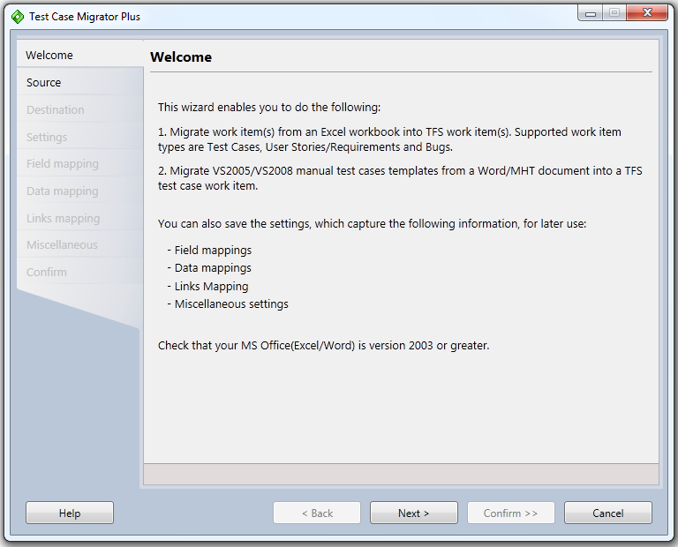
Figure 1: Welcome dialog (Excel flow)

Purpose
Provides you an overview of what options are possible when using the “Test Case Migrator Plus” wizard.

“Source” dialog (Data Source Types)
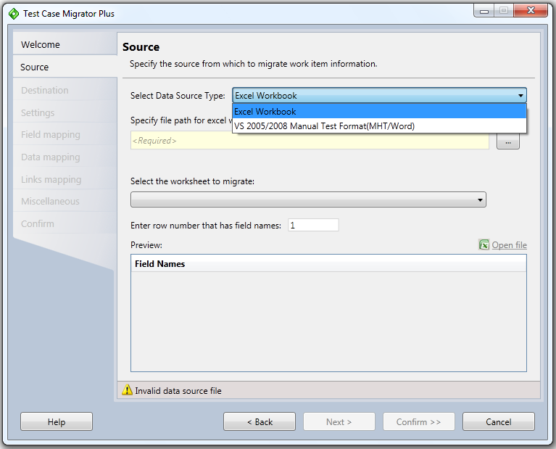
Figure 2: Source Dialog - Data source types supported
The above figure shows the two different options provided for the data source type – use “Excel workbook” option to migrate data (test cases, requirements/user stories, bugs) from Excel and use “VS 2005/2008 Manual Test Case Format (MHT/Word)” option to migrate test cases from mht/word into TFS.

“Source” dialog (Excel flow)
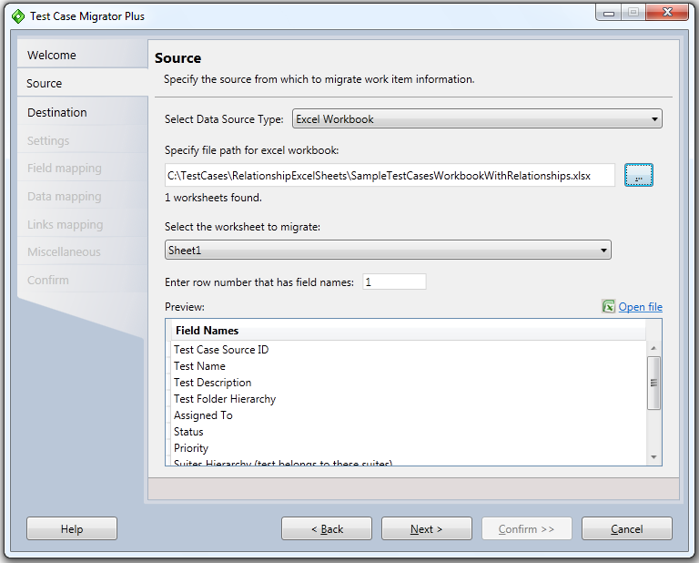
Figure 3: Source Dialog - Excel flow

Purpose
Allows you to specify the excel workbook, the worksheet and the row number from which work item data needs to be migrated.

Interactive fields
File Path: Enter the Excel workbook name from which work item information needs to be migrated.
Worksheet: Enter the excel worksheet that contains the work item data to be migrated.
Row Number: Specify the row number which contains the field names. The field names will be used to map to the TFS work item fields. The field names specified in the row numbers are shown in the Preview area.
Open File: Opens the excel workbook specified in the file path.

“Destination” dialog (Excel flow)
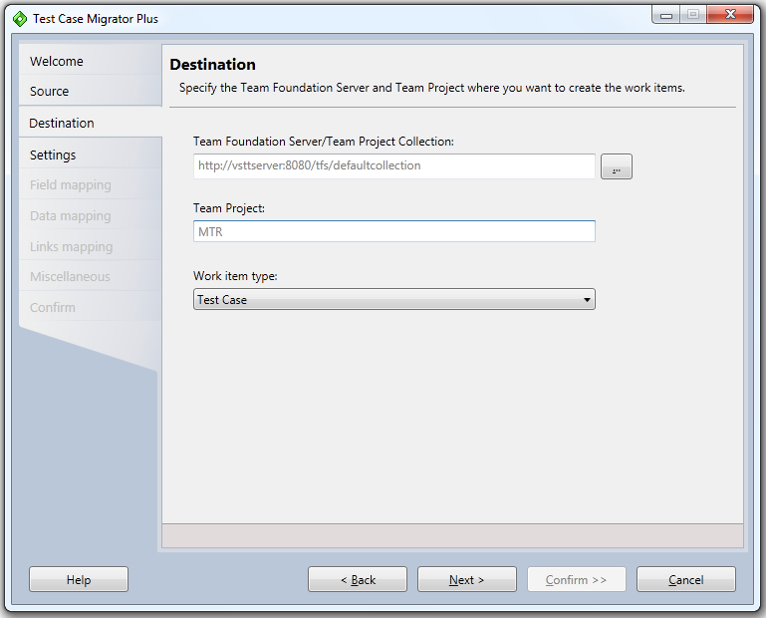
Figure 4: Destination dialog (excel flow)

Purpose
Allows you to specify the TFS Server/Project Collection, Project and the Work Item template where data will be migrated into.

Interactive fields
TFS Server/Project Collection: Select the TFS Server/Project Collection where the data needs to be migrated into. The selection is possible by clicking on “…” button.
Project: Shows the TFS Project selected from the Project selection dialog (after clicking “…” button).
Work item type: Select the “work item type (WIT)” template that will be used to migrate the data into. Supported work item templates include test case, requirement/user story and bug work item categories. The default test case work item type for test case category of project is displayed in the work item type drop down.

“Settings” dialog (Excel flow)
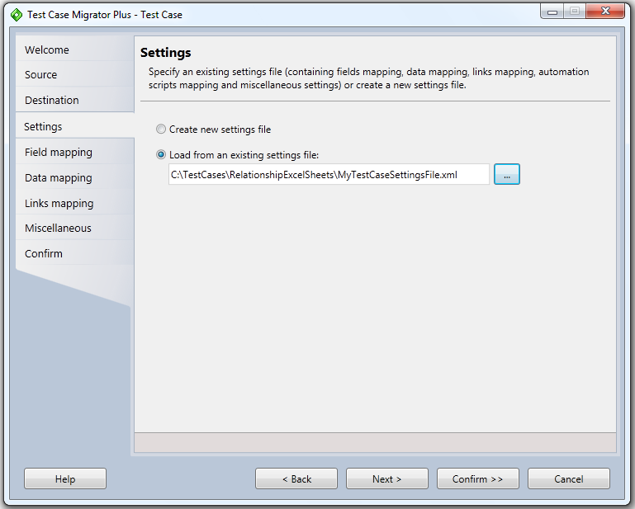
Figure 5: Settings file dialog (excel flow)

Purpose
Allows you to specify a setting/mapping file to load the settings from OR use a blank file. Setting files (when saved) contain the configuration choices made (for field mapping, data mapping, links mapping, miscellaneous mapping) that show up in subsequent wizard dialogs.
Along with the tool, a sample settings file for each work item type that correspond to the Sample excel file are also being released, which have the settings defined that work across both Agile and CMMI project templates (that ship out-of-the-box with TFS). You can use these to jump start your migration process.

Interactive fields
Use blank settings file: When running the tool for the first time or you want to start fresh, then choose this option.
Load from an existing settings file: Select the settings file by clicking on “…” button.

“Field mapping” dialog (Excel flow)
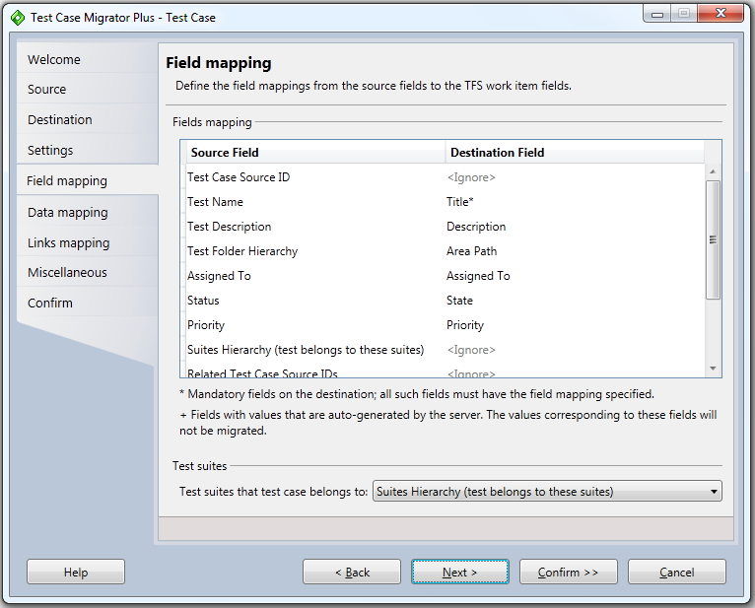
Figure 6: Field mapping dialog (Excel flow)

Purpose
Allows you to specify the field mapping between the Excel workbook columns and TFS work item fields. For each field (column) in the Source field, you need to map the corresponding TFS work item field. Data will be migrated for only those fields/columns which have a destination column mapping defined. Fields with “<Ignore>” will be ignored during migration process. Mandatory fields are marked as “*” in the drop down list. Fields which are auto-generated by the TFS server are marked as “+” in the drop down list.
This page also allows you to specify the field/column mapping representing the test suites a particular test case belongs to. If value is specified, then Test Suites are auto created using the hierarchy specified in the column value.

Interactive fields
Source Field: Shows all the fields/columns present on the row number specified in the Source dialog. This list is not editable.
Destination Field: Each drop-down contains the list of TFS work item fields for the Server/Project/WIT selected in the Destination dialog. Select the corresponding work item field that you want to map the excel source column to.
Test Suite that Test case belongs to Field: Select the field/column representing the test suites a particular test case belongs to. This field will only appear in Excel workflow and if the selected work item type is a Test Case. For all other work item types, this field will not appear. It is possible that one test case may be present in multiple test suites. In such case, the test suite values can be separated using “;” (semicolons) in the excel worksheet. If a value is specified, then the Test suites are created automatically using the hierarchy specified in the column value.
For example, referring to the “SampleTestCaseWorkbookWithRelationships.xls”, the column “Test Execution Plan(s)" folder path” represents the data for Test Suites. Looking at the first row of data for TestCaseID 56913, the different types of test suites that this test case belongs to are represented by OnlineFinancialSystem\E2E; OnlineFinancialSystem\BVT; OnlineFinancialSystem\NARs; OnlineFinancialSystem\FARs; OnlineFinancialSystem\Priority\P1s.
In this above case, the tool will auto-create a Test Plan “OnlineFinancialSystem” and underneath that will create multiple folder based suites – E2E, BVT, NARs, FARs, Priority\P1s and then add the test case 56913 under each of the above test suites.
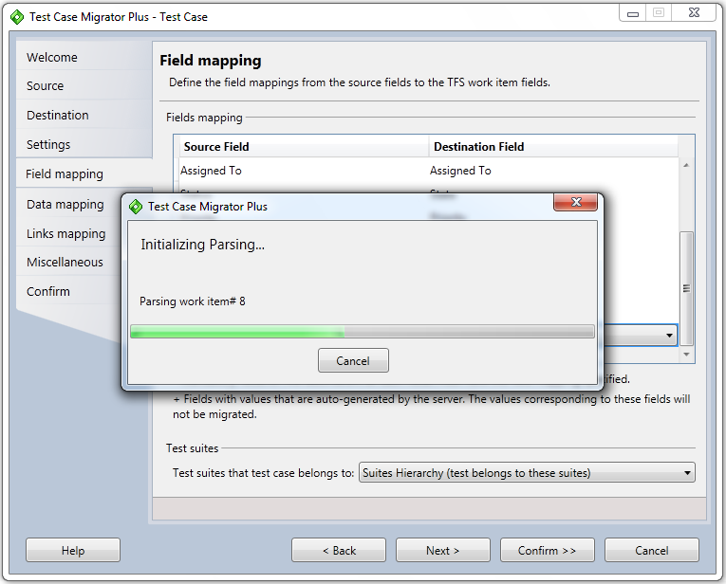
Figure 7: Parsing Excel file records (excel flow)
After specifying the field mapping for the excel workflow, clicking on “Next” starts the parsing process of the records present in the selected excel file. When the number of rows in the excel worksheet is large, you get a “Parsing Progress” window that shows the progress of the parsing. You can cancel the parsing at any time. To restart the parsing, you will have to click on the “Next” button again.

“Data mapping” dialog (Excel flow)
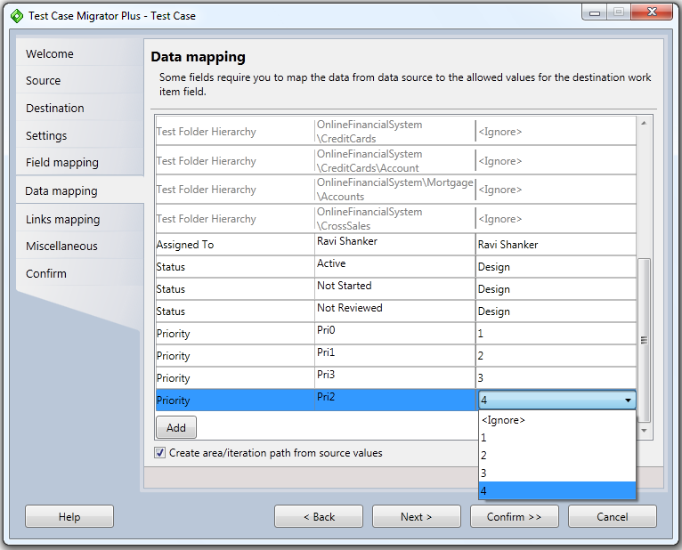
Figure 8: Data mapping dialog (excel flow)

Purpose
If certain fields in your source field in excel worksheet contain data which mismatches with the “allowed values” specified for the corresponding TFS work item field, then you use this dialog to specify the data mappings so that the migration process will not error out for such rows.
By default, the wizard auto-calculates such field values from excel worksheet and shows them in this dialog. However, you can add additional rows (by clicking ‘add’) for defining the data mapping that you know exists in your source fields (excel sheets), but not necessarily within the currently selected worksheet. This allows you to define the data mappings once and then reuse it across multiple excel workbooks.
In the example above, the excel worksheet file contains value of “Pri2” in the source field, but the TFS work item allows values of 1,2,3,4. You are specifying to map “Pri2” to “4” when the migration process runs.
If no value is specified, then the tool will try to apply the defaults that may have been defined at TFS level. If the tool cannot apply any TFS level defaults, then that record will be marked as “error” in the report generated.
If you have mapped any excel source value field to “Area path” or “Iteration path” fields on the destination TFS side, then by default, all the values in the area/iteration path will be created automatically by the tool (if they do not exist in the first place). If you do not want these source values to be created on TFS, you can uncheck the “Create area/iteration path from source values” checkbox and then select the value you want to map on the destination side.

Interactive fields
Data Source Field: Shows all the fields that have allowed values on the TFS side.
Data Source Value: Shows the value currently contained in the excel column.
Destination Value: Specify the destination value to map to.
Add: allows the addition of new rows to handle scenario where the data may not be present in the currently selected excel worksheet, but may be present in other worksheets and you are defining a single mapping file to work across all such input files.
Create area/iteration path from source values: allows you to specify how the area/iteration path source values must be handled by the tool. When this checkbox is checked, all the values present in the area or iteration path will be used to create new area/iteration paths in TFS (if they do not exist already). In such case, the Destination value column will be set to “<ignore>” and that row will not be editable. If you do not want the area/iteration paths to be created from the source values, then you uncheck this checkbox. This will enable you to specify the corresponding TFS mapping value in the Destination value column.

“Links mapping” dialog (Excel flow)
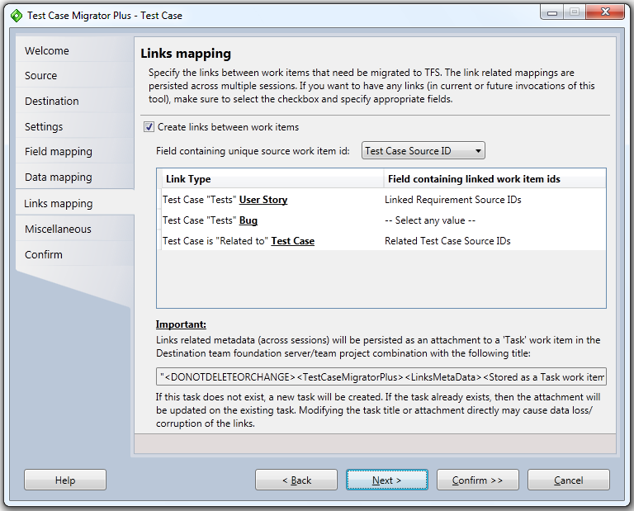
Figure 9: Links mapping dialog (Excel flow)

Purpose
Allows you to specify the different links within a particular work item type (ex: Requirement::Requirement -Parent/Child) or links between work item types (ex: Requirement::Test Case – TestedBy). Since the migration of different work item types can only be done in multiple invocations/sessions of the tool, the linking metadata information is persisted across different invocations/sessions for a TFS Server/Project combination.

Interactive fields
Create links between work items: Check this option if you need to create any types of links in current OR future invocations/sessions of the tool. If this option is checked, then the tool maintains a record of all the invocations/sessions of the tool for a project/server combination. This allows the links to be created between work items even if they may have been migrated over a period of time. Checking this option also ensures that the consolidated reports (excel pivot reports) get generated. Hence, make sure that you check this option if you want any type of links to be created ever for a project/server combination. By default, this checkbox is checked.
Field containing unique source work item ids: select a field/column in the excel worksheet that uniquely identifies the work item record in the source system (either excel or some other 3rd party system). This value will be used to define and track the links between work item types. If the source file does not contain a unique value for the work item record, then links cannot be created using this tool.
Link Type: This field shows the list of default link types you can create either within the same work item type or across work item types. The values in this field differ depending upon the currently selected work item type in the Destination page. If you are using CMMI project, then text of “Requirement” shows up, if you are using an Agile project, then text of “User story” shows up in the links text below.
Requirement/User Story work item category/type:
Source Work Item | Link Type | Destination work item
User Story is | Tested By | Test Case
User Story has | Parent | User Story
User Story is | Related to | User Story
User Story is | Related to | Bug

Test case work item category/type:
Source Work Item | Link Type | Destination work item
Test Case | Tests | User Story
Test Case | Tests | Bug
Test Case is | Related to | Test Case

Bug work item category/type:
Source Work Item | Link Type | Destination work item
Bug is | Tested By | Test Case
Bug is | Related to | Bug
Bug is | Related to | User Story

Field containing linked work item ids: Select a field/column in the excel worksheet that represents the values for the links that need to be created for the selected source work item id. This field can either have a single value (in case of Parent/Child relationship between requirements) or can have multiple values (in case of related bugs for a test case). When multiple values are specified in the excel field, they need to be separated by “;” (semicolon). If no value is specified, then links will not be processed in the current invocation of the tool.
Adding custom link types: If you need to support any additional link types apart from the ones mentioned above, you can directly add them to the corresponding settings file you have created. Once it has been added to the settings file, those link types will appear in the links mapping UI page. This allows you to now save the additional link types into the settings file for later use.
Refer to “LinksMapping(Excel)-Internals-Readme.doc” for internal details on how to add custom link types or learn how the links are tracked and created across multiple invocations/sessions of the “Test Case Migrator Plus” tool.

“Miscellaneous Settings” dialog (Excel flow)
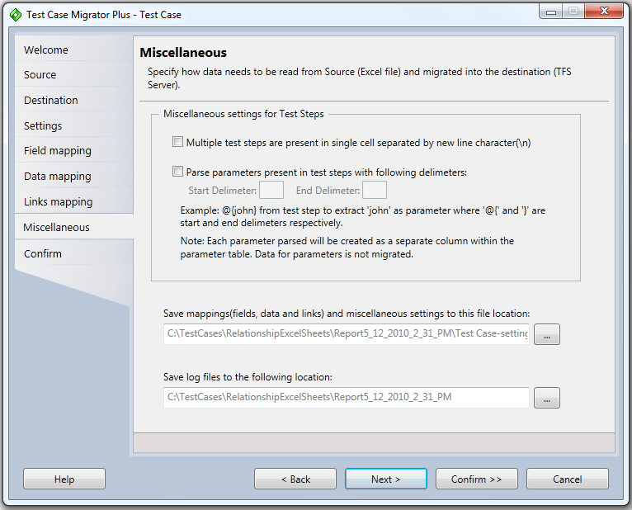
Figure 10: Miscellaneous Settings dialog (Excel)

Purpose
Allows you to specify miscellaneous settings related to Test Steps (in case of Test Case work item) along with ability to save the mappings file and the output log files.

Interactive fields
Multiple steps within single cell: This option only comes up when a test case work item category/type is selected in the Destination page. For all others, this does not appear. Check this option if your excel worksheet contains test steps that are contained within a single cell for a particular Test Case. See below for example. When this option is checked, all the information within the single cell are created as separate steps on TFS.
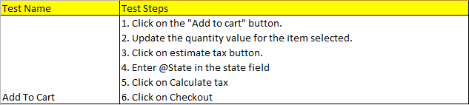

Parse Parameters: This option only comes up when a test case work item category/type is selected in the Destination page. For all others, this does not appear. Check this box if your steps contain parameters and you want the tool to create a parameter table on TFS. To parse the parameter within the test step, tool requires you to specify the “Start” and “End” delimiters. Note that an empty parameter table will be created on TFS, data for the parameters is not migrated. That must be done outside of the current tool.
Save Mappings: Specify the folder location where the mappings (field mapping, data mapping, links mapping, miscellaneous) file can be saved to. This is a required field. By default, it auto-selects the same folder that was used to specify the input worksheets. It adds the “Report_<currentdatetimestamp>” folder to the selected folder and then appends it with a file name of “<workitemtype>-settings.xml”. The default folder can be changed by clicking on the “…” button. The filename can also be changed as per your need.
Output Log folder: Specify the folder location where all the output log files can be saved to. This is a required field. By default, it auto-selects the same folder that was used to specify the input worksheets. It adds the “Report_<currentdatetimestamp>” folder to the selected folder. The default output log folder can be changed by clicking on the “…” button. The session level excel file and the consolidated excel pivot reports are generated in this output log folder.

“Confirm” dialog (Excel flow)
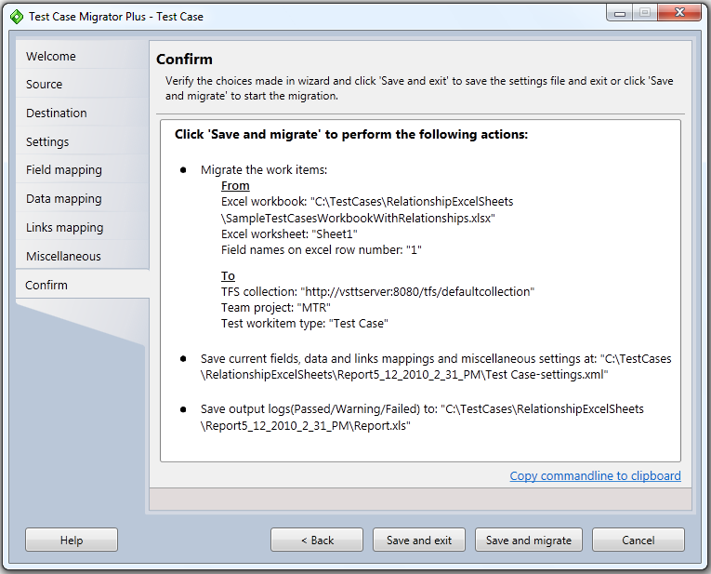
Figure 11: Confirm dialog (Excel)

Purpose
Allows you to preview the choices made in the wizard along with ability to “Save and exit” the wizard without actually doing the migration OR “Save and migrate” which will initiate the migration process.

Interactive fields
Copy command-line to clipboard: This copies a command line invocation of the tool to the clipboard, which can be invoked after doing “Save and exit” on the confirm dialog and which will migrate exactly as this UI based flow would have worked if the user hit “Save and migrate” instead of “Save and exit”. This is helpful if you want to run multiple invocations of the tool using the same settings file but with different input excel file in a batch mode.
Save and exit: Will save the settings file (if specified) containing field mappings, data mappings, links mapping and miscellaneous settings. Note that this saving does not save the Source, Destination or the Output Log folder. All these are outside of the mappings file.
Save and migrate: Will save the settings file (if specified) and then start the migration process.

“Progress” dialog (Excel flow)
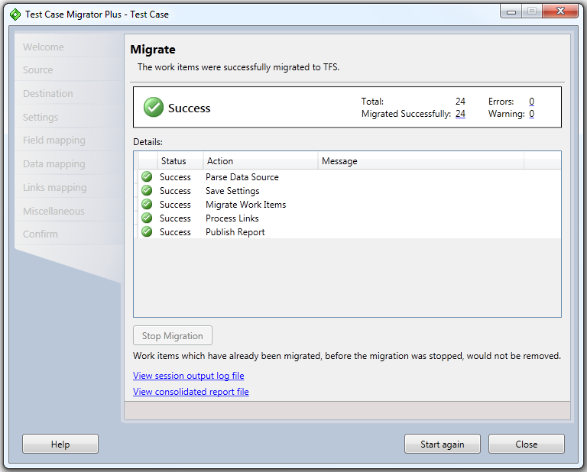
Figure 12: Progress Dialog (excel flow)

Purpose
Shows you the progress of the migration process. It also allows you to stop the migration in middle. Note, if migration is stopped in middle, the rows which have already been migrated will *NOT* be reverted back. Even though you stop the migration is middle, the tool will still process all the links for the already migrated work items and generate the respective output reports. After the completion of the migration process (interrupted or uninterrupted), it also allows you to review the Output log files and the consolidated Linking report (excel pivot based) if “create link mappings” was checked. This dialog also provides a summary of the migration for the current invocation at the top of the dialog.

Interactive fields
Stop Migration: Will stop the in-progress migration process. Rows that have already been migrated into TFS will not be removed. Stopping migration will still process the links/relationships for the already migrated work items and then generate the output reports.
Summary: For the current invocation of the tool, it shows the total number of rows processed, the number of rows successfully migrated, the number of rows migrated with warnings and the number of rows that were not migrated due to errors. Each of the links, opens up the respective worksheets within the session output log file.
Current session Output Log file: Clicking on the link opens the current session’s output log file (workbook) that contains different worksheets – one for successful migration, one for warnings and the last one for errors.
Consolidated report file: Clicking on the link opens the consolidated report file (workbook) that contains the worksheets with raw data (that is used to generate the pivots) along with different Pivot based reports (Migration-Summary, Migration-Details, LinksMapping-Summary, LinksMapping-Success, LinksMapping-Warnings, LinksMapping-Failed, LinksMapping-PerSourceWorkItemID).

“Session Output Log File” (Excel flow)

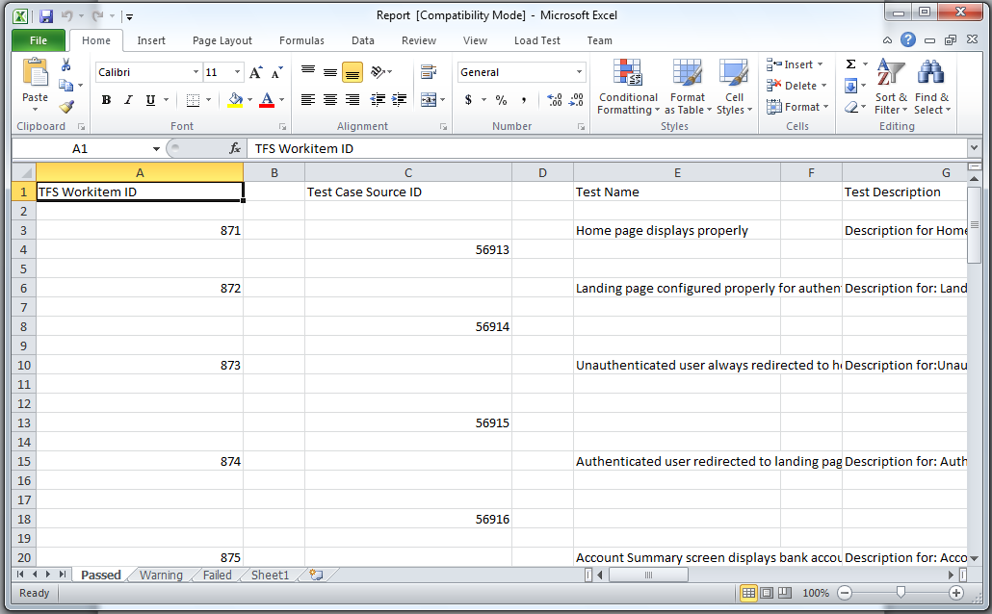
Figure 13: Session Output Log File (Excel flow)

Purpose
Shows you the current session’s output of the migration process.

Interactive fields
Passed worksheet: Shows the columns that were selected in field mappings, test suites mapping, links mapping and the corresponding TFS work item ID that was generated for each of the successful migrated rows.
Warning worksheet: Shows the columns that were selected in field mappings, test suites mapping, links mapping and the corresponding warning message received from TFS during the migration of that particular row.
Failed worksheet: Shows the columns that were selected in field mappings, test suites mapping, links mapping and the corresponding error message received from TFS during the migration of that particular row.

“Consolidated Excel Pivot reports” (Excel flow)
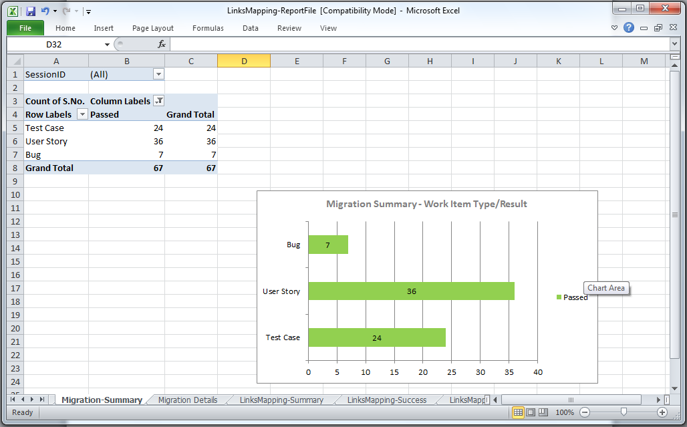
Figure 14: Consolidated Excel pivot report file (after migrating test case, requirements, bugs)

Purpose
Shows you the consolidated report across invocations/sessions that contains both the migration status reports along with the links mapping reports, which are different pivot reports that use the raw table data.

Interactive fields
Raw Data Table: Shows the underlying raw data captured across invocations/sessions (until the last session). The different columns in this worksheet are:
- SNo: captures the record count.
- SessionID: captures the id for each invocation of the tool for a server/project combination.
- MigrationResult: captures the status of the migration of the work items. Values include passed, failed or blank (when the record tracks the links result instead of migration result).
- StartWorkItemType: captures the work item type that was used in the Excel source file for migration/links purpose.
- StartWorkItemSourceID: captures the unique id for the work item record in the excel source file. This is specified in the “Links mapping” page. As mentioned earlier, if the unique source id is not specified, then the consolidated report cannot be generated.
- StartWorkItemTfsID: captures the work item id that was created in TFS post migration. Value of “-1” indicates that migration was attempted, but it failed.
- LinkType: captures the type of link that was used to link the StartWorkItemType and EndWorkItemType records.
- EndWorkItemTfsType: captures the work item type that was used in the TFS destination for creating links.
- EndWorkItemSourceID: captures the unique set of values specified in the excel source file that were used to link the “startworkitemtype” to “endworkitemtfstype”.
- EndWorkItemTfsID: captures the work item id that was created in TFS post migration and post linking.
- IsExistsInTFS: captures whether the link has been created in TFS or not. This is used only for the linkmapping record, not for the migration record.
- Message: captures any error or warning message received from TFS either at time of migration or at the time of creating links.
The good part of the raw table is that it allows you to create any additional custom pivot reports in addition to the default set that come out of the box. The raw table also allows you to slice/dice the data by applying the different excel filters present in the worksheet.
Migration Summary Report: Shows the summary view of migration status with “sessionid” as pivot filter, “migrationresult” as column labels, “Startworkitemtype” as row labels and “count of S.No” as the aggregrating values.
Migration Details Report: Shows the drilldown of migration records with “sessionid” & “migrationresult” as pivot filters, “message” & “startworkitemsourceid” as row labels and “count of S.No” as the aggregating values.
Links Mapping Summary Report: Shows the summary view of links mapping status with “sessionid” as pivot filter, “linksmappingresult” as column labels, “startworkitemtype” & “linktype” as row labels and “count of S.No” as the aggregating values.
Links Mapping Success Report: Shows the drilldown of successful linked records with “sessionid”, “startworkitemtype” & “linksmappingresult=passed” as pivot filters, “linktype” as column labels, “startworkitemsourceid” as row labels and “count of S.No” as the aggregating values.
Links Mapping Warnings Report: Shows the drilldown of warning linked records with “sessionid”, “startworkitemtype” & “linksmappingresult=warning” as pivot filters, “linktype” as column labels, “message” & “startworkitemsourceid” as row labels and “count of S.No” as the aggregating values.
Links Mapping Failed Report: Shows the drilldown of warning linked records with “sessionid” & “linksmappingresult=failed” as pivot filters, “linktype” as column labels, “startworkitemtype”, “message” & “startworkitemsourceid” as row labels and “count of S.No” as the aggregating values.
Links Mapping Per Source Work Item Report: Shows the drilldown linking report for particular source work item id with “startworkitemsourceid” as pivot filter, “linksmappingresult” as column labels, “linktype” as row labels and “count of S.No” as the aggregating values.

“Test Case Migrator Plus” in Mht/doc based workflow

“Welcome” dialog (MHT flow)
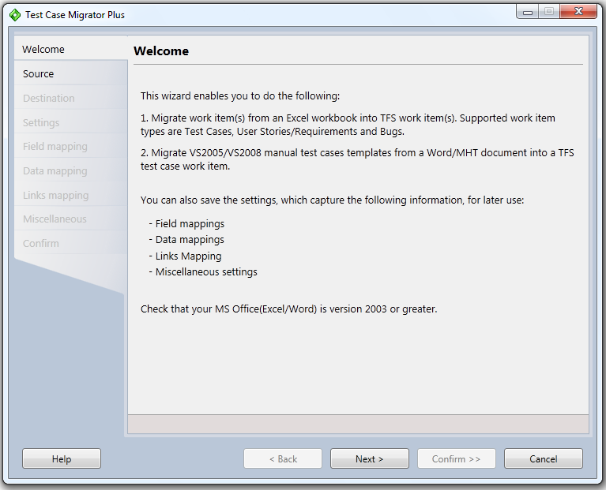
Figure 15: Welcome dialog (Mht flow)

Purpose
Provides you an overview of what options are possible when using the wizard.

“Source” dialog (Data Source Types)
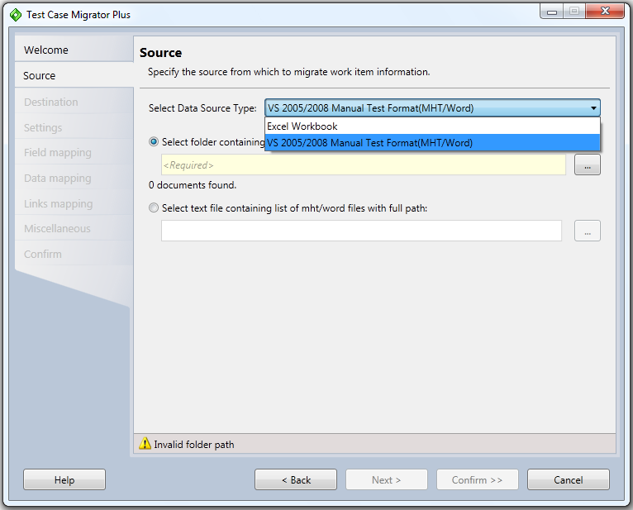
Figure 16: Source Dialog - Data source types supported
The above figure shows the 2 different options provided for the data source type – use “Excel workbook” option to migrate data from Excel and use “VS 2005/2008 Manual Test Case Format (MHT/Word)” option to migrate from mht/word into TFS.

“Source” dialog (MHT flow)

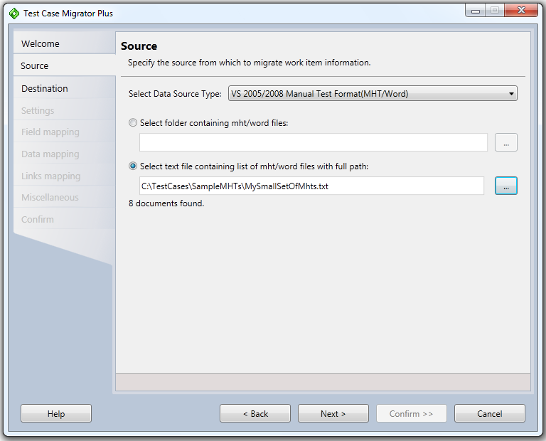
Figure 17: Source Dialog - MHT flow

Purpose
Allows you to specify the MHT/word based documents - mainly from VS2005/VS2008 manual test case templates, from which test case data needs to be migrated. You can choose to specify either a folder path (where all MHT/doc files will be processed) or a text file containing a list of specific MHT files present across different folders.

Interactive fields
Select Data Source Type: Select “VS2005/2008 Manual Test Case(MHT/Word)” option as the data source, when you need to migrate test case information stored in MHT/Word document.
Select folder containing mht/word files: Enter the folder path containing MHT files. All the MHT/Word files present in this folder & sub-folders will be processed by the tool during the migration process.
Select text file containing list of mht/word files with full path: Specify a text file containing a list of specific MHT files that may be present in multiple folder paths. Only the files present in the text file will be processed by the tool. This option allows you to proces files that may be spanning multiple folders. Typically, this option gets used when you want to feed the output from one iteration into the next iteration. Figure 28 shows how the different success/warning/error files gets generated. You could potentially take an error text file (containing list of all failed mht files), correct the errors in the mht files and then specify the text file as input in the next iteration.

“Destination” dialog (MHT flow)
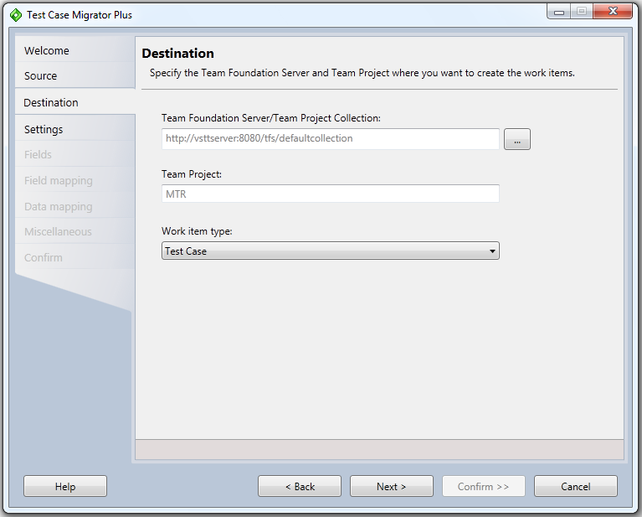
Figure 18: Destination dialog (mht flow)

Purpose
Allows you to specify the TFS Server/Project Collection, Project and the Work Item template where data will be migrated into.

Interactive fields
TFS Server/Project Collection: Select the TFS Server/Project Collection where the data needs to be migrated into. The selection is possible by clicking on “…” button.
Project: Shows the TFS Project selected from the Project selection dialog (after clicking “…” button).
Test work item type: Select the “work item type (WIT)” template that will be used to migrate the data into. By default, default work item type for test case category of project is selected.

“Settings File” dialog (MHT flow)
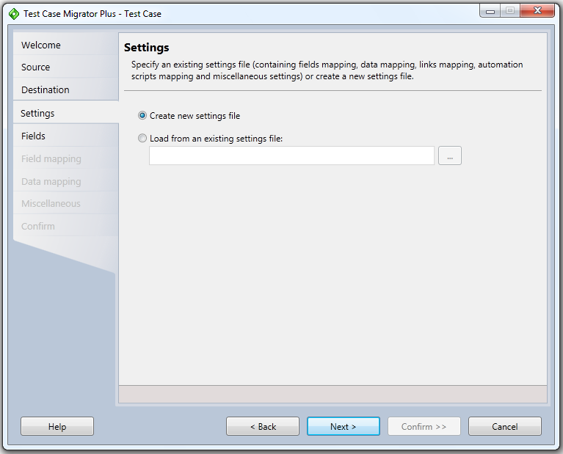
Figure 19: Settings file dialog (mht flow)

Purpose
Allows you to specify a setting/mapping file to load the settings from OR use a blank file. Setting files (when saved) contain the configuration choices made (for field mapping, data mapping, miscellaneous mapping) that show up in subsequent wizard dialogs.
Along with the tool, a default settings file is also being released which have the settings defined that work across both Agile and CMMI project templates (that ship out-of-the-box with TFS). You can use these to jump start your migration process.

Interactive fields
Use blank settings file: When running the tool for the first time or you want to start fresh, then choose this option.
Load from an existing settings file: Select the settings file by clicking on “…” button.

“Fields” dialog (MHT flow)
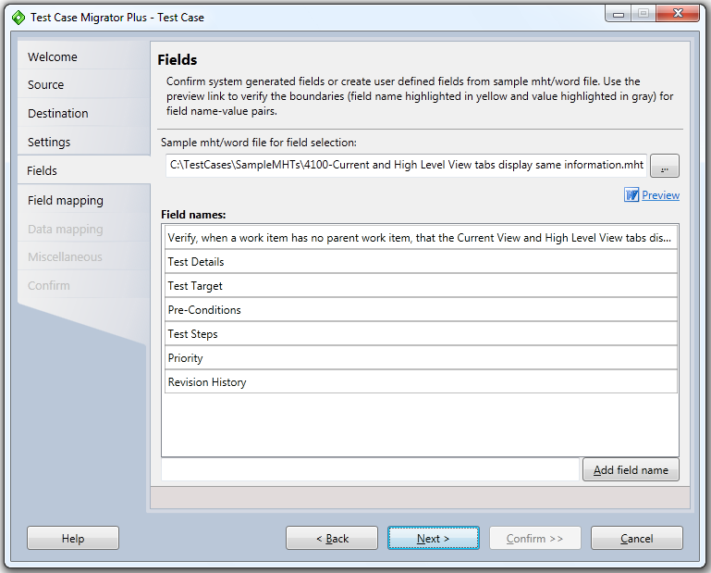
Figure 20: Fields dialog (MHT only)

Purpose
This dialog comes up only when for the MHT data source type. It allows you to review/accept/override the fields auto-selected by the tool from the sample mht/word file. To determine the field/value boundaries, the tool scans for any “heading style” fields from the sample mht/word file. If the document does not contain any “heading styles”, then the “field names” section comes up as empty. In such cases, you can add field names that need to be migrated explicity and then preview the boundaries of the name/value pairs.

Interactive fields
Sample mht/word file for field selection: By default, the ‘last modified’ mht/word file from the ‘folder path specified’ OR the first file specified in the ‘text file’, gets picked as the “sample mht/word file”. This file is used as a template to determine the different types of settings (field mapping, data mapping etc) that then gets applied to every other mht/word file present in the folder or text file. You can always override the default sample file with your specific selection by clicking on “…” button and then selecting a specific mht/word file.
Field Names: For the selected sample file, tool scans for any “heading styles” and picks them as the “fields” present in the document. The scanned field names are shown in the “field names” list box. Any text from the next line of the current heading style up to the next heading style is determined to be the “value” for the field.
Add Field Name: If the sample document contains a field that is not present in a heading style, but you want that field to show up in the “field mapping” dialog, then such fields need to be added to the list. You can add new fields by clicking on the “Add field name” button. Any text following the newly named field till the next heading style is determined to be the “value” for the newly added field.
Preview: Since the core working (migration of data from mht/word file) of the tool is dependent on the “boundaries of name/value pairs” that the tool identifies, it is important to clearly visualize these boundaries. Clicking on the “Preview” button opens the sample mht/word file in a read-only mode with all the “fields” highlighted in “Yellow” and the corresponding “values” for the fields highlighted in “gray” colors.
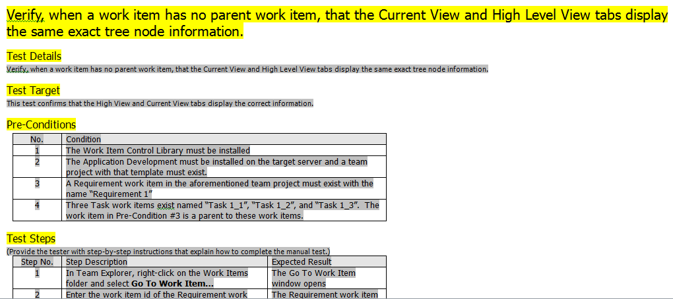
Figure 21: Preview of the sample MHT file.

“Field mapping” dialog (MHT flow)
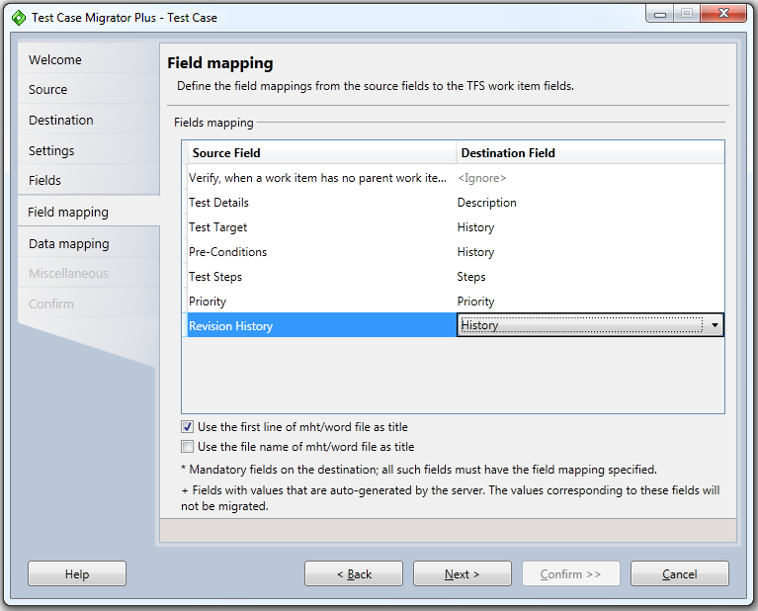
Figure 22: Field Mapping dialog (MHT)

Purpose
Allows you to specify the mht/word fields selected and TFS work item fields. For each column in the Source field, you need to map the corresponding TFS work item field. Data will be migrated for only those columns which have a destination column mapping defined. Columns with “<Ignore>” will be ignored during migration process.
One core assumption that the tool makes in the “field mapping” dialog for MHT flow is that the “Steps” destination column is made up of multiple fields – the first column being “Step No.”, second column corresponds to “Test Step Title” and the third column corresponds to “Expected Results”. See below for the table that is expected – if the “Steps” does not conform to the 3 fields, then migration will not proceed.
Mandatory fields are marked as “*” in the drop down list.
Fields which are auto-generated by the TFS server are marked as “+” in the drop down list.

Interactive fields
Source Field: Shows all the fields listed in the “field list” dialog when used with mht/word as the data source. This list is not editable.
Destination Field: Each drop-down contains the list of TFS work item fields for the Server/Project/Test WIT selected in the Destination dialog. Select the corresponding work item field that you want to map the source field to.
“Use the first line of mht/word file as title” checkbox: If the title of the test case is specified as the first line in the mht/word document, then click this checkbox. This checkbox is enabled only for the MHT/word data source type.
“Use the file name of mht/word file as title” checkbox: If the title of the test case is specified as the file name of the mht/word document, then click this checkbox. This checkbox is enabled only for the MHT/word data source type.
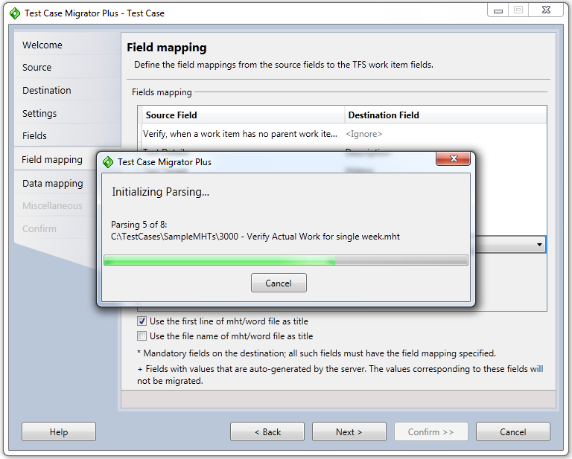
Figure 23: Parsing MHT files (MHT flow)
After specifying the field mapping for the MHT workflow, clicking on “Next” starts the parsing process of the mht/word files. When the list of files is large, you get a “Parsing Progress” window that shows the progress of the parsing. You can cancel the parsing at any time. To restart the parsing, you will have to click on the “Next” button again.

“Data mapping” dialog (MHT flow)
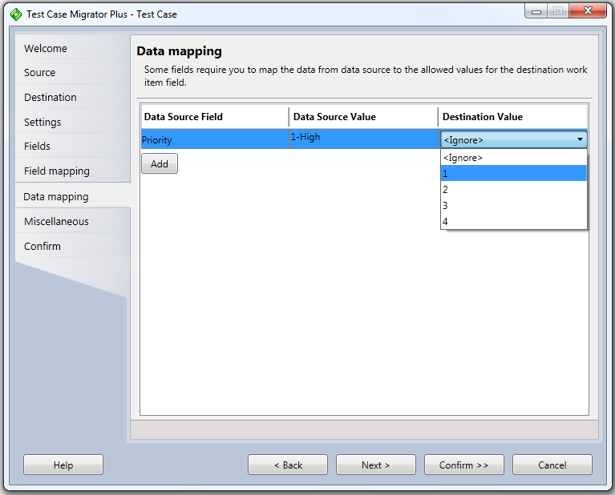
Figure 24: Data Mapping dialog (mht flow)

Purpose
If certain fields in your source field in mht/word document contain data which mismatches with the “allowed values” specified for the corresponding TFS work item field, then you use this dialog to specify the data mappings so that the migration process will not error out for such rows.
By default, the wizard auto-calculates such field values from mht documents and shows them in this dialog. However, you can add additional rows (by clicking ‘add’) for defining the data mapping that you know exists in your source fields (mht/word documents), but not necessarily within the currently selected document. This allows you to define the data mappings once and then reuse it across multiple mht/word documents.
In the example above, the mht/word file contains value of “P1” in the source field, but the TFS work item allows values of 1,2,3. You are specifying to map “P1” to “1” when the migration process runs.
If no value is specified, then the tool will try to apply the defaults that may have been defined at TFS level. If the tool cannot apply any TFS level defaults, then that record will be marked as “error” in the report generated.

Interactive fields
Data Source Field: Shows all the fields that have allowed values on the TFS side.
Data Source Value: Shows the value currently contained in the excel column.
Destination Value: Specify the destination value to map to.
Add: allows the addition of new rows to handle scenario where the data may not be present in the currently selected mht/word document, but may be present in other documents and you are defining a single mapping file to work across all such input files.

“Miscellaneous Settings” dialog (MHT flow)
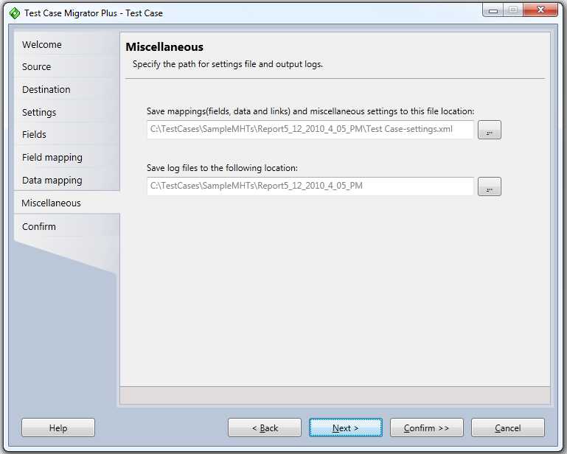
Figure 25: Miscellaneous Settings dialog (MHT)

Purpose
Allows you to specify miscellaneous settings related to Settings file and the output log files.

Interactive fields
Save Mappings: Specify the file name & location where all the mappings (column mappings, data mappings, miscellaneous test step settings) can be saved to.
Output Log folder: Specify the folder location where all the output log files can be saved to. This is a required field. By default, it auto-selects the same folder that was used to specify the input worksheets or mht/word files. It add the “Report_<currentdatetimestamp>” folder to the selected folder. The default output log folder can be changed by clicking on the “…” button.

“Confirm” dialog (MHT flow)
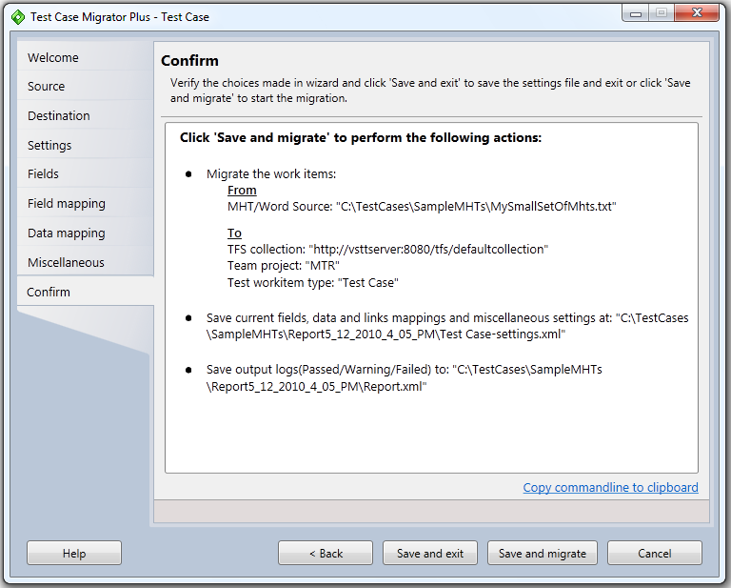
Figure 26: Confirm dialog (MHT)

Purpose
Allows you to preview the choices made in the wizard along with ability to “Save and exit” the wizard without actually doing the migration OR “Save and migrate” which will initiate the migration process.

Interactive fields
Copy command-line to clipboard: This copies a command line invocation of the tool to the clipboard, which can be invoked after doing “Save and exit” on the confirm dialog and which will migrate exactly as this UI based flow would have worked if the user hit “Save and migrate” instead of “Save and exit”. This is helpful if you want to run multiple invocations of the tool using the same settings file but with different input mht/doc files in a batch mode.
Save and exit: Will save the settings file (if specified) containing field mappings, data mappings and miscellaneous settings. Note that this saving does not save the Source, Destination or the Output Log folder. All these are outside of the mappings file.
Save and migrate: Will save the settings file (if specified) and then start the migrate process.

“Progress” dialog (MHT flow)
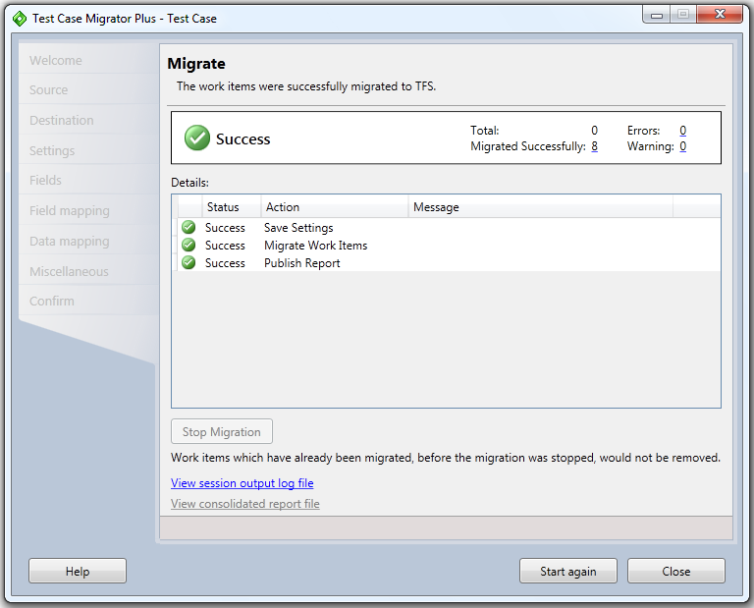
Figure 27: Progress Dialog (mht flow)

Purpose
Shows you the progress of the migration process. It also allows you to stop the migration in middle. Note, if migration is stopped in middle, the rows which have already been migrated will *NOT* be reverted back. After the completion of the migration process, it also allows you to review the session Output log files and provides a summary of the migration at the top of the dialog.

Interactive fields
Stop Migration: Will stop the in-progress migration process. Rows that have already been migrated into TFS will not be removed.
Summary: For the current invocation of the tool, it shows the total number of rows processed, the number of rows successfully migrated, the number of rows migrated with warnings and the number of rows that were not migrated due to errors. Each of the links, opens up the respective reports within the output log file.
View Session Output Log file: For mht/word as data source, it Opens the "html report” that contains links to the text files with success/warning/error text files.

“Output Report File” (MHT flow)

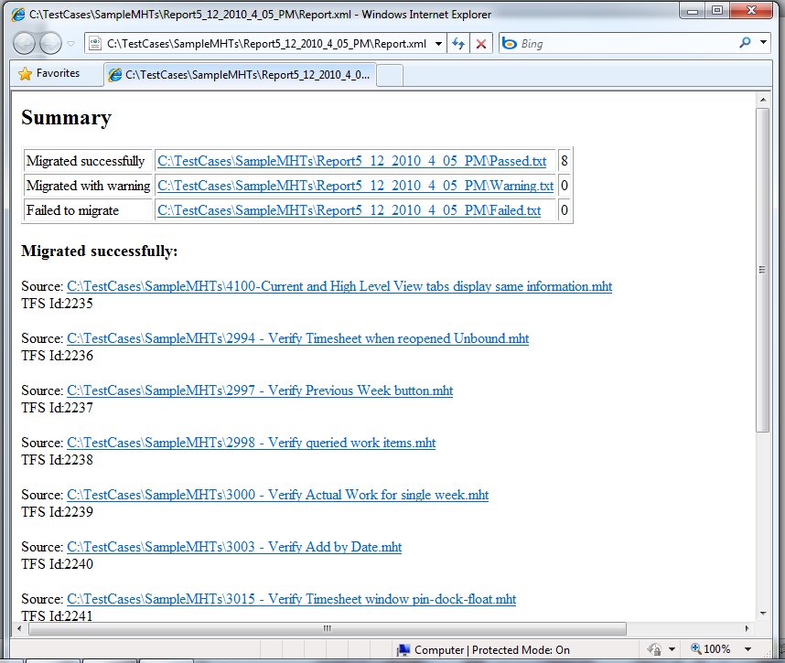
Figure 28: Output MHT report file (MHT)

Purpose
Shows you the outut of the migration process for the MHT flow.

Interactive fields
Passed txt file: Shows a list of all mht/word files that were successfully migrated to TFS. The “Migrated successfully" section shows each individual mht/word file and the corresponding TFS ID generated for that file.
Warning txt file: Shows a list of all mht/word files that were migrated with warning into TFS. The “Migrated with warning” section shows each individual mht/word file and the corresponding TFS ID generated for that file along with the “warning” message.
Failed txt file: Shows a list of all mht/word files that were not migrated due to some error. The “Failed to migrate” section shows each individual mht/word file and the corresponding “error” message encountered.
Command used: Shows the actual command line that was used to run this instance of the migration process.

Using Command line (for both Excel or mht flows)
The “Test Case Migrator Plus” (Excel/MHT) tool can also be used from the command line. This allows you to create a single settings file and then reuse it across different source worksheets/mht files and different TFS projects (as long as the field/data/link mappings are the same) and then invoke the tool in a batch mode.
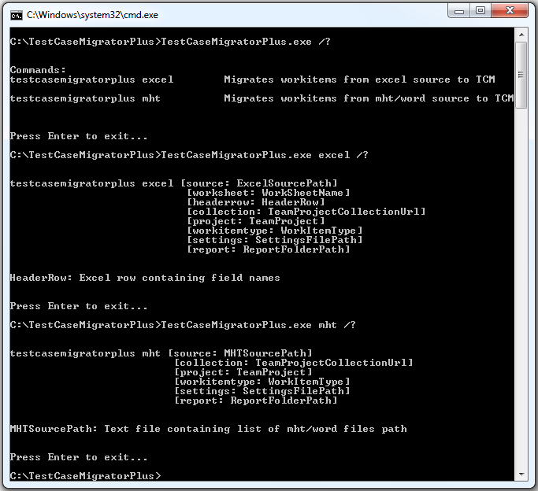
Figure 29: Command Line parameters (Common)

