[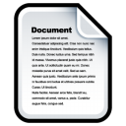](http://www.iconarchive.com/show/sleek-xp-basic-icons-by-hopstarter/Document-icon.html)

[](http://www.iconarchive.com/show/i-icons-by-treetog/Documents-icon.html)

[](http://www.iconarchive.com/show/oxygen-icons-by-oxygen-icons.org/Actions-document-edit-icon.html)

[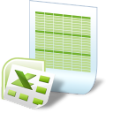](http://www.iconarchive.com/show/junior-icons-by-treetog/document-excel-icon.html)

[](http://www.iconarchive.com/show/satellite-icons-by-apathae/2-Documents-icon.html)

[](http://www.iconarchive.com/show/adobe-cs4-icons-by-hopstarter/File-Adobe-Dreamweaver-XML-01-icon.html)

[](http://www.iconarchive.com/show/sleek-xp-basic-icons-by-hopstarter/Files-icon.html)

[](http://www.iconarchive.com/show/sleek-xp-basic-icons-by-hopstarter/Document-Blank-icon.html)

[](http://www.iconarchive.com/show/junior-icons-by-treetog/folder-documents-icon.html)

[ICO](http://www.iconarchive.com/download/i7724/hopstarter/sleek-xp-basic/Document-Write.ico)[PNG](http://icons.iconarchive.com/icons/hopstarter/sleek-xp-basic/128/Document-Write-icon.png)

[](http://www.iconarchive.com/show/sleek-xp-basic-icons-by-hopstarter/Document-Write-icon.html)

[](http://www.iconarchive.com/show/soft-scraps-icons-by-hopstarter/File-Delete-icon.html)

[](http://www.iconarchive.com/show/sinem-icons-by-robsonbillponte/File-Downloads-icon.html)

[](http://www.iconarchive.com/show/satellite-icons-by-apathae/1-Documents-icon.html)

[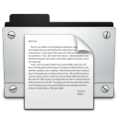](http://www.iconarchive.com/show/wren-icons-by-apathae/Documents-icon.html)

[](http://www.iconarchive.com/show/genesis-3G-icons-by-dario-arnaez/User-Files-icon.html)

[](http://www.iconarchive.com/show/mac-folders-icons-by-hopstarter/Documents-icon.html)

[](http://www.iconarchive.com/show/systematrix-icons-by-royalflushxx/Document-icon.html)

[](http://www.iconarchive.com/show/junior-icons-by-treetog/document-audio-icon.html)

[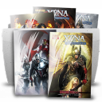](http://www.iconarchive.com/show/series-folder-icons-by-softskin/Folder-BD-Files-icon.html)

[](http://www.iconarchive.com/show/steel-system-icons-by-uriy1966/Documents-icon.html)

[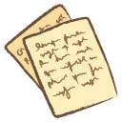](http://www.iconarchive.com/show/whistlepuff-icons-by-firstfear/documents-icon.html)

[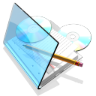](http://www.iconarchive.com/show/blue-crystal-icons-by-lgp85/My-Documents-icon.html)

[](http://www.iconarchive.com/show/id-icons-by-delacro/Documents-icon.html)

[](http://www.iconarchive.com/show/adobe-cs4-icons-by-hopstarter/File-Adobe-Photoshop-01-icon.html)

[Advertise here](http://buysellads.com/buy/detail/47305)