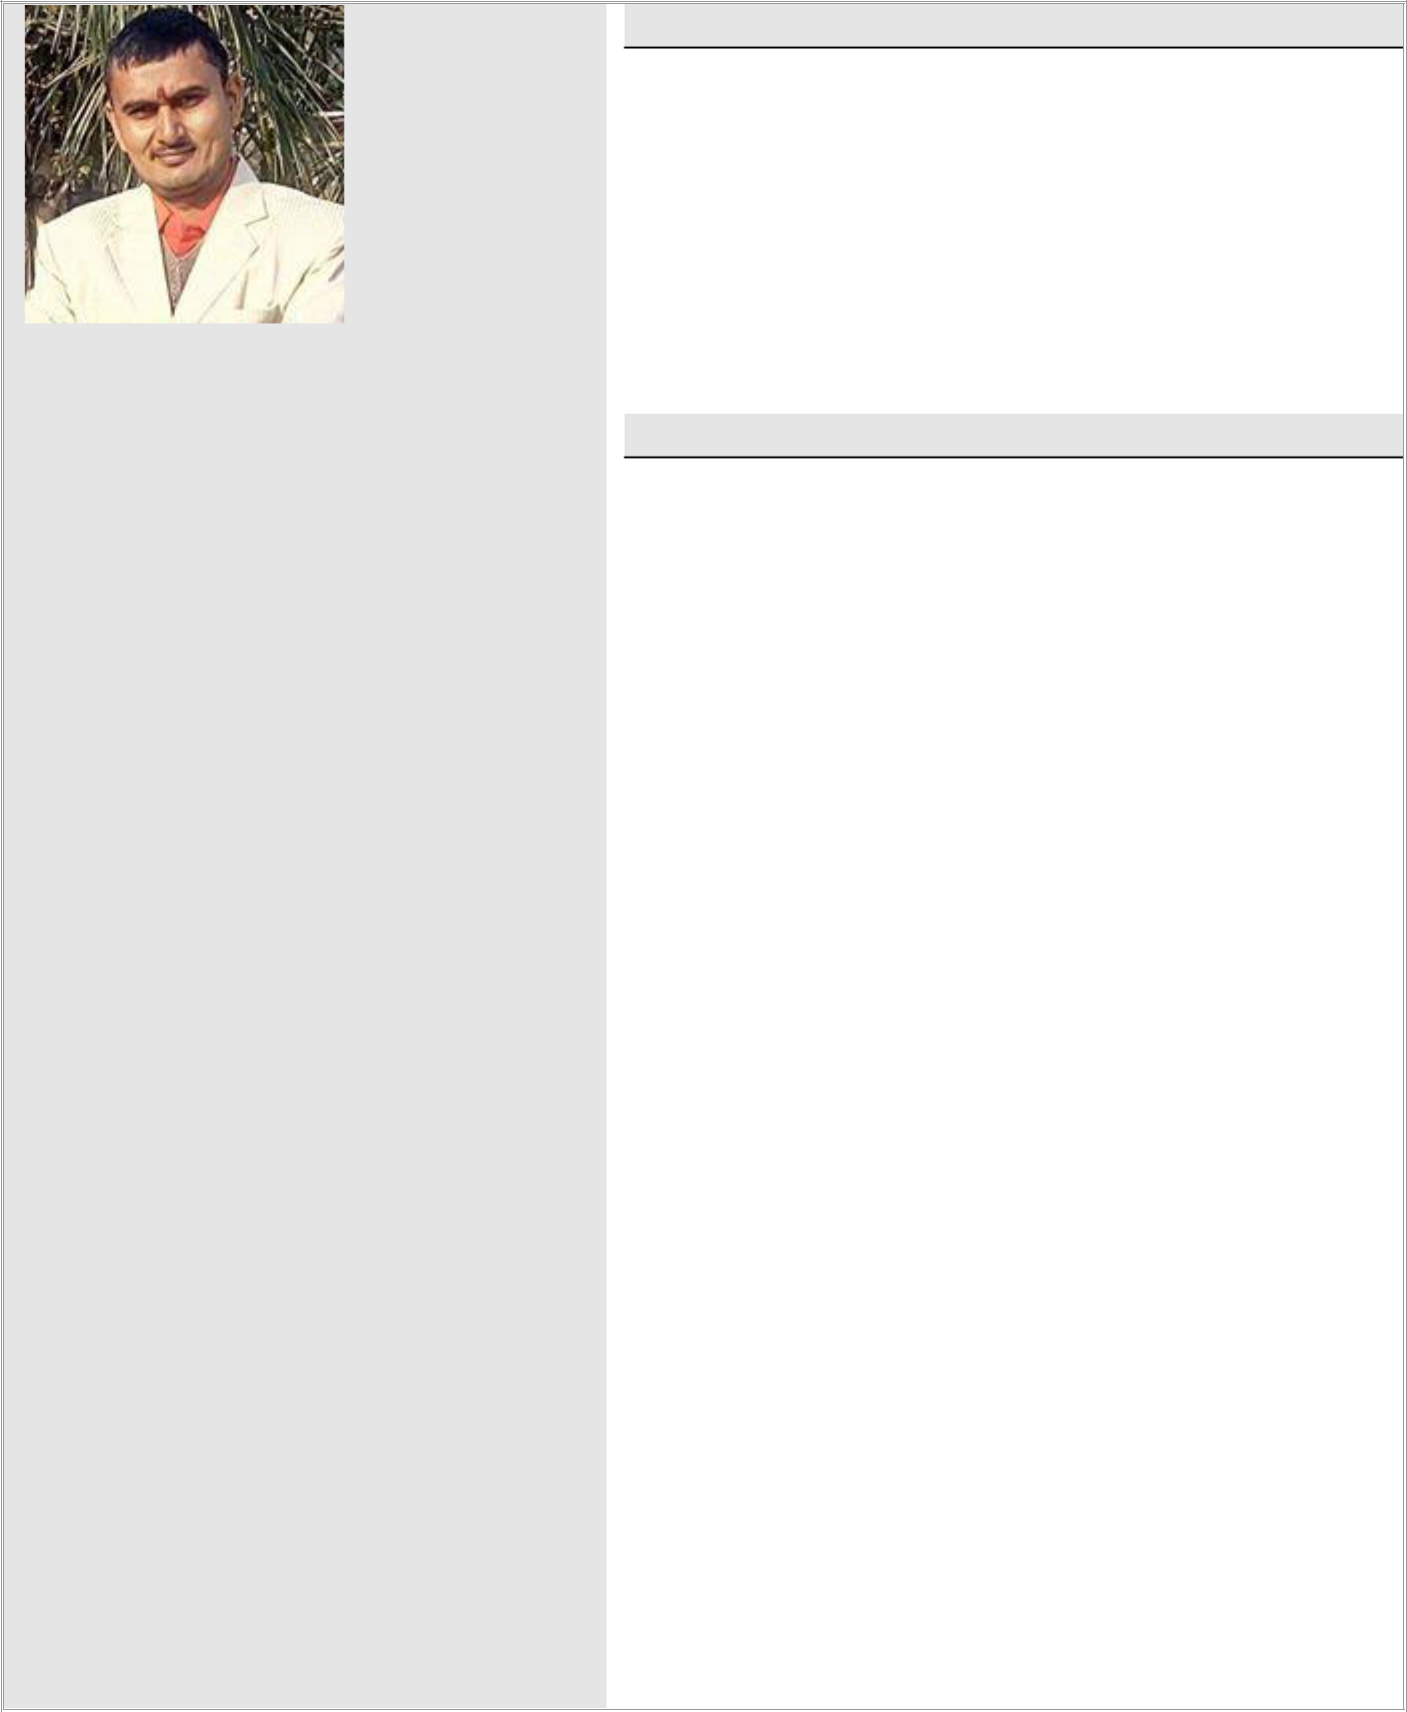
RESUME
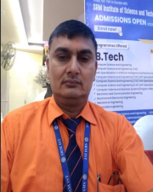

Prem Chand Sharma Email
pcsharma.adm@gmail.com

Mobile No- 91-9410638741

Present Address

C/o Shri Nitya Nand Sharma, Village-Dousa Banjarpur, Post.-Muradnagar Distt.- Ghaziabad (U.P)-201206.

Personal Data

Father’s Name : Mr. N.N.Sharma

Mother’s Name : Mrs. K. Sharma

Date Of Birth | : 07/12/1975
Sex | : Male
Nationality | : Indian
Marital Status | : Married
Contact No. | : 09319057805 (O)

Languages Known

English, Hindi

Hobbies

- Listening Music, Songs, Reading News Paper & Books.

- Going out and meeting new peoples. Playing Game etc.
Objective:

- To seek a challenging career in the IT industry this can integrate my teaching and analytical skills in the area of educational for personal and organizational growth. I look forward to be a part of an interactive work sphere and a favorable environment for my professional growth and development of teaching and managerial skills. I look forward to be a key person of solution space.

Total Working Experience: 22 Yrs.

Teaching Experience: 2 Yrs.

Self-assessment by staff members worth mentioning achievements and contributions may be briefly given:-

- Assist All Students in the Programming Lab (MCA DEPT. ).

- Assist & Motivational support new students for Admission.

- Teach three Elective Subjects Lecture BSc. Ist. Year students since 2022 in SRM IST Delhi-NCR Campus, Modinagar, Ghaziabad (U.P).

Technical Experience: Total – 20 Yrs.

- Presently working in Department of Computer Application as a Programmer since the 11th. of Sept. 2018 to till date. I have handle both of computer labs regarding C, C++, Java programming in SRM IST Delhi-NCR Campus, Modinagar, Ghaziabad (U.P).

- 1.5 years experience working in Computer Sc. & Engg. Deptt. as a Technical Support since the 28th. of Mar. 2017 to till date. I have handled computer labs regarding C, C++, Java programming in Bharat Institute of Technology, Pertapur Bypass-Road, Meerut (U.P).

- 4.7 year’s experience in working in Computer Sc. & Engg.
Deptt. as a System Admin since the 23nd of Aug. 2012 to 27th. Of Mar.2017. I have handled computer labs regarding C, C++, Java programming in Skyline Institute of Engineering & Technology, Greater Noida (U.P).

- 3.7 years experience working in IT Deptt. as a Asstt. Of
Network Admin since 10th. Of Dec. 2008 to 22nd. Of Aug. 2012. I have handled Servers, computer works, Inventories in Lord Krishna Group of Institutions, Ghaziabad (U.P).

- 6 years experience in Computer Sc. & Engg. Deptt. Working as a Asstt. of System Admin Since 14th. Of
Sep. 2002 to 09th.Of Dec. 2008. in Ajay Kumar Garg
Engineering College, Ghaziabad (U.P).

Professional Education:

Examination | College/school | Year of | % | Duration
Examination | College/school | Passing | % | Duration
RHCE | Red Hat India Pvt. Ltd. Mumbai. | 2011 | 95.6 | 2 Months
805011987459334
M. C. A. | IGNOU, New Delhi | 2007 | 57.39 | 3 Yrs.
PGDCST Diploma | ET&T, Modinagar (U.P) | 2005 | 70 | 2 Yrs.
ADCA Diploma | IGNOU, New Delhi | 2002 | 56.75 | 2 Yrs.
PGDCA Diploma | IGNOU, New Delhi | 2006 | 56.83 | 1 Yrs.
“O” Level | DOEACC, New Delhi | 2001 | 60 | 1 Yrs.
DCA Diploma | New Capital College, Modinagar (U.P) | 2000 | 70 | 1 Yrs.
CIC | IGNOU, New Delhi | 2002 | 65.5 | 6 Months
“B” & “C” | National Credit Core (N.C.C) | 1998 | C | 3 Yrs.

Education:

Examination | Board/University | Year Of Passing | Duration
Graduate | C.C.S. University, Meerut (U.P) | 1999 | 3 years
Intermediate | U. P. Board, Allahabad | 1996 | 2 Years
High School | U. P. Board, Allahabad | 1994 | 2 Years

Points leading me towards success:

- Commitment towards work and enthusiasm to learn.
- Effective communication, dedication to work, team building skills and fast learner.
- I believe in that there is no substitute of hard work.
Achievements:

Event organizer in Engg. College Technical Fest. Student coordinator of technical Support.

Got appreciation certificate from Engg. College for Technical Support.

Technical Skills:

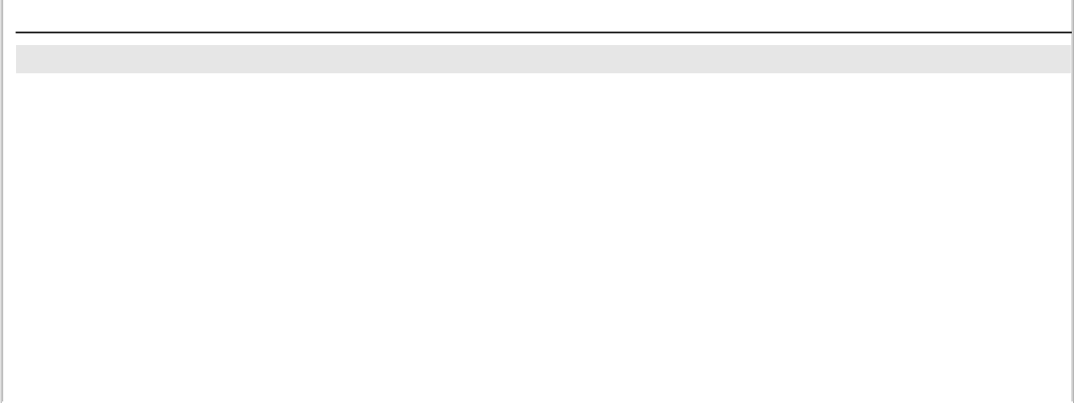

Installation OS :
Installation Win95 / 98 / 2000 / Win XP / Win 2000 Server/ Win 2003/Win 2008/ Red Hat Enterprise Server 5.x , all software are on Servers/PC System.

GUI Environment :
Office 95 / 97 / 2000 / XP / 2003/ 2007 (MS-Word, MS-Excel, MS-Power Point, MS-Access).

Language Known :
Java (JDK), C, HTML, V.Basic (Basic Concept).

H/w Used :
Intel 80 x 86 based computers, Compaq, HCl, and Zenith Pentium III, E-200 HP Servers, HP tc2100 Servers.

Antivirus Used :
e-Scan, Quick Heal Total Security, Norton, MS-Essential 2.1 etc.

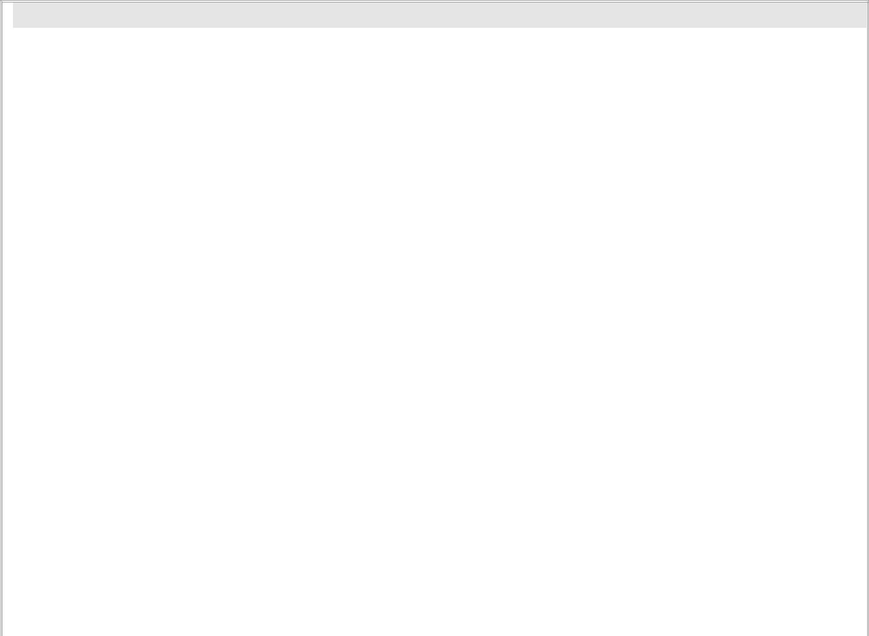
Network Troubleshooting:

Red Hat Enterprise Server’s | :
YUM, NFS, FTP, NIS, | DNS, Apache, Squid (Proxy), Samba, DHCP, NTP, Send Mail,

Dovecot, Postfix, Squirrel-Mail, Virtualization, PAM, LDAP, Xinetd, IPtables, Installation, PXE-Boot, Kick start etc.

Windows Server’s :
(Win-NT, Win-2000, Win-2003, Win-2008 Networking with Client/Server Concept).

DNS, Proxy Server, DHCp, Active Directory Server, LANs, WANs, Antivirus Server, Database Server (Oracle or SQL), Mail Server etc.

 |  | Windows/Linux Client |  |  | :
 |  | Windows XP, Windows Vista, Windows 7, Fedora, Red Hat 7.x,8.x,9.x etc..
 |  | Internet Service |  |  | :
 |  | Distribute Internet Service using TCP/IP,Wifi & Squid through AP, Vsat, RF & Leased-Line.
 |  | Project # 1 |  |  | AIIS (Automation of Institute Information System)
 |  | Organization |  |  | IGNOU New Delhi
 |  | Environment |  |  | V. Basic 6.0, SQL Server 2000
 |  | Duration |  |  | 2 months
 |  | Role |  |  | Developer
 |  | Description |  |  | AIIS is the computerization of all activities related to institute’s
 |  |  |  |  | management. It may be maintaining staff & student details, library,
 |  |  |  |  | inventory and many more. AIIS is a window based software
 |  |  |  |  | application which provides interactive GUI (Graphical User Interface)
 |  |  |  |  | solution using efficient approaches along with a user-friendly easy to
 |  |  |  |  | use interface; it also provides strong security mechanisms like User
 |  |  |  |  | authentication, validation routines to maintain the data integrity and
 |  |  |  |  | confidentiality of the system. AIIS also facilitates the data backup
 |  |  |  |  | and data restore facility with an ease of just a mouse click, thus
 |  |  |  |  | making the system easy & reliable.

I hereby declare that all the details furnished above are true to the best of my knowledge.

Date: 14/11/2024

Place: Ghaziabad (P. C. Sharma)

Date: 14/11/2024

To,
The Director/Registrar/HR,

Sub: Application for the Post of Technical Trainer/Lecturer.
Respected Sir/Madam,
I have come to know through the reliable sources Official Web Site that few vacancies for the said posts are lying vacant under your kind control. I wish to offer my candidature for one of them. A copy of my Curriculum Vitae is being enclosed herewith for your kind consideration. I shall be thankful to you if I am given an opportunity to serve under your able guidance.

Yours truly,

(P.C.Sharma)

