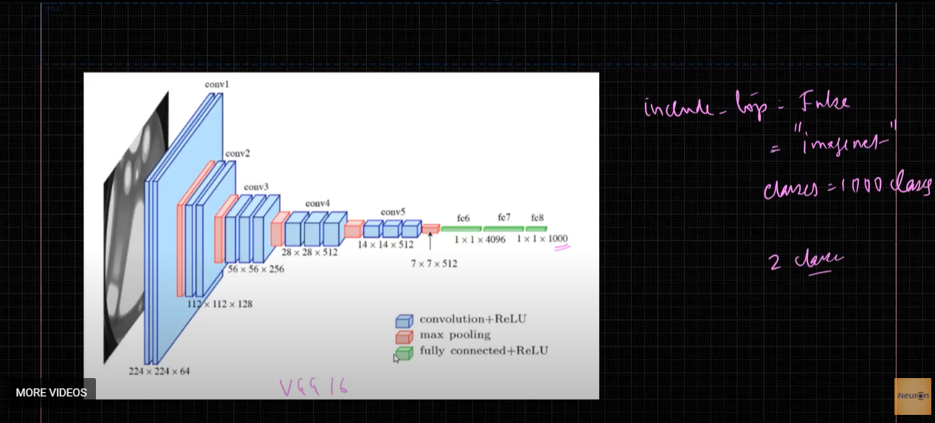

ImageNet contains 1000 classes and we are training for 2 classes.

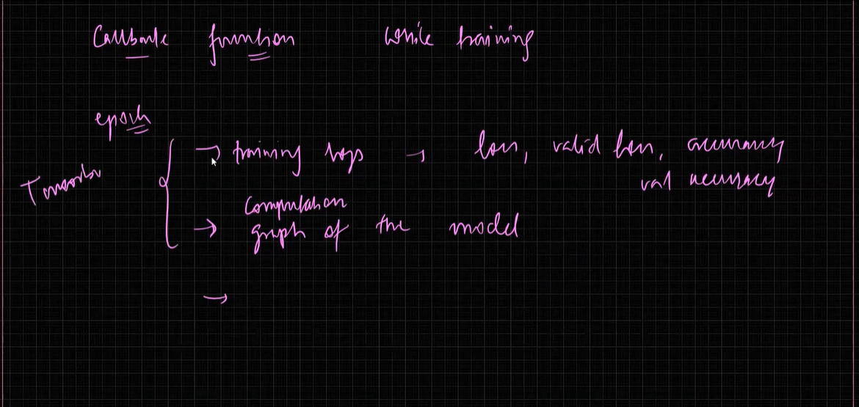

Call backs:

Tensor board

Checkpointing call backs

Early stopping call backs

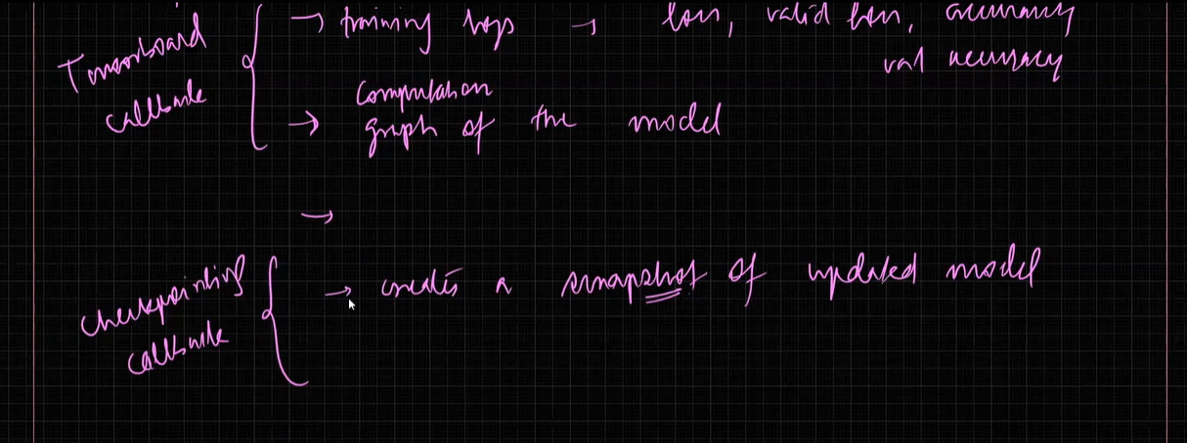

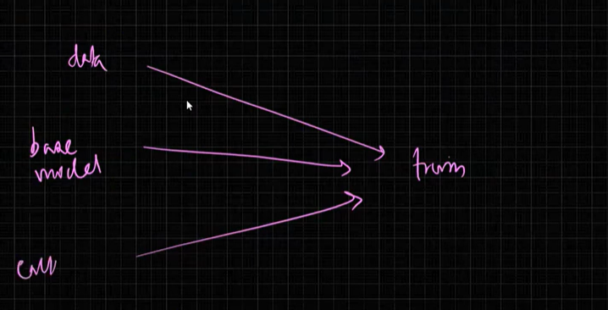

W have got the data , we have got call backs and base model Now we are ready for transfer learning.