ASSIGNMENT NO:- 1

Steps to launch an Instance:-

Step 1:-Login as root user

Step 2:-Go to EC2 web service
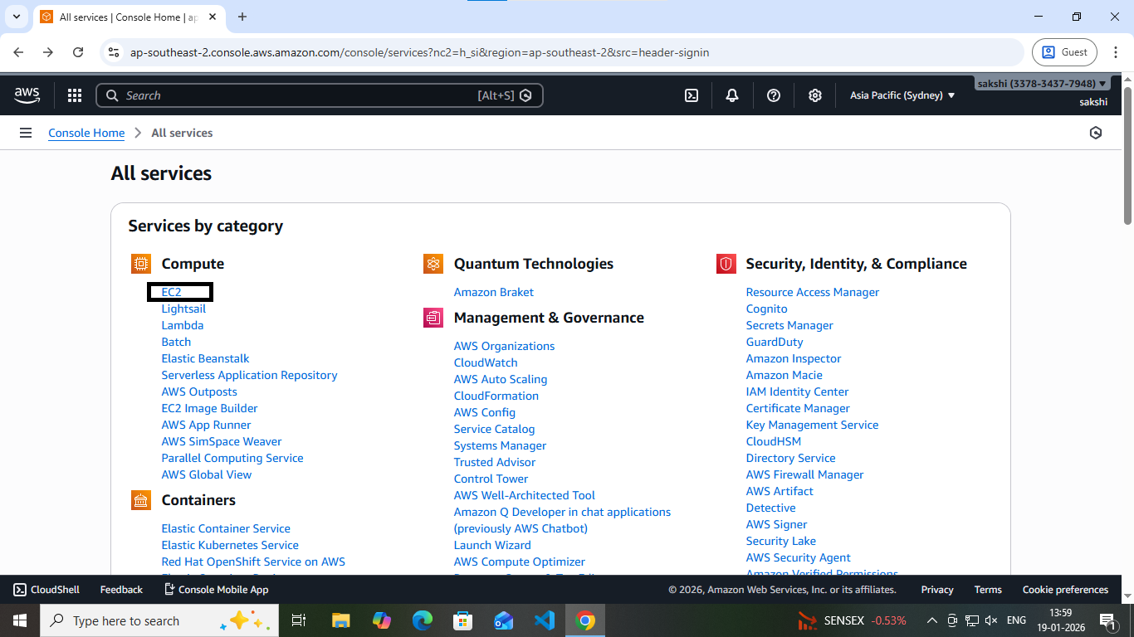

Step 3:- Launch Instance
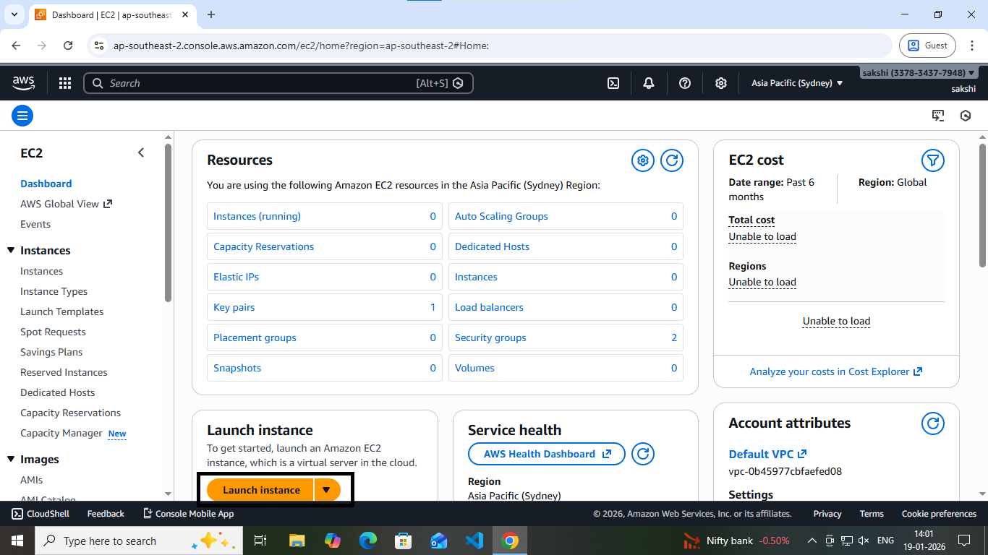

Step 4:- Name the Instance
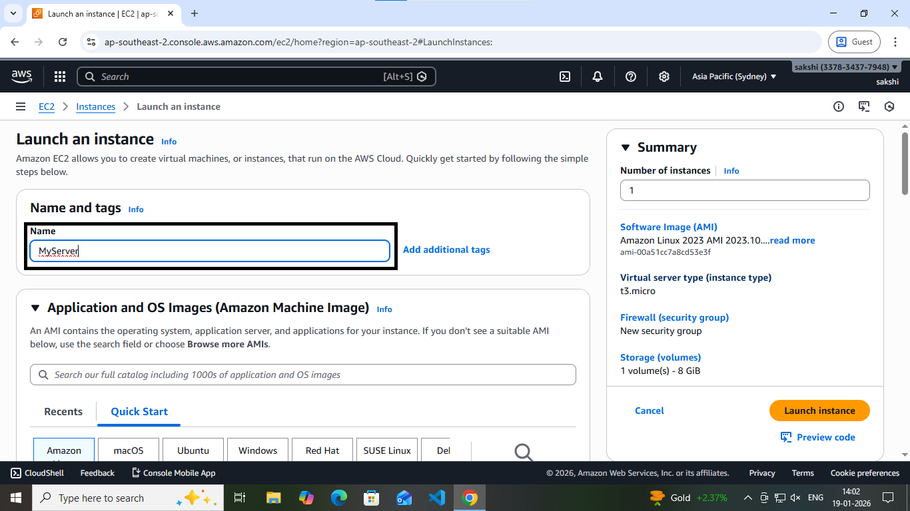
Step 5:-Choose OS
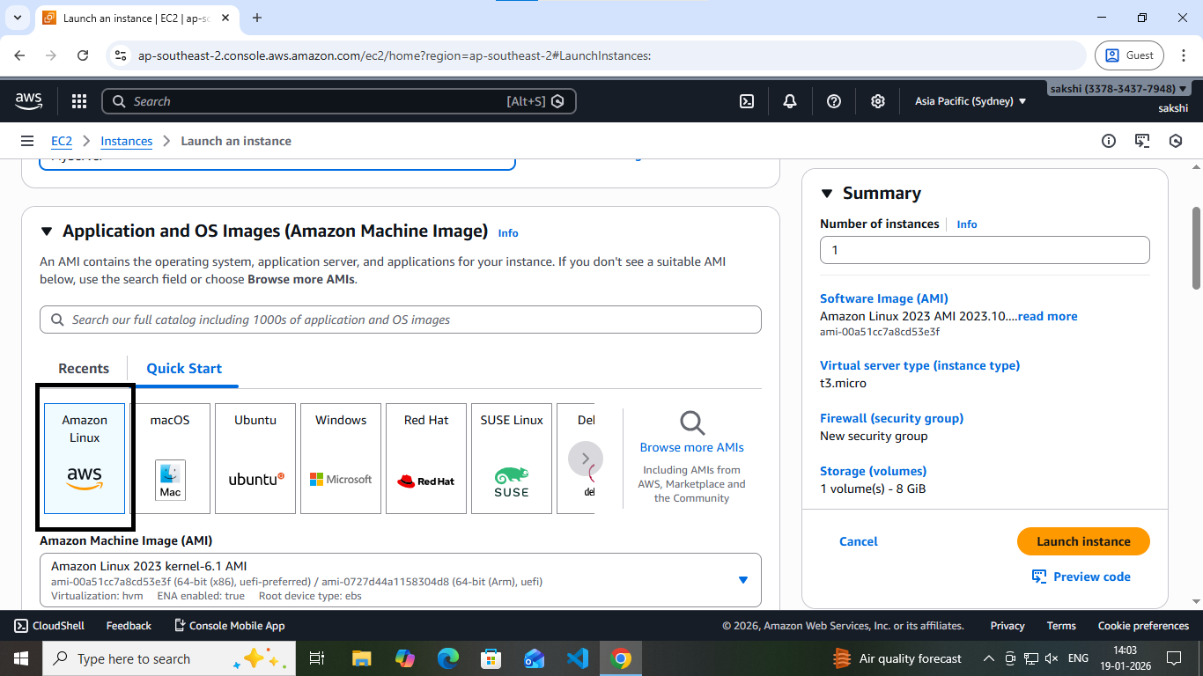

Step 6:-Create a key
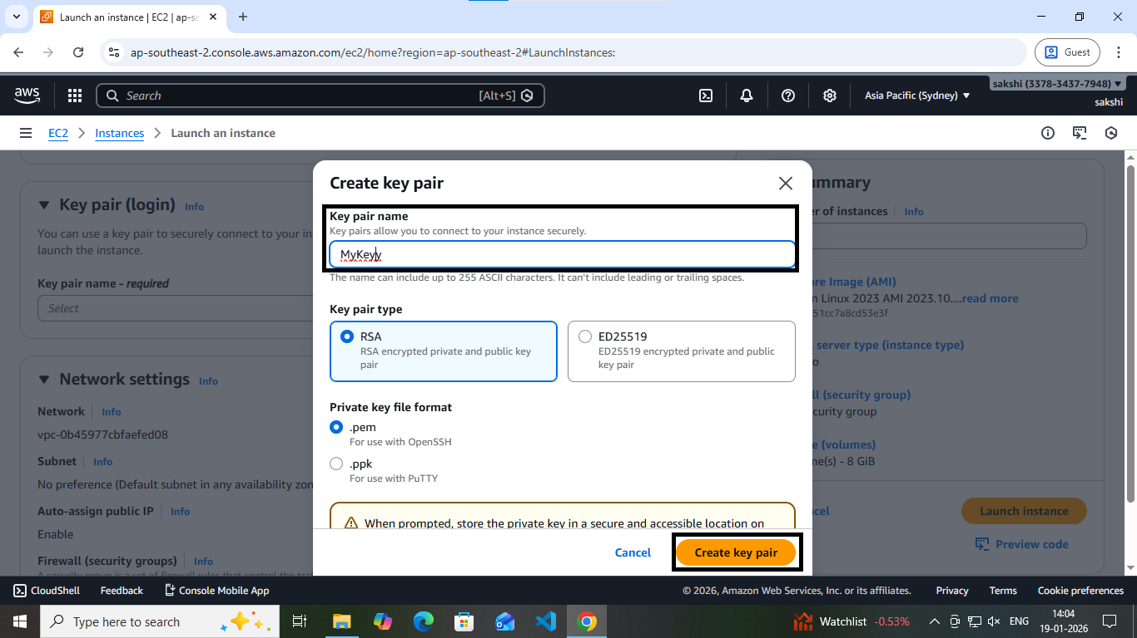
Step 7:-Save the key
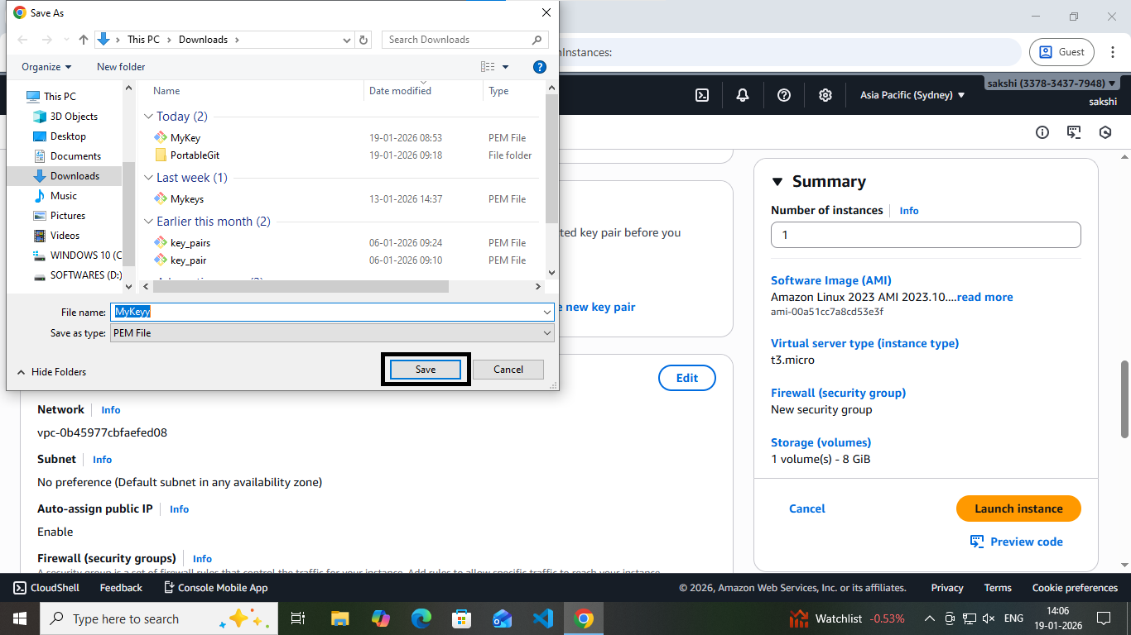

Step 8:-Launch the Instance
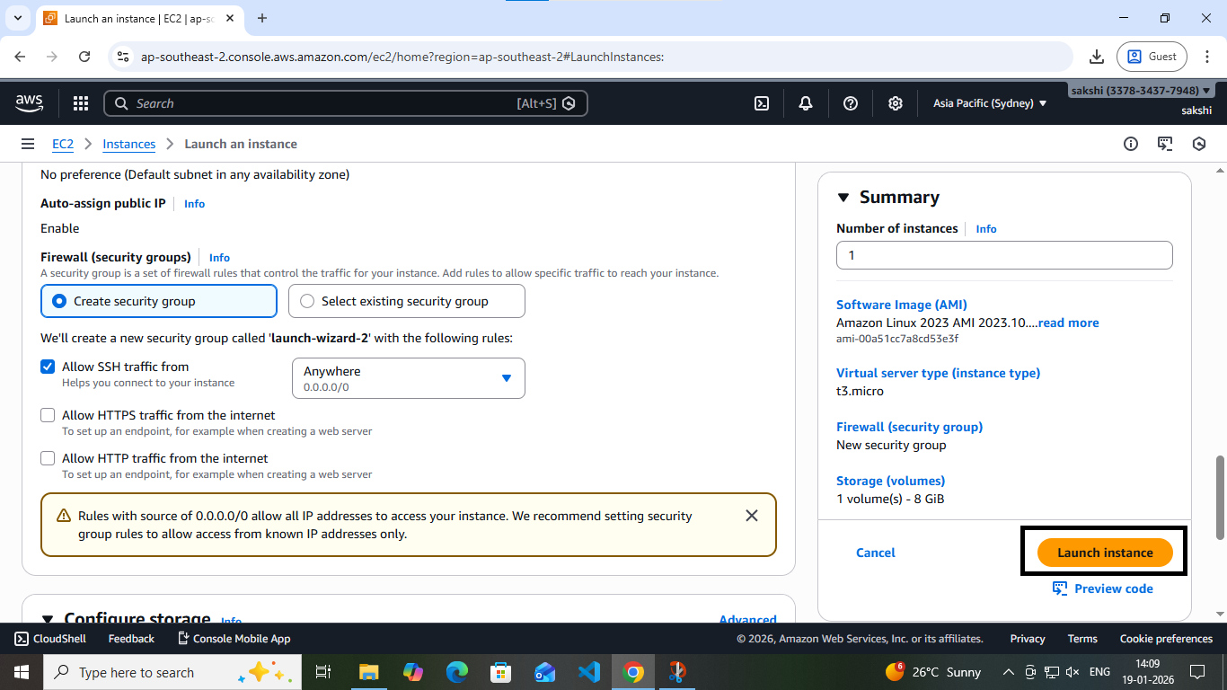

Step 9:-Click on Instance ID

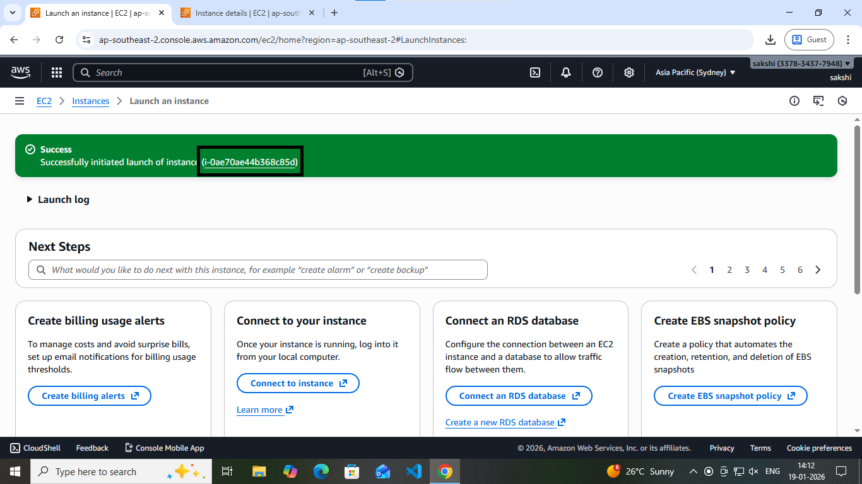

Step 10:-Connect an Instance
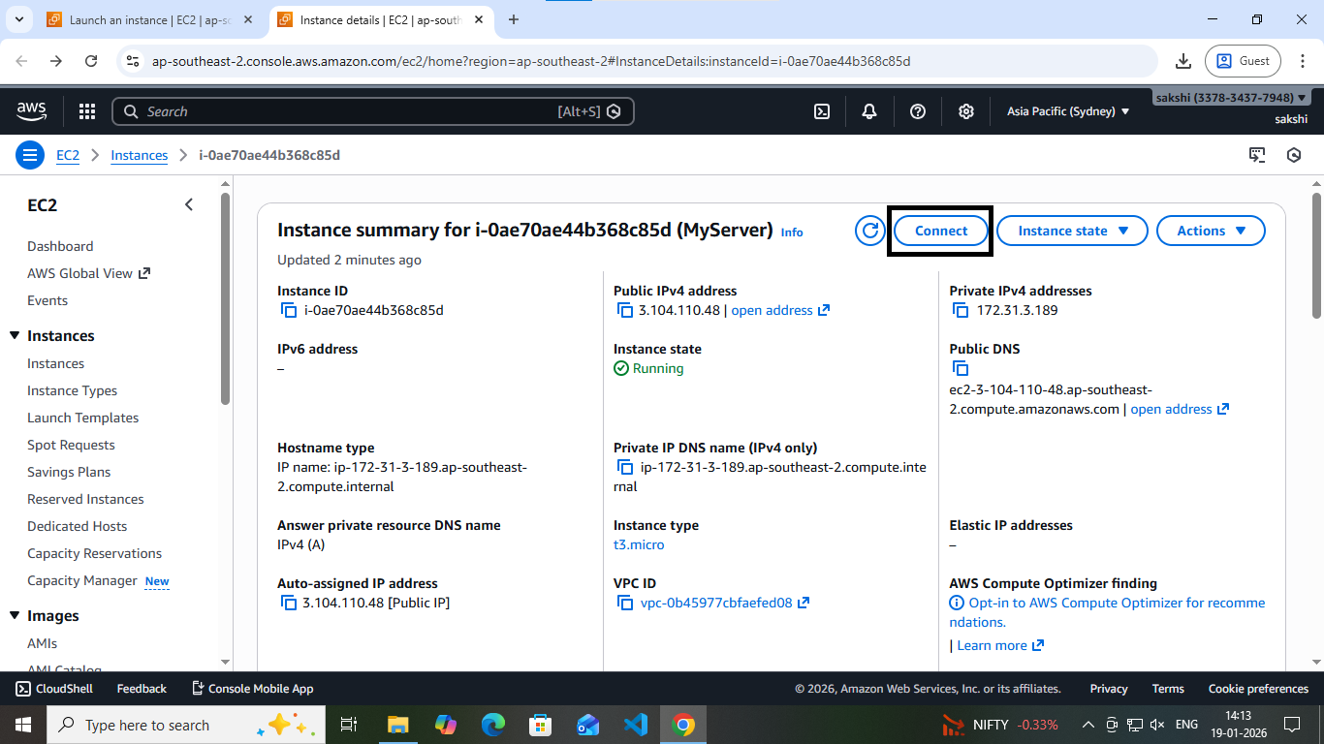

Step 11:-Click on Connect
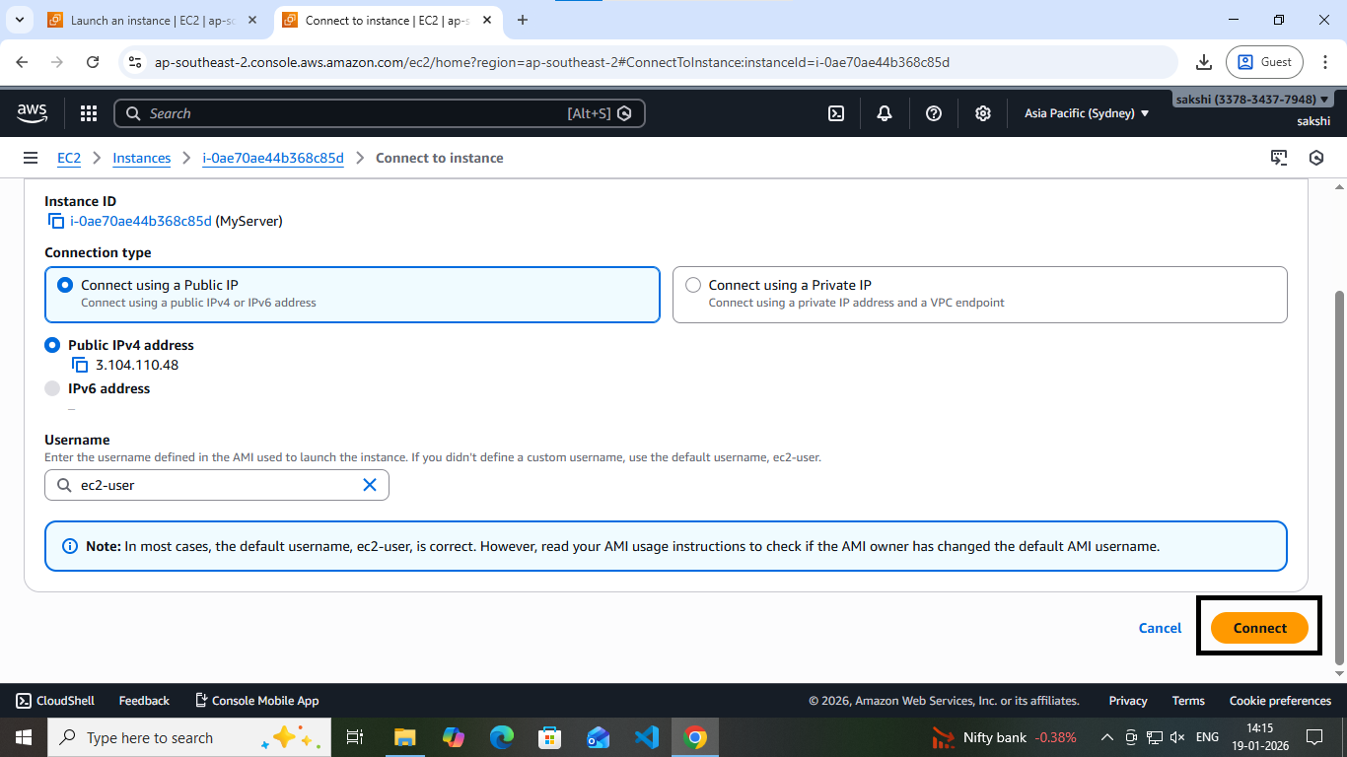

Step 12:-Type command ls –lar
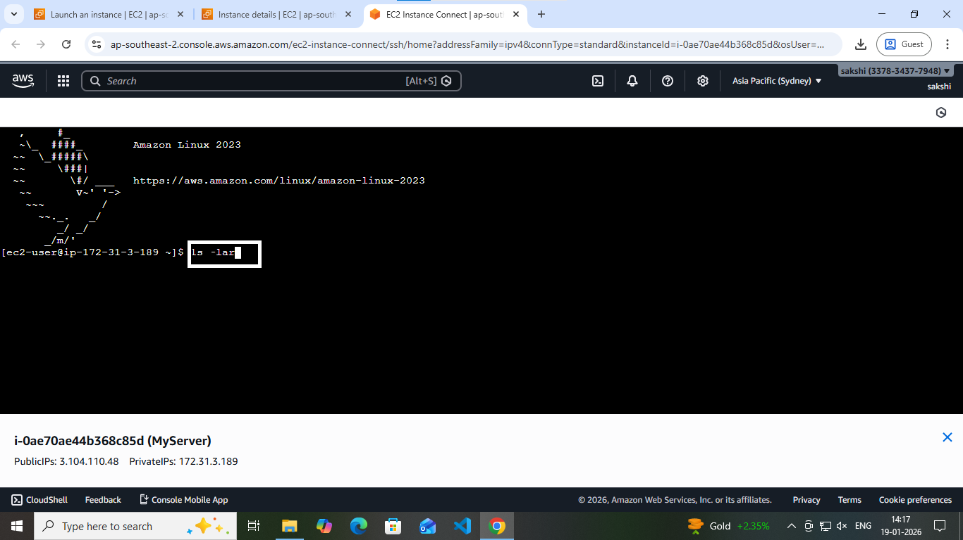

Step 13:-Files present By default in an Instance
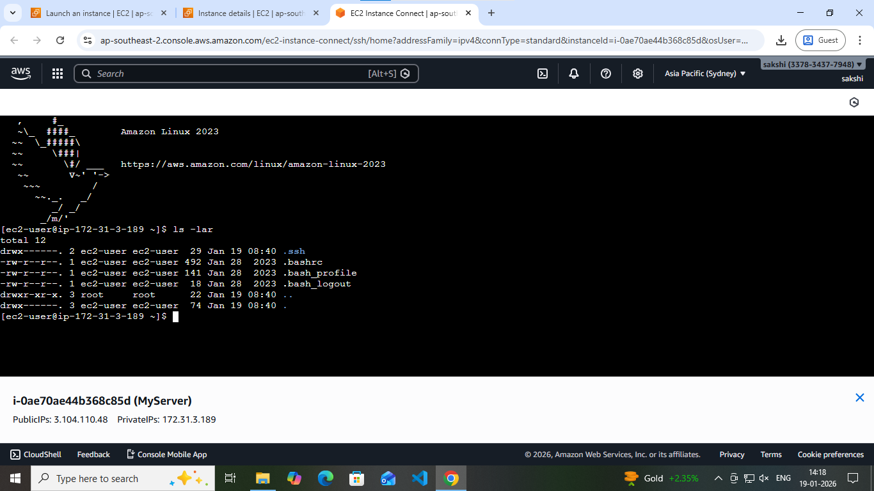

Step 14:-Connect an Instance by using another method
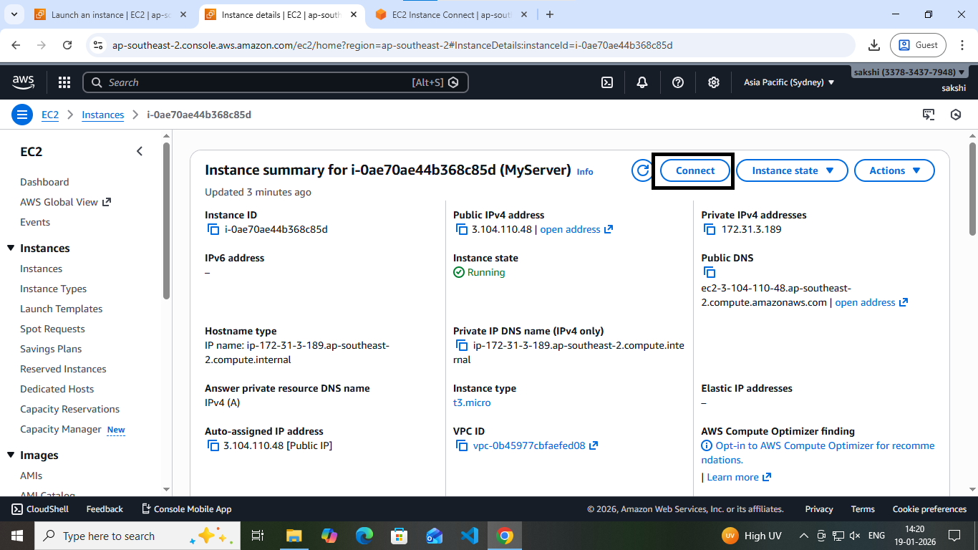

Step 15:-Connect an Instance using SSH Client Method
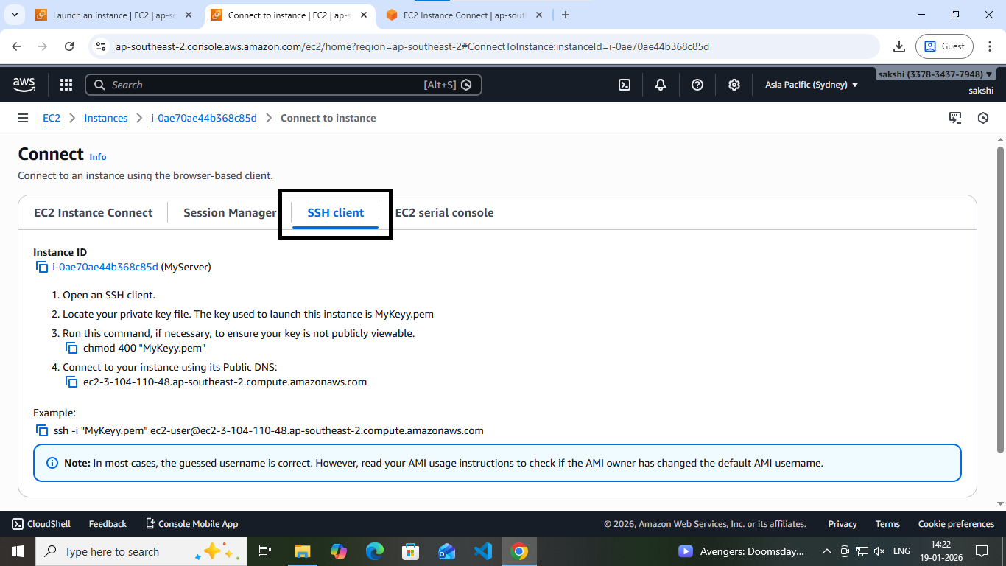

Step 16:-Open MyKeyy.pem file in Git Bash
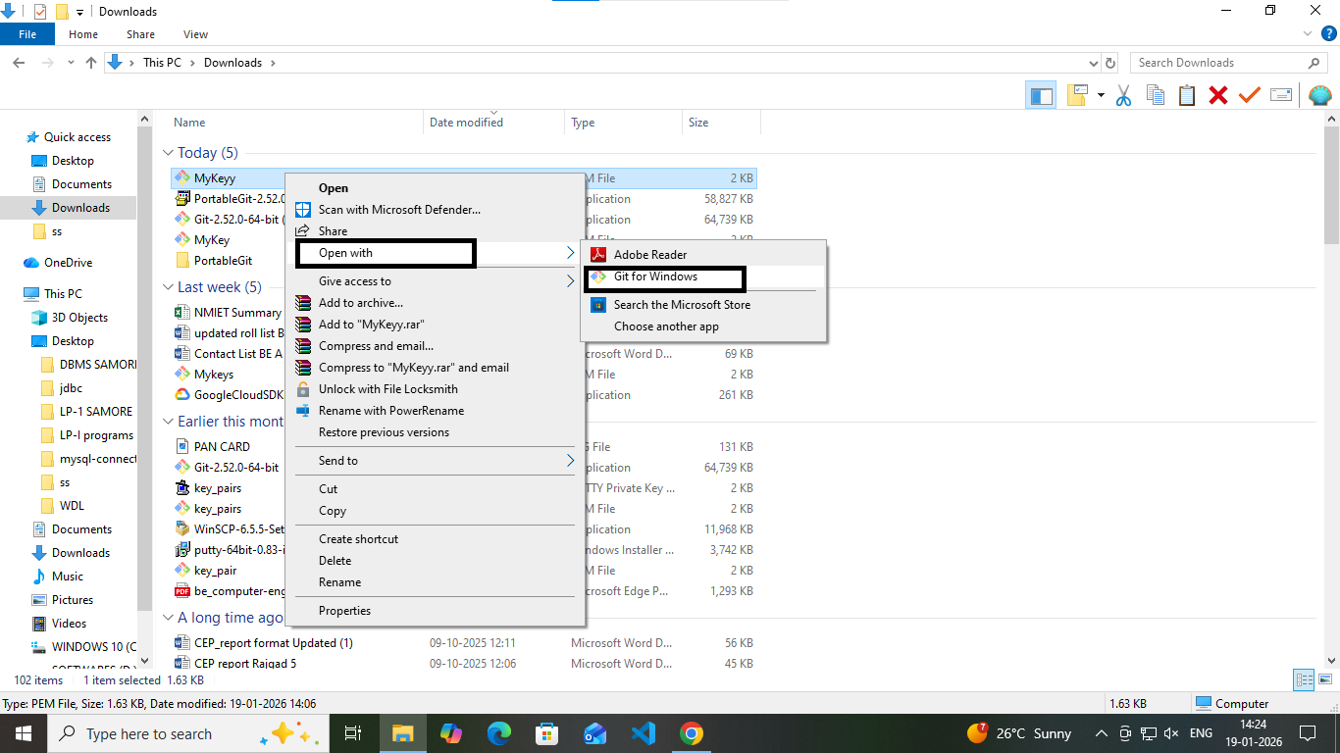

Step 17:-Type commands to check the permission type of file
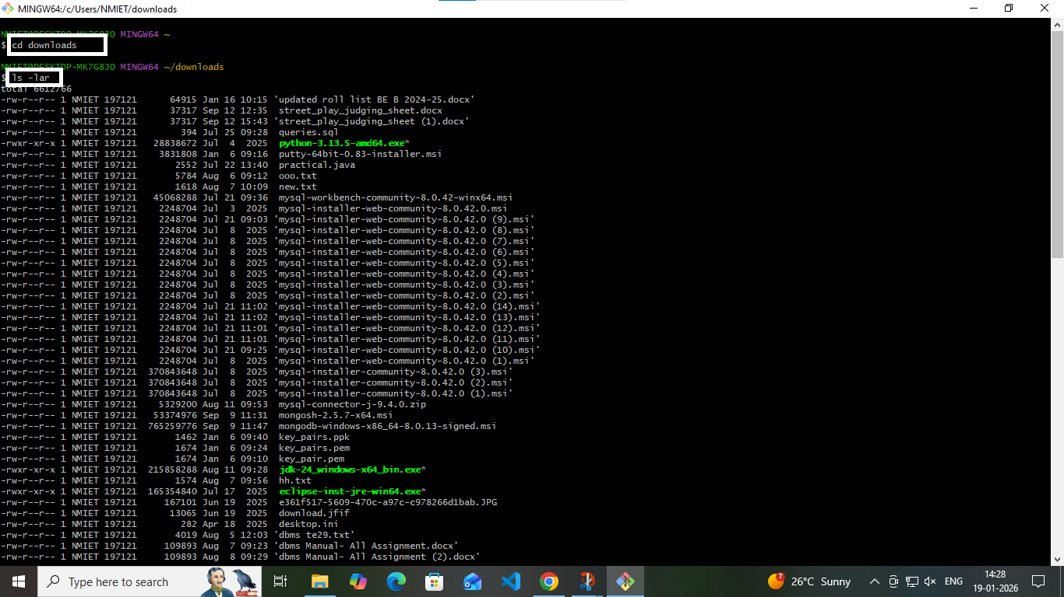

Step 18:- Permission of MyKeyy.pem file
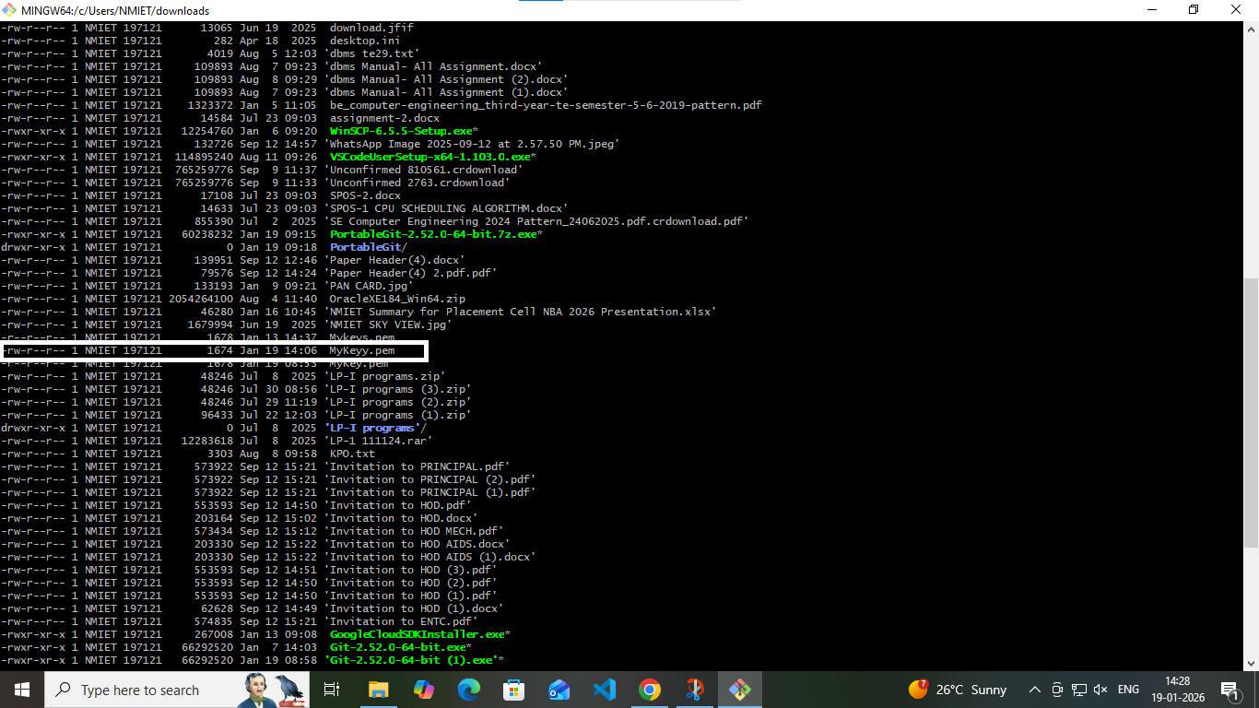

Step 19:-Type command to change the mode
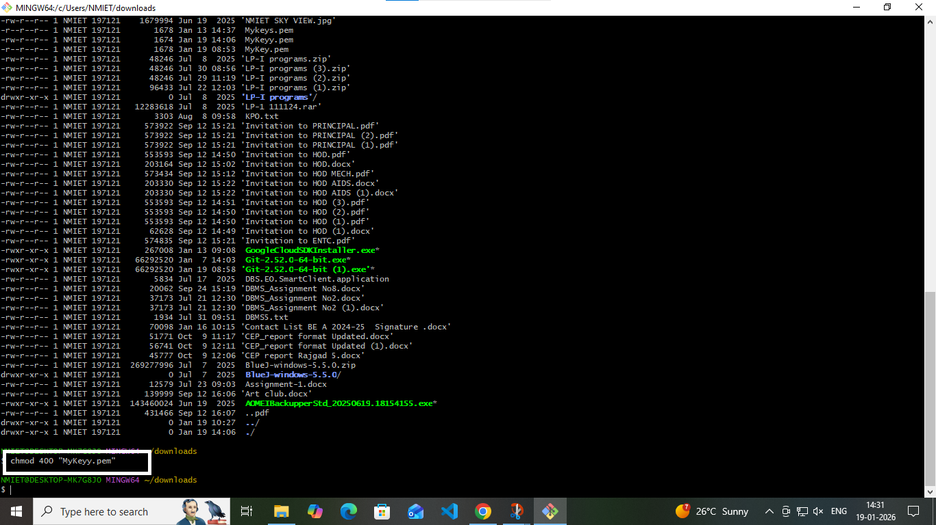

Step 20:-Check changed permission
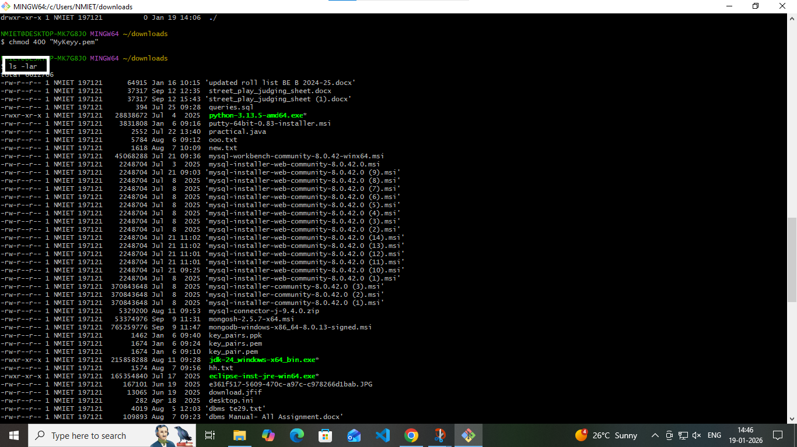

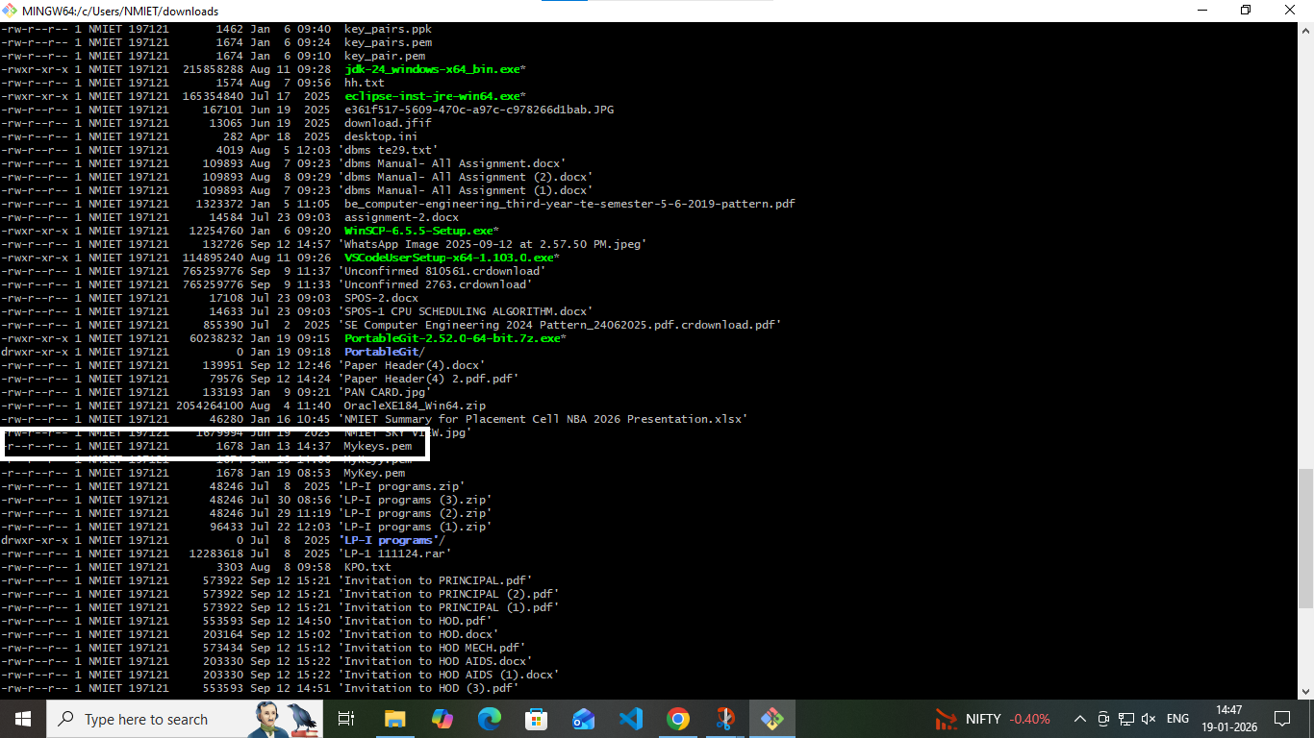

Step 21:- Connect (log in) to an AWS EC2 instance using SSH and check the files present in Instance
