Task: Git Commands Practice

practiced the following Git commands:
- git init
Steps:
- Navigated to the project directory.
- Initialized a Git repository using the command: git init
- Verified the repository contents using: ls -a
Output:
- Git creates a hidden .git directory.
- The .git directory stores Git configuration, commit history, and other repository data.
- The repository is initialized successfully and ready to track files.

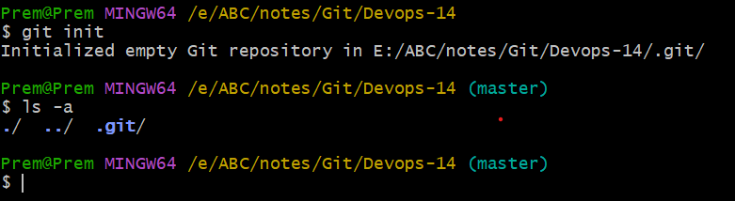

- git add

Steps:
- Listed the files in the project directory using the command ls.
- Added file1 to the staging area using the command git add file1.
Output / Expected Result:
- The git add command stages the specified file for the next commit.
- Only file1 is staged; file2 and file3 remain unchanged.
- The staged changes can be verified using the command git status.

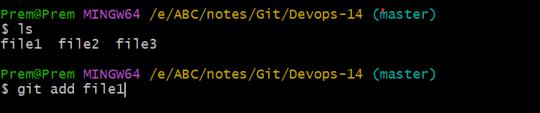

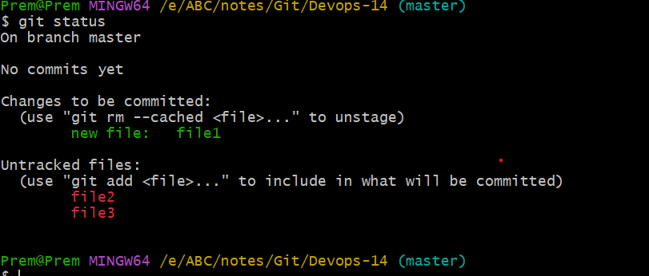

- git commit

Steps:
- Committed the staged file using the command git commit -m "1st commit".
- Added a commit message to describe the changes.
Output:
- Created the first commit in the local Git repository.
- One file (file1) was committed successfully.
- Git recorded the file creation in the commit history.

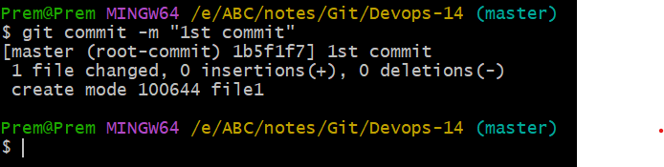

- git push

- git pull

