Git Task(Task-1) – DevOps Batch 14
Date: 07 Oct 2026
Topic: git add, git commit, git push, git pull, git status

1.Practice – git add, git commit, git push, git pull, Git status. Paste your practice snippets in the doc and upload.

git init
git init is used to create a new Git repository in a directory. It initializes Git tracking for your project.
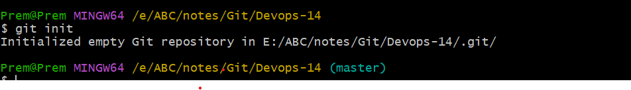
git add
git add is used to move changes from the working directory to the staging area so they can be included in the next commit.
git commit
git commit is used to save staged changes into the local Git repository's history.
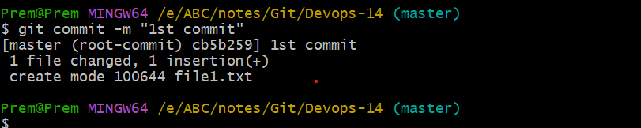
git remote add origin
git remote add origin is used to connect your local Git repository to a remote repository, such as GitHub.
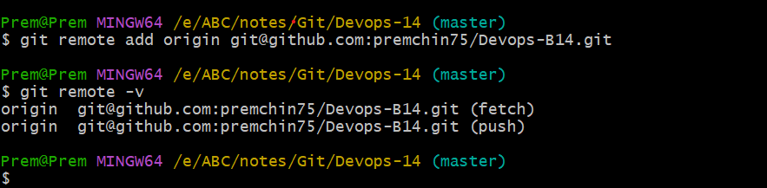

git push
git push is used to upload your local commits to a remote repository, such as GitHub.
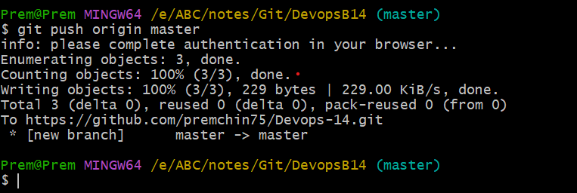

Changes reflected in remote repo

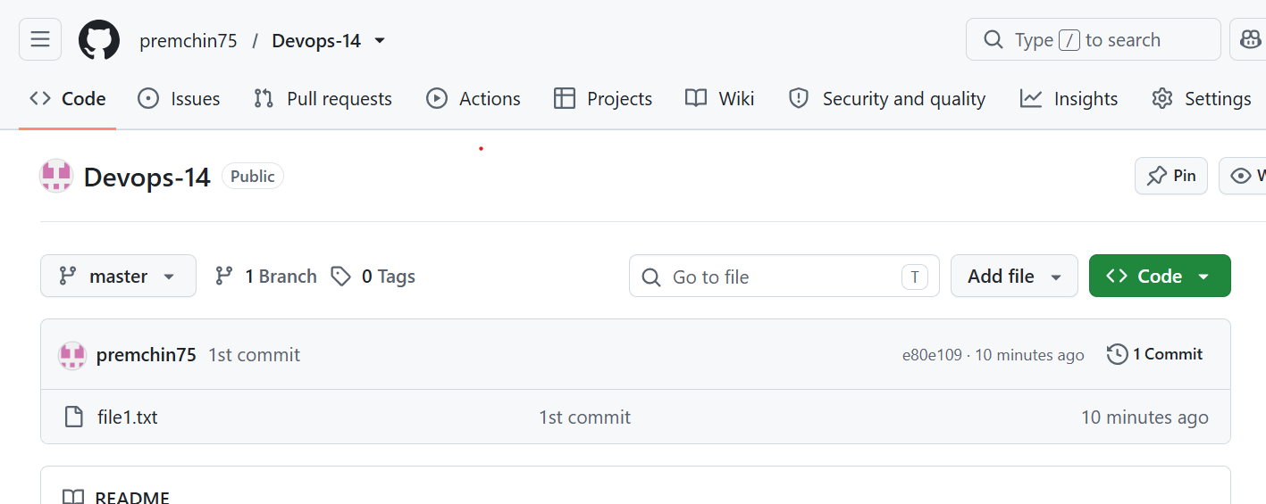

Made changes in remote repo and committed

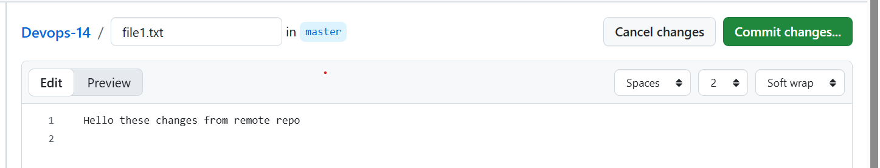
git pull
git pull is used to download the latest changes from a remote repository and integrate them into your current local branch.
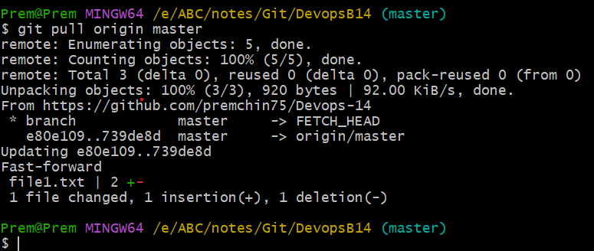
git status
git status is used to check the current state of your Git repository. It tells you which files are modified, staged, untracked, or ready to commit.

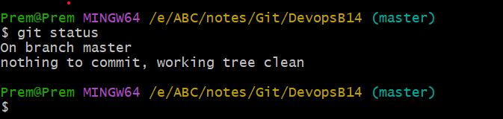

2. How to change the commit message? Execute, add the snippet in doc.

Use git commit --amend -m “message”
To change the recent commit comments
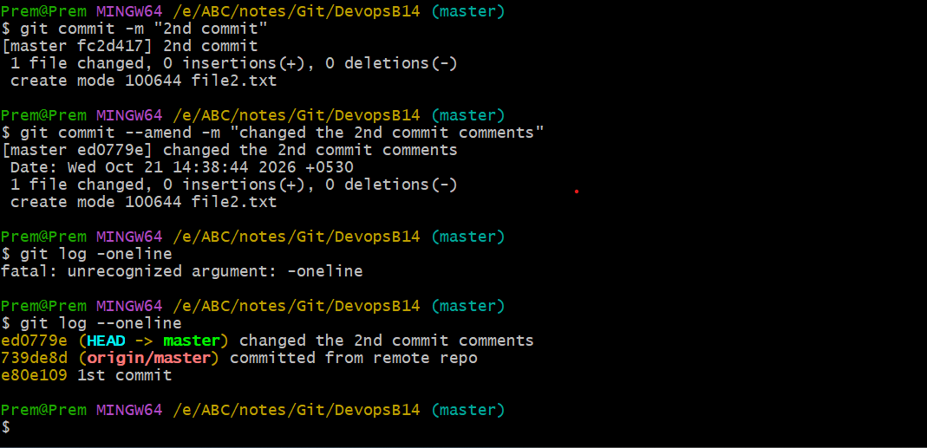

3. How to delete branches from local and remote? Execute, add the snippet in doc.
To delete the local branch can use the command
git branch -d <branch-name>
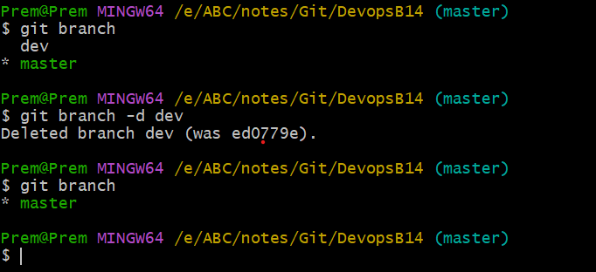

To delete the remote branch from local can use the command
git push origin --delete dev
