Linux-1 Task

1.Create files main.txt, data.txt inside a directory batch14 using single command

mkdir -p batch14 && touch batch14/{main.txt,data.txt}

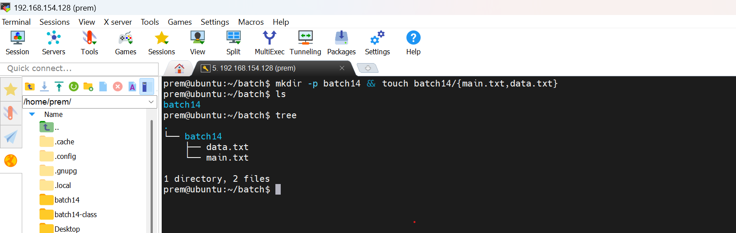

2. You are somewhere inside a directory structure. Which command can you use to return directly to your home directory?

cd command without any arguments
or
cd ~ takes you directly to your home directory



