Linux Commands Practice(linux-2) – DevOps Batch 14
Date: 23 Sep 2026
Topic: Basic Linux Commands

1. Date Command
Purpose: The date command displays the current system date and time.
Command:
Date
Output:

2. Who and Whoami Command
Purpose: The who command displays information about users currently logged in to the Linux system.
Purpose: The whoami command displays the username of the currently logged-in user.
Command
Who
Whoami
Output:
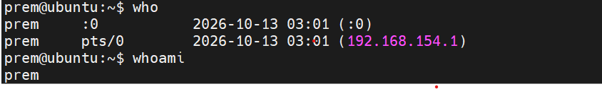
.
3. mv Command
Example 1: Rename a file
mv file1.txt file2.txt
output:
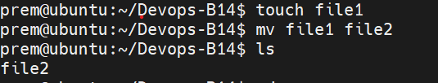
Example 2: Move a file into a directory
mv file1.txt dir1/
output:
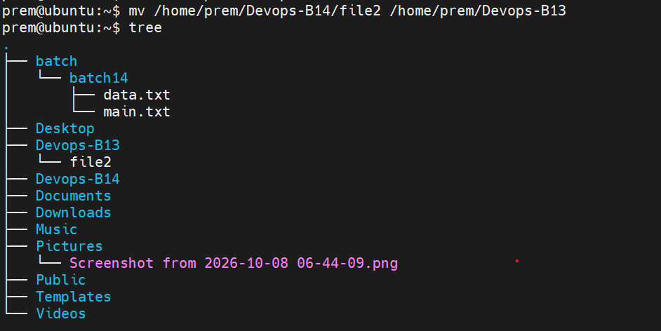
4. cp Command.
cp file1.txt file2.txt
Creates a copy of file1.txt named file2.txt.
output:
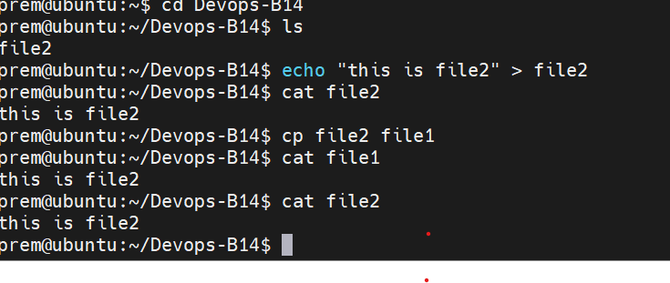
Example 2: Copy a file into a directory
cp file1.txt dir1/
Copies file1.txt into the dir1 directory while retaining the original file.
output:
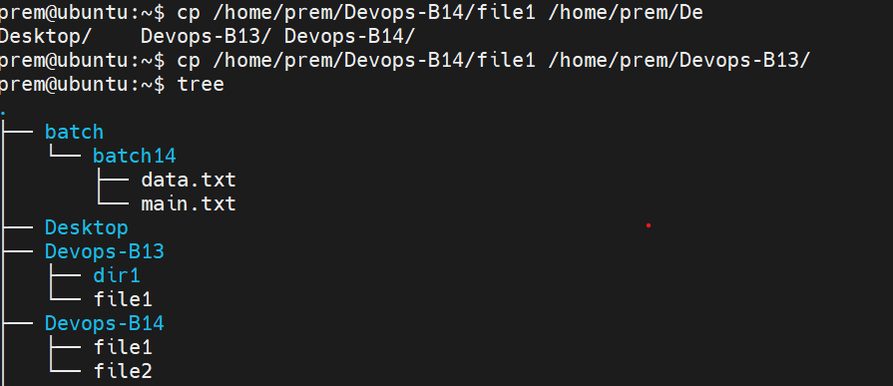

Example 3: Copy a directory
cp -r dir1 dir2

Copies the directory dir1 and its contents into dir2. The -r option enables recursive copying.
output:
