Linux Commands Task(linux-2) – DevOps Batch 14
Date: 23 Sep 2026
Topic: Task-2

1.How do you copy multiple files at once from one location to another?

Command:
cp file1.txt file2.txt file3.txt /home/prem/Devops-B14/dir1/

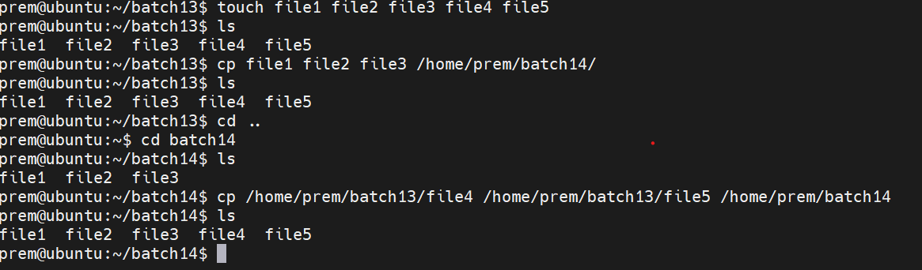

2.What happens if the destination file already exists when copying a file?
By default, cp overwrites the destination file without asking for confirmation in typical Linux configurations.
Command:
cp file1.txt file2.txt

If file2.txt already exists, its contents will be replaced by the contents of file1.txt
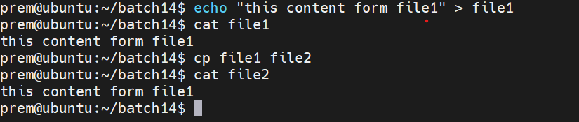
To ask for confirmation before overwriting, use:
Command:
cp -i file1.txt file2.txt
Here, -i means interactive.
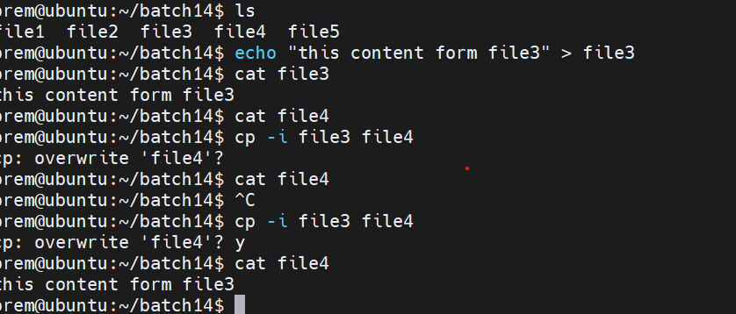
3. How do you move all .txt files to another directory?
Command:
mv *.txt dir1/
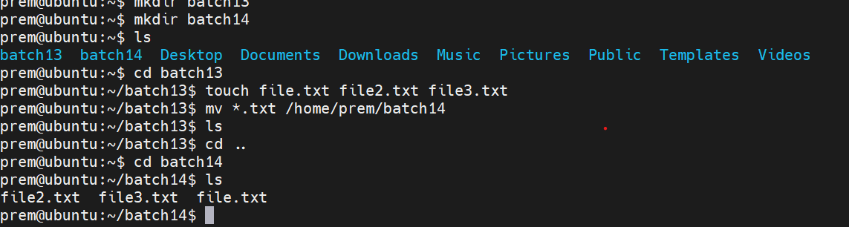

4. How do you copy a directory and all its contents to another location?
Command:
cp -r dir1 /home/prem/Devops-B14/
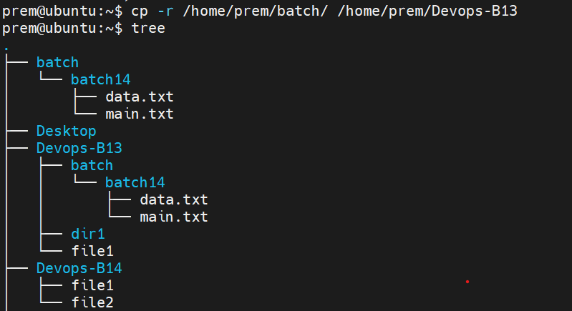
5. How do you identify the kernel name and version of your Linux system?
Command:
uname -a

