Linux Commands Task(linux-3) – DevOps Batch 14
Date: 24 Sep 2026
Topic: Task-3
1. How to search and replace a pattern case-insensitively in Vi editor?
Command:
:%s/apple/orange/gi
% — Entire file.
s — Search and replace.
g — Replace all occurrences in each line.
i — Ignore case.
Example: Apple, apple, and APPLE will all be replaced with orange.
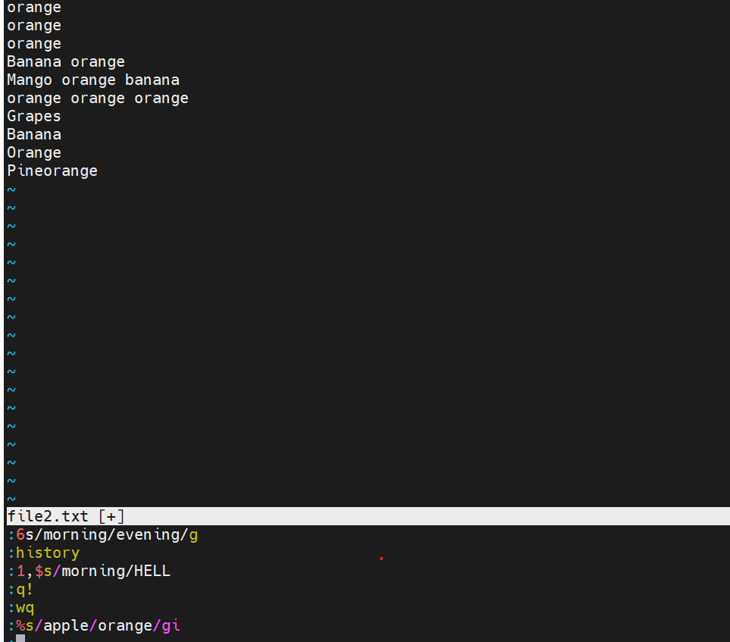
2. How to search a pattern in the forward direction?
/apple
Press Enter.
- n — Search for the next occurrence in the forward direction.
- N — Search in the opposite direction
- To enable case-insensitive searching generally, use:
- :set ignorecase
Example: If your cursor is on line 1, searching /apple finds the next matching occurrence below the cursor.

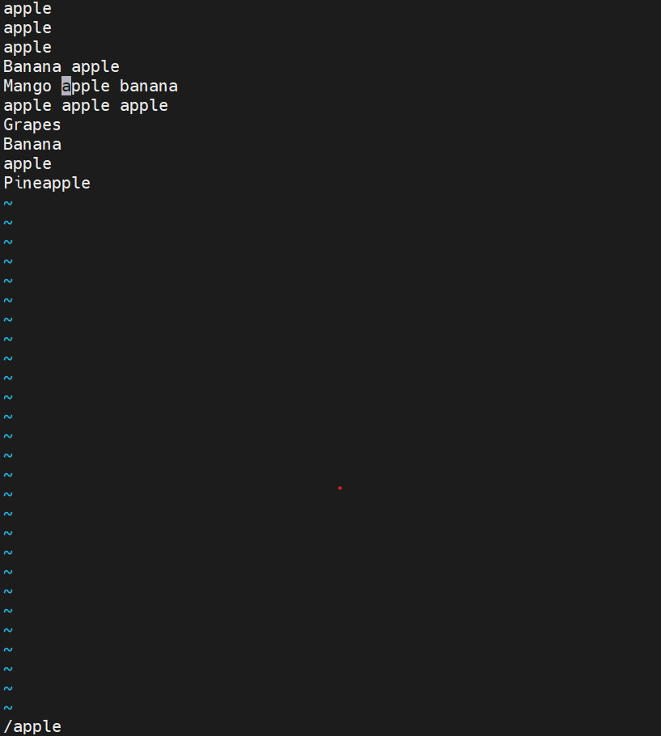

3. How to search a pattern in the reverse direction?
?apple
n — Find the next occurrence in the reverse direction.
N — Search in the forward direction.
Example: If your cursor is on line 10, ?apple searches upward for the previous occurrence.
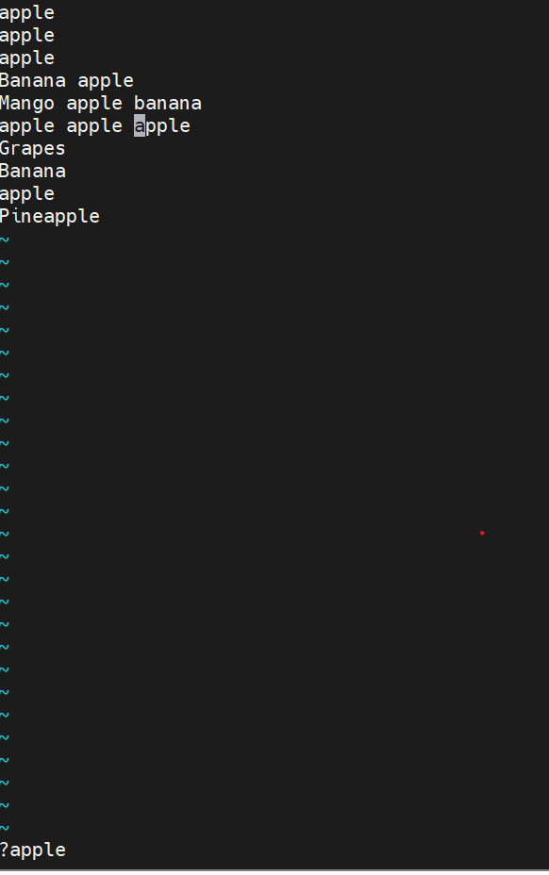
4. How to insert a blank line where the cursor is pointing?

There are two commands:
Insert a blank line below the current line:
o
Insert a blank line above the current line:

O

