Linux Commands Task(linux-4) – DevOps Batch 14
Date: 25 Sep 2026
Topic: Task-4
1.How to search and replace an exact pattern in Vim?
Input:
hello all good morning
goodmorning good morning
:%s/\<morning\>/evening/g

:%s — search and replace throughout the file.
\<morning\> — matches morning as a whole word.
evening — replacement text.
g — replaces all matching occurrences on each line
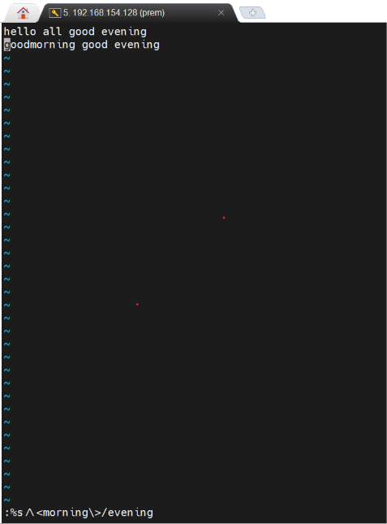

2. How to replace only the 4th occurrence of a word in the entire file in Vim?
- Esc: %s/search pattern/return pattern/gc

- It will point to the first occurance

- Click 3 more times, it will go to the 4th occurance

- Then press enter

- Press 'n' 3 times and Press ‘y’ 4 th time

- 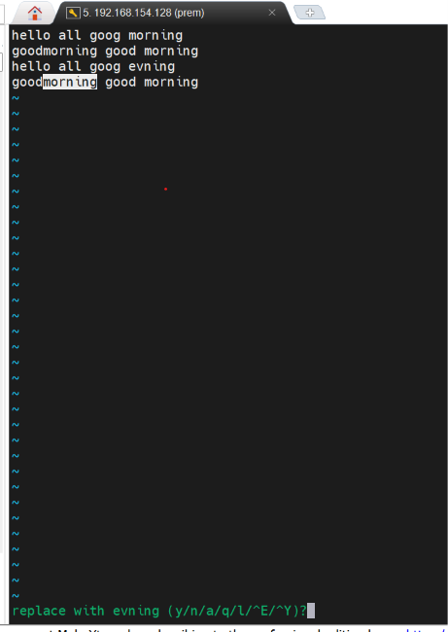

3. What is the difference between man and --help?
Feature | man | --help
Meaning | Manual page | Brief help information
Details | Usually comprehensive | Usually concise
Usage | man ls | ls --help
Navigation | Scroll, search, and navigate pages | Usually prints output in the terminal
Best for | Learning command details | Quickly checking syntax and options

