Linux Commands Task(linux-5) – DevOps Batch 14
Date: 26 Sep 2026
Topic: Task-4

1.How to fetch only the first and last line of a file using head and tail?

head -n 1 file1.txt
tail -n 1 file1.txt

head -n 1 file1.txt – Displays only the first line.
tail -n 1 file1.txt – Displays only the last line.

To display both the first and last lines using a single command:
{ head -n 1 file1.txt; tail -n 1 file1.txt; }
{ head -n 1 file3.txt ; tail -n 1 file3.txt; }| tee file4.txt

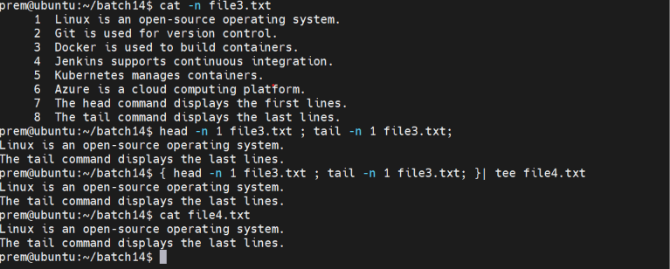

2.How to print all lines of a file except the 4th line?

Using head and tail with a pipe

(head -n 3 file1.txt; tail -n +5 file1.txt)

head -n 3 file1.txt — prints lines 1 to 3.
tail -n +5 file1.txt — prints from line 5 to the end.
; — runs the second command after the first command finishes.
Using head, tail, and tee
(head -n 3 file1.txt; tail -n +5 file1.txt) | tee output.txt

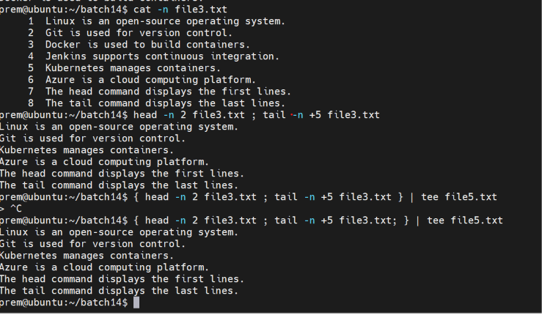

sed '4d' file1.txt

sed – Processes and modifies text output.
4 – Specifies the fourth line.
d – Deletes the specified line from the output.

