Linux Commands Practice(linux-6) – DevOps Batch 14
Date: 28 Sep 2026
Topic: Administrative commands & Permissions

How to create a user
We can user command
Sudo adduser <user-name>
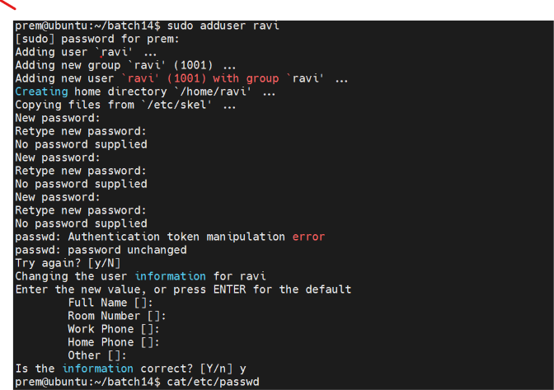
How to check the user created or not
Use command cat /etc/passwd to check the system files that store users basic information
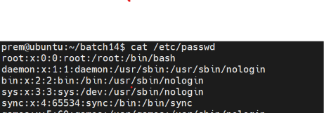

How to switch from user to root user or user
Use command sudo su to switch from user to root user
User command sudo su ravi to switch from user to anther user
User exit to exit from the root user or from other users
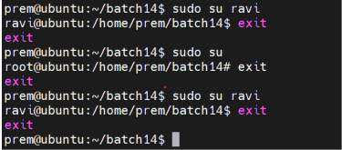

How to create a group
Use Command sudo addgroup <group-name>
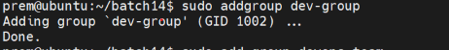

How check the group created or not
Use command cat /ect/group
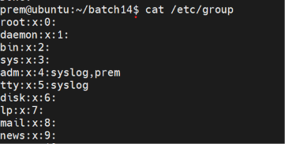

How to add user to a group
Use command sudo usermod -G <group-name> <user-name>

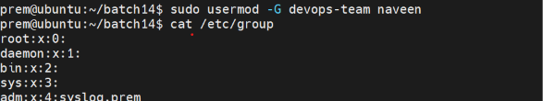
To check user added or not
User command cat /etc/group
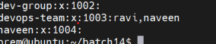

How to delete user
Use command sudo deluser <user-name>
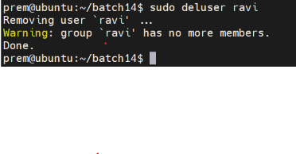
To check the user deleted or not
Use command cat /etc/passwd
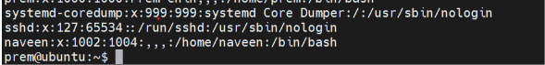

How to delete group
Use command sudo delgroup <group-name>
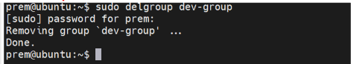

to check group is deleted or not
Use commend cat /etc/group
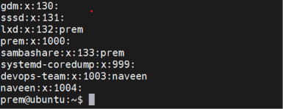

Permissions
User permission : who is owener of file or dir
Group :provide particular permission to a group
Other: any user who is neither owner of file or member of group

Directory is represented by d
File is represented by –
Link is represned by l

Dir/fil/links <user-perm> <group-perm> <other-perm>
d/-/l 4 2 1 4 2 1 4 2 1
r w x r w x r w x

How to change persmission of file/dir/link
Use command sudo chmod 777 <file-name>
Based on required persmmisons we can change numeric format accordingly
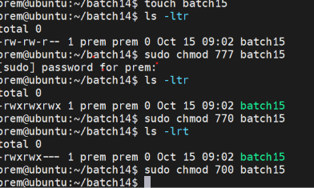

We can give different way as well
