Linux Commands Task(linux-6) – DevOps Batch 14
Date: 28 Sep 2026
Topic: Administrative commands & Permissions

- How to add multiple users together to a group?

sudo gpasswd -M john,ram,prem developers
gpasswd – Manages group membership.
-M – Sets the list of group members.
john,ram,prem – Usernames to add as group members.
developers – Group name
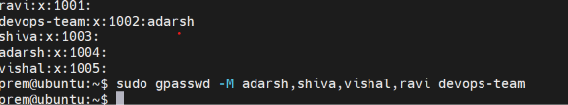

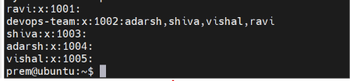

- How to remove multiple users together from a group

To remove mutltiple users together from the group
Use command sudo gpasswd -d <user-name> <gourp-name>

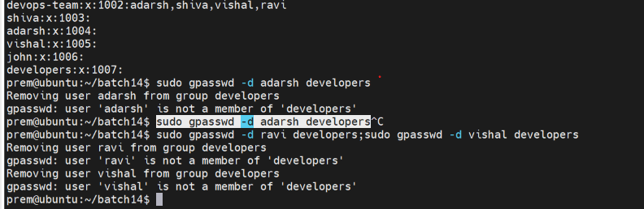
3. What does this command will do?
a) sudo chown john:developers file1.txt
john becomes the owner, and developers becomes the group owner of file1.txt.
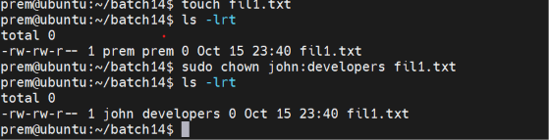

b) chmod o-rwx file1.txt
Removes read, write, and execute permissions from others.

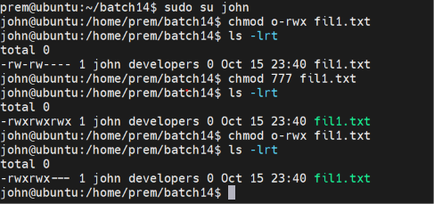
c) chmod u+x,g+x file1.txt
Adds execute permission to the owner and group

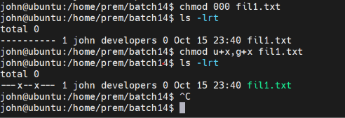

4. How to change the owner of file?
Sudo chmown prem file1.txt
