Linux Commands Practice(linux-7) – DevOps Batch 14
Date: 29 Sep 2026
Topic: Link in Linux, Hard link ,soft link

Link In linux
Link is a reference/pointer to a file/dir
Link allows multiple reference to same data without duplicating same
1.Hard link:
Hard link is an additional name for an existing file where both the original file and the hard link will share same inode which means they are files with different name.
Note : inodes- it is a data structure that stores information about files/dir’s size ,owner..etc
How to create hard link:
Use command ln <file-name> <link-name>
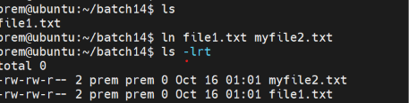

1.If we make any changes in original file the changes reflect in link as well
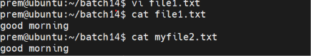
2.if we rename the original file the link will still work
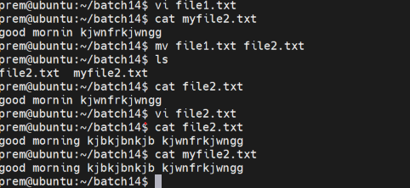
3.if we delete the original the created link will work
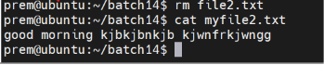

2.Soft link:

Soft link is pointer to a file. It does not share the same inode as original file
How to create softlink:
Use command to ln -s <file-name> <link-name>
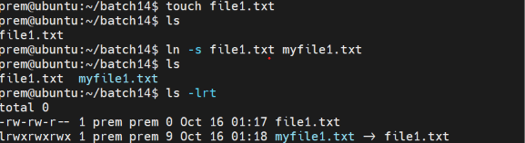
1.If we make any changes in original file the changes reflect in link as well
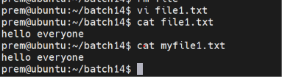

2.if we rename the original file the link will not work
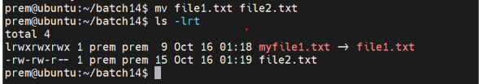
3.if we delete the original the created link will not work
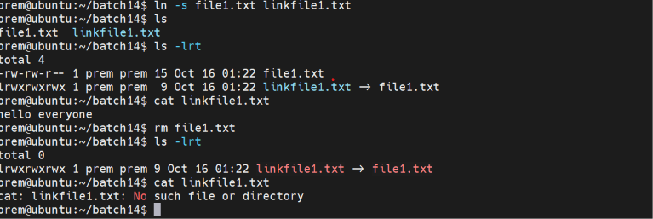

More command:
Used to display all the content of a file on the terminal page wise
Use command more <file-name>
User down or up arrow to check the content

