Linux Commands Practice(linux-8) – DevOps Batch 14
Date: 30 Sep 2026
Topic: Grep

Grep (global regular expression):
Grep command is used to search and filter the text/pattern in a closed file
Use command grep <pattern> <file-name>
This command will display the pattern is present
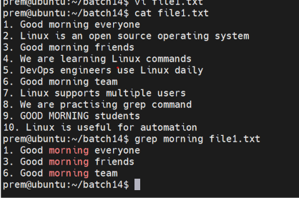

If we want search and filter the exact match in a closed file on terminal
Use command grep -w <pattern> <file-name>
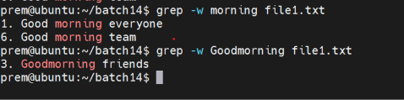

If we want search and filter the exact match in a closed file on terminal with case insensitive are present
Use command grep -i <pattern><file-name>
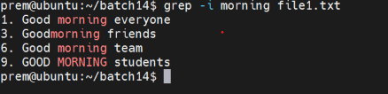

If we want to display exact pattern on the terminal instead of full line
Use command grep -o <pattern><file-name>

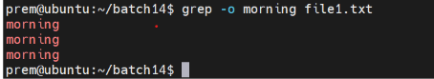

If we want to display all the line except the lines where the is pattern is present
Use command grep -v <pattern> <file-name>
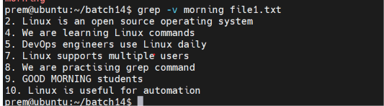

If we want the count of the total no of line where the pattern is present
Use command grep -c <pattern><file-name>

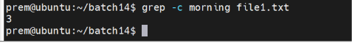

If we want to display the lines where pattern is present on the terminal along with line numbers
Use command grep -n <pattern><file-name>
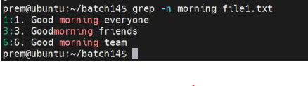
We can use the grep with multiple flags
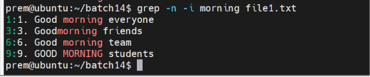

If we want to display the lines where the pattern is present

Use command grep “pattern” <file name>
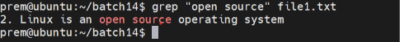

If we want search multiple patters
Use commad grep -e “morning” -e “Linux” -e “system” <file-name>

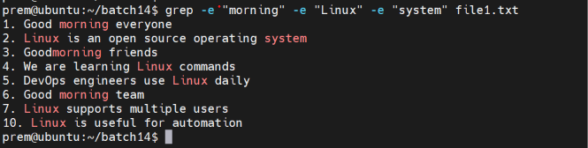

AWK command:
awk command is used to extract the data from structured file
Or
awk command is used to extract the column wise content on the terminal

Use command awk ‘{print}’ <file-name>
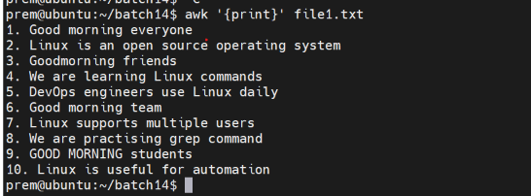

If we want to display only 2nd column and 4th column on teminal
Use command awk ’{print $2,$4}’ <file-name>
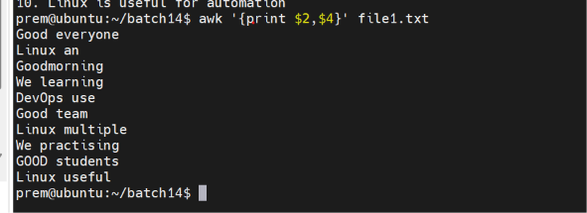
If we want display the 2nd column and content along with total no of words /columns /fields on the terminal
NF = no of fields
Use command awk ‘{print NF $2}’ <file-name>