Mini Project Report
on
TASK MANAGER
A Mobile Application to Add, Update, Delete and Schedule Tasks with Reminder Notifications
Submitted by
Student Name | Roll Number
[Student 1 Name] | [Roll No.]
[Student 2 Name] | [Roll No.]
[Student 3 Name] | [Roll No.]
[Student 4 Name] | [Roll No.]

Class: [Class / Division]
Department: [Department Name]
Academic Year: [20XX – 20XX]
Guide / Instructor: [Name]
Institute: [Institute Name]

1. Introduction
In everyday life, students and professionals must keep track of assignments, meetings and personal errands. Paper lists and memory are easily lost or forgotten, and a missed deadline is often the result. A mobile application that stores tasks and reminds the user at the right time is a simple and effective answer to this problem.
This mini project presents Task Manager, a mobile application built with the Flutter framework and the Dart language. The application offers a clean, minimal interface in which a user can create tasks, edit them, mark them as completed, delete them and attach a due date and time to each one. All data is stored on the device in a SQLite database, so the application works fully offline. For every scheduled task the application raises a local notification at the due time, reminding the user about the upcoming work even when the application is closed.
Flutter was selected because a single code base can target Android and iOS, and because its Material 3 widget library makes it easy to build a simple and consistent user interface.

2. Problem Statement
People frequently forget tasks because they have no single, reliable place to record them and no mechanism that alerts them when a task becomes due. Existing task applications are often feature-heavy, require an internet connection or an account, and present complicated interfaces for what is a basic need.
The problem addressed by this project is therefore to design and develop a lightweight, offline-capable mobile application that allows a user to create, modify, delete and schedule tasks through a simple interface, store them persistently on the device, and be reminded automatically through notifications when a task is due.

3. Aim and Objectives

3.1 Aim
To develop a simple, user-friendly mobile task management application with persistent local storage and scheduled reminder notifications.

3.2 Objectives
- To implement create, read, update and delete (CRUD) operations for tasks using a SQLite database.
- To allow the user to schedule each task by choosing a due date and time through standard date and time pickers.
- To deliver a local notification at the scheduled time so that the user is reminded of upcoming tasks.
- To provide a simple, intuitive interface that supports marking tasks as done, swipe-to-delete with an undo option, and clear indication of overdue tasks.

4. Software and Hardware Requirements

4.1 Software Requirements
Component | Details
Operating system (development) | Windows 11
Framework / language | Flutter 3.44 (stable channel), Dart 3.12
IDE | Android Studio with the Flutter and Dart plugins; Visual Studio Code
Local database | SQLite through the sqflite package (v2.4)
Notifications | flutter_local_notifications (v22), timezone, flutter_timezone
Utility packages | path (file paths), intl (date and time formatting)
Build tools | Android SDK, Gradle, Android Emulator (Android 16, API 36)

4.2 Hardware Requirements
Component | Details
Development computer | Laptop / desktop, 64-bit processor, minimum 8 GB RAM, 20 GB free disk space
Test device | Android emulator (x86_64) or any Android phone running Android 6.0 or later
Connectivity | Internet is needed only to download dependencies during development; the application itself works offline

5. System Design

5.1 Architecture
The application follows a simple layered structure. The user interface layer contains the screens. A service layer contains the database helper and the notification service. The model layer defines the Task object that is passed between the layers. The screens never access SQLite or the notification plugin directly; they call the service classes, which keeps the code easy to understand and test.

5.2 Block Diagram
User
↓
User Interface (Flutter screens)
Home Screen | Add / Edit Task Screen
↓
Application Logic
Task model | Validation | Scheduling decisions
↓
DatabaseHelper (SQLite / sqflite)
insert, update, delete, query
↕
Device storage: tasks.db

NotificationService
schedules / cancels local notifications
↓
Android AlarmManager
fires at the due time → reminder notification on the device
Figure 1: Block diagram of the Task Manager application

5.3 Flowchart: Adding or Updating a Task
Start: user taps "+" or selects an existing task
↓
Enter title, description and (optional) due date and time
↓
Is the title empty? Yes: show "Enter a title" and stay on the form
↓
No: save task to SQLite (insert new row or update existing row)
↓
Due date set, task not done and time in the future?
↓
Yes: cancel any old reminder and schedule a new notification
No: cancel any existing reminder
↓
Return to Home Screen and refresh the task list
Figure 2: Flowchart of the add / update operation

5.4 Database Design
A single table named tasks is used. Due dates are stored as milliseconds since the epoch so that sorting and comparison are simple.
Column | Type | Description
id | INTEGER, primary key, auto-increment | Unique identifier; also used as the notification id
title | TEXT, not null | Short name of the task
description | TEXT, default empty | Optional details
due_date | INTEGER, nullable | Due date and time in milliseconds since epoch
is_done | INTEGER, default 0 | 0 = pending, 1 = completed

6. Implementation

6.1 Project Structure
File | Purpose
lib/main.dart | Application entry point; initialises notifications and sets the Material 3 theme
lib/models/task.dart | Task class with copyWith, toMap and fromMap for database conversion
lib/services/database_helper.dart | Opens the SQLite database and provides insert, update, delete and getAll
lib/services/notification_service.dart | Time-zone setup, permission requests, scheduling and cancelling reminders
lib/screens/home_screen.dart | Task list, checkbox, swipe-to-delete with undo, overdue indicator
lib/screens/task_form_screen.dart | Form for adding and editing a task, with date and time pickers

6.2 Main Modules
Task Model. The Task class holds the id, title, description, due date and completion flag. Conversion methods translate between the Dart object and the map stored in SQLite.
Database Module. DatabaseHelper is a singleton that opens tasks.db and creates the tasks table on first run. getAll() returns pending tasks first, ordered by due date, with tasks that have no due date placed last, so the most urgent task is always at the top.
Task Form Module. The form validates that the title is not empty, lets the user pick a date with showDatePicker and a time with showTimePicker, and allows the due date to be cleared. On save it inserts or updates the row and then asks the notification service to schedule a reminder.
Home Screen Module. The home screen loads the tasks and displays them in a list. A checkbox marks a task as completed (shown with a strike-through), tapping a task opens it for editing, and swiping a task to the left deletes it. A snackbar offers an Undo action that re-inserts the deleted task and restores its reminder. Pending tasks whose due time has passed are marked with a warning icon.
Notification Module. NotificationService initialises the time-zone database, detects the device time zone, requests the notification permission, and schedules a notification with zonedSchedule at the due time. If the exact-alarm permission is granted the notification is sent as an exact alarm so that it appears on time; otherwise the application falls back to an inexact alarm. When a task is edited, completed or deleted, its previous reminder is cancelled first, so the user is never reminded about a task that no longer needs attention.

6.3 Technologies Used
- Flutter and Dart for the cross-platform user interface and application logic.
- SQLite via the sqflite package for persistent local storage.
- flutter_local_notifications with Android AlarmManager for scheduled reminders.
- Android permissions: POST_NOTIFICATIONS (Android 13 and above), SCHEDULE_EXACT_ALARM and RECEIVE_BOOT_COMPLETED.

6.4 Issues Found and Resolved During Testing
The application was installed and tested on an Android emulator. Testing exposed one important defect: reminders were scheduled correctly, but no notification appeared. Inspection of the system alarm log showed that the alarm was firing at the right time, yet nothing was displayed. The cause was that the plugin’s broadcast receivers had not been declared in the application’s AndroidManifest.xml, so Android silently discarded the alarm broadcast. After declaring ScheduledNotificationReceiver and ScheduledNotificationBootReceiver, and switching to exact alarms, the notification was delivered at the due time. A second observation was that inexact alarms can be delayed by several minutes on modern Android versions, which is why exact scheduling is now used whenever it is permitted.

7. Results and Screenshots
The following screenshots were captured from the application running on an Android emulator (Android 16). Each function of the application was tested and gave the expected result.
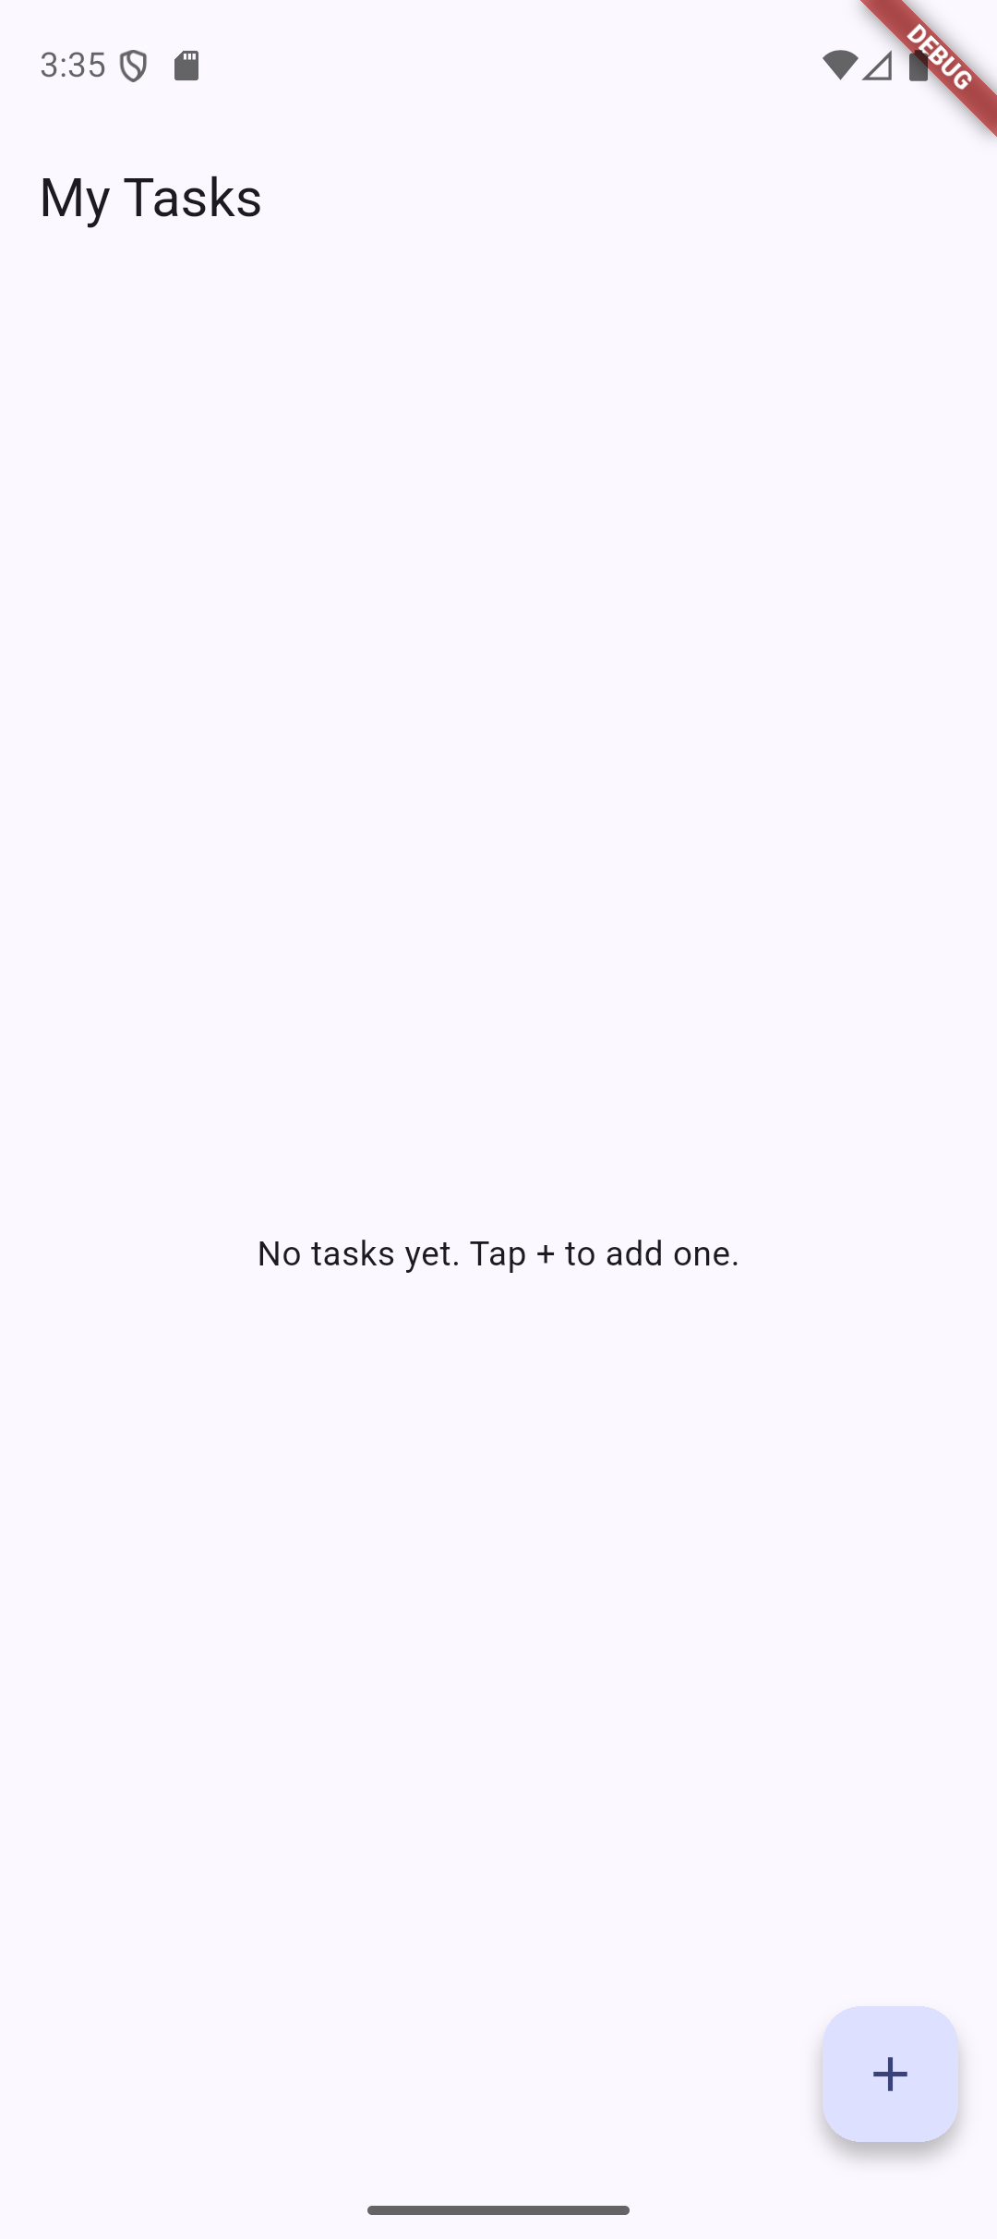  Figure 3: Home screen with no tasks | 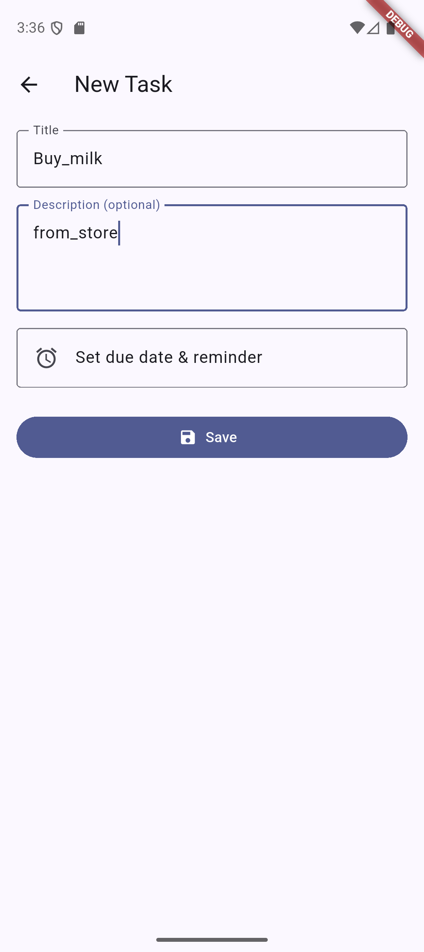  Figure 4: Add Task form with title and description
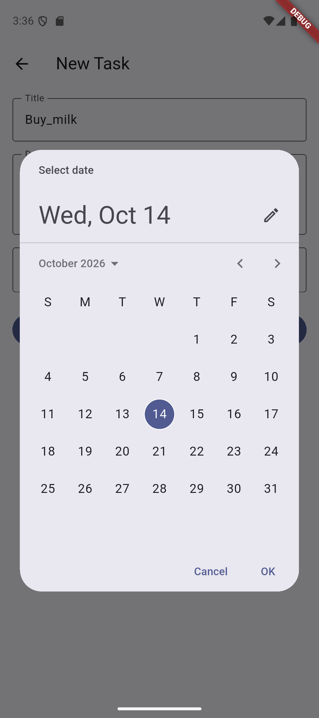  Figure 5: Choosing the due date | 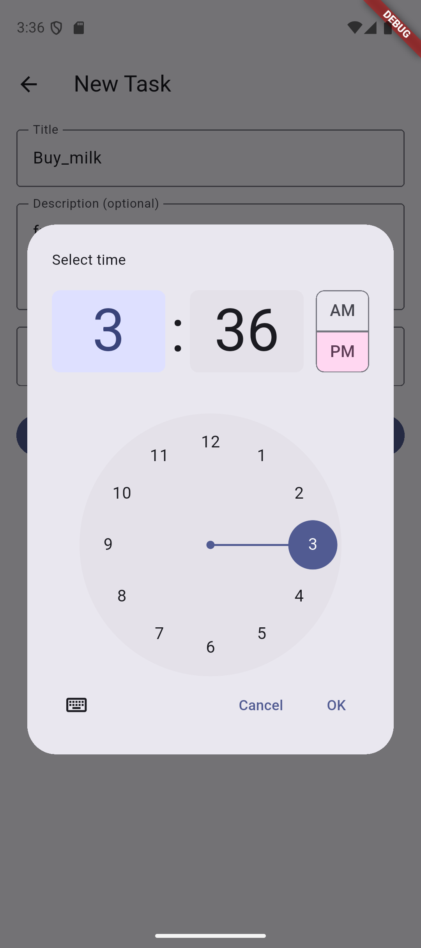  Figure 6: Choosing the due time
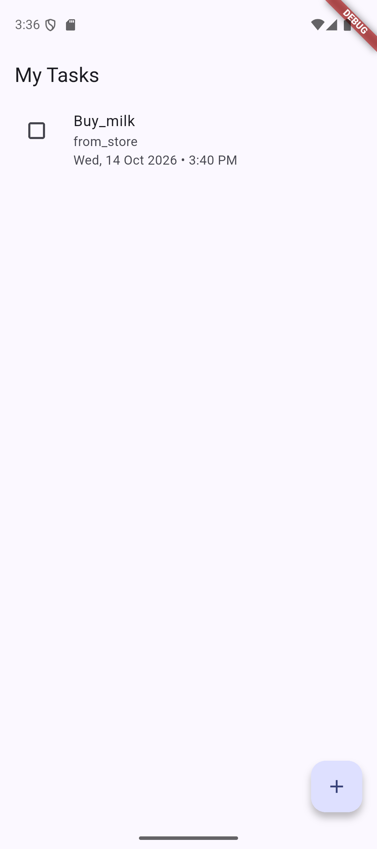  Figure 7: Task saved and shown in the list with its due date | 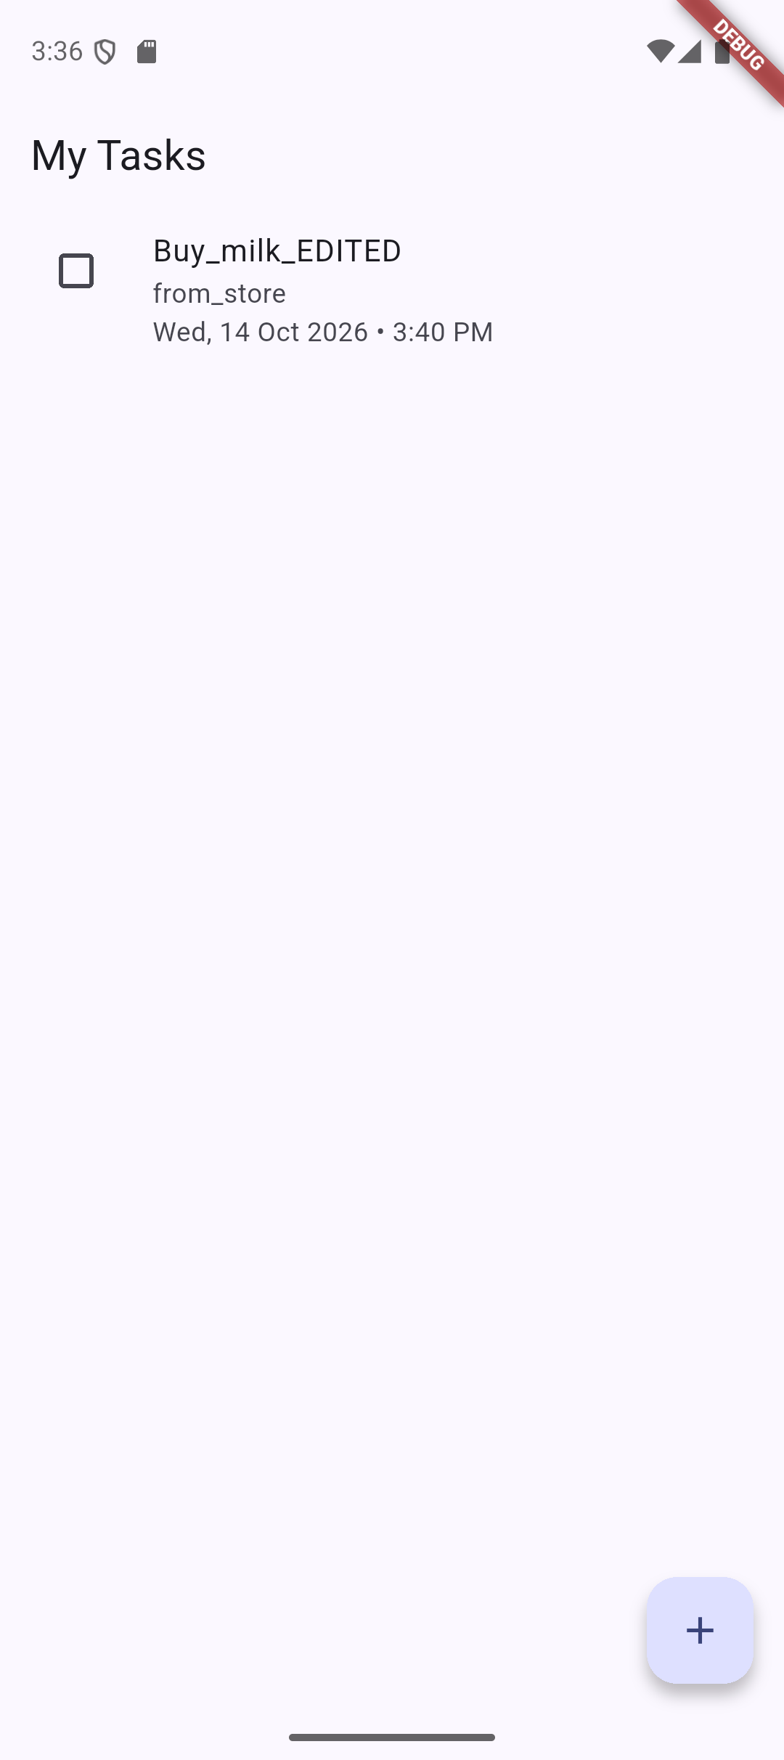  Figure 8: Task after being edited (title updated)
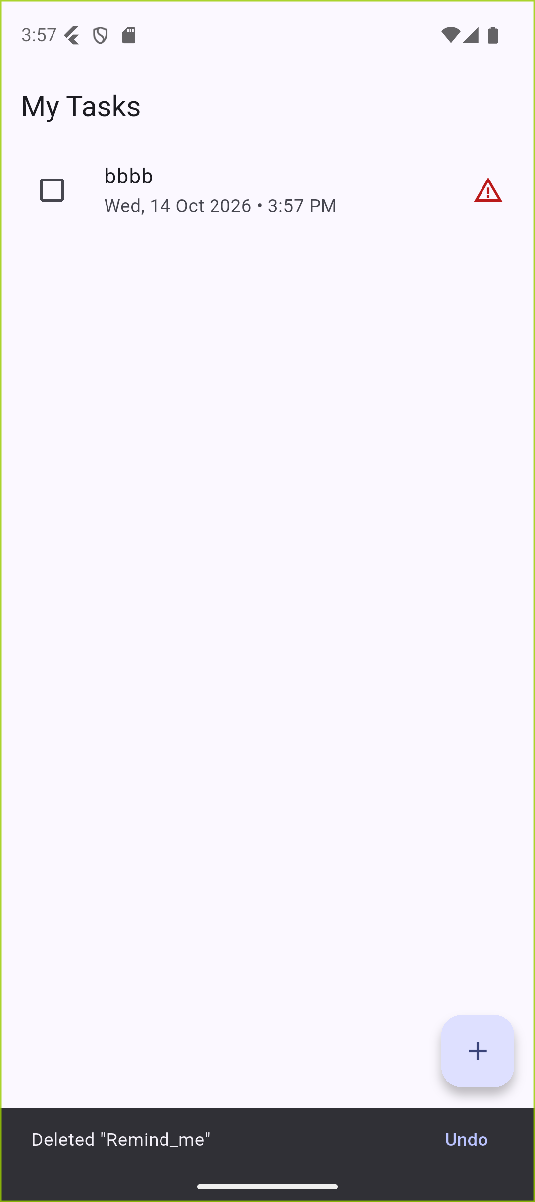
Figure 9: Swipe-to-delete with Undo option; overdue tasks show a warning icon

7.1 Test Summary
Function tested | Observed result | Status
Add task | Task saved to SQLite and displayed with title, description and due date | Pass
Update task | Edited title appeared in the list after saving | Pass
Mark as done | Task moved below the pending tasks | Pass
Delete task | Task removed; Undo snackbar displayed | Pass
Schedule task | Alarm registered with Android AlarmManager at the chosen time | Pass
Reminder notification | Notification posted on channel task_reminders at the due time, with the task title and the text "This task is due now" | Pass (after fix in 6.4)

8. Conclusion
The Task Manager mini project achieved its aim of providing a simple mobile application in which a user can add, update, delete and schedule tasks, with all data stored locally in SQLite and reminders delivered through local notifications. The interface was kept deliberately minimal: a single list screen, a single form screen, a checkbox, a swipe gesture and two standard pickers.
The project gave the team practical experience in building a Flutter application, designing a small relational schema, integrating a native Android feature (alarms and notifications) through a plugin, and handling runtime permissions. Debugging the missing notification taught an important lesson: a successful scheduling call does not guarantee delivery, and platform-level configuration such as manifest declarations and alarm permissions must be verified on a real device or emulator.

8.1 Future Scope
- Task categories, priorities and search or filter options.
- Repeating reminders (daily, weekly) and snooze actions from the notification.
- Cloud backup and synchronisation across devices.
- Dark theme, home-screen widget and testing on iOS.

9. References
- Flutter Documentation. https://docs.flutter.dev
- Dart Programming Language. https://dart.dev/guides
- sqflite package, pub.dev. https://pub.dev/packages/sqflite
- flutter_local_notifications package, pub.dev. https://pub.dev/packages/flutter_local_notifications
- timezone package, pub.dev. https://pub.dev/packages/timezone
- intl package, pub.dev. https://pub.dev/packages/intl
- SQLite Documentation. https://www.sqlite.org/docs.html
- Android Developers: Schedule alarms. https://developer.android.com/develop/background-work/services/alarms
- Android Developers: Notification runtime permission. https://developer.android.com/develop/ui/views/notifications/notification-permission
- Material Design 3. https://m3.material.io

