**ReactJS HOS 1**A1) SPA (Single-Page Application) is a web application that loads a single HTML page and dynamically updates content as the user interacts with the app without reloading the entire page.

Benefits of SPA:

* It helps in faster navigation where only data is fetched, not the full pages
* It helps in better user experience because in does not have full page loads
* It has reduced server load which means backend serves only data, not full HTML.
* It helps in efficient development that is frontend and backend are separated

A2) React is a JavaScript library developed by Facebook for building user interfaces, using components.

Working of React:

* Uses components to build UI.
* Maintains a virtual DOM.
* When data changes, React updates only the parts of the DOM that changed, improving performance.
* It uses unidirectional data flow (parent to child only).

A3) Difference between SPA and MPA:

|  |  |  |
| --- | --- | --- |
| **Feature** | **SPA (Single-Page App)** | **MPA (Multi-Page App)** |
| Page Load | Loads once, then updates dynamically | Reloads entire page for each interaction |
| Speed | Faster navigation | Slower due to full reloads |
| User Experience | Seamless, like desktop apps | Traditional page reloads |
| Development | Frontend-heavy, uses frameworks like React | Backend-heavy (HTML rendered server-side) |
| SEO | More challenging (requires extra setup) | Easier, as pages are pre-rendered |

A4) Pros:

* Smooth user experience
* Faster performance after initial load
* Easier to build with frontend frameworks (React, Vue, Angular)
* Reusable components

Cons:

* Initial load might be heavy
* SEO optimization is harder
* Browser history and analytics require extra setup
* Security risks (if not handled properly)

A5) React is a JavaScript library used to build interactive UIs in a component-based structure. It allows developers to build reusable UI components and efficiently update and render them using the virtual DOM. It supports:

* JSX (HTML + JavaScript)
* Hooks and State Management
* Unidirectional Data Flow
* Fast rendering with virtual DOM

A6) Virtual DOM is a lightweight JavaScript representation of the actual DOM. When the state of a component changes :

1. A virtual DOM is updated.
2. React compares the new virtual DOM with the previous one (diffing).
3. Only the changed parts are updated in the real DOM (efficient rendering)

A7) Key Features of React:

* JSX: JavaScript + HTML syntax for UI definition.
* Components: Reusable, independent building blocks.
* Virtual DOM: Efficient UI rendering.
* Unidirectional Data Flow: Predictable and easy-to-debug state management.
* Hooks: Use state and lifecycle methods in functional components.
* One-way Binding: Data flows from parent to child components.
* React Native: Build mobile apps using React principles.

**First React Application  
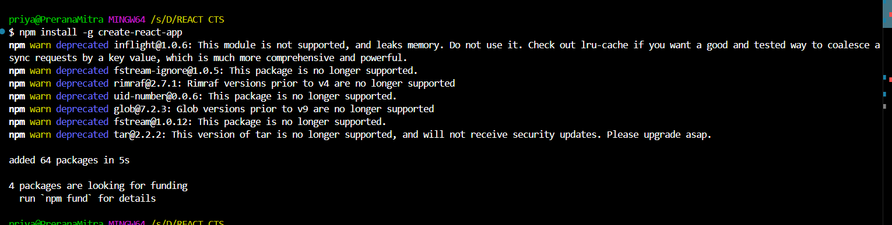  
  
  
  
  
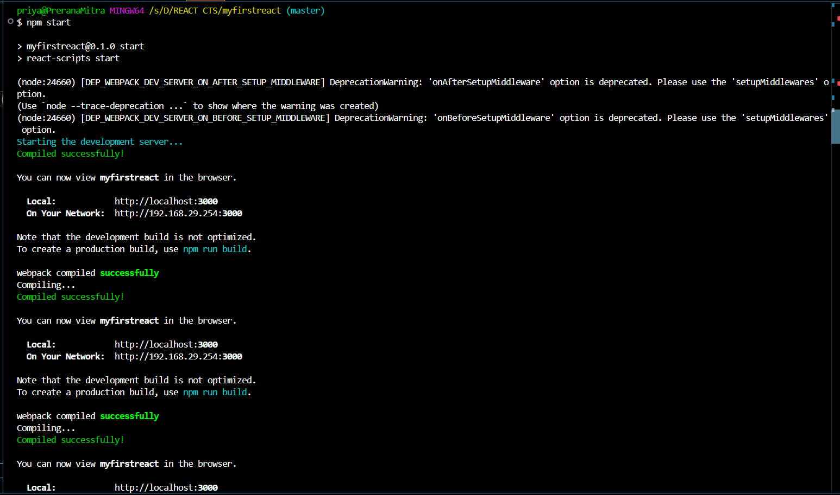**

**OUTPUT  
  
**