**REACTJS HOS 10**

A1) JSX (JavaScript XML) is a syntax extension for JavaScript used in React to describe UI.  
It looks like HTML but compiles to React.createElement() calls.

A2) ECMAScript (ES) is the standardized version of JavaScript.  
Modern JS features (like let, const, arrow functions, classes) come from ECMAScript versions like ES6, ES7, etc.

A3) React.createElement() method creates a virtual DOM element manually.  
ex - React.createElement('h1', null, 'Hello');  
Equivalent JSX: <h1>Hello</h1>

A4) React nodes (UI elements) are created using JSX syntax inside components.

A5) Use ReactDOM.render() to mount JSX into the HTML DOM to render JSX into DOM

A6) Use {} inside JSX to embed JS expressions (not statements).

Example:

const name = "John";

<h1>Hello, {name}</h1>

A7) Use style={{}} with camelCase property names.

Example: <h1 style={{ color: 'blue', fontSize: '20px' }}>Styled Text</h1>

**CODES:**

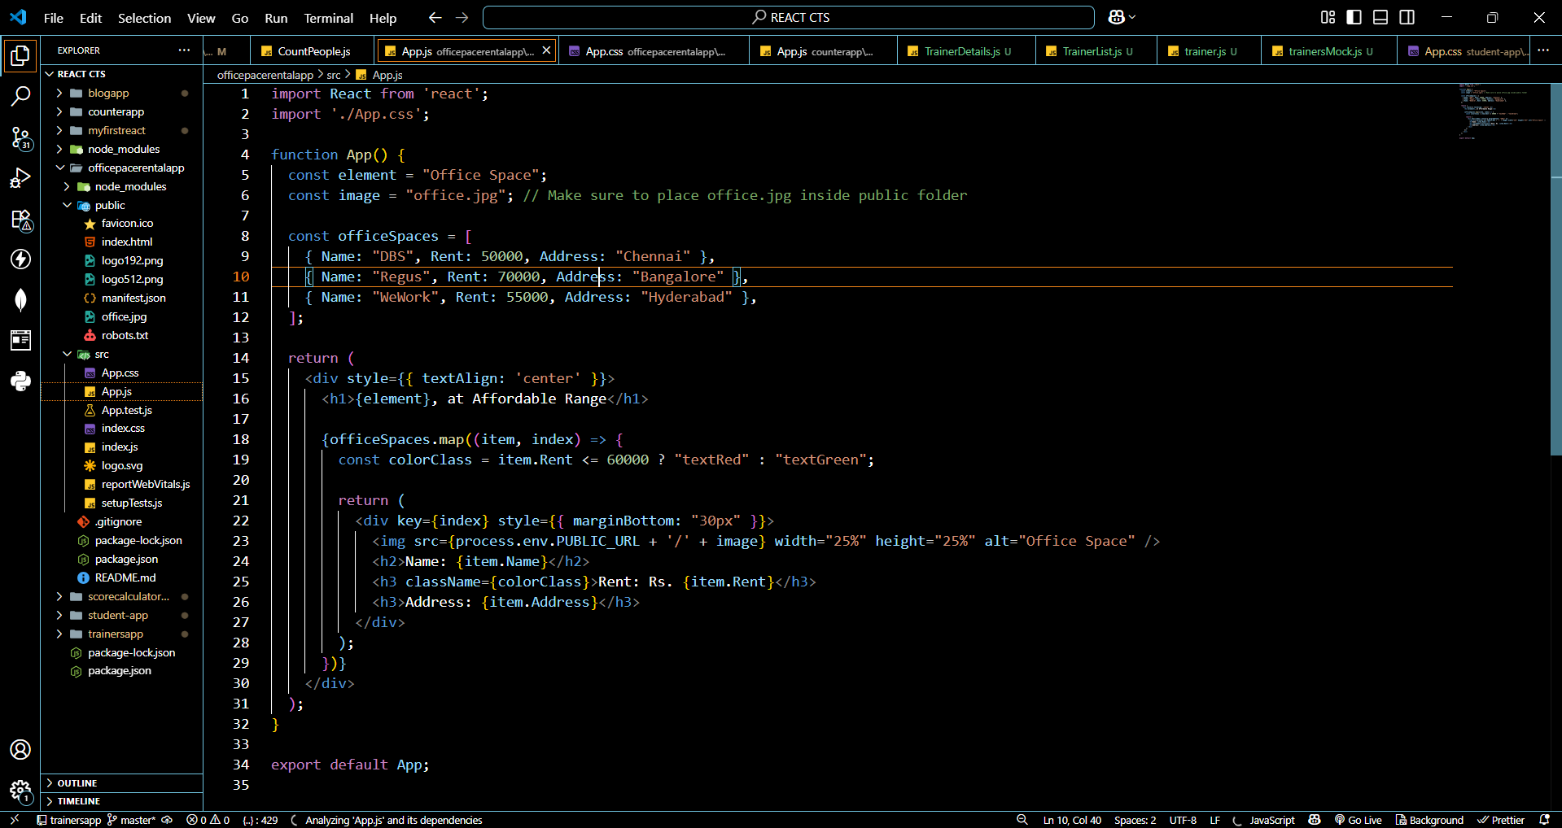

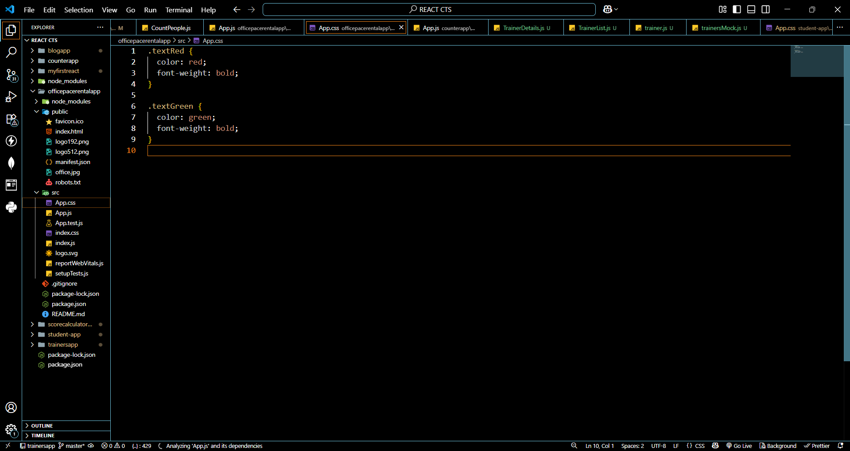

**OUTPUT:  
  
  
