**ReactJS HOS 2**

A1) React components are reusable building blocks of a UI. Each component defines how a part of the interface should appear and behave.

A2) Difference between Components and Js Functions:

|  |  |
| --- | --- |
| **React Component** | **JavaScript Function** |
| Returns JSX | Returns primitive value or object |
| Manages state/lifecycle (if needed) | Doesn't have lifecycle |
| Used to build UI | Used for logic or computation |

A3) Types of components are :   
**->** Function components

**->** Class components

A4) A class component is a React component defined using ES6 class syntax. It has a render() method and can use lifecycle methods and state.

Ex : class MyComponent extends React.Component {

render() {

return <h1>Hello</h1>;

}

}

A5) A function component is a simpler way to write components using JavaScript functions. With React Hooks, it can manage state and side effects.  
Ex: function MyComponent() {

return <h1>Hello</h1>;

}

A6) The constructor is a special method in a class component used to initialize state and bind methods.  
Ex: constructor(props) {

super(props);

this.state = { count: 0 };

}  
A7) The render() method is required in class components and returns the JSX to display the UI.

Ex: render() {

return <div>Hello</div>;

}

**CODES**

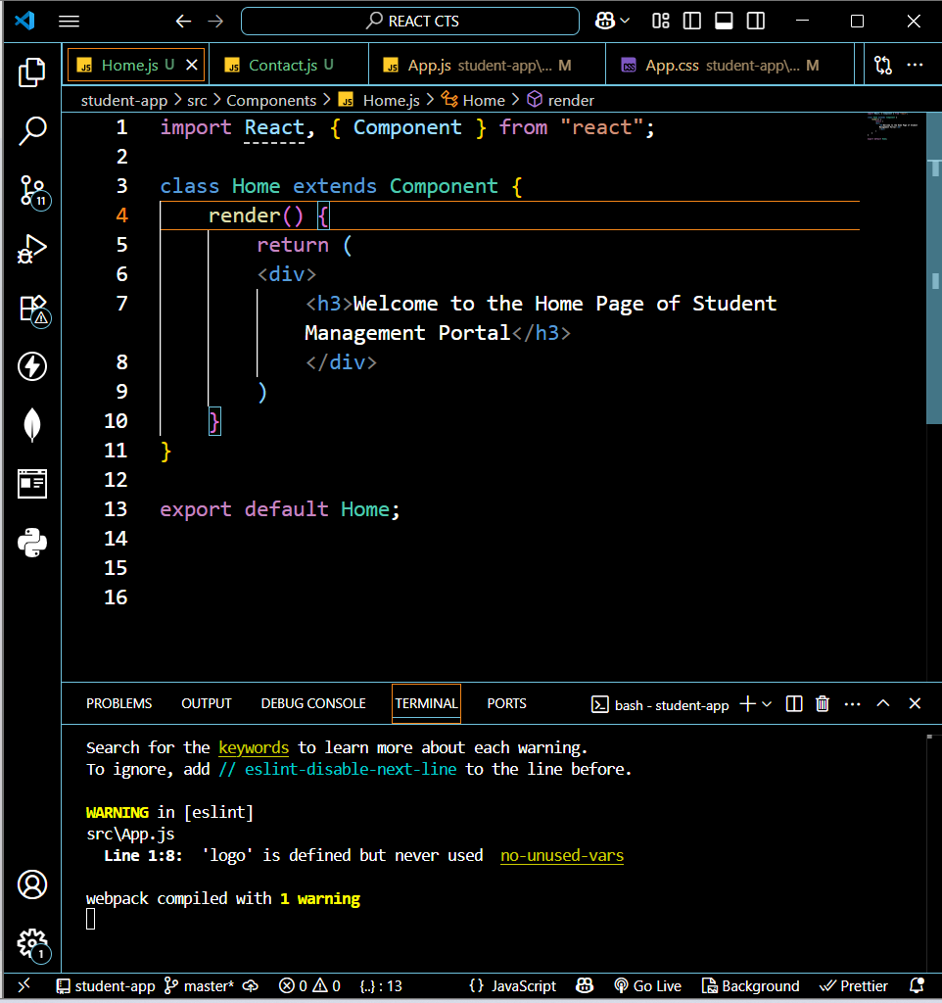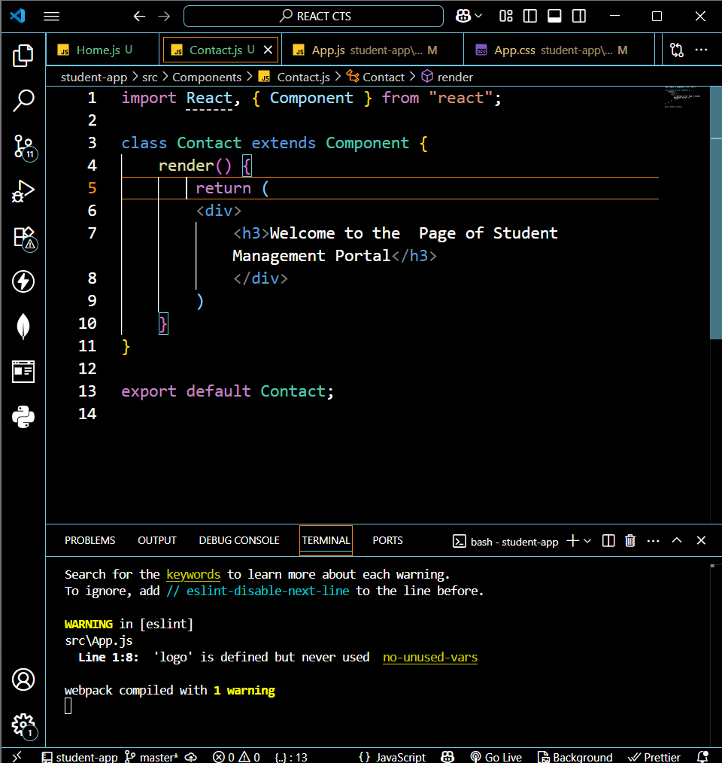

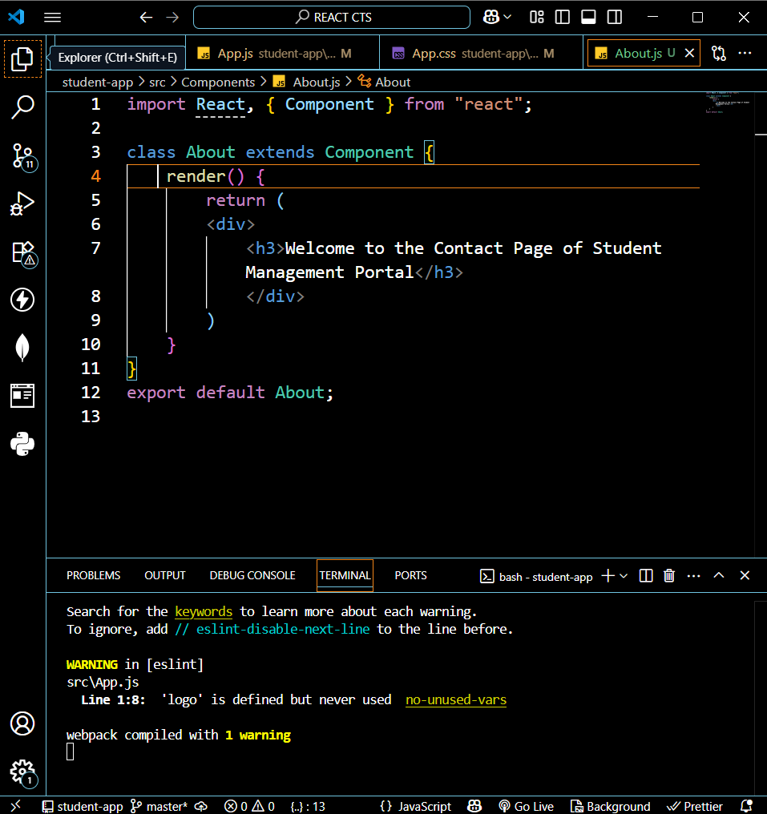

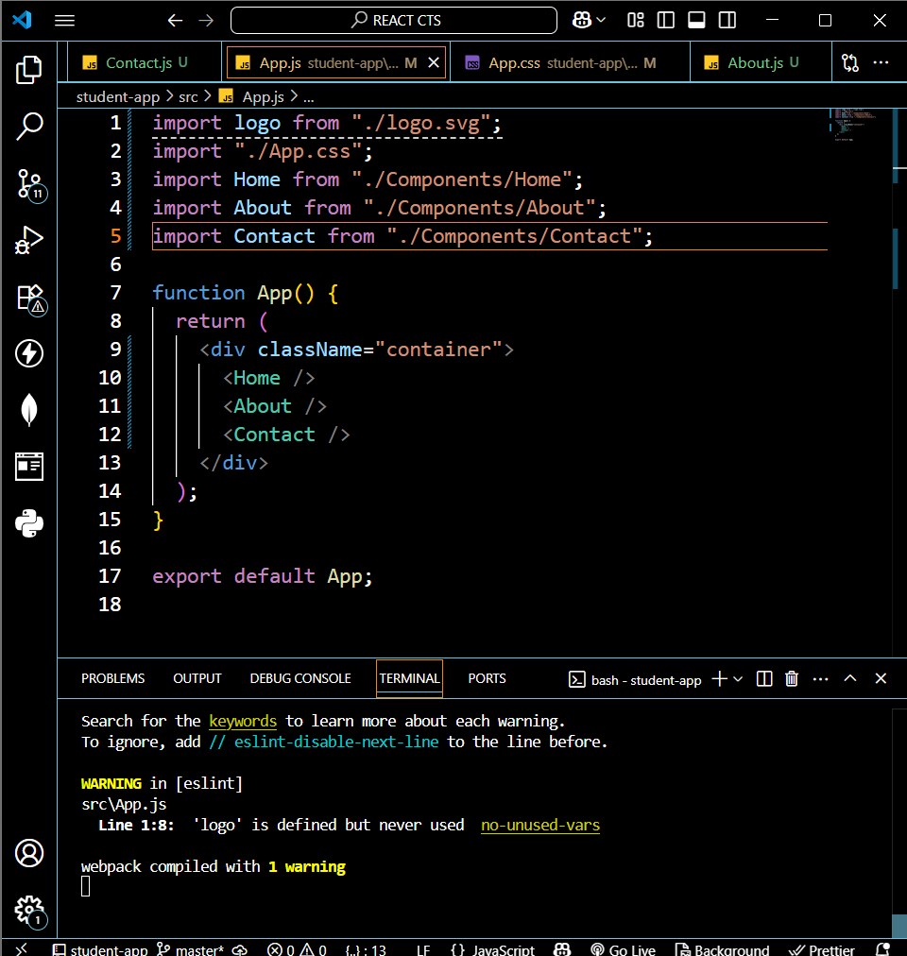

**OUTPUT**

