**ANSWERS:**

A1) Need:  
Lifecycle methods help manage a component’s creation, updates, and removal from the DOM.

Benefits:

* Control over behavior at each phase
* Efficient data fetching and cleanup
* Error handling during rendering
* Performance optimization

A2) Various life cycle hook methods

Class Components:

* constructor()
* render()
* componentDidMount()
* componentDidUpdate()
* componentWillUnmount()
* componentDidCatch()

Function Components (with Hooks):

* useEffect()
* useLayoutEffect()
* useState() (for updates)

A3) List the sequence of steps in rendering a component

* Constructor → initialize state
* Render → returns JSX
* componentDidMount → runs after first render
* (State/props change)
* Render again
* componentDidUpdate → after re-render
* componentWillUnmount → before removal

**CODES:**

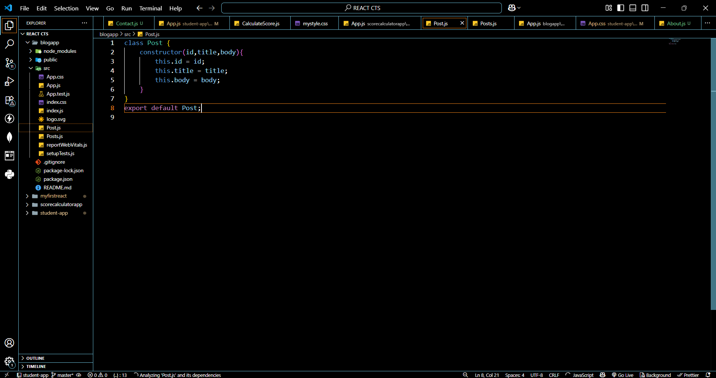

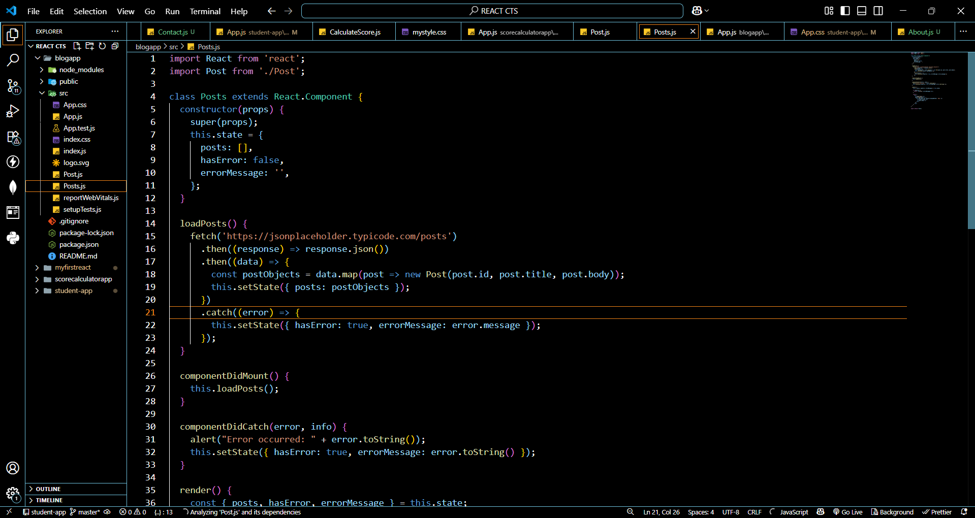

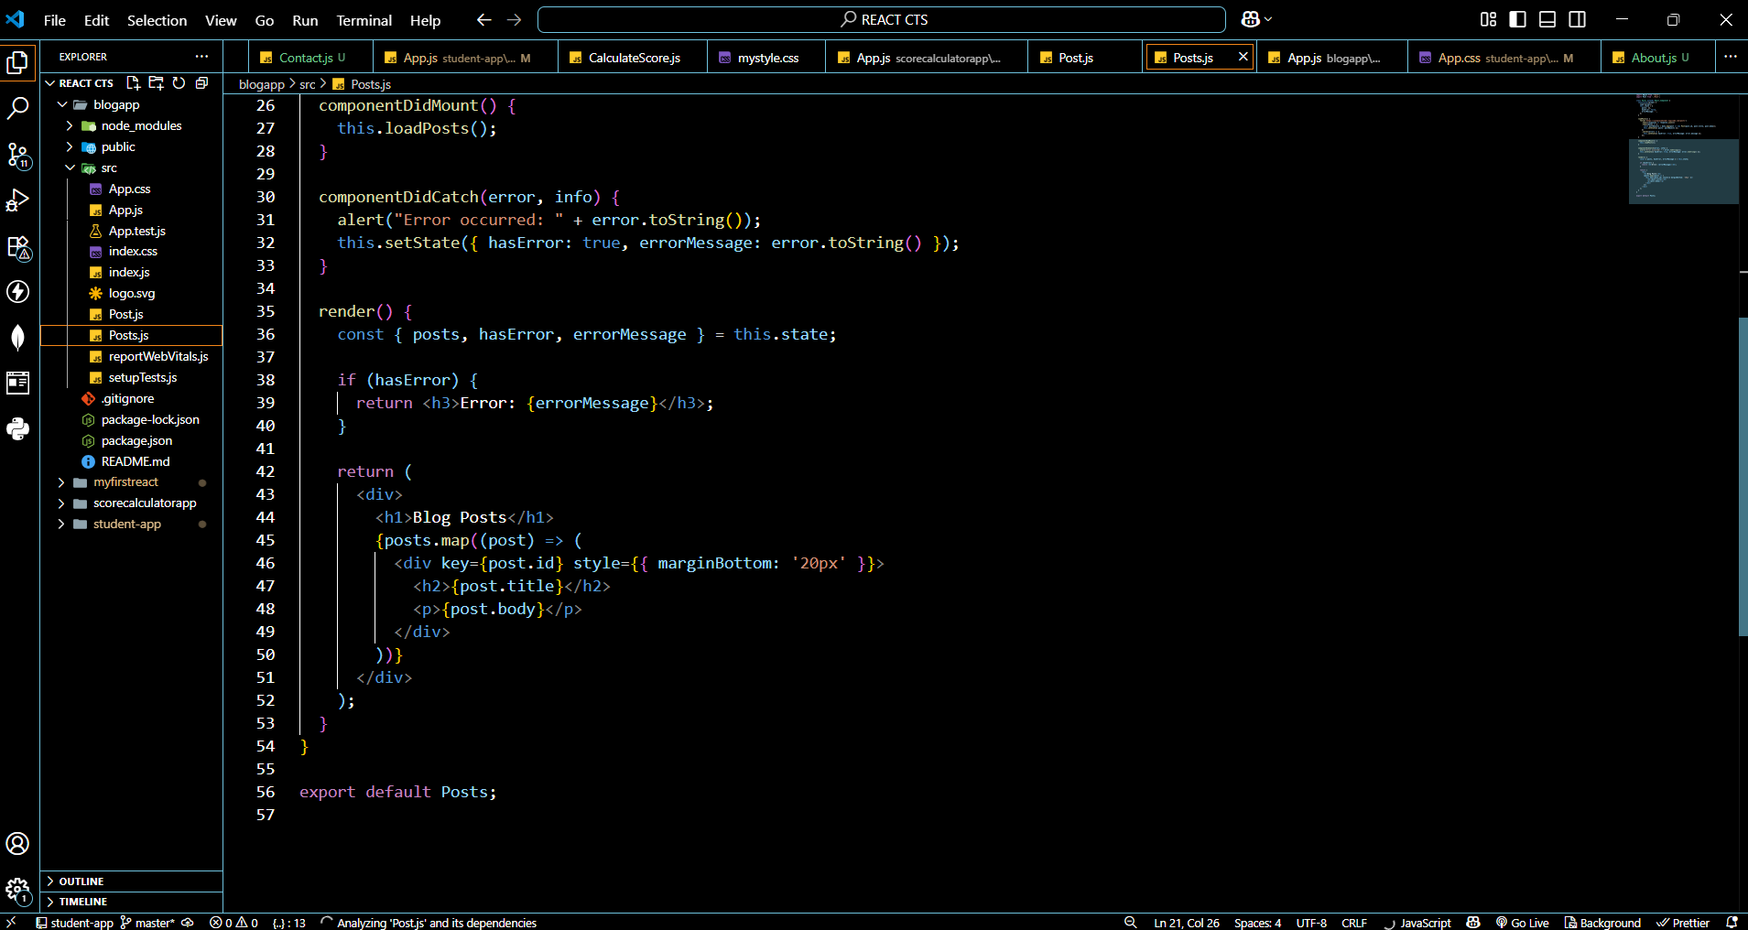

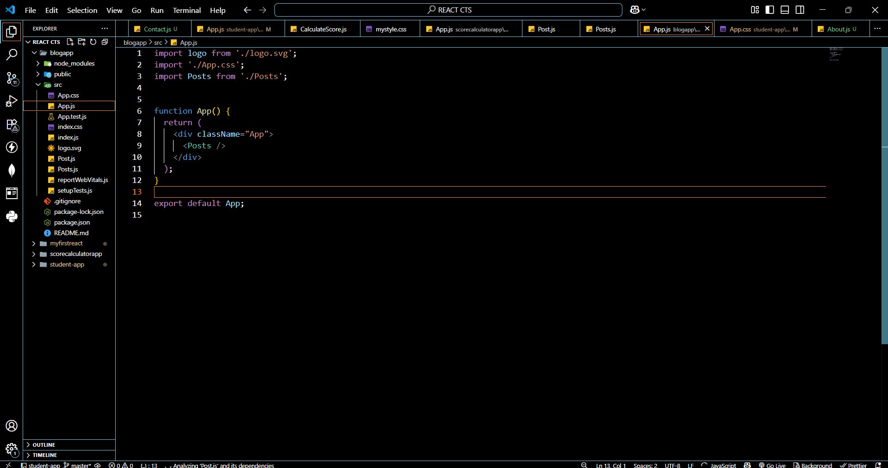

**OUTPUT:**



