**ReactJS HOS 6**

A1) Need and Benefits of React Router

* Need: React is a single-page application (SPA) framework, meaning it doesn't reload the page. To manage navigation and display different views, we need routing.
* Benefits:
  + Enables navigation between components without full page reload.
  + Keeps UI in sync with the URL.
  + Supports dynamic routing and nested routes.
  + Makes SPAs feel like traditional multi-page websites.

A2) Components in React Router

* BrowserRouter: Wraps the app and enables routing using browser history.
* Routes: A container for multiple Route components.
* Route: Defines the path and the component to render.
* Link: Used to create navigation links without reloading the page.
* useParams: A hook to access dynamic parameters in the URL.

A3) Types of Router Components

1. BrowserRouter – Uses HTML5 history API (commonly used).
2. HashRouter – Uses URL hash (e.g., /#/route) for older browser support.
3. MemoryRouter – Stores history in memory (used for testing or non-browser environments).
4. StaticRouter – Used for server-side rendering (SSR).

A4) Parameter Passing via URL

* How: Use dynamic route segments like :id in the path.
* Example:
  + Define route: <Route path="/user/:id" element={<User />} />
  + Access param: const { id } = useParams(); inside User component.

**CODES:**

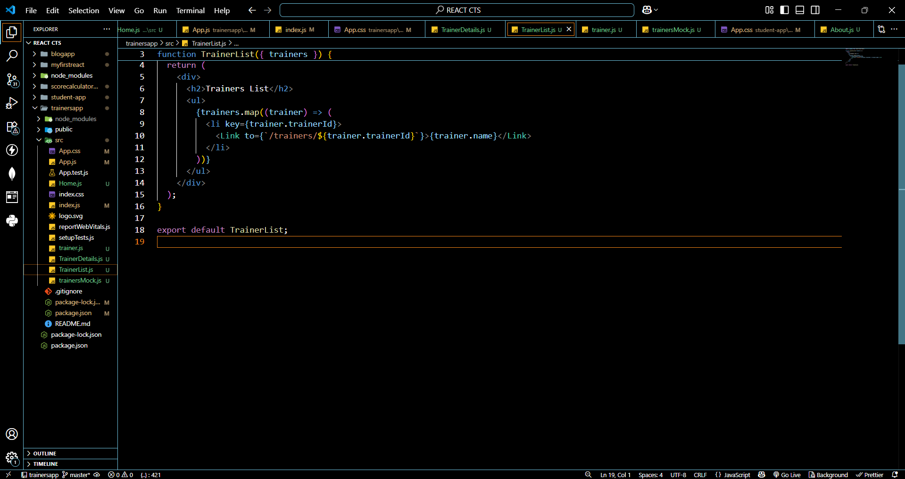

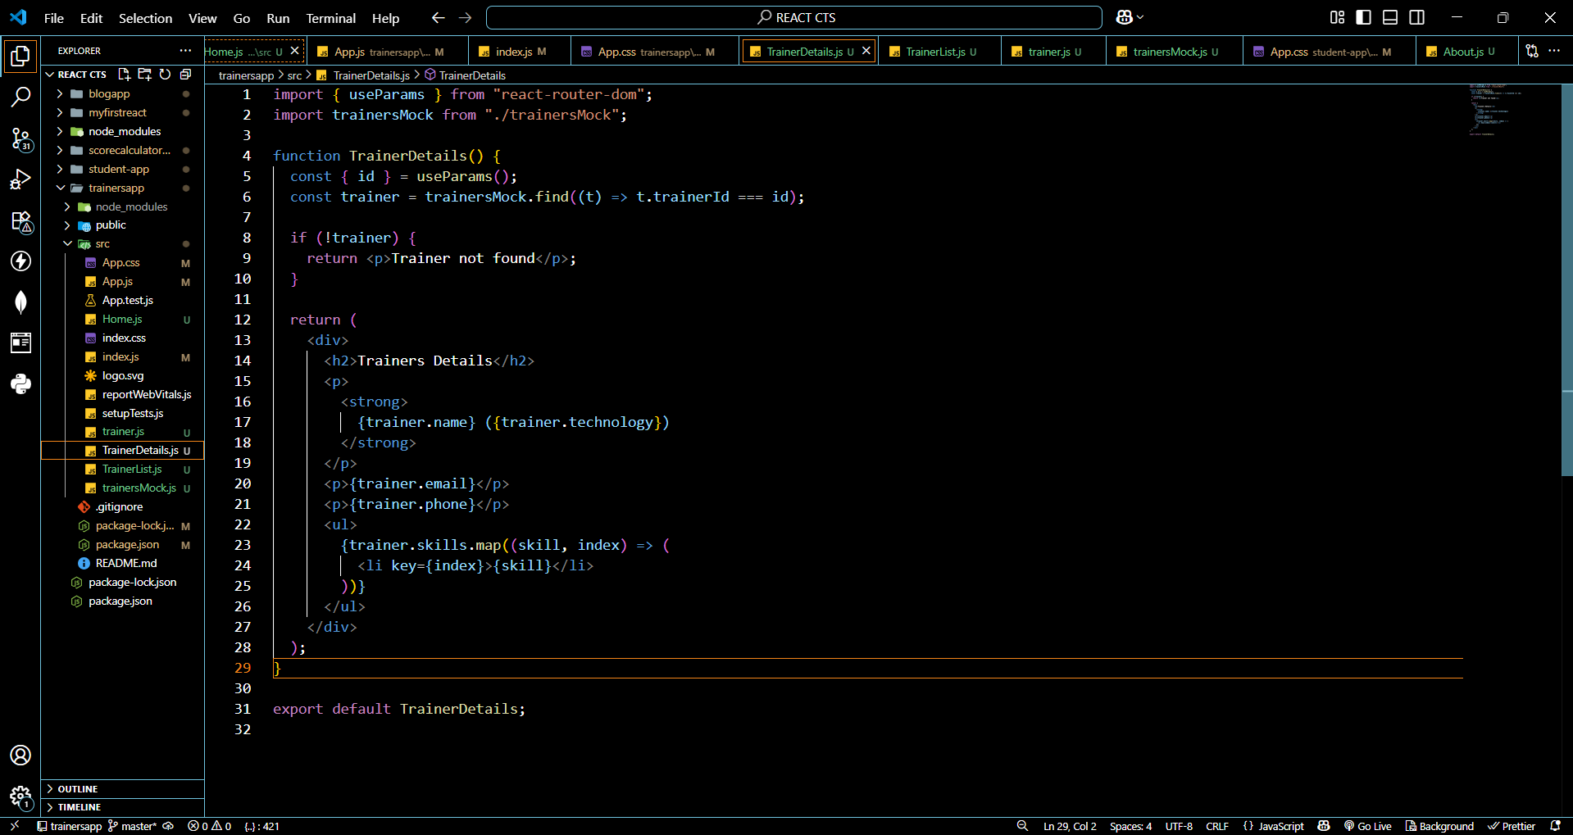

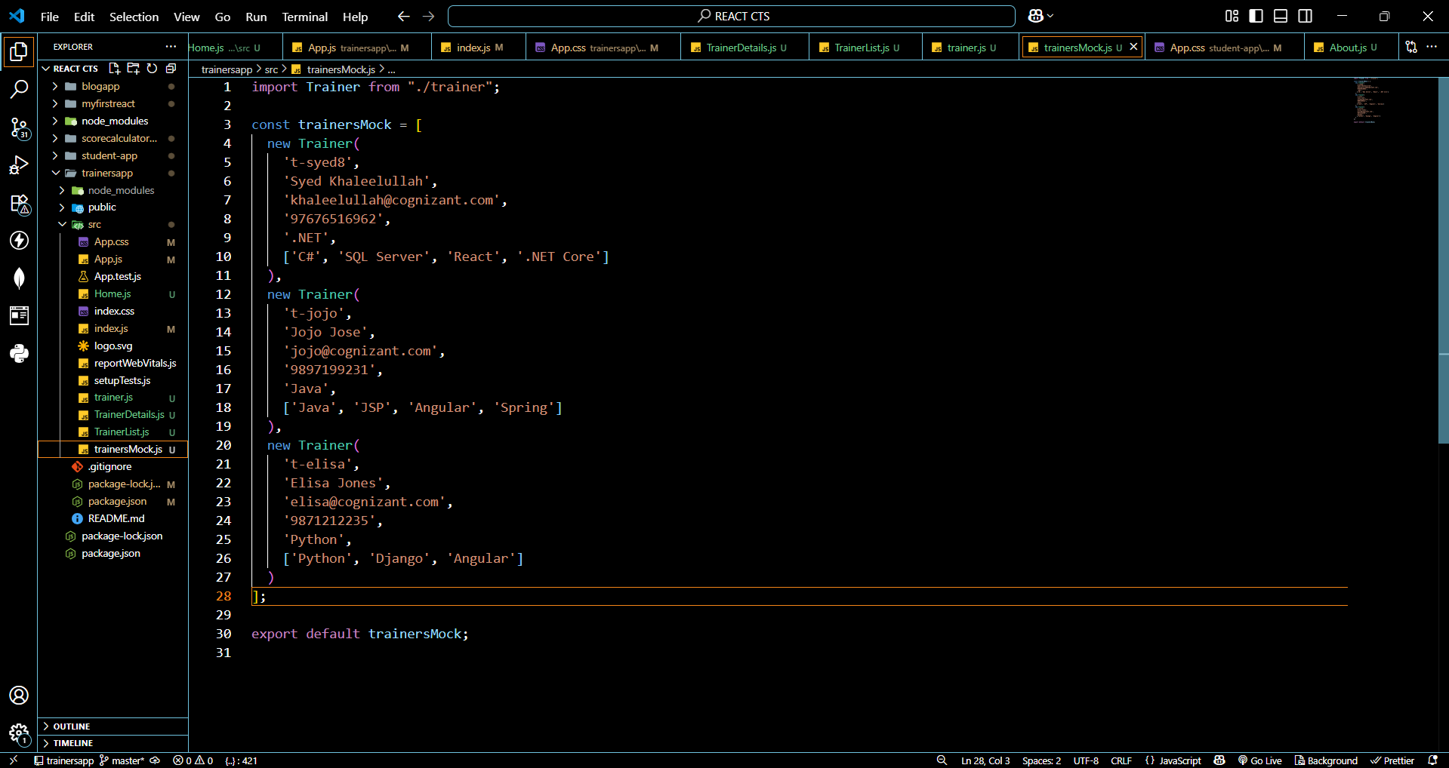

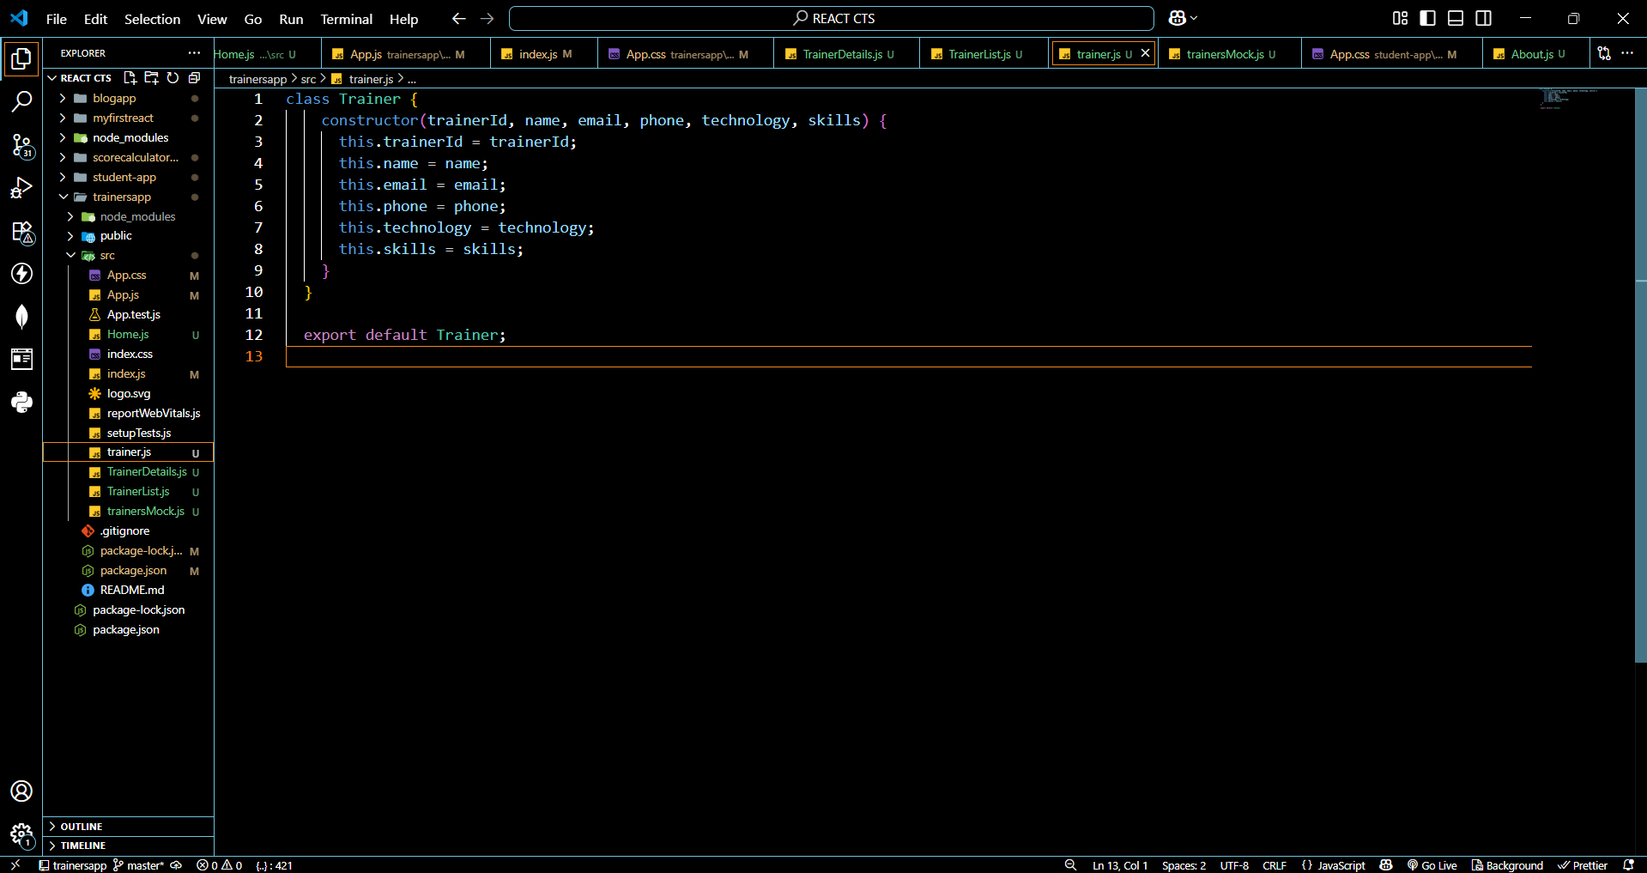

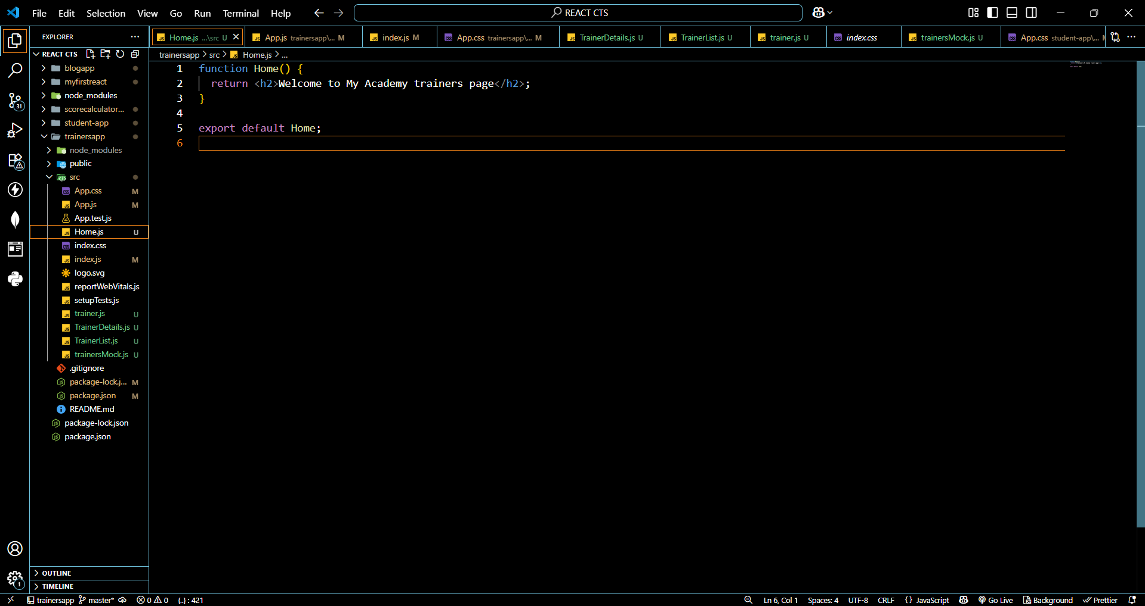

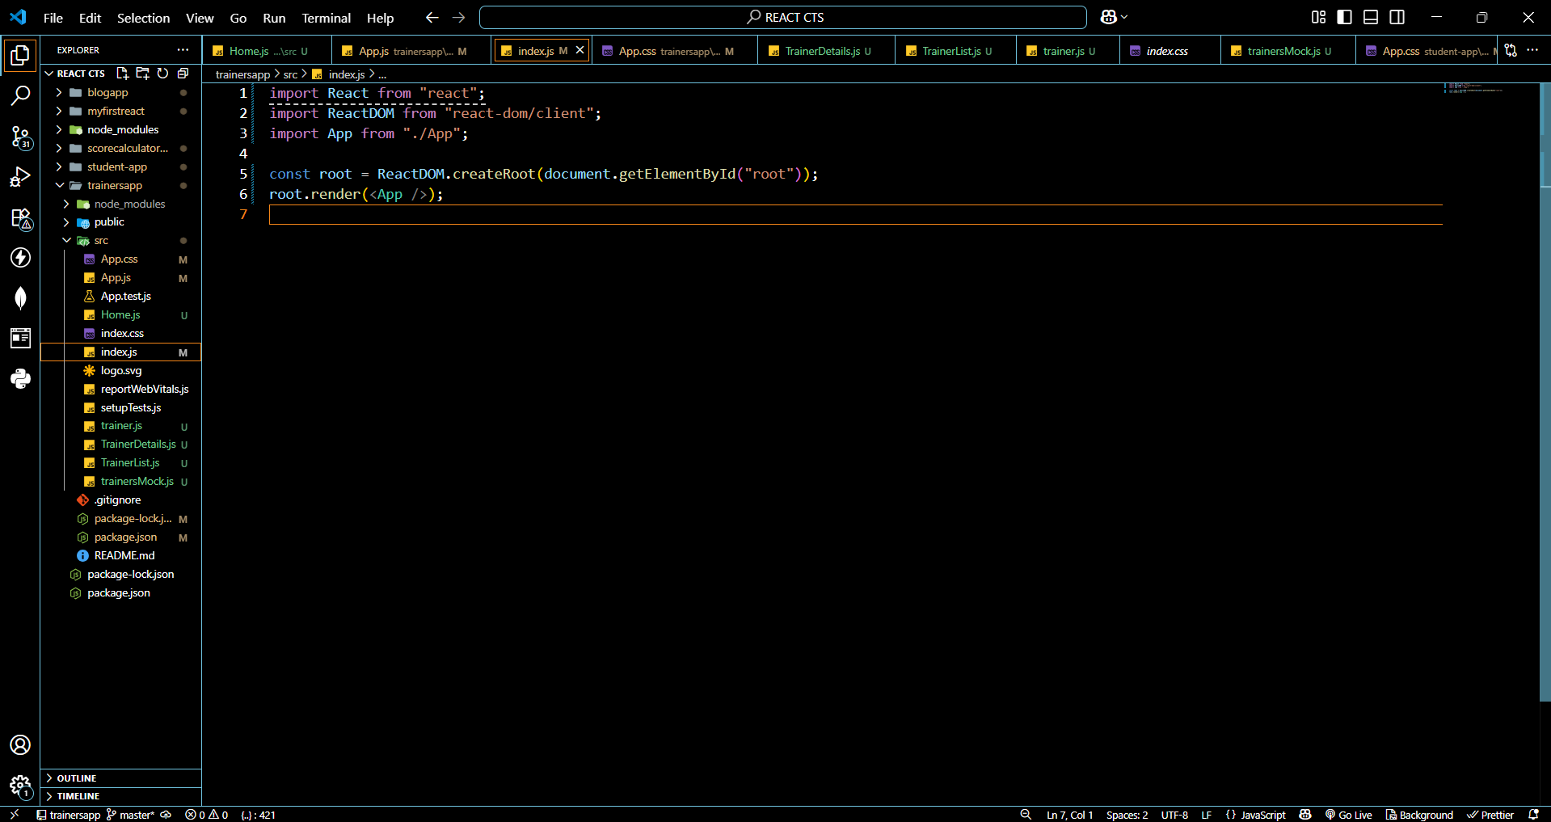

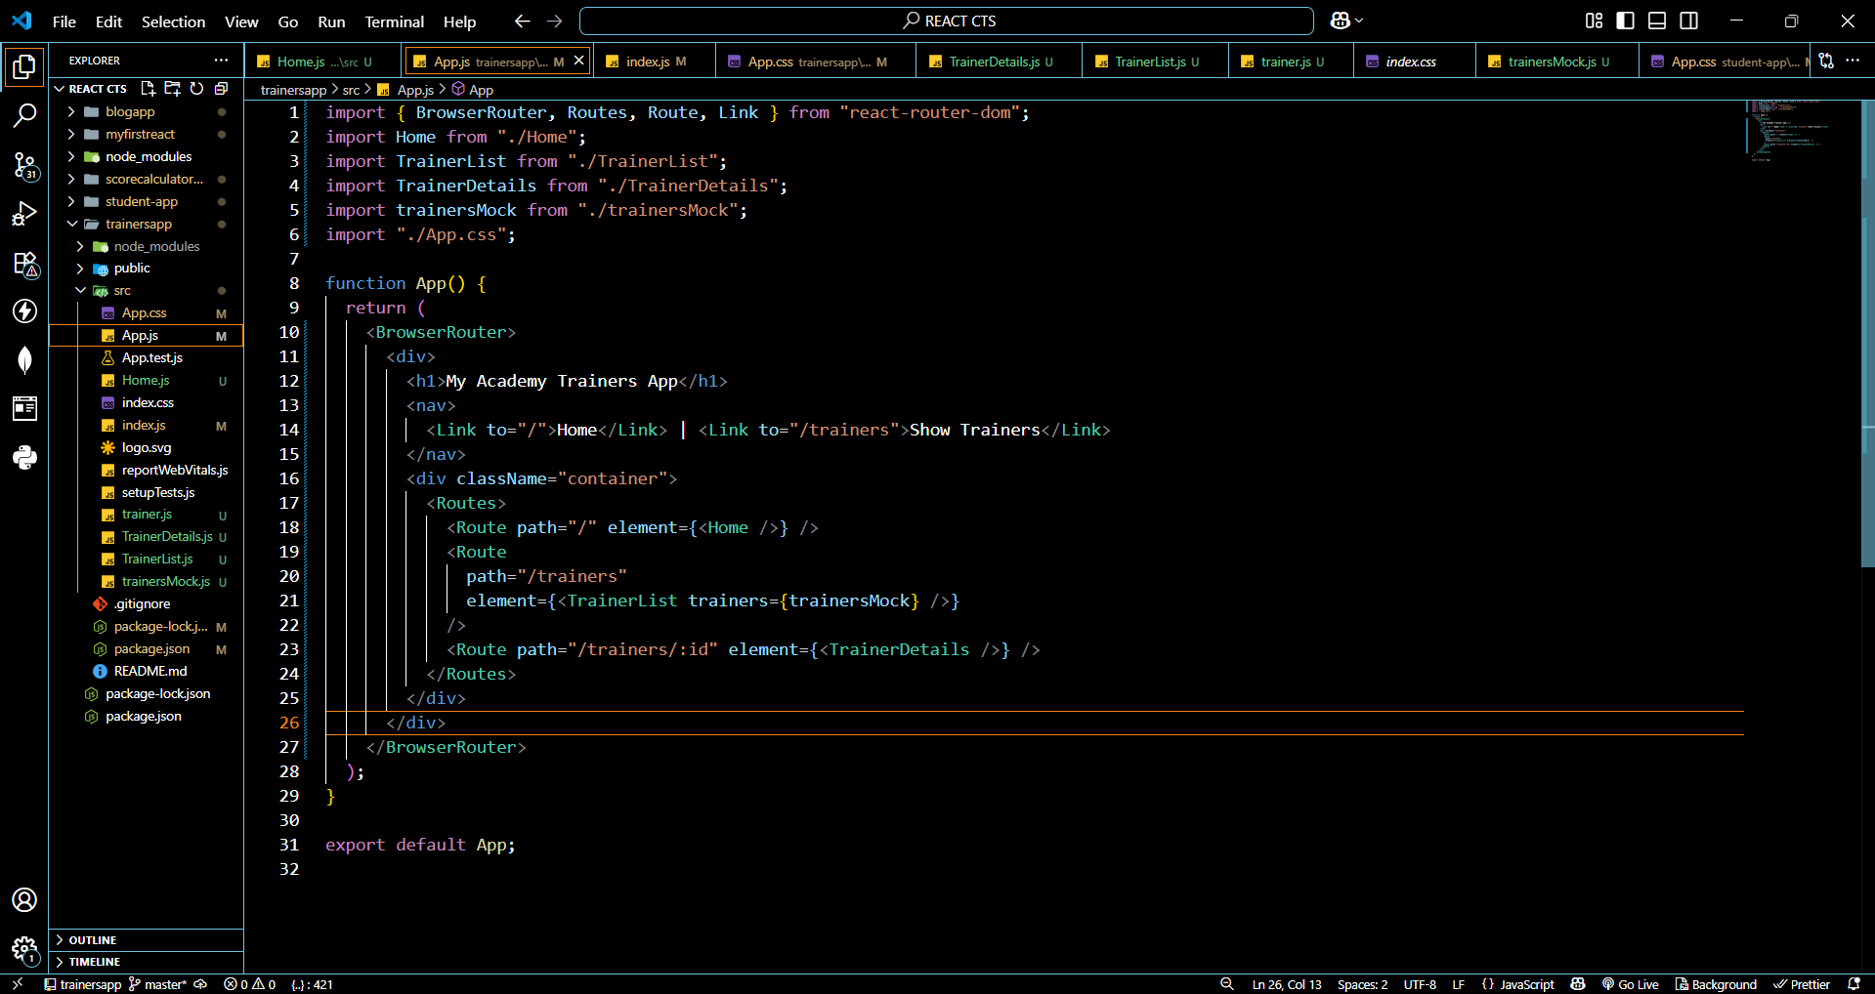

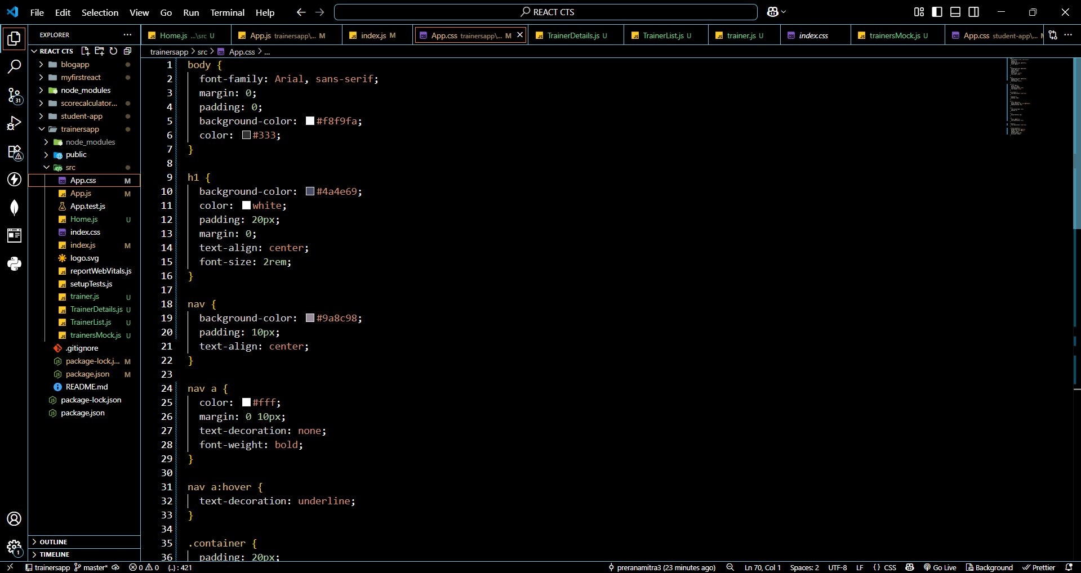

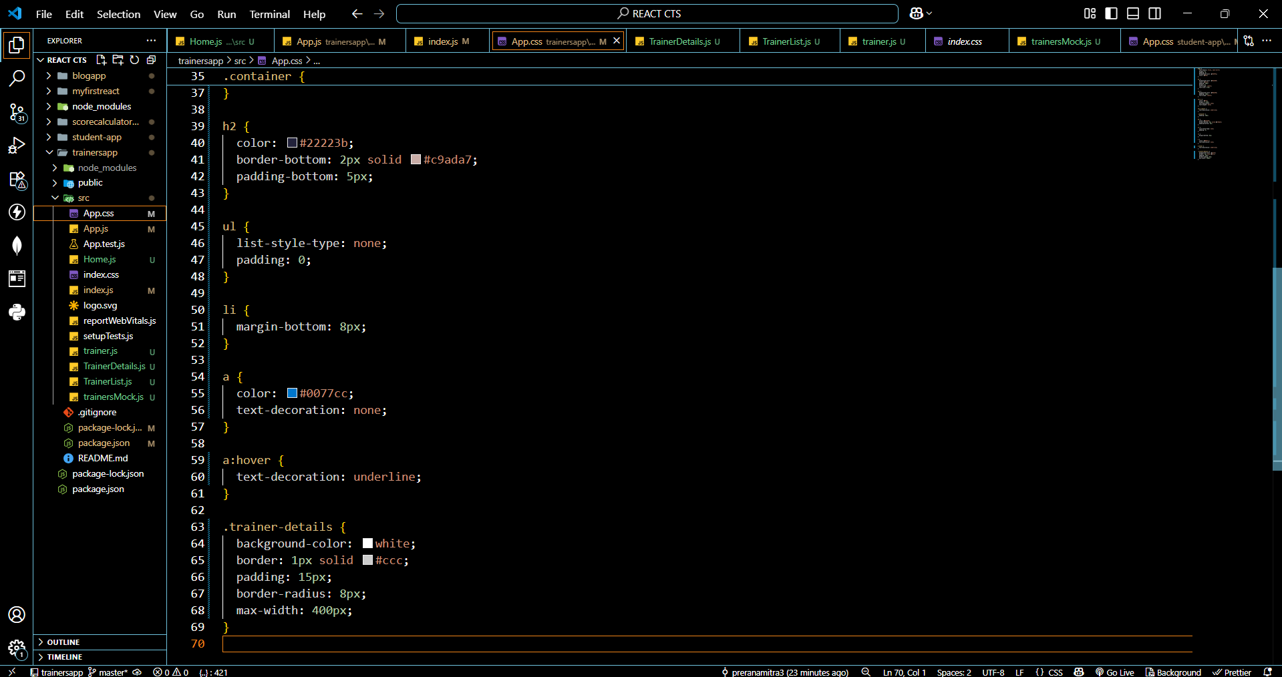

**OUTPUTS:**

