**REACTJS HOS 8**

A1) React state is a built-in object that stores data specific to a component.  
It allows the component to respond to user actions and change dynamically over time.

* Defined in a class component with this.state
* Updated using this.setState()
* Changing state re-renders the component

**CODES:  
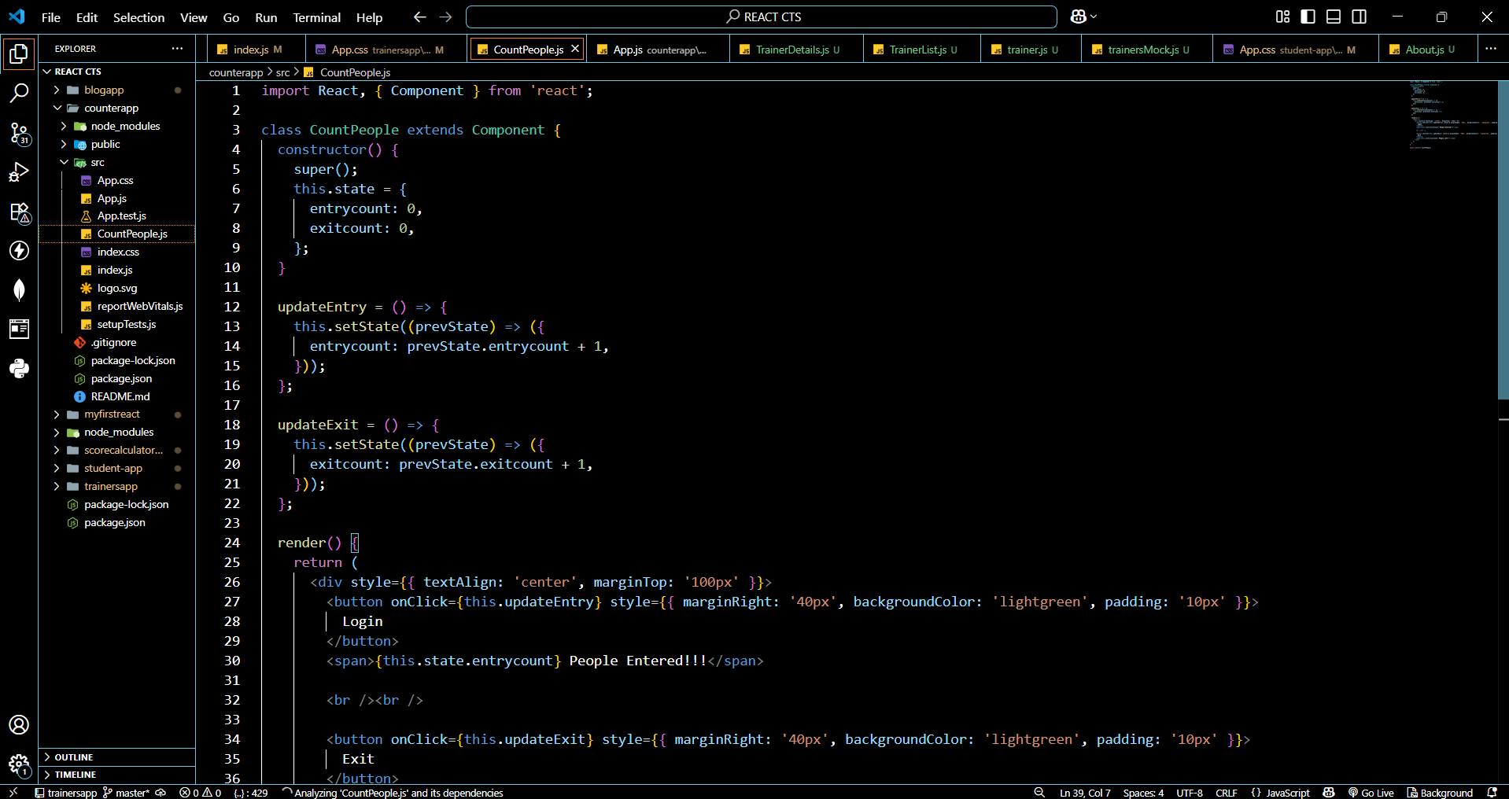**

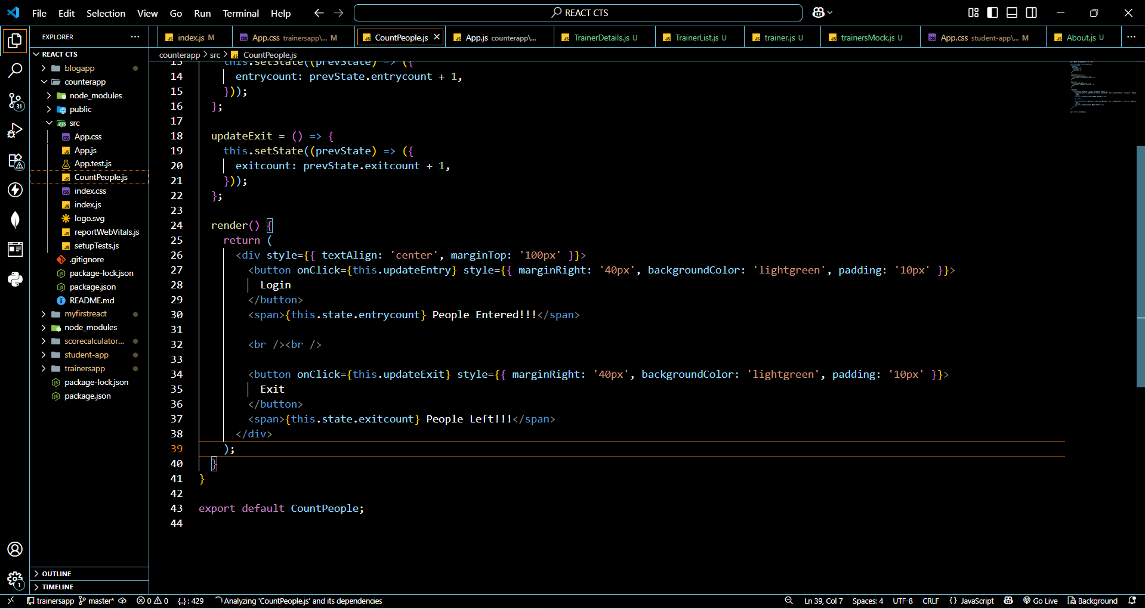

**OUTPUTS:**

