Exp No: 1.a — Analyze the Trend of Data Science Job Postings

Aim
To analyze the trend of data science job postings over the last decade using Python.

Description
Web scraping (e.g., BeautifulSoup) or APIs (e.g., LinkedIn API) can be used to gather data on the number of data science job postings each year. In this experiment, pandas is used for data manipulation and matplotlib is used for visualization of a representative dataset.

Code
import pandas as pd
import matplotlib.pyplot as plt

data = {'Year': list(range(2010, 2021)),
'Job Postings': [150, 300, 450, 600, 800, 1200, 1600, 2100, 2700, 3400, 4200]}
df = pd.DataFrame(data)

plt.plot(df['Year'], df['Job Postings'], marker='o')
plt.title('Trend of Data Science Job Postings')
plt.xlabel('Year')
plt.ylabel('Number of Job Postings')
plt.show()

Sample Data
Year = 2010 to 2020
Job Postings = 150, 300, 450, 600, 800, 1200, 1600, 2100, 2700, 3400, 4200
Year | Job Postings
2010 | 150
2011 | 300
2012 | 450
2013 | 600
2014 | 800
2015 | 1200
2016 | 1600
2017 | 2100
2018 | 2700
2019 | 3400
2020 | 4200

Output
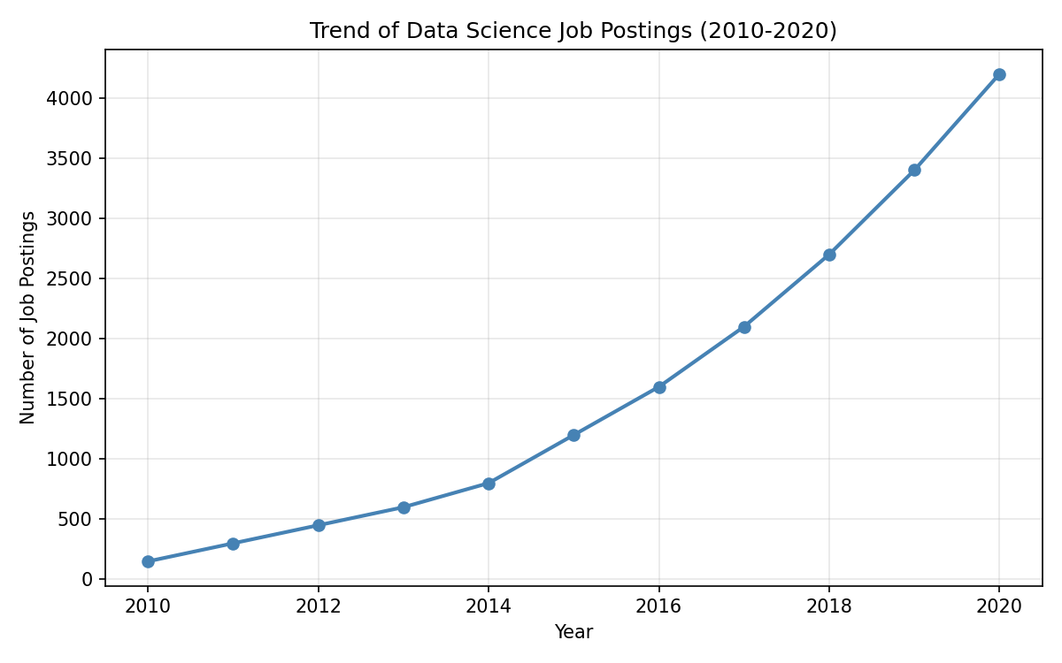

Analysis / Result
• Job postings grew from 150 in 2010 to 4,200 in 2020 — roughly a 28x increase over the decade.
• Growth was slow but steady from 2010-2014, reflecting the early, niche stage of data science as a discipline.
• From 2015 onward, growth accelerates sharply, coinciding with wider industry adoption of big data, machine learning, and cloud computing.
• The overall pattern resembles exponential growth, consistent with real-world reports naming Data Scientist one of the fastest-growing job titles of the 2010s.

Conclusion
The program successfully demonstrates the use of pandas and matplotlib to analyze and visualize the increasing trend of data science job postings over the last decade.

