

A MINI PROJECT REPORT

on
WEB DESIGN TECHNOLOGIES (24CSE361)
Movie Review Website
Submitted by
P J PREM JESURAJ
1NH24CS143
Under the guidance of
Ms. DIVYANSHI CHHABRA
Assistant Professor

In partial fulfillment for the award of the degree of

BACHELOR OF ENGINEERING
in

COMPUTER SCIENCE AND ENGINEERING
Academic Year: 2025-26 (ODD SEM)

CERTIFICATE

This is to certify that the mini project work titled “Movie Review Website” is a bonafide work carried out by P J Prem Jesuraj (1NH24CS143) in partial fulfillment of the degree of Bachelor of Engineering in Computer Science and Engineering of the New Horizon College of Engineering during the year 2025-2026.

Signature of Guide Signature of HOD

SEMESTER END EXAMINATION

Name of the Examiner Signature with date

1.

2.

ABSTRACT
With the increasing popularity of online entertainment platforms, movie review websites have become an important source of information for audiences to evaluate films before watching them. This project focuses on the design and development of a Movie Review Website using HTML, CSS, and basic JavaScript, providing a simple and user-friendly interface to display movie details and reviews.
The website is structured using HTML to organize content such as movie titles, posters, genres, ratings, and reviews, while CSS is used to enhance visual appearance and ensure a clean and responsive layout. Basic JavaScript can be incorporated to add interactivity, such as highlighting ratings or improving user navigation. The system is entirely client-side, making it lightweight, fast, and easy to deploy without requiring backend support or databases.
The primary objective of this project is to demonstrate fundamental web design concepts, including page layout, navigation menus, content presentation, and responsive design. It serves as an effective learning platform for beginners to understand front-end web development techniques. The Movie Review Website can be further enhanced by adding dynamic features such as user review submission, rating systems, and database integration in future developments.

ACKNOWLEDGEMENT
The satisfaction and euphoria that accompany the successful completion of any task would be impossible without the mention of the people who made it possible, who’s constant guidance and encouragement crowned our efforts with success.

I have great pleasure in expressing gratitude to Dr. Mohan Manghnani, Chairman, New Horizon Educational Institutions, for providing necessary infrastructure and creating good environment.

I take this opportunity to express my profound gratitude to Dr. Manjunatha, Principal, New Horizon College of Engineering, for the constant support and encouragement.

I would like to thank Dr. Anandhi R J, Professor and Dean-Academics, NHCE, for her valuable guidance.

I would also like to thank Dr. B. Rajalakshmi, Professor and HOD, Department of Computer Science and Engineering, for the constant support.

I also express my gratitude to Ms. Divyanshi Chhabra, Assistant Professor, Department of Computer Science and Engineering, my mini project reviewer, for constantly monitoring the development of the project and setting up precise deadlines. Her valuable suggestions were the motivating factors in completing the work.
P J Prem Jesuraj
1NH24CS143

CONTENTS
ABSTRACT
ACKNOWLEDGEMENT
LIST OF FIGURES
- INTRODUCTION
1.1 PROBLEM DEFINITION
  - OBJECTIVES

1.3 METHODOLOGIES TO BE FOLLOWED

1.4 EXPECTED OUTCOMES
- FUNDAMENTALS OF THE LANGUAGES USED
2.1 HTML 5
2.2 CSS
2.3 JAVASCRIPT
- REQUIREMENT SPECIFICATION
3.1 HARDWARE REQUIREMENTS
3.2 SOFTWARE REQUIREMENTS
- DESIGN
4.1 DESIGN GOALS
- IMPLEMENTATION
- OUTPUTS
- CONCLUSION
- REFERENCES
LIST OF FIGURES
Figure No. | Description | Page No.
5.1 | CODE SNIPPET FOR DOC DECLARATION AND HEAD SECTION
5.2 | CODE SNIPPET FOR STYLING AND LAYOUT
5.3 | CODE SNIPPET FOR HEADER SECTION
5.4 | CODE SNIPPET FOR NAVIGATION BAR
5.5 | CODE SNIPPET FOR MAIN CONTENT CONTAINER
5.6 | CODE SNIPPET FOR MOVIE CARD SECTION
5.7 | CODE SNIPPET FOR FOOTER SECTION
5.8 | CODE SNIPPET FOR HOVER EFFECTS
6.1 | MOVIE REVIEW WEBSITE USING HTML

CHAPTER 1
INTRODUCTION
The Movie Review Website project aims to design and develop a simple and user-friendly web application using HTML, CSS, and basic JavaScript to display movie information and reviews. In the digital age, online movie reviews help users make informed decisions about what to watch, and this website provides a structured platform to present movie titles, genres, ratings, posters, and detailed descriptions in an organized manner. The project focuses on demonstrating fundamental web design concepts such as page layout, navigation, content presentation, and interactivity, making it suitable for beginners. It is a lightweight, client-side application that can be further enhanced with advanced features such as user reviews, search functionality, and database integration.
  - PROBLEM DEFINITION
With the increasing number of movies released across different platforms, users often find it difficult to access reliable and organized movie reviews in one place. Existing platforms can be cluttered, complex, or overloaded with unnecessary features, making it hard for users to quickly understand movie details and reviews. There is a need for a simple, lightweight, and easy-to-navigate website that presents movie information, ratings, and reviews in a clear and structured manner. This project addresses the problem by developing a Movie Review Website using basic web technologies, ensuring ease of use, clarity of information, and improved user experience.

1.2 OBJECTIVES
- To design and develop a movie review website using HTML as the primary markup language.
- To use CSS to create an attractive, clean, and user-friendly layout for displaying movie information.
- To present movie details such as title, genre, poster, ratings, and detailed reviews in an organized format.
- To implement basic interactivity, such as hover effects, to enhance user experience.
- To ensure easy navigation across different sections of the website.
- To provide a lightweight, client-side web application suitable for beginners in web development.
1.3 METHODOLOGY
- Requirement Analysis:
Identified the need for a simple and user-friendly movie review platform to display movie details, ratings, and reviews.
- Design Planning:
Planned the layout of the website including header, navigation bar, movie cards, and footer to ensure clear content presentation.
- HTML Structure Development:
Used HTML to create the basic structure of the website, organizing movie information into reusable sections.
- Styling with CSS:
Applied CSS for layout design, color schemes, fonts, and hover effects to enhance visual appeal and user interaction.
- Interactivity Enhancement:
Implemented hover effects and smooth transitions to improve user experience.
- Testing and Validation:
Tested the website across different browsers to ensure proper display, responsiveness, and functionality.
1.4 EXPECTED OUTCOMES
- A fully functional movie review website developed using HTML and CSS.
- Clear and organized presentation of movie details, ratings, and reviews.
- An interactive and visually appealing user interface with hover effects.
- Easy navigation and improved user experience.
- A lightweight, client-side web application suitable for beginners.
- A foundation that can be extended with advanced features such as user reviews, ratings, and database integration in the future.

CHAPTER 2
FUNDAMENTALS OF THE LANGUAGES USED
The Movie Review Website on Web Design covers the foundational languages of web development: HTML, CSS, and JavaScript. These languages are essential for creating structured, styled, and interactive web pages.

  - HTML (Hyper Text Markup Language)
HTML is the standard markup language for creating web pages. It structures the content of a webpage using elements enclosed in tags. HTML (Hyper Text Markup Language) was created by Tim Berners-Lee in 1989 as part of the World Wide Web project at CERN, aimed at enabling scientists to share documents through hyperlinks. The first version of HTML was introduced in 1991, consisting of 18 basic tags like <p>,<a>,<img>,<div>.
In 1995, HTML 2.0 became the first standardized version, introducing new features like forms and tables. Subsequent updates, such as HTML 3.2 in 1997, added support for CSS, while HTML 4.0 in 1999 integrated multimedia elements and scripting capabilities. During the late 1990s and early 2000s, XHTML emerged as a stricter version of HTML but faced adoption challenges. HTML5, introduced in 2014, revolutionized the web by adding semantic elements, multimedia capabilities, and cross-platform support, cementing its role as the cornerstone of modern web development.

Key Features:
• Structure: Defines elements like headings, paragraphs, lists, and images.
• Links: Connects to other documents using hyperlinks.
• Forms: Captures user input.

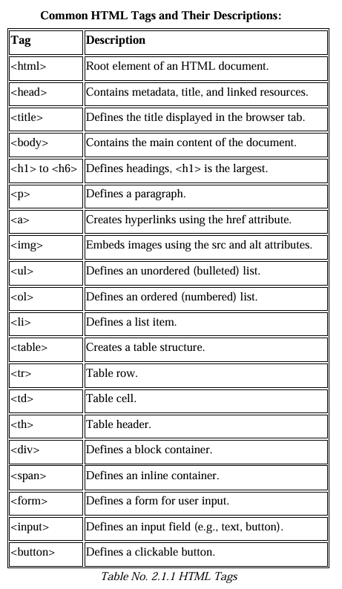

2.2 CSS (Cascading Style Sheets)

CSS (Cascading Style Sheets) was introduced in 1996 by the World Wide Web Consortium(W3C) as a solution to separate the content of web pages from their presentation. The concept was first proposed by Hakon Wium Lie in 1994, aiming to provide web developers with a way to control the appearance of web pages without altering their HTML structure. The first specification, CSS1, included basic styling features such as font customization, text alignment, and margins. In 1998, CSS2 expanded its capabilities with features like positioning, media types, and table styling. However, inconsistent browser support slowed adoption during the early 2000s. CSS3, introduced as a modular update, brought transformative features like animations, transitions, and responsive design through media queries. Today, CSS remains a fundamental technology in web development, empowering developers to create visually engaging and responsive websites. It defines the presentation of HTML documents, including layout, colours, fonts, and spacing, ensuring a seamless user experience across devices.

Key Features:
• Selectors: Targets HTML elements (e.g., p, #id, .class).
• Box Model: Defines padding, border, and margin for layout.
• Flexibility: Enables responsive design and animations.

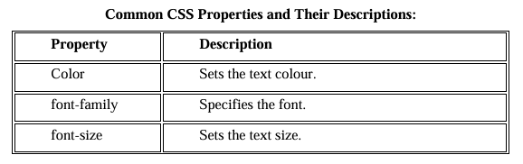

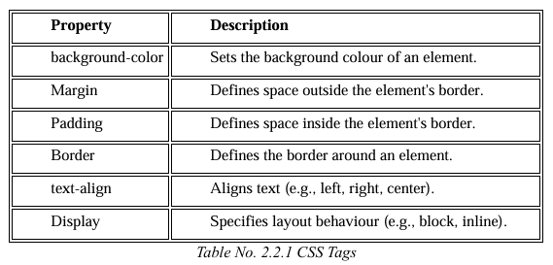

2.3 JAVA SCRIPT
JavaScript is a high-level, lightweight, and versatile programming language primarily used to create interactive and dynamic web applications. It enables developers to add features such as animations, form validations, and real-time content updates. Initially developed by Brendan Eich at Netscape in 1995, it was originally called Mocha, later renamed LiveScript, and eventually JavaScript to align with the popularity of Java at the time. JavaScript gained widespread adoption with the introduction of ECMAScript standards in 1997, which ensured consistency across implementations. Over the years, JavaScript has evolved significantly, adding modern features like asynchronous programming, modularization, and extensive libraries, making it a cornerstone of modern web development alongside HTML and CSS.
Key Features and examples:
• Basics: Understanding variables (var, let, const), data types, operators, and expressions.
• Functions: Writing reusable blocks of code to perform specific tasks.
• DOM Manipulation: Selecting and modifying elements dynamically.
• Event Handling: Responding to user actions like clicks and keypresses.
• Form Validation: Ensuring proper user input.

CHAPTER 3
REQUIREMENT SPECIFICATION
3.1 HARDWARE REQUIREMENTS:
- Processor:
Minimum Dual-core processor (Intel Core i3 or equivalent)
- RAM:
Minimum 2 GB (4 GB recommended for smooth performance)
- Storage:
At least 100 MB of free disk space
- Display:
Screen resolution of 1024 × 768 or higher
- Input Devices:
Keyboard and Mouse / Touch input (for mobile devices)
- Internet Connection:
Optional (required only for loading online images or references)
3.2 SOFTWARE REQUIREMENTS:
- Operating System:
Windows 7 or higher / Linux / macOS
- Web Browser:
Google Chrome, Mozilla Firefox, Microsoft Edge, or Safari (latest versions)
- Text Editor / IDE:
Visual Studio Code, Notepad++, Sublime Text, or any basic text editor
- Web Technologies:
HTML5, CSS3, and basic JavaScript
- Optional Tools:
Local web server (for testing) or browser developer tools

CHAPTER 4
DESIGN

4.1 DESIGN GOALS
- To create a simple and user-friendly movie review website.
- To design a clean and attractive layout for displaying movie details and reviews.
- To ensure easy navigation between different sections of the website.
- To maintain consistency in colors, fonts, and layout throughout the website.
- To enhance user interaction using hover effects and smooth transitions.
- To provide clear readability with proper spacing and font sizes.
- To ensure the website is responsive and works well on different screen sizes.
- To design a modular structure that supports future enhancements and scalability.

CHAPTER 5
IMPLEMENTATION

1. Document Declaration and Head Section
This section defines the basic structure and metadata of the webpage. The HTML5 doctype ensures proper rendering across modern browsers. The <head> section includes character encoding, page title, and internal CSS styles. Internal CSS is used to control the overall layout, fonts, colors, spacing, and hover effects of the website without relying on external files.
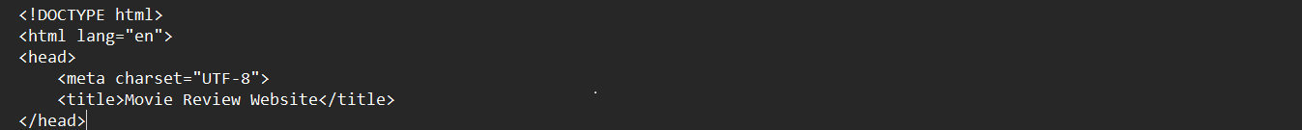
5.1 CODE SNIPPET FOR DOC DECLARATION AND HEAD SECTION

2. Styling and Layout (CSS Section)
The CSS section defines the visual appearance of the website. Styles are applied to the body for background color and font selection. The header and navigation bar are styled to provide a consistent top layout. The movie card layout uses Flexbox to align posters and descriptions neatly. Hover effects and smooth transitions are added to movie cards and images to enhance interactivity and user experience.
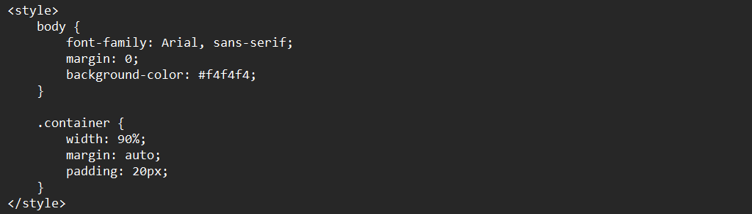
5.2 CODE SNIPPET FOR STYLING AND LAYOUT

3. Header Section
The header section displays the website title and a short description. It introduces the purpose of the website and creates a strong visual identity using contrasting colors and prominent text.
5.3 CODE SNIPPET FOR HEADER SECTION

4. Navigation Bar
The navigation bar contains links such as Home, Latest, Top Rated, and Genres. These links improve usability by allowing users to navigate between different sections easily. Hover effects on links provide visual feedback to the user.
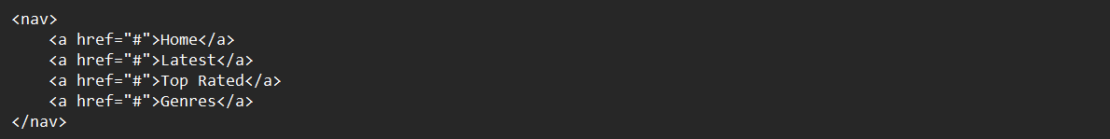
5.4 CODE SNIPPET FOR NAVIGATION BAR

5. Main Content Container
The main container holds all the movie review cards. It ensures consistent alignment and spacing of content across different screen sizes. This container acts as the central area where all movie-related information is displayed.
5.5 CODE SNIPPET FOR MAIN CONTENT CONTAINER

6. Movie Card Section
Each movie card represents an individual movie review. It includes a movie poster, title, genre, rating, and a detailed description. The cards are designed as reusable components, allowing more movies to be added easily. Hover effects on movie cards improve engagement by creating a dynamic and interactive browsing experience.
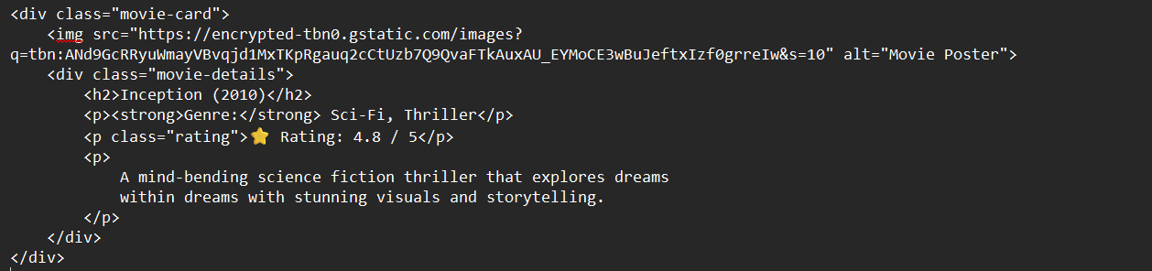
5.6 CODE SNIPPET FOR MOVIE CARD SECTION

7. Footer Section
The footer appears at the bottom of the webpage and contains copyright information. It gives the website a complete and professional look.
5.7 CODE SNIPPET FOR FOOTER SECTION

8. Hover Effects (Interactivity using CSS)
Hover effects are implemented using the CSS :hover pseudo-class to enhance user interaction. When the user hovers over a movie card, the card slightly lifts and a shadow effect is applied, while the movie poster zooms in smoothly. These effects provide visual feedback, improve user engagement, and make the interface more dynamic without affecting performance.
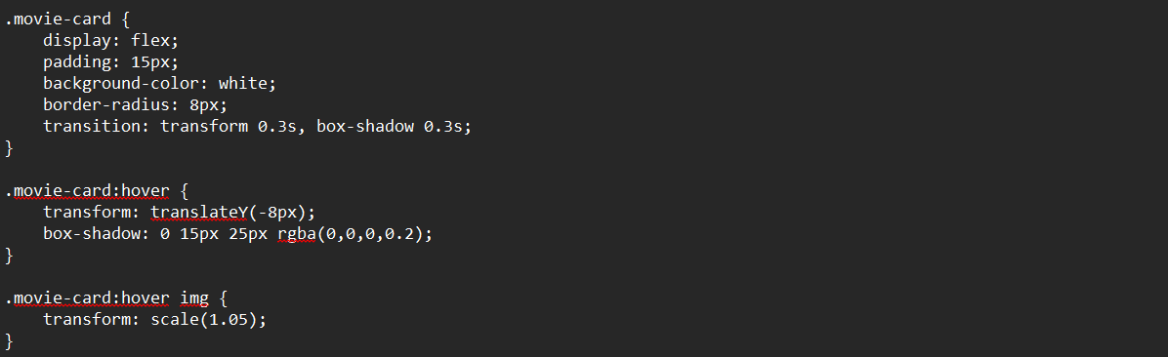
5.8 CODE SNIPPET FOR HOVER EFFECTS

CODE
<!DOCTYPE html>
<html lang="en">
<head>
<meta charset="UTF-8">
<title>Movie Review Website</title>
</head>
<style>
body {
font-family: Arial, sans-serif;
margin: 0;
background-color: #f4f4f4;
}

header {
background-color: #222;
color: white;
padding: 15px;
text-align: center;
}

nav {
background-color: #444;
padding: 10px;
text-align: center;
}

nav a {
color: white;
margin: 0 15px;
text-decoration: none;
font-weight: bold;
}

nav a:hover {
text-decoration: underline;
}

.container {
width: 90%;
margin: auto;
padding: 20px;
}

.movie-card {
background-color: white;
margin-bottom: 20px;
padding: 15px;
border-radius: 8px;
box-shadow: 0 0 10px rgba(0,0,0,0.1);
display: flex;
}

.movie-card:hover {
transform: translateY(-8px);
box-shadow: 0 15px 25px rgba(0,0,0,0.2);
}

.movie-card img {
width: 150px;
height: 220px;
border-radius: 5px;
margin-right: 20px;
}

.movie-card:hover img {
transform: scale(1.05);
}

.movie-details h2 {
margin-top: 0;
}

.rating {
color: #f39c12;
font-weight: bold;
}

footer {
background-color: #222;
color: white;
text-align: center;
padding: 10px;
margin-top: 30px;
}
</style>
</head>

<body>

<header>
<h1>🎬 Movie Review Hub</h1>
<p>Honest reviews of the latest movies</p>
</header>

<nav>
<a href="#">Home</a>
<a href="#">Latest Reviews</a>
<a href="#">Top Rated</a>
<a href="#">Contact</a>
</nav>

<div class="container">

<!-- Movie 1 -->
<div class="movie-card">
<img src="https://encrypted-tbn0.gstatic.com/images?q=tbn:ANd9GcRRyuWmayVBvqjd1MxTKpRgauq2cCtUzb7Q9QvaFTkAuxAU_EYMoCE3wBuJeftxIzf0grreIw&s=10" alt="Movie Poster">
<div class="movie-details">
<h2>Inception (2010)</h2>
<p><strong>Genre:</strong> Sci-Fi, Thriller</p>
<p class="rating">⭐ Rating: 4.8 / 5</p>
<p>
Inception is a visually stunning science-fiction thriller that explores the concept of dreams within dreams. The story follows Dom Cobb, a skilled thief who steals secrets from people's subconscious while they dream. Tasked with planting an idea instead of stealing one, Cobb assembles a team to perform an impossible mission. The film is praised for its complex narrative, powerful performances, and groundbreaking visual effects.
</p>
</div>
</div>

<!-- Movie 2 -->
<div class="movie-card">
<img src="https://encrypted-tbn0.gstatic.com/images?q=tbn:ANd9GcSngBJ0B7UDrLUkDlp6DCQLsEYuWR-DiHwbnxFFCniB3HiP3f3NZmR1-lKSC34ge6YXu4LX&s=10" alt="Movie Poster">
<div class="movie-details">
<h2>Interstellar (2014)</h2>
<p><strong>Genre:</strong> Sci-Fi, Drama</p>
<p class="rating">⭐ Rating: 4.7 / 5</p>
<p>
Interstellar is an epic space exploration film that blends science with emotional storytelling. As Earth becomes uninhabitable, a group of astronauts travel through a wormhole in search of a new home for humanity. The movie explores themes of time dilation, love, sacrifice, and survival, supported by stunning visuals and a powerful musical score.
</p>
</div>
</div>

<!-- Movie 3 -->
<div class="movie-card">
<img src="https://encrypted-tbn0.gstatic.com/images?q=tbn:ANd9GcTfE_qrYMBZ_JB8om-34WGaZARhpX26yWRttqIDvn4_7l--UzX8mxKcPrc59IcvTpEA_G8gPA&s=10" alt="Movie Poster">
<div class="movie-details">
<h2>The Dark Knight (2008)</h2>
<p><strong>Genre:</strong> Action, Crime</p>
<p class="rating">⭐ Rating: 4.9 / 5</p>
<p>
The Dark Knight redefines the superhero genre with its intense storyline and moral complexity. Batman faces his greatest challenge in the form of the Joker, a criminal mastermind who thrives on chaos. Heath Ledger’s iconic performance elevates the film, making it one of the most critically acclaimed superhero movies of all time.
</p>
</div>
</div>
<div class="movie-card">
<img src="https://encrypted-tbn0.gstatic.com/images?q=tbn:ANd9GcTwJPOxfRiaHwXkICnf6LKMHIPWJPGLx8wht-wZH-qFs0OXXUCBvOeCQTs79z7Bx9odsdsB&s=10" alt="Avatar">
<div class="movie-details">
<h2>Avatar (2009)</h2>
<p><strong>Genre:</strong> Fantasy, Adventure</p>
<p class="rating">⭐ Rating: 4.5 / 5</p>
<p>
Avatar is a visually immersive fantasy film set on the alien planet Pandora. The story follows Jake Sully, who becomes part of the Na’vi culture while exploring the planet’s rich ecosystem. The movie is known for its revolutionary visual effects, 3D technology, and environmental themes.
</p>
</div>
</div>

<!-- Movie 5 -->
<div class="movie-card">
<img src="https://encrypted-tbn0.gstatic.com/images?q=tbn:ANd9GcTNI2SBzYW95C8Wo7zYV3bzVzem58xPnUzsZGLsnLg17mSMgR574acQZpgNK7a5XeF3THjqgQ&s=10" alt="Forrest Gump">
<div class="movie-details">
<h2>Forrest Gump (1994)</h2>
<p><strong>Genre:</strong> Drama, Romance</p>
<p class="rating">⭐ Rating: 4.8 / 5</p>
<p>
Forrest Gump is a heart-warming drama that tells the story of a man with a low IQ who unintentionally influences several historical events in the United States. The film highlights themes of love, destiny, and perseverance, supported by a memorable performance by Tom Hanks.
</p>
</div>
</div>
</div>

<footer>
<p>© 2025 Movie Review Hub | Designed using HTML & CSS</p>
</footer>
</body>
</html>

CHAPTER 6
RESULTS
This Movie Review Website is a simple and user-friendly web application designed using HTML and CSS. It displays movie posters, titles, genres, ratings, and detailed reviews in a clean and organized layout. Interactive hover effects enhance user engagement, making it easy for users to browse and explore movie information.
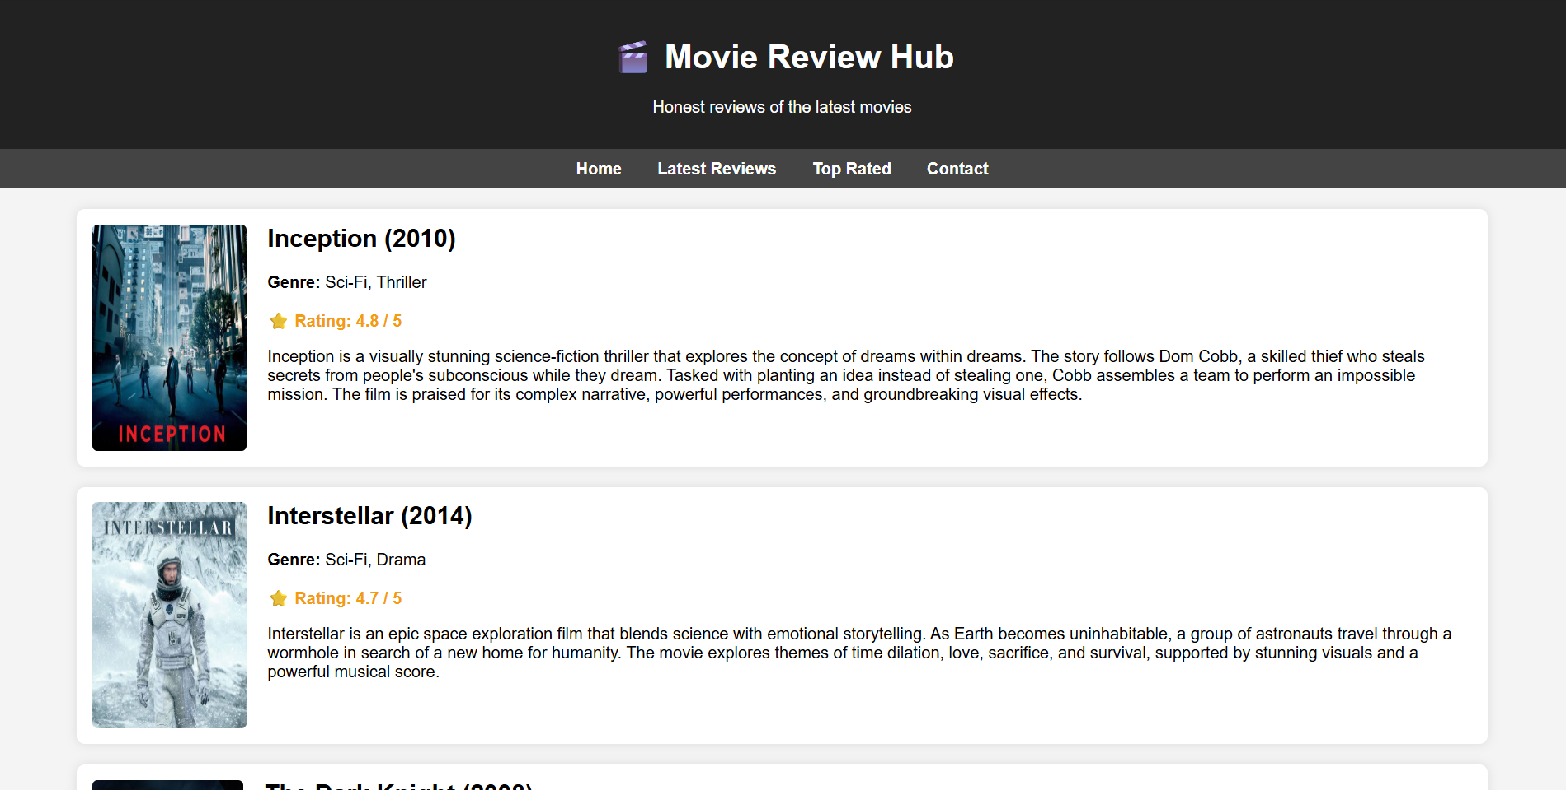
6.1 MOVIE REVIEW WEBSITE USING HTML

CHAPTER 7
CONCLUSION
The Movie Review Website project successfully demonstrates the application of fundamental web development concepts using HTML, CSS, and basic interactivity techniques. The website provides a clean and well-structured platform for displaying movie information, including posters, genres, ratings, and detailed reviews. The use of reusable movie cards and hover effects enhances user engagement and improves the overall browsing experience.
This project helped in understanding the importance of proper page structure, styling, and user-friendly design in web applications. Since the website is completely client-side, it is lightweight, easy to deploy, and suitable for beginners. The project can be further enhanced by adding advanced features such as user-submitted reviews, dynamic ratings, search functionality, and backend database integration, making it a strong foundation for future web development projects.

CHAPTER 8
REFERENCES
- MDN Web Docs – HTML, CSS, and Web Development Concepts
- W3Schools – HTML and CSS Tutorials
- CSS Tricks – Guide to CSS Flexbox and Hover Effects
- Stack Overflow – Community Discussions on Web Design
- ECMAScript Documentation – JavaScript Standards

