ZERO WASTE KITCHEN

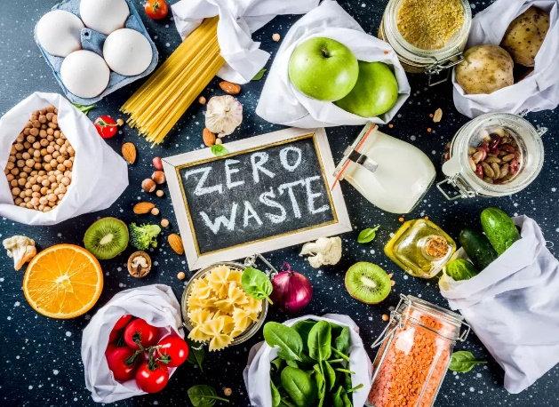

OCTOBER 5, 2023 | KATHRYN KELLOGG

Last Updated on October 11, 2023

I don’t know about you, but when the weather turns colder and the holidays start to approach, it makes me want to fire up my oven and bake cookies, pies, and bread and other family favorites.

I have had the same baking sheets over 10 years and they’re in really rough shape. I’m in need of a few replacements, and during my research, I learned that some bake sheets contain PFAS.

PFAS, also known as forever chemicals, can be found in non-stick cookware (and that includes bakeware), along with food packaging, firefighting foam, household items, outdoor gear that’s “water repellent”. We’ll discuss why this is problematic below, but switching to non-toxic bakeware is one way you can reduce your exposure.

Today, more than 97% of the U.S. population has PFAS in their bodies, according to the Centers for Disease Control and Prevention (CDC).

According to a study released by the USGS, nearly half of US tap water, from both public utilities and private wells, contains forever chemicals.

So I try to limit any unnecessary exposure and here are some of the best bakeware brands I came across during my research. All these brands are naturally non-stick without the use of PFAs.