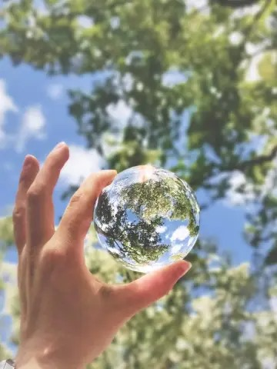Zero Waste Movement

Bea Johnson is the 21st Century's zero-waste movement's origin story. The internet simply states that she is a writer and motivational speaker but Bea is nothing short of a downright zero-waste rockstar- can you tell that I'm a huge fan?!

Bea's Zero Waste Movement blog turned best-selling book kicks butt in two ways: it teaches people how to reduce waste and busts myths around waste reduction being expensive, time-consuming, and difficult. By educating people on the how-tos of zero-waste living and dispelling harmful mistruths, Bea gives people the information (and nudge) needed to maintain a greener life.

As a zero-waste newbie, I was first drawn to Bea's biggest flex: reducing her family's annual trash to a single pint. I love that her writing is sharply written, often packing a witty punch while never ceasing to educate and inspire.

While Bea's blog is a weekly read, I recommend her book Zero Waste Home: The Ultimate Guide to Simplifying Your Life by Reducing Your Waste, where she has condensed her wisdom on waste reduction and green living.