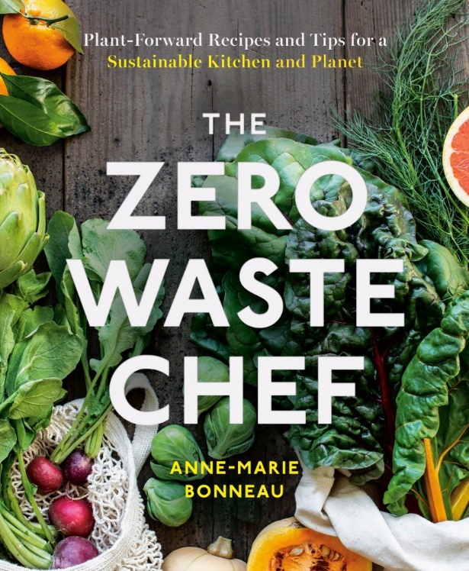Zero Waste Chef

I am my happiest in the kitchen. I naturally gravitate to bloggers and resources that focus on the kitchen and cooking, which is why Zero Waste Chef is a personal favorite.

Founder and author Chef Anne-Marie Bonneau offers tips and tricks in the kitchen and beyond, but it's the Zero Waste Chef for the recipes that I ADORE. Anne-Marie proves that the "good" in "good cooking" can come from ethical, zero-waste culinary creations. I love that I can rely on her recipes to feed myself or impress guests and with no expense to the environment.

She also educates readers on how to create a zero-waste kitchen space and think about food from a new perspective. I have changed how I see meal planning and approach my meals with more creativity and consideration. Her resources on going plastic-free were life-changing and I'll use her tricks on zero-waste hosting forever.