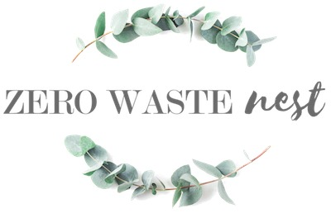Zero Waste Nest

Morgane Beernaert is a realist. She showed me that "zero-waste" can be a clumsy way of putting things because "zero-waste,” as a concept, is impossible. Managing your expectations can profoundly affect how we approach ethical living, and Morgane taught me to shift my attitude from the intimidating quest for perfect "zero-waste" to a more approachable "low waste" mindset.

if I had to use one word to describe Zero Waste Nest is would be: helpful. From her fun and whimsical guides on zero-waste fashion to her recommendations on podcasts, books, and documentaries, Morgane has become the little voice in my head helping me live life with a little more style, consideration, and mindfulness.

Zero Waste Nest has helped make my waste reduction a slow and steady adventure that I take day and day and with a playful curiosity.