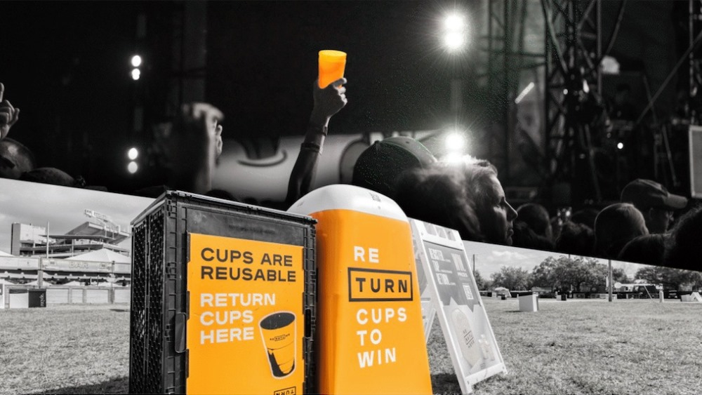Reusable Nation

Reusable Nation is the lovechild of Dave and Vix, a dynamic duo hailing from South Africa. The pair come up a lot in the zero-waste community, and for good reason: their vibrant content consistently brightens days and inspires.

As a color fiend, I love their bright visual, and colorful content. The nature of social media these days is carefully curated, often soulless content but these two radiate authenticity- their love for nature and commitment to their zero-waste journey is palpable, transparent, and downright wholesome.

Their blog and online presence have garnered an impressive following thanks to the couple's informative articles, zero-waste shopping maps, waste-reducing challenges, and how-tos that add community and support to what often feels like a daunting, lonely journey. Their grocery shop breakdown in particular really helped me make more informed and conscientious choices when doing my weekly shop and have helped me save money and the planet.