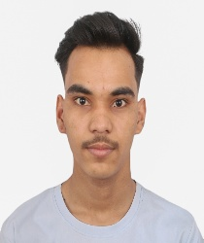
RESUME
PREM KATHAYAT
9827633522
Email id: premkathayat@gmail.com
OBJECTIVE
To work with an organization where can learn new skills and increase my abilities for the organizational goals as well as myself.
EDUCATION QUALIFICATION

- Pursuing BCA 3rd year from Samriddhi College
- Passed out 12th from SPA college in 2078
GPA 3.35
- Passed out 10th from Amar Sec School in 2075
GPA 2.90
Other Academic Details
- Complete MERN Stack
Technical Skills
- Web Development
WORK EXPERIENCE
FRESSER
Strength & Hobbies
- Hard and Smart Working
- Honest and punctual
- Good Communication skill
- Reading book, Cricket
Personal Details
Father’s Name : Man Bahadur Kathayat
Mother’s Name : Batu Davi Kathayat
Permanent Address : Gauriganga-6,Kailali
Current Address : Kathmandu-32, Koteshwor

